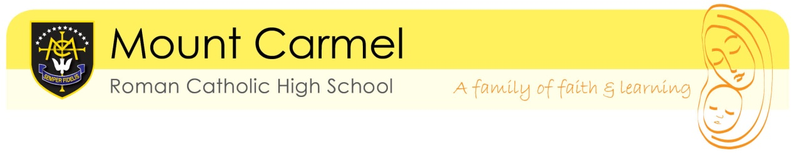
YEAR 11 PPE TIMETABLE
DECEMBER 2025

DATE | TIME | LENGTH | EXAMINATION
Mon 1 Dec 2025 (A) | SCHOOL DAY CLOSURE
Tue 2 Dec 2025 | 9am | 1hr 45 | English Literature -  Macbeth + Poetry Anthology
Tue 2 Dec 2025 | 11:30am | 1hr 45 | RS- Catholic Christianity
Wed 3 Dec 2025 | 9am | 1hr 30 | Maths paper 1
Wed 3 Dec 2025 | 11:30am | 1hr 30 | Computer Science 1 / Imedia
Thur 4 Dec 2025 | 9am | 1hr 15 | Biology
Thur 4 Dec 2025 | 11:30am | 1hr 30 | Geography
Fri 5 December 2025 | 9am | 2hrs | History
Fri 5 December 2025 | 11:30am | 1hr | GCSE PE-paper 1
Mon 8 Dec 2025 (B) | 9am | 1hr 45 | English Language paper 1
Mon 8 Dec 2025 (B) | 11:30am | 1hr 15 | Chemistry
Tue 9 Dec 2025 | 9am | 1hr 30 | Maths paper 2 - calculator
Tue 9 Dec 2025 | 11:30am | 1 hr 15/20 | Spanish - writing
Wed 10 Dec 2025 | 9am | 1hr 15 | Physics
Wed 10 Dec 2025 | 11:30am | 50m | RS - Judaism
Thur 11 Dec 2025 | 9am | 1hr 30/15 | Computer Science 2 / PE paper 2
Thur 11 Dec 2025 | 11:30am | 2hrs/1hr45 | DT/Food
Fri 12 Dec 2025 | 9am |  | Catch up
Fri 12 Dec 2025 | 11:30am |  | Catch up

