Teaching & Learning Policy

School Name: | The White Horse Federation
Version No: | 7 | Ratified date: | September 2023
Author: | A Capstick | Interim review date: | n/a
Owner: | S Cowley | Next review date: | September 2024
Approved by: | CEO

A shared approach to Teaching and Learning – Back to Basics: A Pedagogical Model

Contents

Introduction 2
Key Features of the Teaching and Learning Policy 3
The 6 Pedagogical Principles 4
Challenge 5
Explanation 5
Modelling 6
Practice 6
Feedback 6
Questioning 7
References, resources and further reading: 9

Introduction

Learning and teaching is the core business of schools in The White Horse Federation. It is our aim to motivate all our students to have high aspirations, to want to do their personal best and to have the desire to be successful in and out of school. To prepare our students for a rapidly changing world, we need to create a stimulating and successful learning environment in order to nurture flexible, driven and creative learners.

This policy sets out the principles and expectations behind our approach, which is underpinned by the Teachers Standards, and in doing so provides new and existing staff with a clear vision of the school’s expectations, providing an agreed focus for monitoring.

There are two sources that have informed this Teaching and Learning Policy. The first is Making Every Lesson Count by Allison and Tharby (2015). This distils teaching and learning into 6 core principles explained in more detail below and is based on robust evidence and practical classroom practice. The second source is Rosenshine’s Principles of Instruction (2012). Again, based on research from cognitive science, the classroom practice of master teachers, and cognitive scaffolds to help teach complex concepts, this is an evidence-informed approach to teaching.

This policy also provides further references and reading in the last section to complement the policy.

Key Features of the Teaching and Learning Policy

Curriculum design

A detailed, structured curriculum is mapped out across all phases, ensuring continuity and supporting transition. Fundamental skills and knowledge are secured first.
The Ofsted Framework has a focus on a ‘broad and balanced curriculum’ where there is the expectation that manageable steps for each subject are mapped meticulously and with reason across the primary phase to allow pupils to build on previous skills / knowledge purposefully and with evidence of ‘knowing more and remembering more’.

Lesson design

The starting point of lesson planning is skilled practitioners’ ‘craft knowledge’ (Wilson, 2012). This is knowledge of an individual, class, school and community context, and the evidence of what works within these contexts. This, alongside the T and L policy, should inform planning. Allison and Tharby (2015, pp 269-272) provide a useful audit tool to aid planning in relation to the 6 pedagogical principles presented in the policy below.

High Expectations and Adaptive Teaching

Taking a mastery approach every student works towards the same goal. Every pupil is required to answers that demand critical thinking. Students’ difficulties and misconceptions are identified through immediate formative assessment and addressed with rapid intervention. This is an inclusive approach to individual learners’ needs, ensuring language, questioning, concepts and ultimately learning is accessible to all.

Fluency comes from deep knowledge and practice. Explicit learning is important in the journey towards fluency and embedding. All tasks are chosen and sequenced carefully. Both class work and homework provide this ‘intelligent practice’, which helps to develop deep and sustainable knowledge.

The 6 Pedagogical Principles

The Teaching and Learning policy is encapsulated by the following diagram, designed by Shaun Allison and Andy Tharby (2015). Teachers are clear that their role is to teach in a precise way which makes it possible for all pupils to engage successfully with tasks at the expected level of challenge:
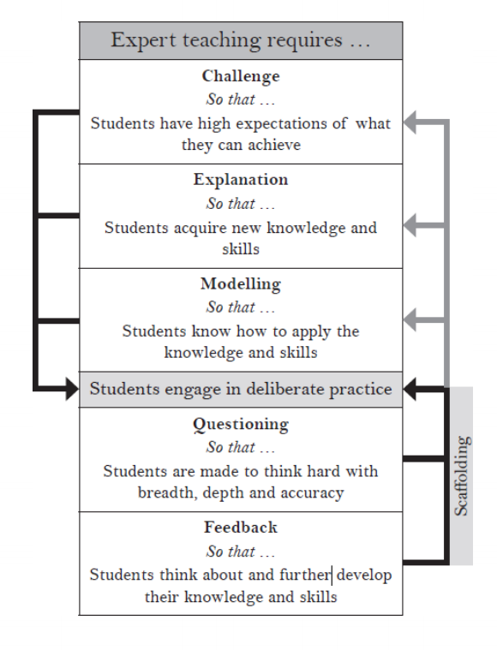

How is this achieved, and what does it look like in the classroom?

These 6 principles are key to effective teaching but by its very nature, teaching is a creative profession so there is no prescribed formula for the way they are implemented in the classroom. When dealing with varied subjects it is about how these principles are best implemented to present subject and lesson specific concepts in the most effective way to students.

Challenge

With the mastery learning model, rather than prejudging potential outcomes and stifling expectations by setting a host of differentiated learning objectives based on prior attainment, have a single challenging learning objective and then think about what each individual student needs to achieve it via the use of the 6 teaching principles.

- What do they struggle with?
- What switches them off?
- How much and what type of support do they respond well to?

All students may have different starting points but should aspire to the learning objective and a teacher is responsive in helping them to work towards is, for example:

- focused questioning
- adult/ peer help with starting their sentences
- some may need to do a draft
- some will need apparatus to help
- some will reach the objective and need to be challenged further

It is about equity of opportunity, not all getting exactly the same to reach the objective. The aim is to keep students in the challenge zone, or as Vygotsky describes, the ‘zone of proximal development’

Explanation

Three key principles should guide explanations:

- Plan in to schemes of learning how to link to and build on something already known.
  - Begin each lesson with a short review of previous learning (Rosenshine, 2012)
- Allow for the limitations of the working memory when asking students to take on board new information, giving instructions, asking them to sort key bits of information etc.
  - Present new information in small steps with student practice after each step (Rosenshine, 2012)
- Where possible try to make the abstract concrete – think about and plan, how to make abstract ideas make sense:
  - Drawing diagrams; demonstrations in science; sharing and discussing images; taking the learning outside etc.
  - Provide scaffolds for difficult tasks (Rosenshine, 2012)
  - Direct explicit instruction (Kirschner, Sweller, Clarke, 2006)

Modelling

Explain the key ideas, then model how to do it / what to do with it. This falls in to two main categories:

- Model the creation of products/procedures. For example: write an essay, show pupils how to do it and articulate your thinking. Write it out on the board and discuss how/why you are doing each step as you go. Question them on what is being done. Explain, out loud, thought processes. If mistakes are made, point them out.
- Deconstruct expert examples and use worked examples – have an excellent finished product and share it, discuss why it is good.

Practice

Plan in time, during the lesson and over a series of lessons, for students to practice using new knowledge and skills. Consider the type of practice and its purpose:

  - Practice for fluency and long-term retention – repeating things in order to master them; coming back to things in subsequent lessons etc.
  - Deliberate ‘intelligent’ practice at the outer reaches of ability – allowing students to make connections and see patterns. Practising at the outer reaches of ability means students will have to layer skills and use them with agility.
    - Guide student practice (Rosenshine, 2012)
    - Require and monitor independent practice (Rosenshine, 2012)

Feedback

Plan in how you will give feedback during/after lessons and – for this feedback to be meaningful -how you will allow students to respond this feedback. Feedback is a two-way process and the teacher should use the students’ feedback to inform future planning.
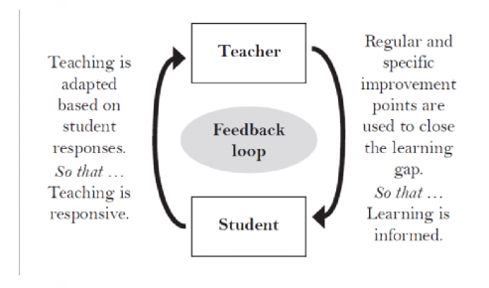

Moreover, it is our goal to nurture independent and agile learners who have the skills to be successful in an increasingly globalised and rapidly changing world. To achieve this, we must equip students to be critical and reflective learners in their own right by ‘learning how to learn’. Students need to be engaged in their own learning, be part of the creation of their ‘next steps’ and have the opportunity to assess their own work and that of their peers in a meaningful and useful manner.

- Engage students in weekly and monthly review (Rosenshine, 2012)
- Guide student practice

Questioning

Some questions can be planned for, but some should be responsive to what is happening in the lesson. When considering planned questions, they should be to:

- Check for understanding – i.e. hinge questions that students should be able to answer at a certain point in the lesson, before they move on.
  - Ask a large number of questions and check the responses of all students,
  - Check for understanding (Rosenshine, 2012)
- Provoke deeper thinking
- Increase the ratio of participation and thinking of all students

Other factors to consider

The Role of the Environment
The school and classroom environment are key in underpinning and supporting the 6 core principles. Maslow’s Hierarchy of Needs puts the learner first, with the responsibility of ensuring the learner’s needs are met. This can be physical; the physical environment of the school and classroom setting, social and emotional in relation to an individuals’ needs and starting point, and the teachers’ role in socially competency. Working walls and displays should evolve as the learning develops and be a point to provide:
- further explanation based on that used in the sessions
- additional challenge
- model examples
- probing questions/prompts to promote deeper thinking
- a backdrop that supports the hook/ stimulus for learning
- relevant resources

The Role of Parents/Carers

Parents/Carers have particular insights about the strengths, skills, interests, preferences, aspirations, anxieties and difficulties of their children. Accordingly, the importance of meaningful communications and co-operation between the school and the pupils’ parents/carers cannot be overstated and is a key contribution to learning. This communication is an important part of developing understanding of individual needs as well as praising students in line with school rewards policies.

A ‘Values Based’ Organisation

All of The White Horse Federation Schools are committed to a Values Based Education which is an approach to teaching that creates a strong learning environment that enhances academic attainment and develops students’ social and relationship skills. Values are principles that drive behaviour. They influence actions and attitudes and become a framework for living. The wide range of values highlighted and encouraged in schools include resilience, responsibility and collaboration.

The learning environment is enhanced through the positive modelling of these values by staff throughout the school. It also provides social capacity to students, equipping them with social and relationship skills, intelligences and attitudes to succeed at school and throughout their lives.

References, resources and further reading:

Allison, S & Tharby, T (2015) ‘Making Every Lesson Count’ Crownhouse.

Kirschner, P. A., Sweller, J. and Clark, R. E. (2006), ‘Why minimal guidance during instruction does not work: an analysis of the failure of constructivist, discovery, problem-based, experiential, and inquiry-based teaching’ Educational Psychologist 41 (2) pp. 75–
86.

Rosenshine, B (2012) ’10 Principles of Instruction’ American Educator Wilson, E (2012) ‘School-based Research’ Routledge

Teaching and Learning Research Summaries: https://teacherhead.com/2017/06/03/teaching-and-learning-research-summaries-a- collection- for-easy-access/

Theories of Learning
https://impact.chartered.college/issue/issue-2-science-of-learning/ https://impact.chartered.college/article/shibli-cognitive-load-theory-classroom/ https://impact.chartered.college/article/brookman-byrne-neuroscience-psychology- education/

Curriculum design
https://impact.chartered.college/browse-issue/?issue=issue-4-designing-a-curriculum

Direct Explicit Instruction – Summary can be found at https://researched.org.uk/inquiry- learning-isnt-a-call-for-direct-explicit-instruction/

