‘A CHRISTMAS CAROL’ REVISION
1. REVISING THE GHOSTS
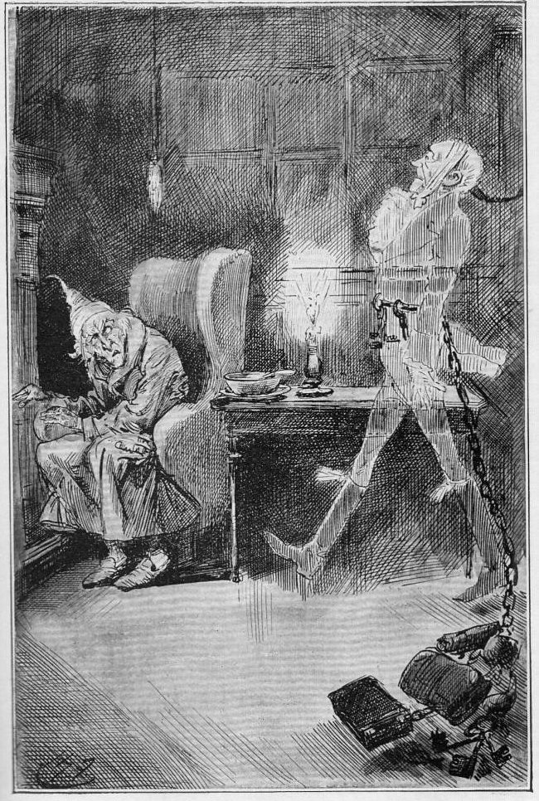
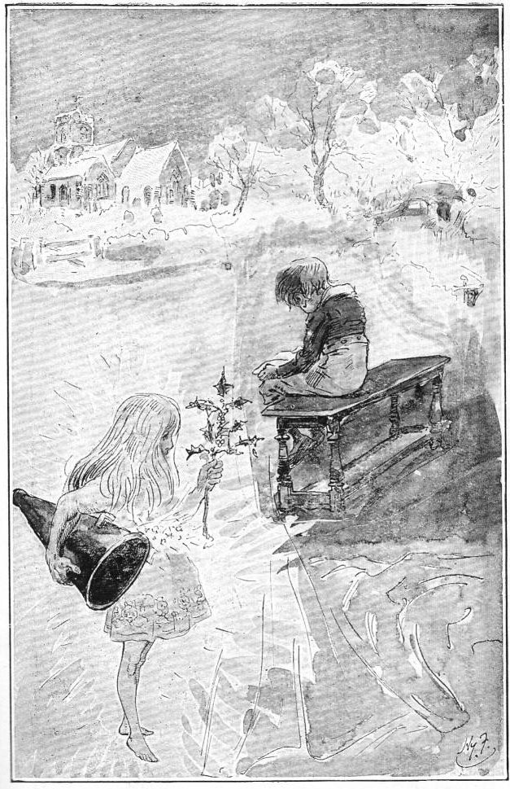
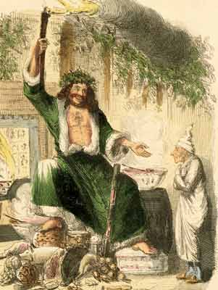
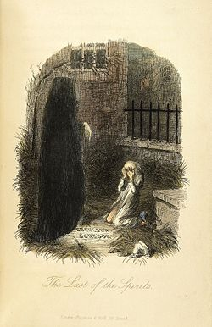
1. Marley’s ghost

The same face: the very same. Marley in his pigtail, usual waistcoat, tights, and boots; the tassels on the latter bristling, like his pigtail, and his coat-skirts, and the hair upon his head. The chain he drew was clasped about his middle. It was long, and wound about him like a tail; and it was made (for Scrooge observed it closely) of cash-boxes, keys, padlocks, ledgers, deeds, and heavy purses wrought in steel. His body was transparent; so that Scrooge, observing him, and looking through his waistcoat, could see the two buttons on his coat behind.

Scrooge had often heard it said that Marley had no bowels, but he had never believed it until now.

No, nor did he believe it even now. Though he looked the phantom through and through, and saw it standing before him; though he felt the chilling influence of its death-cold eyes; and marked the very texture of the folded kerchief bound about its head and chin, which wrapper he had not observed before; he was still incredulous, and fought against his senses …

To sit, staring at those fixed, glazed eyes, in silence for a moment, would play, Scrooge felt, the very deuce with him. There was something very awful, too, in the spectre's being provided with an infernal atmosphere of its own. Scrooge could not feel it himself, but this was clearly the case; for though the Ghost sat perfectly motionless, its hair, and skirts, and tassels, were still agitated as by the hot vapour from an oven…

Scrooge fell upon his knees, and clasped his hands before his face.

``Mercy!'' he said. ``Dreadful apparition, why do you trouble me?''

``Man of the worldly mind!'' replied the Ghost, ``do you believe in me or not?''

``I do,'' said Scrooge. ``I must. But why do spirits walk the earth, and why do they come to me?''

``It is required of every man,'' the Ghost returned, ``that the spirit within him should walk abroad among his fellow-men, and travel far and wide; and if that spirit goes not forth in life, it is condemned to do so after death. It is doomed to wander through the world -- oh, woe is me! -- and witness what it cannot share, but might have shared on earth, and turned to happiness!''

Again the spectre raised a cry, and shook its chain, and wrung its shadowy hands.

``You are fettered,'' said Scrooge, trembling. ``Tell me why?''

``I wear the chain I forged in life,'' replied the Ghost. ``I made it link by link, and yard by yard; I girded it on of my own free will, and of my own free will I wore it. Is its pattern strange to you?''

Scrooge trembled more and more.

``Or would you know,'' pursued the Ghost, ``the weight and length of the strong coil you bear yourself? It was full as heavy and as long as this, seven Christmas Eves ago. You have laboured on it, since. It is a ponderous chain!'' …

``But you were always a good man of business, Jacob,'' faltered Scrooge, who now began to apply this to himself.

``Business!'' cried the Ghost, wringing its hands again. ``Mankind was my business. The common welfare was my business; charity, mercy, forbearance, and benevolence, were, all, my business. The dealings of my trade were but a drop of water in the comprehensive ocean of my business!''

Interpretations and symbolism: Marley’s Ghost

Why does the ghost drag a chain around?

…………………………………………………………………………………………………………………………………………………………
…………………………………………………………………………………………………………………………………………………………
…………………………………………………………………………………………………………………………………………………………
…………………………………………………………………………………………………………………………………………………………

What is the chain made up of? Why do you think this is?

…………………………………………………………………………………………………………………………………………………………
…………………………………………………………………………………………………………………………………………………………
…………………………………………………………………………………………………………………………………………………………
…………………………………………………………………………………………………………………………………………………………

Why does Marley’s ghost have to travel the earth after death?

…………………………………………………………………………………………………………………………………………………………
…………………………………………………………………………………………………………………………………………………………
…………………………………………………………………………………………………………………………………………………………
…………………………………………………………………………………………………………………………………………………………

The ghost tells Scrooge ‘the weight and length of the strong coil you bear yourself’ was as heavy as Marley’s seven years ago? What do you think he is suggesting to Scrooge here?

…………………………………………………………………………………………………………………………………………………………
…………………………………………………………………………………………………………………………………………………………
…………………………………………………………………………………………………………………………………………………………
…………………………………………………………………………………………………………………………………………………………

The ghost tells Scrooge ‘Mankind was my business’. What do you think this means?

…………………………………………………………………………………………………………………………………………………………
…………………………………………………………………………………………………………………………………………………………
…………………………………………………………………………………………………………………………………………………………
…………………………………………………………………………………………………………………………………………………………

2. The Spirit of Christmas Past

It was a strange figure -- like a child: yet not so like a child as like an old man, viewed through some supernatural medium, which gave him the appearance of having receded from the view, and being diminished to a child's proportions. Its hair, which hung about its neck and down its back, was white as if with age; and yet the face had not a wrinkle in it, and the tenderest bloom was on the skin. The arms were very long and muscular; the hands the same, as if its hold were of uncommon strength. Its legs and feet, most delicately formed, were, like those upper members, bare. It wore a tunic of the purest white and round its waist was bound a lustrous belt, the sheen of which was beautiful. It held a branch of fresh green holly in its hand; and, in singular contradiction of that wintry emblem, had its dress trimmed with summer flowers. But the strangest thing about it was, that from the crown of its head there sprung a bright clear jet of light, by which all this was visible; and which was doubtless the occasion of its using, in its duller moments, a great extinguisher for a cap, which it now held under its arm.

Even this, though, when Scrooge looked at it with increasing steadiness, was not its strangest quality. For as its belt sparkled and glittered now in one part and now in another, and what was light one instant, at another time was dark, so the figure itself fluctuated in its distinctness: being now a thing with one arm, now with one leg, now with twenty legs, now a pair of legs without a head, now a head without a body: of which dissolving parts, no outline would be visible in the dense gloom wherein they melted away. And in the very wonder of this, it would be itself again; distinct and clear as ever.

``Are you the Spirit, sir, whose coming was foretold to me?'' asked Scrooge.

``I am!''

The voice was soft and gentle. Singularly low, as if instead of being so close beside him, it were at a distance.

``Who, and what are you?'' Scrooge demanded.

``I am the Ghost of Christmas Past.''

``Long past?'' inquired Scrooge: observant of its dwarfish stature.

``No. Your past.''

Perhaps, Scrooge could not have told anybody why, if anybody could have asked him; but he had a special desire to see the Spirit in his cap; and begged him to be covered.

It put out its strong hand as it spoke, and clasped him gently by the arm.

``Rise! and walk with me!''

It would have been in vain for Scrooge to plead that the weather and the hour were not adapted to pedestrian purposes; that bed was warm, and the thermometer a long way below freezing; that he was clad but lightly in his slippers, dressing-gown, and nightcap; and that he had a cold upon him at that time. The grasp, though gentle as a woman's hand, was not to be resisted. He rose: but finding that the Spirit made towards the window, clasped his robe in supplication.

``I am mortal,'' Scrooge remonstrated, ``and liable to fall.''

``Bear but a touch of my hand there,'' said the Spirit, laying it upon his heart, ``and you shall be upheld in more than this!'' As the words were spoken, they passed through the wall …

Interpretations and symbolism: The Spirit of Christmas Past

The Spirit of Christmas Past shows Scrooge a series of memories from past Christmases. The ghost has a ‘bright clear jet of light’ emanating from the ‘crown’ of its head. What do you think this light could represent?

…………………………………………………………………………………………………………………………………………………………
…………………………………………………………………………………………………………………………………………………………
…………………………………………………………………………………………………………………………………………………………
…………………………………………………………………………………………………………………………………………………………

Holly is an evergreen plant. Why do you think the spirit carries a ‘branch of fresh green holly’ whilst also having a dress fringed with ‘summer flowers’? What might Dickens be suggesting about memory?

…………………………………………………………………………………………………………………………………………………………
…………………………………………………………………………………………………………………………………………………………
…………………………………………………………………………………………………………………………………………………………
…………………………………………………………………………………………………………………………………………………………

Why might this Spirit change form so often? What is the significance of its strong grip?

…………………………………………………………………………………………………………………………………………………………
…………………………………………………………………………………………………………………………………………………………
…………………………………………………………………………………………………………………………………………………………
…………………………………………………………………………………………………………………………………………………………

The Spirit asks Scrooge to ‘touch’ his heart in order to be transported. Why might this be?

…………………………………………………………………………………………………………………………………………………………
…………………………………………………………………………………………………………………………………………………………
…………………………………………………………………………………………………………………………………………………………
…………………………………………………………………………………………………………………………………………………………
Scrooge, at the end of this chapter, attempts to hide the light with the ‘extinguisher cap’ but the light still remains. Why do you think this is?

…………………………………………………………………………………………………………………………………………………………
…………………………………………………………………………………………………………………………………………………………
…………………………………………………………………………………………………………………………………………………………
…………………………………………………………………………………………………………………………………………………………

3. The Spirit of Christmas Present

It was his own room. There was no doubt about that. But it had undergone a surprising transformation. The walls and ceiling were so hung with living green, that it looked a perfect grove; from every part of which, bright gleaming berries glistened. The crisp leaves of holly, mistletoe, and ivy reflected back the light, as if so many little mirrors had been scattered there; and such a mighty blaze went roaring up the chimney, as that dull petrification of a hearth had never known in Scrooge's time, or Marley's, or for many and many a winter season gone. Heaped up on the floor, to form a kind of throne, were turkeys, geese, game, poultry, brawn, great joints of meat, sucking-pigs, long wreaths of sausages, mince-pies, plum-puddings, barrels of oysters, red-hot chesnuts, cherry-cheeked apples, juicy oranges, luscious pears, immense twelfth-cakes, and seething bowls of punch, that made the chamber dim with their delicious steam. In easy state upon this couch, there sat a jolly Giant, glorious to see: who bore a glowing torch, in shape not unlike Plenty's horn, and held it up, high up, to shed its light on Scrooge, as he came peeping round the door.

``Come in!'' exclaimed the Ghost. ``Come in. and know me better, man!''

Scrooge entered timidly, and hung his head before this Spirit. He was not the dogged Scrooge he had been; and though the Spirit's eyes were clear and kind, he did not like to meet them.

``I am the Ghost of Christmas Present,'' said the Spirit. ``Look upon me!''

Scrooge reverently did so. It was clothed in one simple green robe, or mantle, bordered with white fur. This garment hung so loosely on the figure, that its capacious breast was bare, as if disdaining to be warded or concealed by any artifice. Its feet, observable beneath the ample folds of the garment, were also bare; and on its head it wore no other covering than a holly wreath, set here and there with shining icicles. Its dark brown curls were long and free: free as its genial face, its sparkling eye, its open hand, its cheery voice, its unconstrained demeanour, and its joyful air. Girded round its middle was an antique scabbard; but no sword was in it, and the ancient sheath was eaten up with rust.

``You have never seen the like of me before!'' exclaimed the Spirit.

``Never,'' Scrooge made answer to it.

``Have never walked forth with the younger members of my family; meaning (for I am very young) my elder brothers born in these later years?'' pursued the Phantom.

``I don't think I have,'' said Scrooge. ``I am afraid I have not. Have you had many brothers, Spirit?''

``More than eighteen hundred,'' said the Ghost.

``A tremendous family to provide for!'' muttered Scrooge.

The Ghost of Christmas Present rose.

``Spirit,'' said Scrooge submissively, ``conduct me where you will. I went forth last night on compulsion, and I learnt a lesson which is working now. To-night, if you have aught to teach me, let me profit by it.''

``Touch my robe!''

Scrooge did as he was told, and held it fast.

Holly, mistletoe, red berries, ivy, turkeys, geese, game, poultry, brawn, meat, pigs, sausages, oysters, pies, puddings, fruit, and punch, all vanished instantly. So did the room, the fire, the ruddy glow, the hour of night, and they stood in the city streets on Christmas morning …

Interpretations and symbolism: The Spirit of Christmas Present

The Spirit of Christmas Present is surrounded by copious amounts of food and drink. It also holds a cornucopia-style ‘glowing torch’. Why do you think Dickens presents the Spirit in this way?

…………………………………………………………………………………………………………………………………………………………
…………………………………………………………………………………………………………………………………………………………
…………………………………………………………………………………………………………………………………………………………
…………………………………………………………………………………………………………………………………………………………

Beneath the Spirit’s ‘one simple green robe’, its ‘capacious breast’ is ‘bare’, as are its feet. What to you think could be the significance of this?

…………………………………………………………………………………………………………………………………………………………
…………………………………………………………………………………………………………………………………………………………
…………………………………………………………………………………………………………………………………………………………
…………………………………………………………………………………………………………………………………………………………

Dickens uses the word ‘free’ a number of times in this description, meaning ‘unconstrained’ and open. What do you think Dickens might be telling us about Christmas?

…………………………………………………………………………………………………………………………………………………………
…………………………………………………………………………………………………………………………………………………………
…………………………………………………………………………………………………………………………………………………………
…………………………………………………………………………………………………………………………………………………………

We are told that, around its middle, is ‘an antique scabbard’ but with ‘no sword in it’. What do you think might be the significance of this?

…………………………………………………………………………………………………………………………………………………………
…………………………………………………………………………………………………………………………………………………………
…………………………………………………………………………………………………………………………………………………………
…………………………………………………………………………………………………………………………………………………………

Explain how the Spirit has had ‘more than eighteen hundred brothers’.

…………………………………………………………………………………………………………………………………………………………
…………………………………………………………………………………………………………………………………………………………
…………………………………………………………………………………………………………………………………………………………
………………………………………………………………………………………………………………………………………………

4. The Spirit of Christmas Yet to Come

The Phantom slowly, gravely, silently approached. When it came, Scrooge bent down upon his knee; for in the very air through which this Spirit moved it seemed to scatter gloom and mystery.
It was shrouded in a deep black garment, which concealed its head, its face, its form, and left nothing of it visible save one outstretched hand. But for this it would have been difficult to detach its figure from the night, and separate it from the darkness by which it was surrounded.

He felt that it was tall and stately when it came beside him, and that its mysterious presence filled him with a solemn dread. He knew no more, for the Spirit neither spoke nor moved.

``I am in the presence of the Ghost of Christmas Yet To Come?'' said Scrooge.

The Spirit answered not, but pointed onward with its hand.

``You are about to show me shadows of the things that have not happened, but will happen in the time before us,'' Scrooge pursued. ``Is that so, Spirit?''

The upper portion of the garment was contracted for an instant in its folds, as if the Spirit had inclined its head. That was the only answer he received.

Although well used to ghostly company by this time, Scrooge feared the silent shape so much that his legs trembled beneath him, and he found that he could hardly stand when he prepared to follow it. The Spirit paused a moment, as observing his condition, and giving him time to recover.
But Scrooge was all the worse for this. It thrilled him with a vague uncertain horror, to know that behind the dusky shroud, there were ghostly eyes intently fixed upon him, while he, though he stretched his own to the utmost, could see nothing but a spectral hand and one great heap of black.

``Ghost of the Future!'' he exclaimed, ``I fear you more than any spectre I have seen. But as I know your purpose is to do me good, and as I hope to live to be another man from what I was, I am prepared to bear you company, and do it with a thankful heart. Will you not speak to me?''

It gave him no reply. The hand was pointed straight before them.

``Lead on!'' said Scrooge. ``Lead on! The night is waning fast, and it is precious time to me, I know. Lead on, Spirit!''

The Phantom moved away as it had come towards him. Scrooge followed in the shadow of its dress, which bore him up, he thought, and carried him along.

They scarcely seemed to enter the city; for the city rather seemed to spring up about them, and encompass them of its own act.

Interpretations and symbolism: Spirit of Christmas Yet to Come

Perhaps the symbolism Dickens uses here is much more explicit. What do you think the ‘shrouded’ figure in the ‘deep black garment’ represents?

…………………………………………………………………………………………………………………………………………………………
…………………………………………………………………………………………………………………………………………………………
…………………………………………………………………………………………………………………………………………………………
…………………………………………………………………………………………………………………………………………………………

Look at the adverbs Dickens uses to describe the Spirit’s approach on the opening line. What do you think is the significance of these words?

…………………………………………………………………………………………………………………………………………………………
…………………………………………………………………………………………………………………………………………………………
…………………………………………………………………………………………………………………………………………………………
…………………………………………………………………………………………………………………………………………………………

The Spirit continually points ‘onward’ with its ‘outstretched hand’. What might this symbolise?

…………………………………………………………………………………………………………………………………………………………
…………………………………………………………………………………………………………………………………………………………
…………………………………………………………………………………………………………………………………………………………
…………………………………………………………………………………………………………………………………………………………

Dickens tells us that Scrooge fears the ‘silent shape’ so much ‘that his legs trembled beneath him’. Why do you think it is that Scrooge fears this Spirit more than the others?

…………………………………………………………………………………………………………………………………………………………
…………………………………………………………………………………………………………………………………………………………
…………………………………………………………………………………………………………………………………………………………
…………………………………………………………………………………………………………………………………………………………

Scrooge’s reaction to this Spirit is different as he commands it to ‘Lead on’, rather than ‘submissively’ waiting as we have seen earlier in the novel. Why do you think this might be?

…………………………………………………………………………………………………………………………………………………………
…………………………………………………………………………………………………………………………………………………………
…………………………………………………………………………………………………………………………………………………………
…………………………………………………………………………………………………………………………………………………………

The Spirit of Come Christmas Yet To | The Spirit of Christmas Present | The Spirit of Christmas Past | Marley’s Ghost
 |  |  |  | One-sentence summary of its symbolic significance
 |  |  |  | What the ghost shows Scrooge
 |  |  |  | Three most important quotations about the ghost

