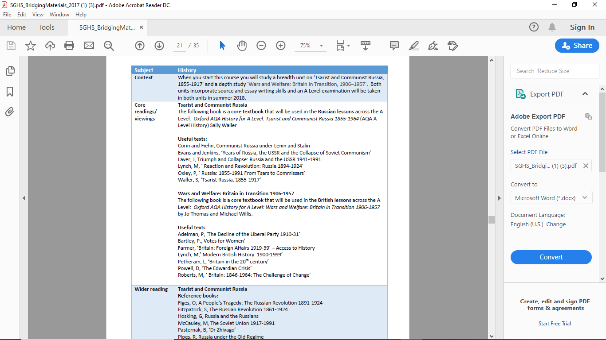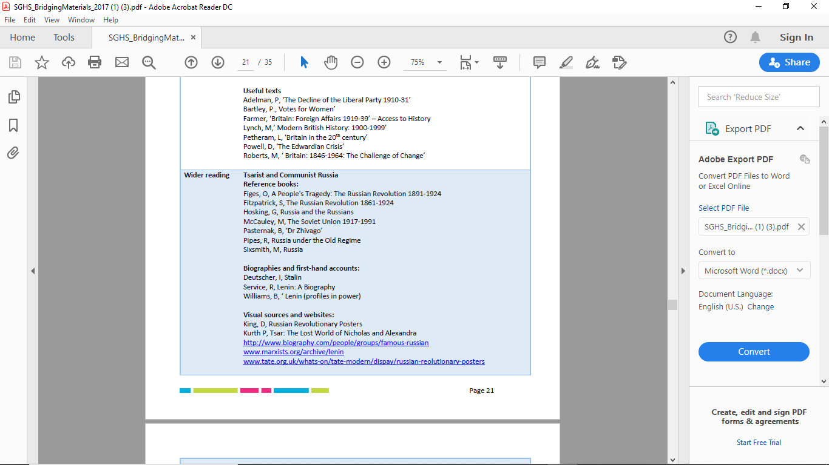

**If you decide to do A’Level history there are a range of specifications that your college might do but below is a sample from AQA A’Level history. The course has a lengthy topic on ‘Tsarist & Communist Russia, 1855-1917’ and a depth study ‘Wars and Welfare: Britain in Transition, 1906-1957’.**

