ENGLISH LANGUAGE
PAPER 1 QUESTIONS
Reading Time  - Use this to actually read the text!  - Highlight elements for each questions in different colours/styles.  - Prepare and plan your answers as you are reading!  15 minutes | Question 1  - Small section of text;  - List four explicit pieces of information;  - Quotations or paraphrasing;  - No need for inference!  4 marks in 5 minutes
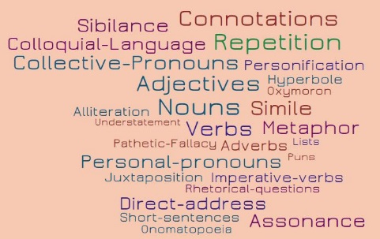
Question 2 – Language
- Small section of text;
- Analyse the writer’s use of language for effect;
- Use terminology to introduce points;
- Analyse elements such as effect on reader, and link directly back to focus of question.
8 marks in 10 minutes; 2 -3 paragraphs
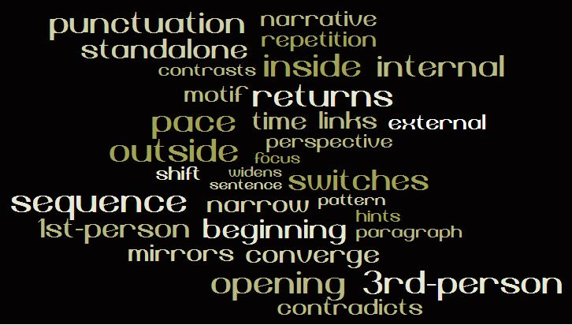
Question 3 – Structure
- Whole text coverage
- Analyse how the writer has used structure to interest you – what is it that interests you
- Use key terminology
- Analyse the reason why this makes you want to engage with the text.

8 marks in 10 minutes; 2 -3 paragraphs
Question 4 – Critical Evaluation
- Focus on half of the text;
- Respond to a given statement about an element of the writer’s craft;
- Most likely to agree with the statement – they will never give you a completely disagreeable/wrong statement;
- Evaluative adverbs – cleverly, effectively, usefully.
- Find evidence to support your response;
- Analyse how the language is used in your evidence, and then how this links to/proves the argument.
20 marks in 20 minutes; 4-5 paragraphs
Question 5
- Writing to describe or narrate [tell a story]
- ALWAYS go for the descriptive option – never narrate!
- Employ all the language features you know to say a lot about a tiny amount!
- Consider the effect you want to have – think about how the writer in your reading text has done this!
- Remember to paragraph and structure deliberately!
- 40% of marks are for Spelling, Punctuation and Grammar!
40 marks in 45 minutes
24 marks for Content and Organisation
16 marks for Spelling, Punctuation, Grammar and Sentence Structure

ENGLISH LANGUAGE
PAPER 2 QUESTIONS
Reading Time  - Use this to actually read both texts!  - Highlight elements for each questions in different colours/styles.  - Prepare and plan your answers as you are reading!  15 minutes | Question 1  - Small section of text;  - Identify four true statements from a choice of eight.  - These will need inference skills! Careful not to be tricked!  4 marks in 5 minutes
Question 2 – Synthesis  - Whole text coverage of both texts;  - The question will give you a focus – either similarities or differences.  - Have a statement that summarises your point, and incorporate evidence;  - Make an inference from this quotation – what is the writer hinting at/suggesting?  8 marks in 10 minutes | Question 3 – Language  - Whole text coverage  - Analyse how the writer uses language for effect  - Use terminology to introduce your points  - Analyse elements such as effect on reader, and link directly back to focus of question.  12 marks in 12 minutes
Question 4 – Comparison of Viewpoints and Perspectives
- Whole text comparisons of both texts;
- What is the writer’s perspective? How are they writing? Through what lenses?
- What is the writer’s viewpoint? What do they think/feel about the issue?
- Support every idea with evidence?
- How does the writer use language to convey this? What is the effect on the reader?
- Could you make an inference to take your understanding further?

16 marks in 16 minutes
Question 5
- Writing to present your viewpoint and opinion.
- You will be given a purpose from persuade, argue, explain or instruct/advise.
- You will be asked to write for one of five purposes – essay, speech, letter, leaflet or article.
- Employ all the language features you know to develop an argument!
- Consider the effect you want to achieve – show people you are fair, balanced and reasonable.
- Remember to paragraph and structure deliberately!
- 40% of marks are for Spelling, Punctuation and Grammar!

40 marks in 45 minutes
24 marks for Content and Organisation
16 marks for Spelling, Punctuation, Grammar and Sentence Structure

