This should keep you busy over the coming weeks:

Try all the research and listening exercises in the booklet.
If you are lucky enough to be able to try any of the practical activities, have a go.
Make a presentation on Film Music. Lots of clips on YouTube which are interesting
If you have a keyboard, piano or other instrument, have a go at the music included at the end (pieces we have been working on in class)

VOCABULARY

adagio | slow
allegro | fast
bagpipes | a musical instrument with reed pipes that are sounded by the pressure of wind emitted from a bag squeezed by the player's arm
fife | a small shrill flute often used with the drum in military bands
forte | loud
harmonising | to sing the melody but at a different pitch to the tune
lyrics | the words that are sung in a song
march | a piece of music with a strong marching, walking in time rhythm
orchestrator | someone who arranges music for an orchestra to play
ostinato | a repeated rhythmic pattern
piano | quiet
sitar | a large, long-necked Indian guitar-like lute with movable frets, played with a wire pick
time signature | notation to specify how many beats (pulses) are to be contained in each bar and which note value is to be given one beat

MUSIC AT THE MOVIES

LESSON 1: Can I create an ostinato?

Listen to the following piece of music https://www.youtube.com/watch?v=cXOanvv4plU

In the table below, write down some musical ideas about what you hear.

Answer the following:

- Name any instruments you hear playing.

- Is the tempo fast, slow or medium?

- Are the dynamics loud, quiet or a mixture?

- What do you like/not like about this music?

- How does the music make you feel – can you think of any adjectives to describe the music?

- If you had to give this music a title, what would it be?

Now listen to the second piece of music.

What do you notice compared to the first piece?

Do you know the title of either piece of music?

Performing Activity

In music, the concept of ostinato is a repeated rhythmic pattern.

Using the lyrics ‘get in a space-ship, go to Mars’, remember this rhythm pattern whilst clapping the opening of the first piece of music, ‘Mars’ by the composer Gustav Holst from his orchestral suite, ‘The Planets’.

How many beats are there per section?

Practice the ostinato above in small groups and try to maintain a steady tempo/pulse by using physical movement such as stepping on the spot or marching around the classroom.

Next we are going to develop this by using pitched notes. The pitch or note, G.

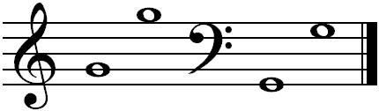
Experiment playing the ostinato again, this time with a conductor.

- Can you play the ostinato at various dynamics such as forte and piano?
- Can you play the ostinato at various tempos such as allegro and adagio?

Working in groups, create your own ‘G’ ostinato.

Create lyrics like we did for Mars ‘get in a space-ship go to Mars’ - but this time with your own rhythmic words:
The two pieces we studied today were:
- ‘Mars’ from ‘The Planets Suite’ by Gustav Holst
- ‘Imperial March’ from ‘Star Wars’ by John Williams

To finish, we are going to listen to the main theme tune from the ‘Mission: Impossible’ movie - this also uses the 5/4 time signature like Mars and Imperial March.

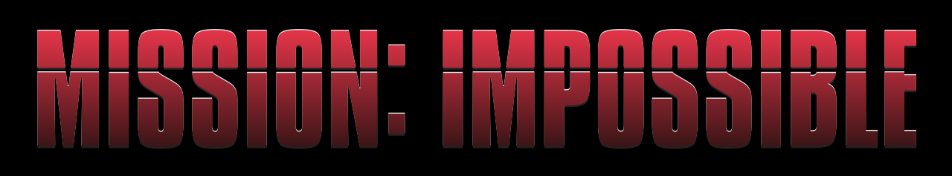

If this music accompanied a scene from the movie, what do you think you would see on the screen? Describe the action/what might be happening…

How did you do today? 😊 😕 😩

Lesson 2: Can I learn more about the life of film composer John Williams?

You will need access to the internet for your lesson today.

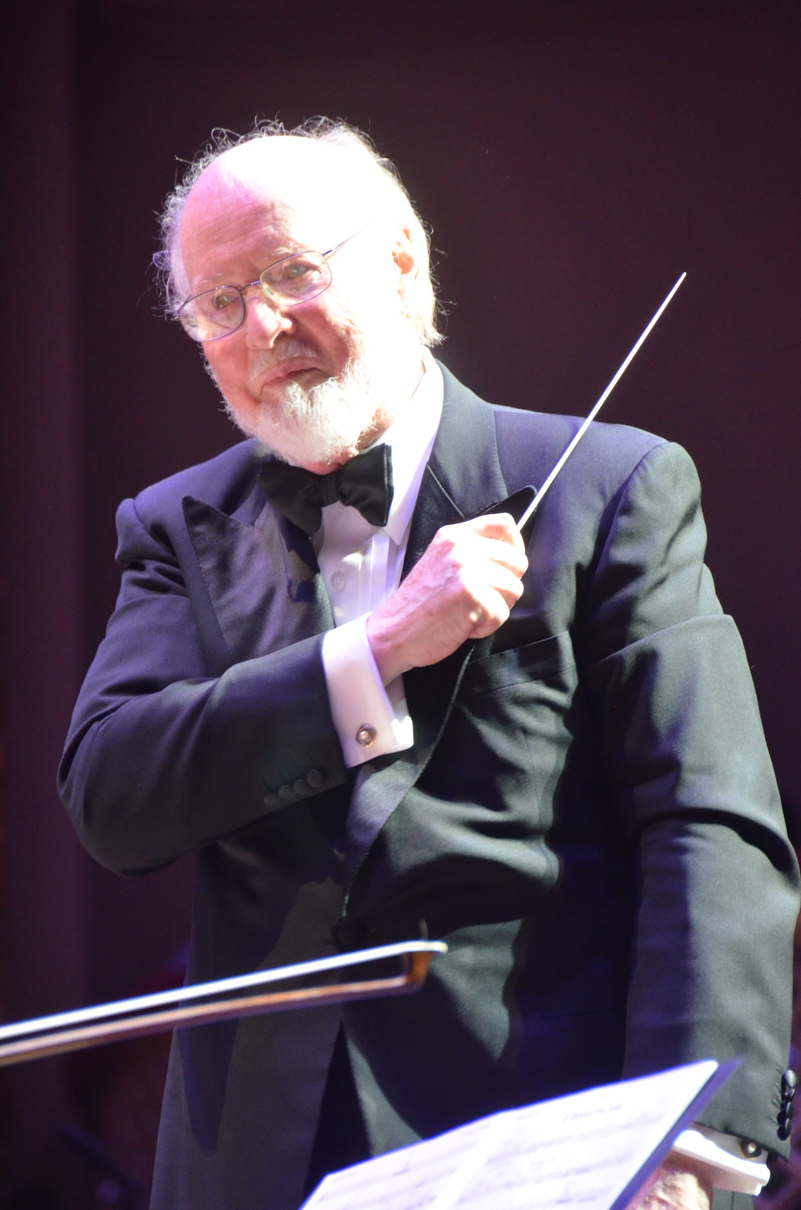
Firstly let’s begin by watching an interview with John Williams at https://www.youtube.com/watch?v=0TFAR2NpO18

John Williams was born on February 8, 1932, in Floral Park, New York. In 1948 John moved with his family to Los Angeles, California. He later attended college near his home in Los Angeles where he began to study composition. After college he was drafted into the United States Air Force where he had the opportunity to conduct and arrange music for the Air Force band.
In 1954, when his service ended, Williams moved to New York City and enrolled in the Juilliard School of Music. After completing his education at Juilliard, Williams moved back to Los Angeles to begin working as a film studio orchestrator. Eventually he was given the opportunity to compose the theme to the television series Lost in Space. This marked the beginning of a career that has spanned six decades. During this time Williams produced some of the best music ever written for film, including his music for Star Wars which was selected by the American Film Institute as the greatest film score of all time.

His film scores include:
Jaws (1975)
Star Wars (1977)
Superman (1978)
Raiders of the Lost Ark (1981)
E.T. the Extra-Terrestrial (1982)
Indiana Jones and the Temple of Doom (1984)
Home Alone (1990)
Jurassic Park (1993)
Harry Potter and the Sorcerer's Stone (2001)

In total John Williams has received 5 Academy (also known as Oscar) Awards and 50 Academy Award nominations. He is the second most nominated individual after Walt Disney.
Having read the information above, complete the word search. There are 9 words or phrases associated with John Williams to find!

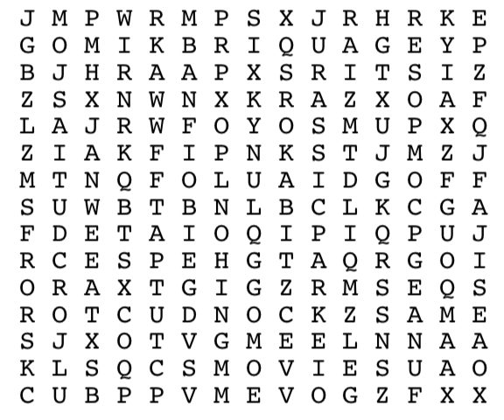
Study Piece:
Choose two of the nine films mentioned on the previous page.
For each film use resources online and YouTube to listen to clips to write about:
- The main storyline of the film and how the music creates a picture in your head and helps you think of the storyline.
- What instruments you hear playing in the music.
- Which adjectives would you choose to describe the music?
- What are the dynamics of the music?
- What is the tempo of the music?
- Why do you like this piece of music?

Piece 1: Title -

Piece 2: Title -

How did you do today? 😊 😕 😩

LESSON 3: Can I identify the main features of a March?

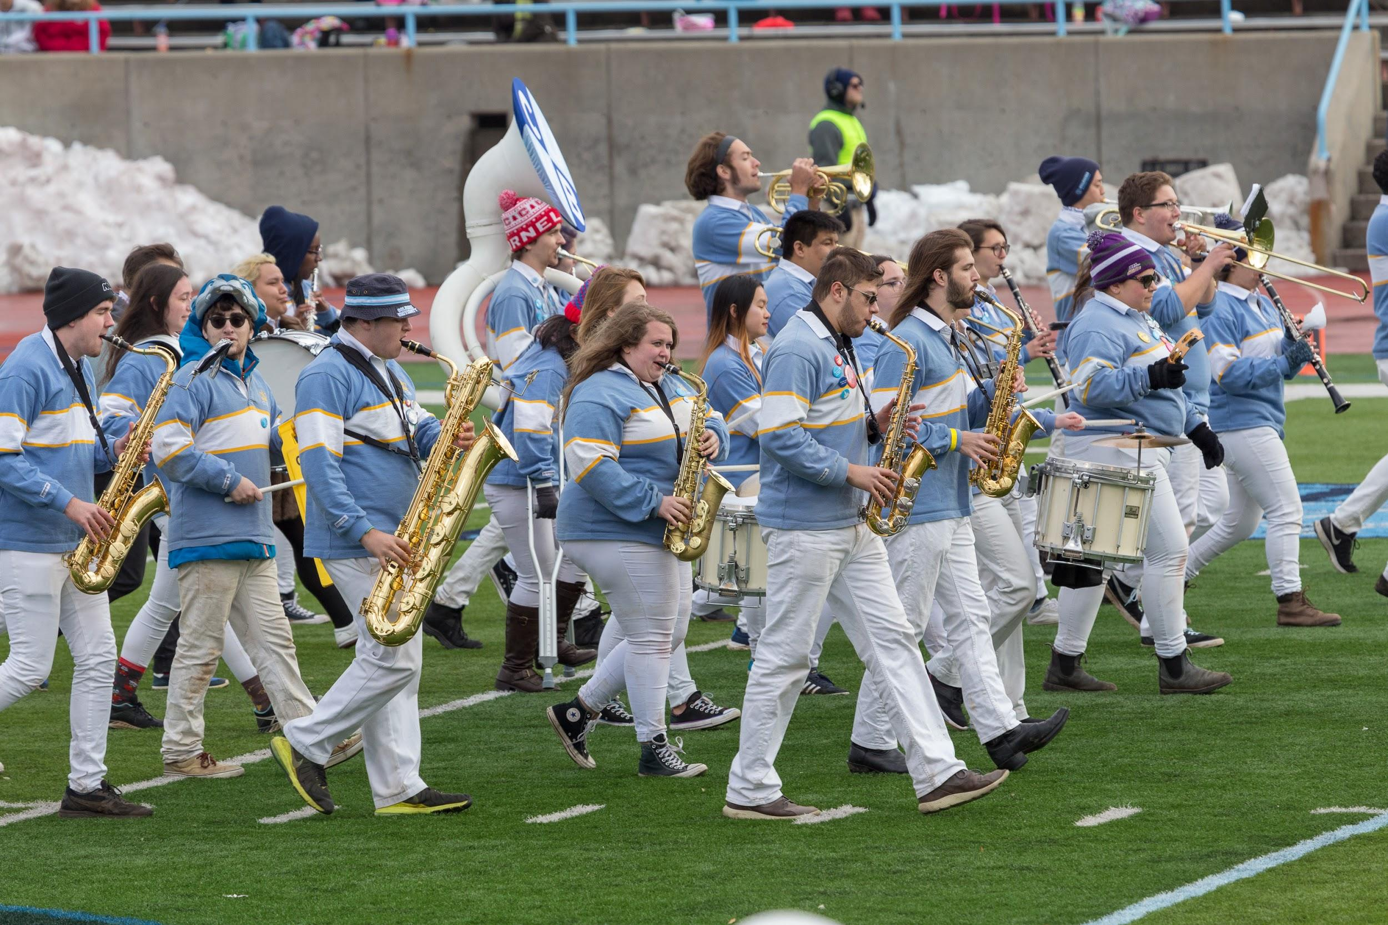

A March is a piece of music with a strong marching, walking in time rhythm. Marches were often written so that soldiers could march to them, keeping them in time. Other marches may not be intended for marching, but they still have a strong, regular beat so that people could, if they wanted to, march to the music. Marches are usually 2/4 time (One - two - one - two - left - right - left - right) or 4/4 although other time signatures are possible (such as 5/4 from our previous lesson).

Marches can be slow or quick. An example of a slow march may be a funeral march such as the ‘Marche funèbre’ in Chopin's Piano Sonata in B flat minor, and the Dead March in Handel’s oratorio ‘Saul’.

In classical music many composers wrote marches, which are not intended to be marched to, but still give the mood of a march. Gustav Mahler often wrote marches in his symphonies. Marches also occur in operas (e.g. Verdi’s Aïda), ballets (e.g. Prokofiev's Romeo and Juliet) or, indeed, any kind of music.

Music composed for marching uses instruments that soldiers play in marching bands, such as brass instruments, woodwind instruments including fife, snare drum and bass drum. So composers writing marches in classical music may imitate the sound of military bands by using these instruments.

March music is often composed for special ceremonial occasions such as coronations. Edward Elgar ‘Coronation March’ and William Walton ’Crown Imperial’, both wrote march music for Coronations.

Listening Activity
Listen to these five pieces of music:
Superman March https://www.youtube.com/watch?v=EBatxZ90wag
Radetzky March https://youtu.be/eab_eFtTKFs
Red Alert 3 https://www.youtube.com/watch?v=fMDXl36gypw
March of the Toy Soldiers from the Nutcracker Suite https://www.youtube.com/watch?v=LmlEmi2HxjY&feature=youtu.be
The Great Escape Theme Tune https://youtu.be/MbsuAbTTsV8
Your teacher will mix up the order in which you hear them! Answer the following questions for each piece and try to decide which title best fits each piece of music:

Extract 1
What instruments are playing the melody and is the pitch of the melody high/low/a mixture – how does it change?

What adjectives would you use to describe the mood of this music?

What is the dynamic (volume) of this piece? Use Italian terms if you know them. Does the dynamic stay the same throughout?

If this piece was written for a public occasion, what do you think that occasion would be and why?

Name the variety of instruments you hear in this piece. Can you identify instruments from each of the following families – strings, woodwind, brass, and percussion, vocal?

Identify the march beat in this piece. Would it be a fast or slow paced march, or a mixture of the two? Does the beat remain constant throughout?

What is the title of this piece of music (choose from the list at the beginning) and when do you think it may have been written?

Extract 2
What instruments are playing the melody and is the pitch of the melody high/low/a mixture – how does it change?

What adjectives would you use to describe the mood of this music?

What is the dynamic (volume) of this piece? Use Italian terms if you know them. Does the dynamic stay the same throughout?

If this piece was written for a public occasion, what do you think that occasion would be and why?

Name the variety of instruments you hear in this piece. Can you identify instruments from each of the following families – strings, woodwind, brass, and percussion, vocal?

Identify the march beat in this piece. Would it be a fast or slow paced march, or a mixture of the two? Does the beat remain constant throughout?

What is the title of this piece of music (choose from the list at the beginning) and when do you think it may have been written?

Extract 3
What instruments are playing the melody and is the pitch of the melody high/low/a mixture – how does it change?

What adjectives would you use to describe the mood of this music?

What is the dynamic (volume) of this piece? Use Italian terms if you know them. Does the dynamic stay the same throughout?

If this piece was written for a public occasion, what do you think that occasion would be and why?

Name the variety of instruments you hear in this piece. Can you identify instruments from each of the following families – strings, woodwind, brass, and percussion, vocal?

Identify the march beat in this piece. Would it be a fast or slow paced march, or a mixture of the two? Does the beat remain constant throughout?

What is the title of this piece of music (choose from the list at the beginning) and when do you think it may have been written?

Extract 4
What instruments are playing the melody and is the pitch of the melody high/low/a mixture – how does it change?

What adjectives would you use to describe the mood of this music?

What is the dynamic (volume) of this piece? Use Italian terms if you know them. Does the dynamic stay the same throughout?

If this piece was written for a public occasion, what do you think that occasion would be and why?

Name the variety of instruments you hear in this piece. Can you identify instruments from each of the following families – strings, woodwind, brass, and percussion, vocal?

Identify the march beat in this piece. Would it be a fast or slow paced march, or a mixture of the two? Does the beat remain constant throughout?

What is the title of this piece of music (choose from the list at the beginning) and when do you think it may have been written?

Extract 5
What instruments are playing the melody and is the pitch of the melody high/low/a mixture – how does it change?

What adjectives would you use to describe the mood of this music?

What is the dynamic (volume) of this piece? Use Italian terms if you know them. Does the dynamic stay the same throughout?

If this piece was written for a public occasion, what do you think that occasion would be and why?

Name the variety of instruments you hear in this piece. Can you identify instruments from each of the following families – strings, woodwind, brass, and percussion, vocal?

Identify the march beat in this piece. Would it be a fast or slow paced march, or a mixture of the two? Does the beat remain constant throughout?

What is the title of this piece of music (choose from the list at the beginning) and when do you think it may have been written?

Finally, which was your favourite extract of music and why? Try to give a musical explanation…

How did you do today? 😊 😕 😩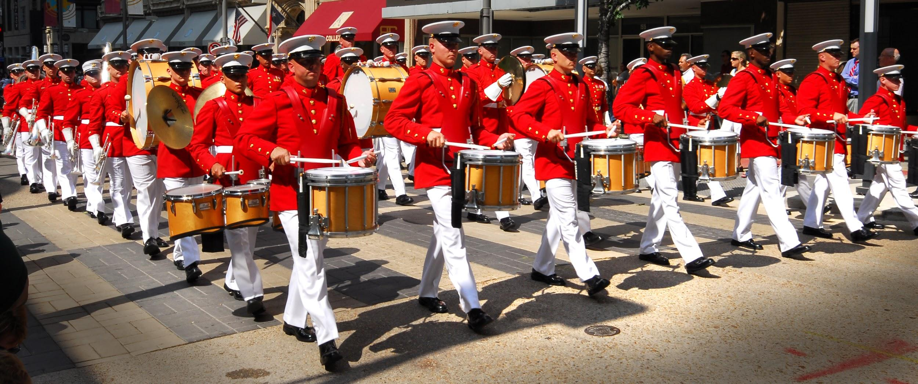

LESSON 4: Can I sing in two-part harmony some of the title songs from the James Bond series?

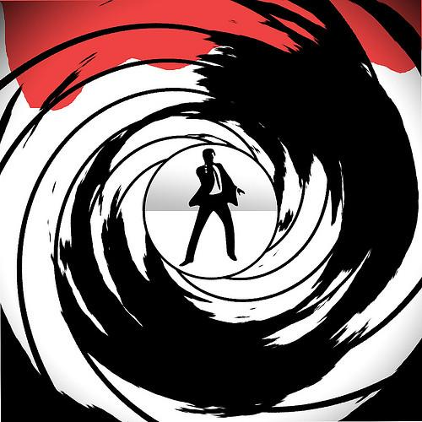

Listen to the theme tune to the classic Bond series at https://www.youtube.com/watch?v=ye8KvYKn9-0

This is such an effective melody as many people are instantly able to recognise the James Bond franchise.

Watch an orchestral performance from the 2011 Proms at https://www.youtube.com/watch?v=J9-cDa4JCwM

The History of Bond songs

James Bond movie theme songs are the cinematic equivalents of paperback book-series covers — they suggest familiarity and the promise of a compelling new adventure for Western culture’s oldest, most recognisable secret agent.

Bond's first big screen adventure, 1962's, Dr. No had no precedent to follow, and therefore no need for the song title treatments that would come to define the franchise (it opted for a gentle calypso medley). By the time the franchise's third film was released two years later, we already had Shirley Bassey roaring Goldfinger over the credits, and audiences knew just what kind of fun 007 had in store for them.

Each Bond gets the themes he deserves, from the smooth and impenetrable tunes of the Sean Connery era to the radio-ready offerings from the Daniel Craig years, as his muscular and wounded version of the legendary spy.

Performances, ranked by Rolling Stone magazine, of all the Bond title songs can be viewed at http://www.rollingstone.com/movies/lists/james-bond-movie-theme-songs-ranked-worst-to-best-20151102/the-man-with-the-golden-gun-lulu-20151030

Singing Activity
Today we are going to sing two famous James Bond songs, ‘Skyfall’ by Adele, and ‘Writing’s On The Wall’ by Sam Smith.

Firstly we are going to learn the melody line before developing this into learning sections of the written harmonies. If you sing in the choir, you should take the non-melody, harmonising part.

Throughout the lesson today remember to:
- sing with clear diction
- control your pitch
- sing with a sense of phrase and musical expression

If time, we will record your performances!

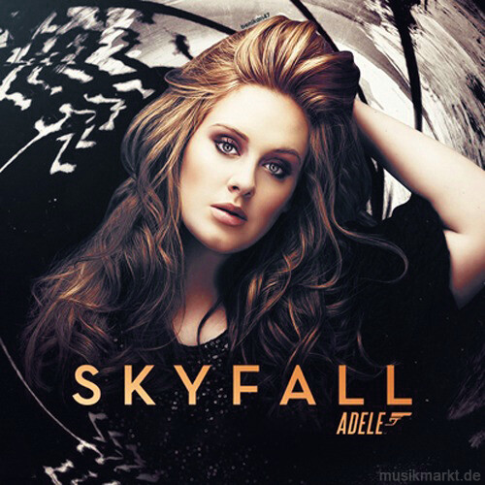
Skyfall

This is the end
Hold your breath and count to ten
Feel the earth move and then
Hear my heart burst again

For this is the end
I've drowned and dreamt this moment
So overdue I owe them
Swept away, I'm stolen

Let the sky fall
When it crumbles
We will stand tall
Face it all together

Let the sky fall
When it crumbles
We will stand tall
Face it all together
At skyfall
That skyfall

Skyfall is where we start
A thousand miles and poles apart
Where worlds collide and days are dark
You may have my number, you can take my name
But you'll never have my heart

Let the sky fall (let the sky fall)
When it crumbles (when it crumbles)
We will stand tall (we will stand tall)
Face it all together

Let the sky fall (let the sky fall)
When it crumbles (when it crumbles)
We will stand tall (we will stand tall)
Face it all together
At skyfall

[x2:]
(Let the sky fall
When it crumbles
We will stand tall)

Where you go I go
What you see I see
I know I'd never be me
Without the security
Of your loving arms
Keeping me from harm
Put your hand in my hand
And we'll stand

Let the sky fall (let the sky fall)
When it crumbles (when it crumbles)
We will stand tall (we will stand tall)
Face it all together
Let the sky fall (let the sky fall)
When it crumbles (when it crumbles)
We will stand tall (we will stand tall)
Face it all together
At skyfall

Let the sky fall
We will stand tall
At skyfall

Writing's On The Wall

I've been here before
But always hit the floor
I've spent a lifetime running
And I always get away
But with you I'm feeling something
That makes me want to stay

I'm prepared for this
I never shoot to miss
But I feel like a storm is coming
If I'm gonna make it through the day
Then there's no more use in running
This is something I gotta face

If I risk it all
Could you break my fall?

[Chorus:]
How do I live? How do I breathe?
When you're not here I'm suffocating
I want to feel love run through my blood
Tell me is this where I give it all up?
For you I have to risk it all
'Cause the writing's on the wall

A million shards of glass
That haunt me from my past
As the stars begin to gather
And the light begins to fade
When all hope begins to shatter
Know that I won't be afraid

If I risk it all
Could you break my fall?

[Chorus:]
How do I live? How do I breathe?
When you're not here I'm suffocating
I want to feel love, run through my blood
Tell me is this where I give it all up?
For you I have to risk it all
'Cause the writing's on the wall

The writing's on the wall

[Chorus:]
How do I live? How do I breathe?
When you're not here I'm suffocating
I want to feel love run through my blood
Tell me is this where I give it all up?
How do I live? How do I breathe?
When you're not here I'm suffocating
I want to feel love, run through my blood
Tell me is this where I give it all up?
For you I have to risk it all
'Cause the writing's on the wall

Which song did you prefer singing, and why?

What did you do particularly well with your singing today?

Is there anything you could do to improve your performance?

If time at the end of the lesson, continue the Prom concert at https://www.youtube.com/watch?v=BTFfW29DP24 in which the BBC Concert Orchestra perform an arrangement of many of the Bond theme songs.

How did you do today? 😊 😕 😩

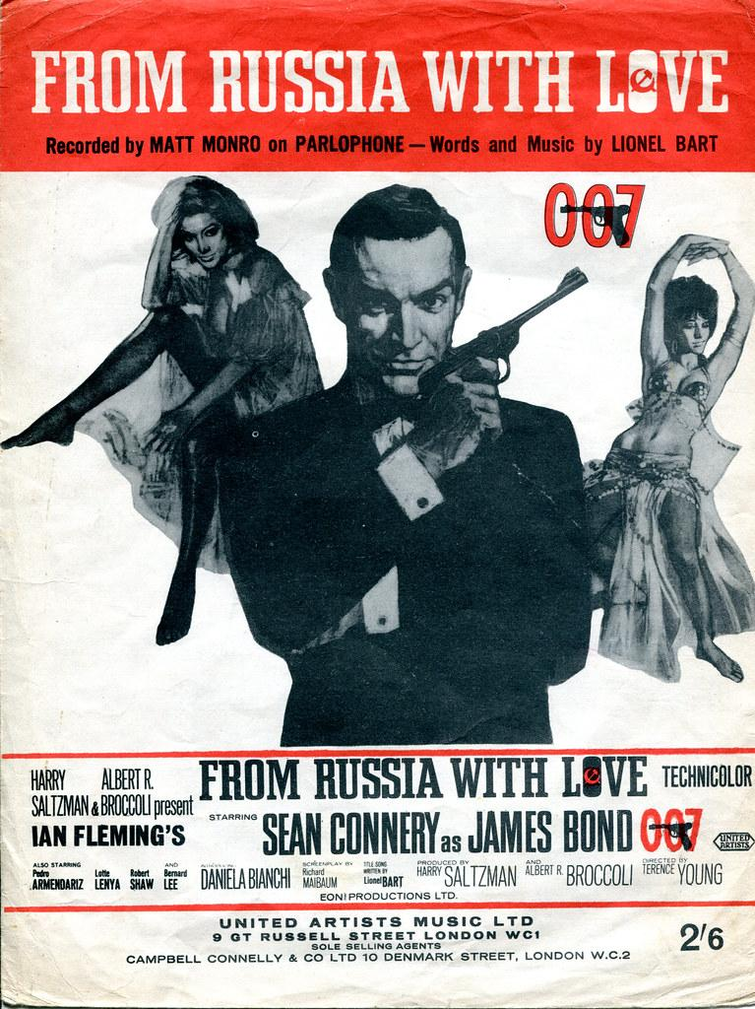

If you play a musical instrument, please bring it with you to the next lesson!

LESSON 5: Can I understand how music enhances different moods and can be composed for a specific purpose?

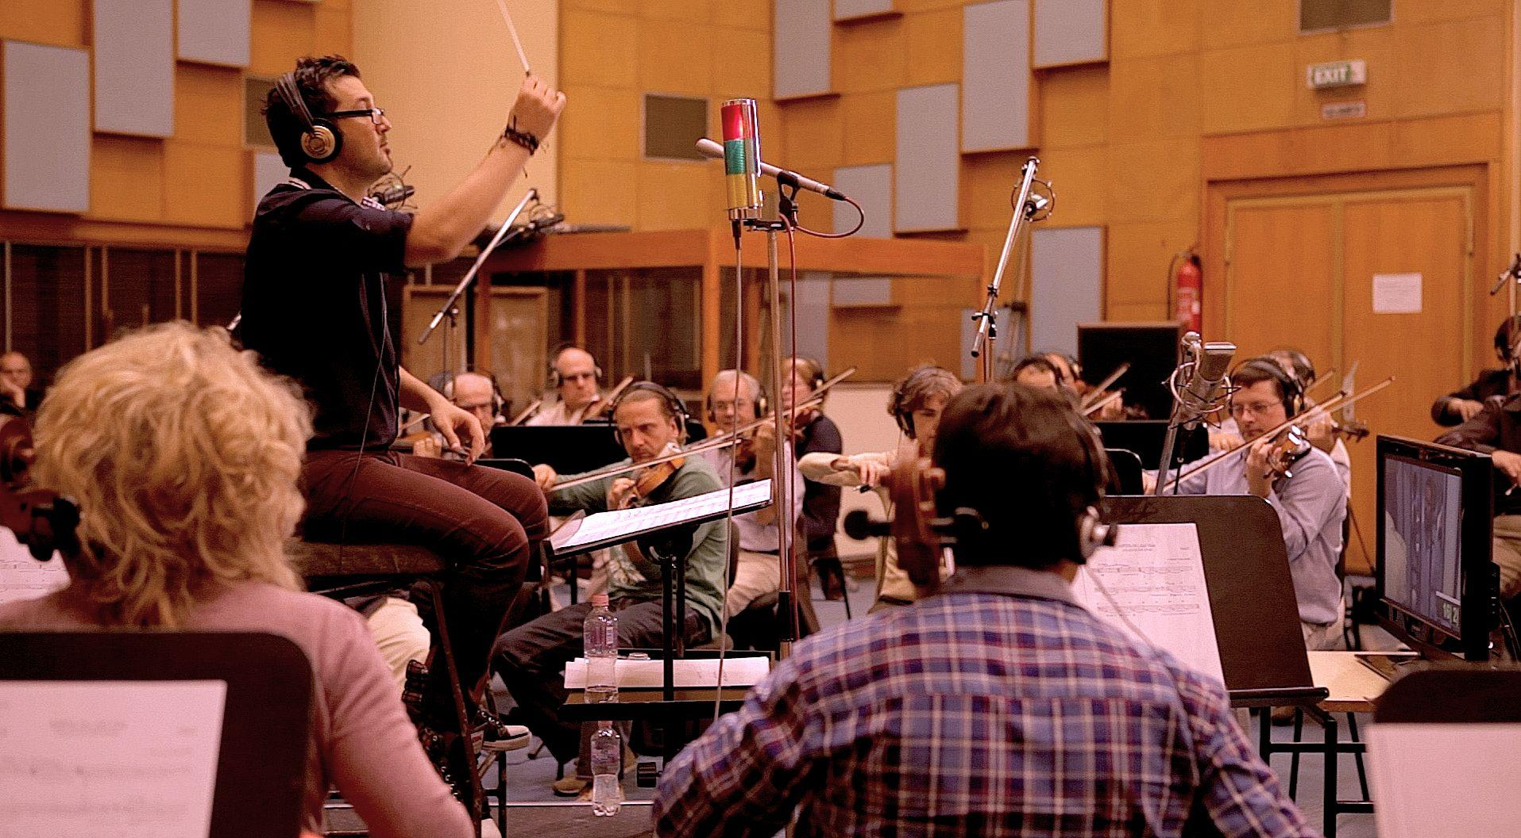

Since the very first silent films, music has been essential to the storytelling process. Music can create a convincing atmosphere for a setting, help tell a story and strike an emotional cord, all of which are elements that will have the audience wanting more. Filmmakers understand the importance that music in their movies can turn a good film into a great one.

Music impacts the audience
Could you imagine your favourite epic film without a rousing musical score? I doubt it would be nearly as exciting and inspiring without the drums and orchestrated energy. Or have you ever turned down the volume on your television while watching a scary movie? If you have, then you realise that the ‘jumpy’ factor is almost completely eliminated!
Incorporating music into films cannot only make them more interesting, but it also allows the audience the ability to connect emotionally to characters and their situation and reinforces the story or message. For example, a scene of a happy couple exiting the church after having just been married would probably include an inserted love song to match what the characters were feeling at that moment. Meanwhile, our favourite action movies would take a different approach: using music to create suspense and impending fear of what lies around the corner.
The added music changes the audience's mood entirely and provokes strong emotions from them, or at least in a horror movie, it lets us know when we should cover our eyes! The music and the picture relate to one another in order to inspire the desired effect upon the audience.
Think this sounds like a hard thing to do? You are right. Using music to connect with an audience on a higher level is a tricky thing because choosing the right piece of music could make or break a film.

Setting the scene
Music can also create a more convincing atmosphere of time and place for films. The sound of bagpipes might conjure up ideas of Scotland and misty green fields, or the strings of a sitar invoke images of the far East. Muted bass notes might denote something sinister whereas rock music might suggest something youthful. Without even realising it, the audience will relate to the sounds and get pulled into a story.
Finding the right music
Most music in films can be heard in the background of a scene, or sometimes it takes centre stage in an action sequence, but either way the right music does make a statement. The most common style of movie music is instrumentals because music with lyrics often distracts the audience from the intended storyline or dialogue.

Music for suspense
Directors pay painstaking attention to the music they use and often try out their musical scenes on test audiences to gauge their reactions. Steven Spielberg only needed three notes in his suspenseful Jaws theme, composed by John Williams, to work up his audience: Da-Dum ... Da-Dum ... Da-Dum Da-Dum Da-Dum Da-Dum ...DA DA DUM!

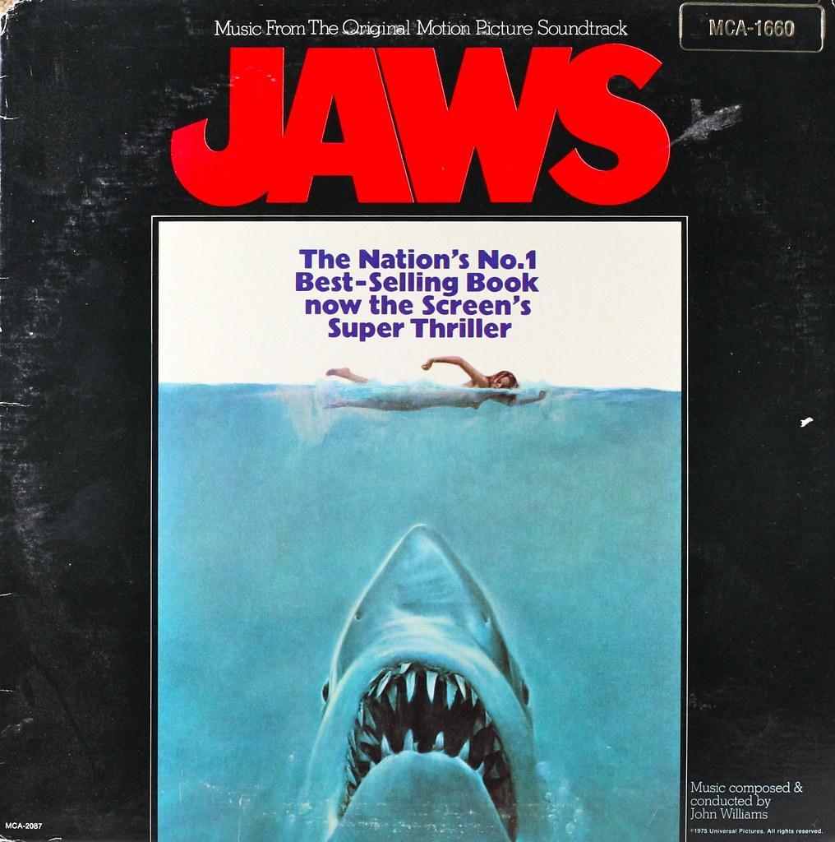

Listen to the music of Jaws – https://www.youtube.com/watch?v=E-sX2Y0W8l0
Answer the following questions:

How does John Williams create suspense through the music?

What instruments are being used?

How would you describe the texture of the music?

How would you describe the timbre of the music?

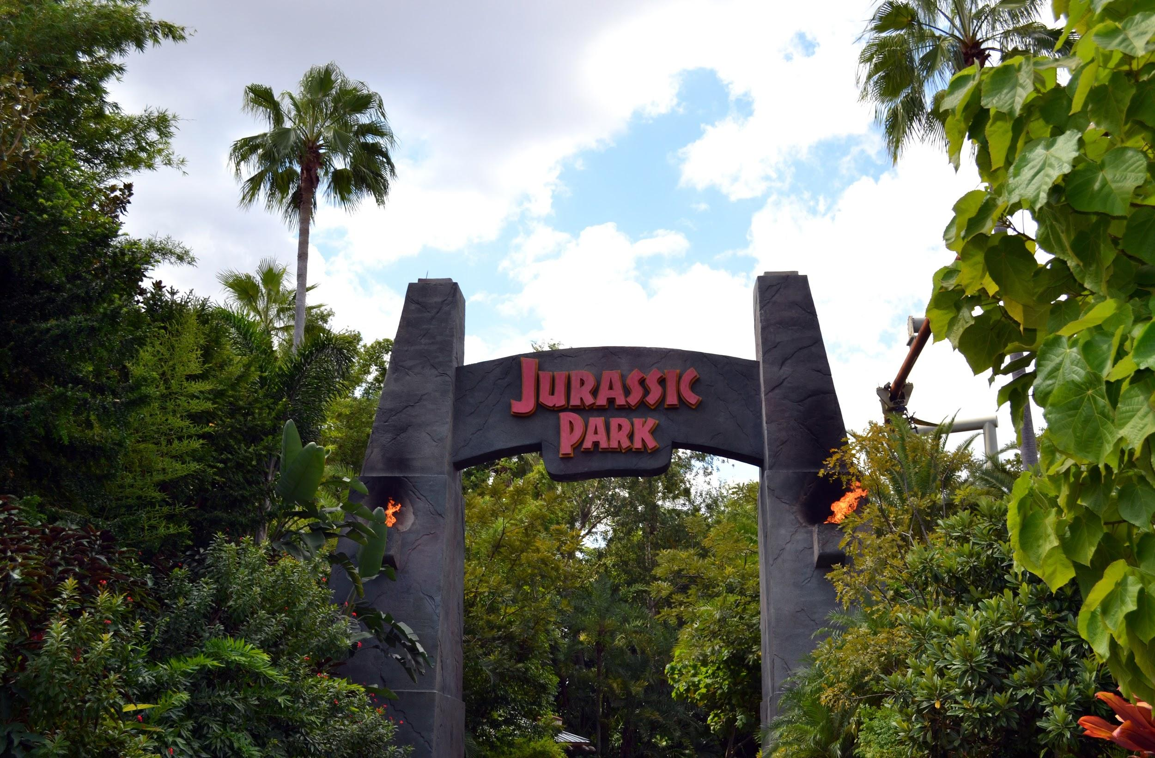

Next watch the Jurassic Park extract – https://www.youtube.com/watch?v=oEZh88vz8b8
How does John Williams create suspense and a spooky feeling through the music?

What instruments are being used?

How would you describe the texture of the music?

How would you describe the timbre of the music?

Describe what you imagine might be happening in the movie during the opening music (listen to it again if necessary)...

Composition Activity
Now you are to compose your own short suspense phrase, like the Jaws theme.
You may work in groups of 2-3.

Firstly, you need to create your own scenario. Write a paragraph of background information (a Haunted House, a Spooky Wood etc.) to set the scene before you perform it to the class.

Next, use your own instrument, or a selection in class to compose a short, spooky phrase. Write down your phrase in any way you wish in the box below - you can use lines, dot, dashes, symbols or musical notation:

Finally we will listen to each group read out their descriptive paragraph and perform their suspense phrase.

Which group do you think did really well, and why?

Was your performance successful? What did you do well, and if you had more time, would you change anything?

How did you do today? 😊 😕 😩

If you play a musical instrument, please bring it with you to the next lesson!

LESSON 6 & 7: Can I create music to accompany an action sequence?
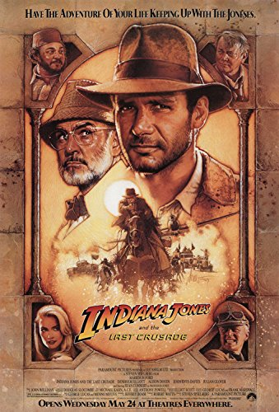

What is this film extract about?

The third adventure of Indiana Jones sees the brave archaeologist in a race against time to find the Holy Grail before the Nazis can do so. Indy returns in his third adventure, this time on the trail of his missing dad - a bad-tempered professor, who was once on the trail of the Holy Grail himself. However, the courageous archaeologist soon finds Jones Senior isn't the only one looking for the mythical object, and his search becomes a race against time to stop his old enemies the Nazis finding and using it in their quest for power.

Director Steven Spielberg's thrilling film is lighter in tone than the earlier Raiders of the Lost Ark prequel The Temple of Doom that sense of fun due in part to the constant sparring between Sean Connery and Harrison Ford as the dad-and-son adventurers.

The soundtrack was created by John Williams and is his tenth collaboration with Steven Spielberg.

Composition Activity
The following activity relates to Chapter 2 of the DVD, Indiana Jones and the Last Crusade opening scene: ‘The Train Pursuit’, also at https://www.youtube.com/watch?v=OKYWXIAJKNM

*Animals such as snakes are shown in the extract, some of you may wish to only watch sections of the clip*

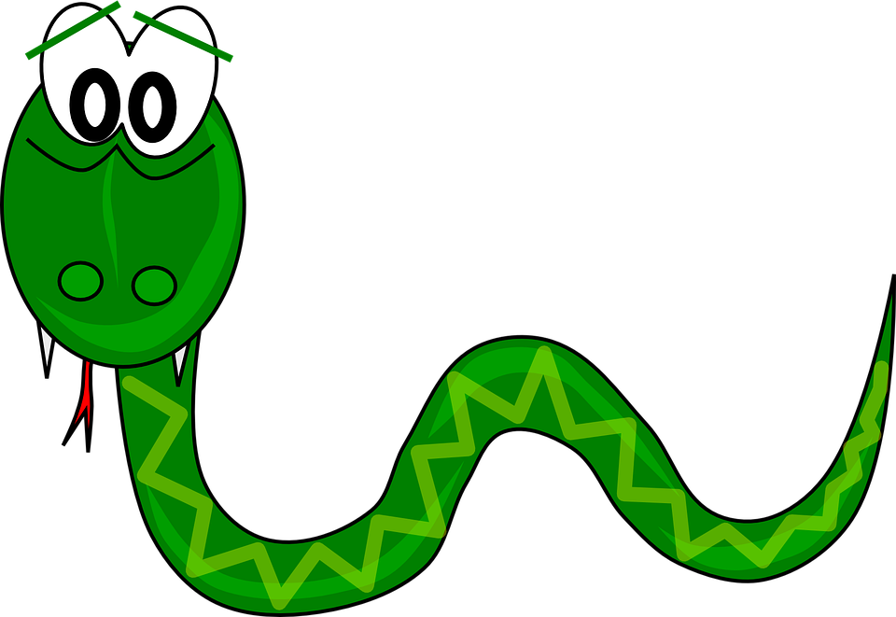
Answer the following questions about the extract:
1. Watch the first scene where Indy has his first adventure with the sound muted. Now watch it again with the sound on. What difference does the music make? Give examples.

2. How does the music change when he jumps on the horse?

3. Why does the music change when he enters the circus carriage on the train?

4. How does the music add comedy to this scene?

Composition Activity
In small groups, you are to compose music and sound effects to accompany one of the following scenes:
Raiders of the Lost Ark, Truck Chase: https://www.youtube.com/watch?v=F1ZyHNmb1yU
Kingdom of the Crystal Skull, Jungle Chase: https://www.youtube.com/watch?v=vtwiMlm4u6w
The Last Crusade, Boat Chase: https://www.youtube.com/watch?v=uuIRHvhZVkE
Temple of Doom, Cart Chase: https://www.youtube.com/watch?v=4ds9mfUB7Dg

Things to remember:
- Try to make the music and sound effects match the action.
- Experiment with improvising and developing different rhythmic and melodic material.
- Your first idea may not be the best, so work as a group to develop your ideas.

You will need to produce a final ‘score’ in the box below from which you can perform your chase music alongside the extract, whilst the rest of the class watches.

Write down in any way you wish, your ideas and plan for your performance here:

We will record your performances for you to watch back and evaluate.

- In your opinion, which group did a really good job of creating a suitable soundtrack and why?

- If you had more time, what would you change or do differently to your own performance?

- What do you think your group did especially well?

How did you do today? 😊 😕 😩

