UNIT 10 – VOCABULARY

binary | one melody labeled ‘A’ is followed by a new melody labeled ‘B’ = AB melody form
choreography | dance movements
cover versions | a new version of an original song, usually in a different style or by a different performer
dynamics | volume
fanfare | a loud, uplifting announcement - usually performed by brass instruments at the start of a ceremony
harmonies | notes that are heard alongside the main tune, melody
leitmotifs | musical phrases associated with individual characters, places, ideas or plot elements
Minimalism | a style of classical music which uses repetition and has a steady beat throughout
Motown | an American recording company in the 1960’s that promoted music by black artists
orchestra | a group of classical musicians that play together
rhythm | a strong, regular repeated pattern of movement or sound
ska | a music genre that originated in Jamaica in the late 1950s and was the precursor to rocksteady and reggae. It combines elements of Caribbean mento and calypso with American jazz and rhythm and blues
string quartet | four musicians playing string instruments together - usually two violins, viola and ‘cello
tempo | speed
ternary | one melody labeled ‘A’ is followed by a new melody labeled ‘B’ which then goes back to melody A = ABA melody form
texture | layers - how many? Thick or thin textures would mean many or less musical lines being played
woodblock | a small single block of wood that is played as a percussion instrument

WHAT A RIDE!

LESSONS 1 & 2: Can I compare different versions of the same piece of music?

Study Piece:
‘Ride of the Valkyries’ by Richard Wagner

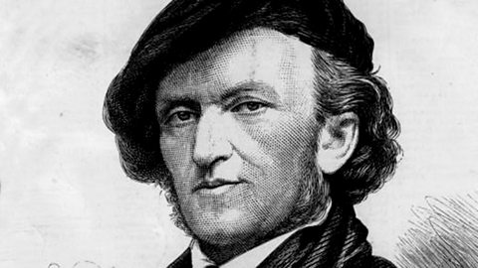

https://www.bbc.co.uk/programmes/articles/4gdCGV8y3gxdkKrq3HP8S3M/ride-of-the-valkyries-from-die-walkure-by-richard-wagner

Who was Richard Wagner?
BORN: 1813 / DIED: 1883 / NATIONALITY: German

Wilhelm Richard Wagner was a 19th Century musician and composer, and a very controversial figure. He is credited with ‘the birth of modern music'. Wagner had an established musical reputation in Germany and wrote music for the King of Saxony. His comfortable royal set-up was interrupted by his involvement in the 'May Uprising', though. As a result he had to flee for his life to Sweden.

Was there anything Richard Wagner couldn’t do? He wrote enormous operas (story, words and music), conducted them and designed the sets. He even invented instruments and developed many of the theatrical ideas we still use today:
- the orchestra sit below the stage in a theatre 'pit' because Wagner decided it would sound better.
- We dim the lights in the audience because Wagner thought it would focus us more on the action.
Wagner was a true theatrical genius in control of all aspects of his work.

During his early career, Wagner would write an opera and get into enormous debt getting it ready for the stage. When it opened he would move on to the next project in the next town, leaving all his debts and chaos behind him. In 1871 he settled in the town of Bayreuth, Germany and it was here that he had his biggest success with the ‘Ring Cycle’ – a series of four operas, each one over four hours long, that are performed on four consecutive nights. The Bayreuth Festival continues to this very day and is still managed by members of Wagner's family.

Ride of the Valkyries comes at the beginning of Act 3 of Die Walküre, the third of the four operas that make up Der Ring des Nibelungen or The Ring Cycle. The whole thing took 27 years to compose and takes over 15 hours to perform. If you want to settle in and listen to the whole thing, make sure you've got plenty of snacks and drinks!

His compositions, particularly those of his later period, are notable for their complex textures, rich harmonies and orchestration and the elaborate use of leitmotifs - musical phrases associated with individual characters, places, ideas or plot elements. If he were still alive today he would probably be the biggest film composer around.

Today we are going to listen to a variety of performances of this piece, each of them very different!

Version 1: https://www.youtube.com/watch?v=P73Z6291Pt8
Version 2: https://www.youtube.com/watch?v=xeRwBiu4wfQ
Version 3: https://www.youtube.com/watch?v=rlQaie1GE58
Version 4: https://www.youtube.com/watch?v=rGA3YUfr1vk

VERSION 1
During the performance, answer the following questions:
- What pictures or ideas come to mind when hearing the piece?
- Can you name any instruments in this version?
- What are the dynamics of this version? Does it always stay the same?
- What is the tempo of this version? Is it faster, slower or the same as the version before?
- How many instruments can you hear playing? So is the texture thick or thin?

VERSION 2
During the performance, answer the following questions:
- What pictures or ideas come to mind when hearing the piece?
- Can you name any instruments in this version?
- What are the dynamics of this version? Does it always stay the same?
- How is this version different from the previous one?
- What is the tempo of this version? Is it faster, slower or the same as the version before?
- How many instruments can you hear playing? So is the texture thick or thin?

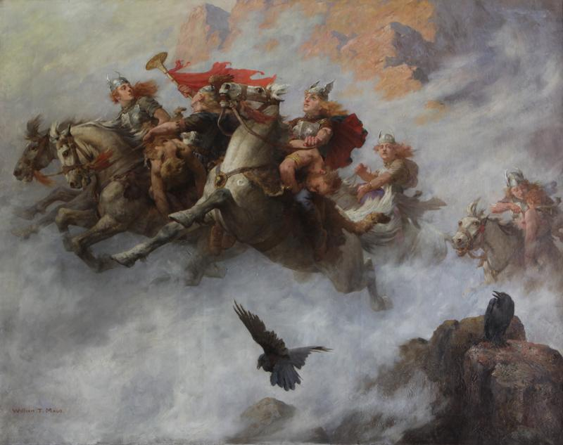
VERSION 3
During the performance, answer the following questions:
- What pictures or ideas come to mind when hearing the piece?
- Can you name any instruments in this version?
- What are the dynamics of this version? Does it always stay the same?
- How is this version different from the previous one?
- What is the tempo of this version? Is it faster, slower or the same as the version before?
- How many instruments can you hear playing? So is the texture thick or thin?

VERSION 4
During the performance, answer the following questions:
- What pictures or ideas come to mind when hearing the piece?
- Can you name any instruments in this version?
- What are the dynamics of this version? Does it always stay the same?
- How is this version different from the previous one?
- What is the tempo of this version? Is it faster, slower or the same as the version before?
- How many instruments can you hear playing? So is the texture thick or thin?

After listening to all four versions:
Does the main melody first ascend or descend in pitch?

Does the melody move in steps or leaps?

How would you describe the rhythm of the main melody?

Which was your favourite version of ‘Ride of the Valkyries’ and why?

How did you do today? 😊 😕 😩

Lesson 3: Can I investigate the life of an influential classical composer?

Richard Wagner (1813-1883) German Composer, Theatre Director, and Conductor
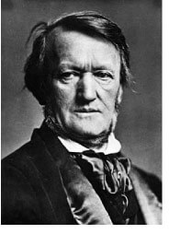
Firstly let’s begin by watching the animated guide to ‘The Ring’ at https://www.youtube.com/watch?v=ykQ7jc09OAk

There are also further suitable excerpts on the BBC show: https://www.youtube.com/watch?v=wOJ3r0OqItw

Richard Wagner was born in Leipzig, Germany, on May 22, 1813. He was the ninth son of Carl Friedrich Wagner and Johanna Rosine. Richard's father died of typhus six months after his birth. His mother then married painter, actor, and poet, Ludwig Geyer, and the family moved to Dresden.
Richard took an interest in the plays in which his step-father performed, and Richard sometimes even participated in the plays alongside him. In late 1820, Richard received some piano instruction from a Latin teacher. As a teen, Richard's teacher said that he would "torture the piano in a most abominable fashion." Despite what his teacher thought, Richard enjoyed playing the piano and began to compose music as a teenager.
In 1831, he attended Leipzig University. He was impacted greatly by famous musicians, such as Beethoven, Mozart, and Wilhelmine Schröder-Devrient.
In 1833 Wagner became a choir master in Würzburg, Germany. Within a year of obtaining this position, Wagner composed his first opera, Die Feen (The Fairies). This opera was not performed until after his death.
Between 1857-1864, he wrote the opera Tristan and Isolde, a tragic love story. Many musicians consider Tristan and Isolde to be the beginning of modern classical music. Because of Wagner's strong political views and his poor money management, Wagner had to move often, moving to Russia, France, Switzerland, and then back to Germany. Even though his life was turbulent, he produced some of his most famous works during this time.
Wilhelm Richard Wagner died on February 13, 1883, at the age of 69 while visiting Venice, Italy. His was buried in Bayreuth, Germany, where there is still an annual musical festival that performs his operas. Richard Wagner is best-known for Tristan and Isolde, The Ride of the Valkyries and Bridal Chorus, also commonly called Here Comes the Bride.
Complete the following word search whilst listening to some famous pieces by Wagner.
The words are all important words or phrases from what you have just read!

There are 8 in total to find.

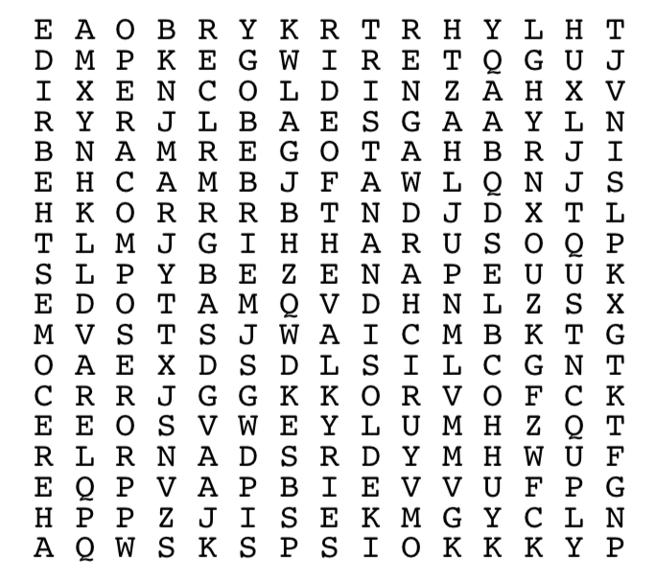

How did you do today? 😊 😕 😩

LESSON 4: Can I perform a rhythmic piece of minimalist music?

Study Piece:
‘Short Ride In A Fast Machine’ by John Adams

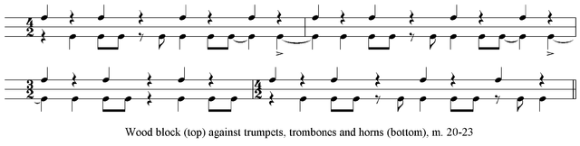

‘Short Ride in a Fast Machine’ was composed by 20th century American composer John Adams, who is still alive today. He was inspired to write this, the most performed piece in history, after a scary ride in his brother’s new sports car!

It was written for an American orchestra to play at a big music festival called the ‘Great Woods Festival’, and is also known as a fanfare. A fanfare is something that grabs people’s attention. It is often a loud piece, and usually played by brass instruments. The music is written for a large orchestra, including many different types of percussion instruments. Throughout the 20th century, percussion instruments were used more and more in classical music, and these instruments often provided the foundation of the piece.

Warm-up

Pass a clap around the circle and have a race to see how fast you can pass it.

Then try clapping two times each, going clockwise and anti-clockwise, passing a stamp or a vocal sound.

Listening Activity

Visit https://www.bbc.co.uk/programmes/articles/3xwJ8Zpzz44vNJlZfqtxbbX/short-ride-in-a-fast-machine-by-john-adams for performances and information about the piece.

Pay attention to the following whilst watching the performances:
- Listen and watch carefully for the trumpets, and other brass instruments. They are playing a rhythm made up of long and short notes.
- Identify the sound of the woodblock at the very beginning of the music. Can you hear this percussion instrument playing throughout most of the piece? This sets the tempo and the pulse of the piece. What does this sound like and why is it important in this piece of music?

John Adams is a minimalist composer. This means that he wrote music that involved lots of repeated patterns. So, the same rhythm over and over again, or the same few notes. He builds these patterns up, one on top of another, using different instruments, to create a complete piece of music.

Minimalism is the genre of music used in this piece – it uses repetition and has a steady beat throughout.

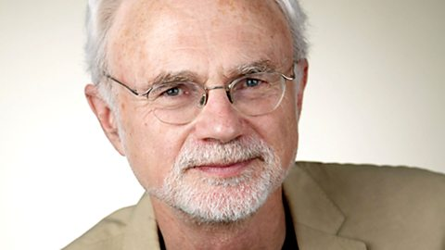

Who is John Adams?
BORN: 1947 / NATIONALITY: American
John Adams is one of the most famous composers in the world. It's estimated that Short Ride in a Fast Machine is performed somewhere in the world at least once every day!

He was born in Massachusetts, USA and began writing music when he was about 10.

As a student he became fascinated with a slightly older American composer called Steve Reich and his new style of music called minimalism. Minimalism is music made from short musical patterns that are repeated many, many times to create a hypnotic sound.

Adams used this idea to create Shaker Loops for string quartet – his first big success. He then developed his sound further to create an opera about US President Richard Nixon and his visit to China. This piece made him world famous and since its composition in 1987 he has gone from success to success, writing and conducting his unique music all around the world.

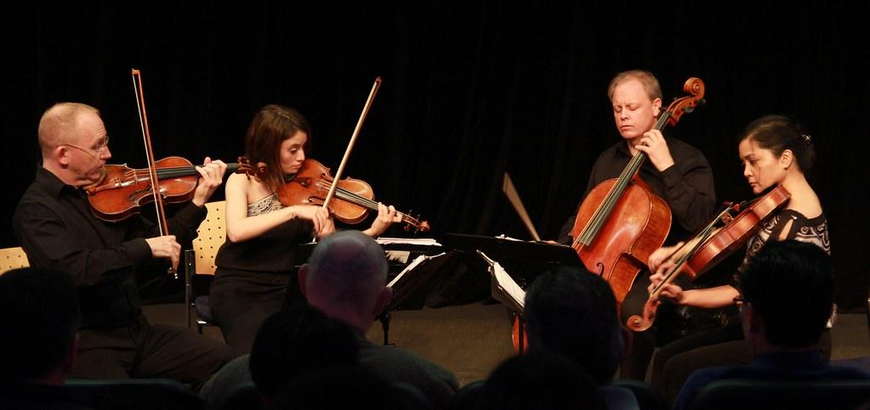

Composing

We are going to create a group piece of minimalist music:

- Sit in a circle, and equip yourselves each with a musical instrument
- Take it in turns to play a short rhythmic pattern on your instrument then have everyone copy you
- Select one of the patterns and use dots and dashes to represent the short and long notes, so that we can see the pattern below:

- Choose a second pattern and copy it below:

- Half of the group will now play a steady pulse, like the woodblock from ‘Short Ride’, with their instruments
- The other half will take it in turns to play the pattern, using the pulse as an accompaniment.

How did you do today? 😊 😕 😩

LESSON 5: Can I identify similarities and differences between original and cover songs?

Study Piece:
‘Ticket To Ride’ by The Beatles

Listen to four different versions, the original plus three cover versions of ‘Ticket To Ride’ and answer the following questions:

Version 1 - The Beatles - original

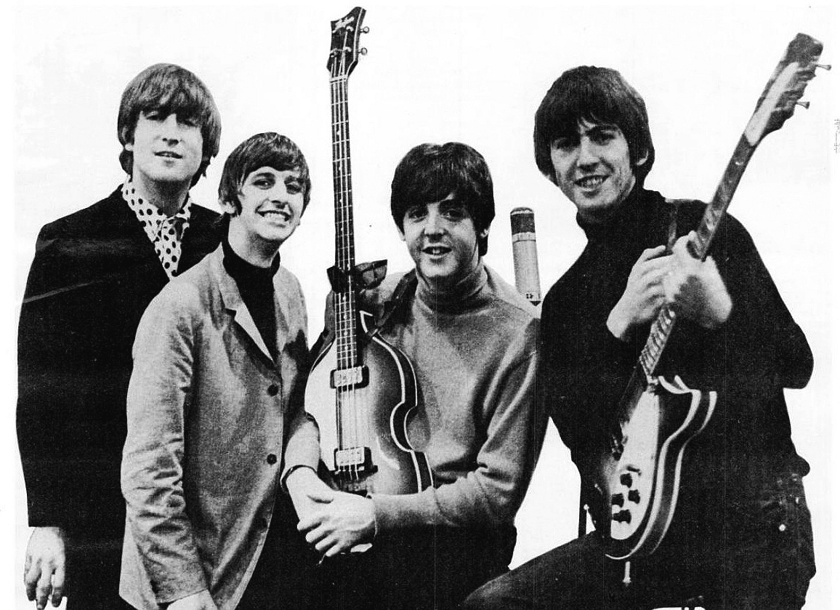

Vocals - what gender, how many singers? | Dynamics - volume?
Tempo - speed | How does this version make you feel?
Rating out of 10 and why | What is the main thing you notice about this version?

Version 2 - The Carpenters - cover version

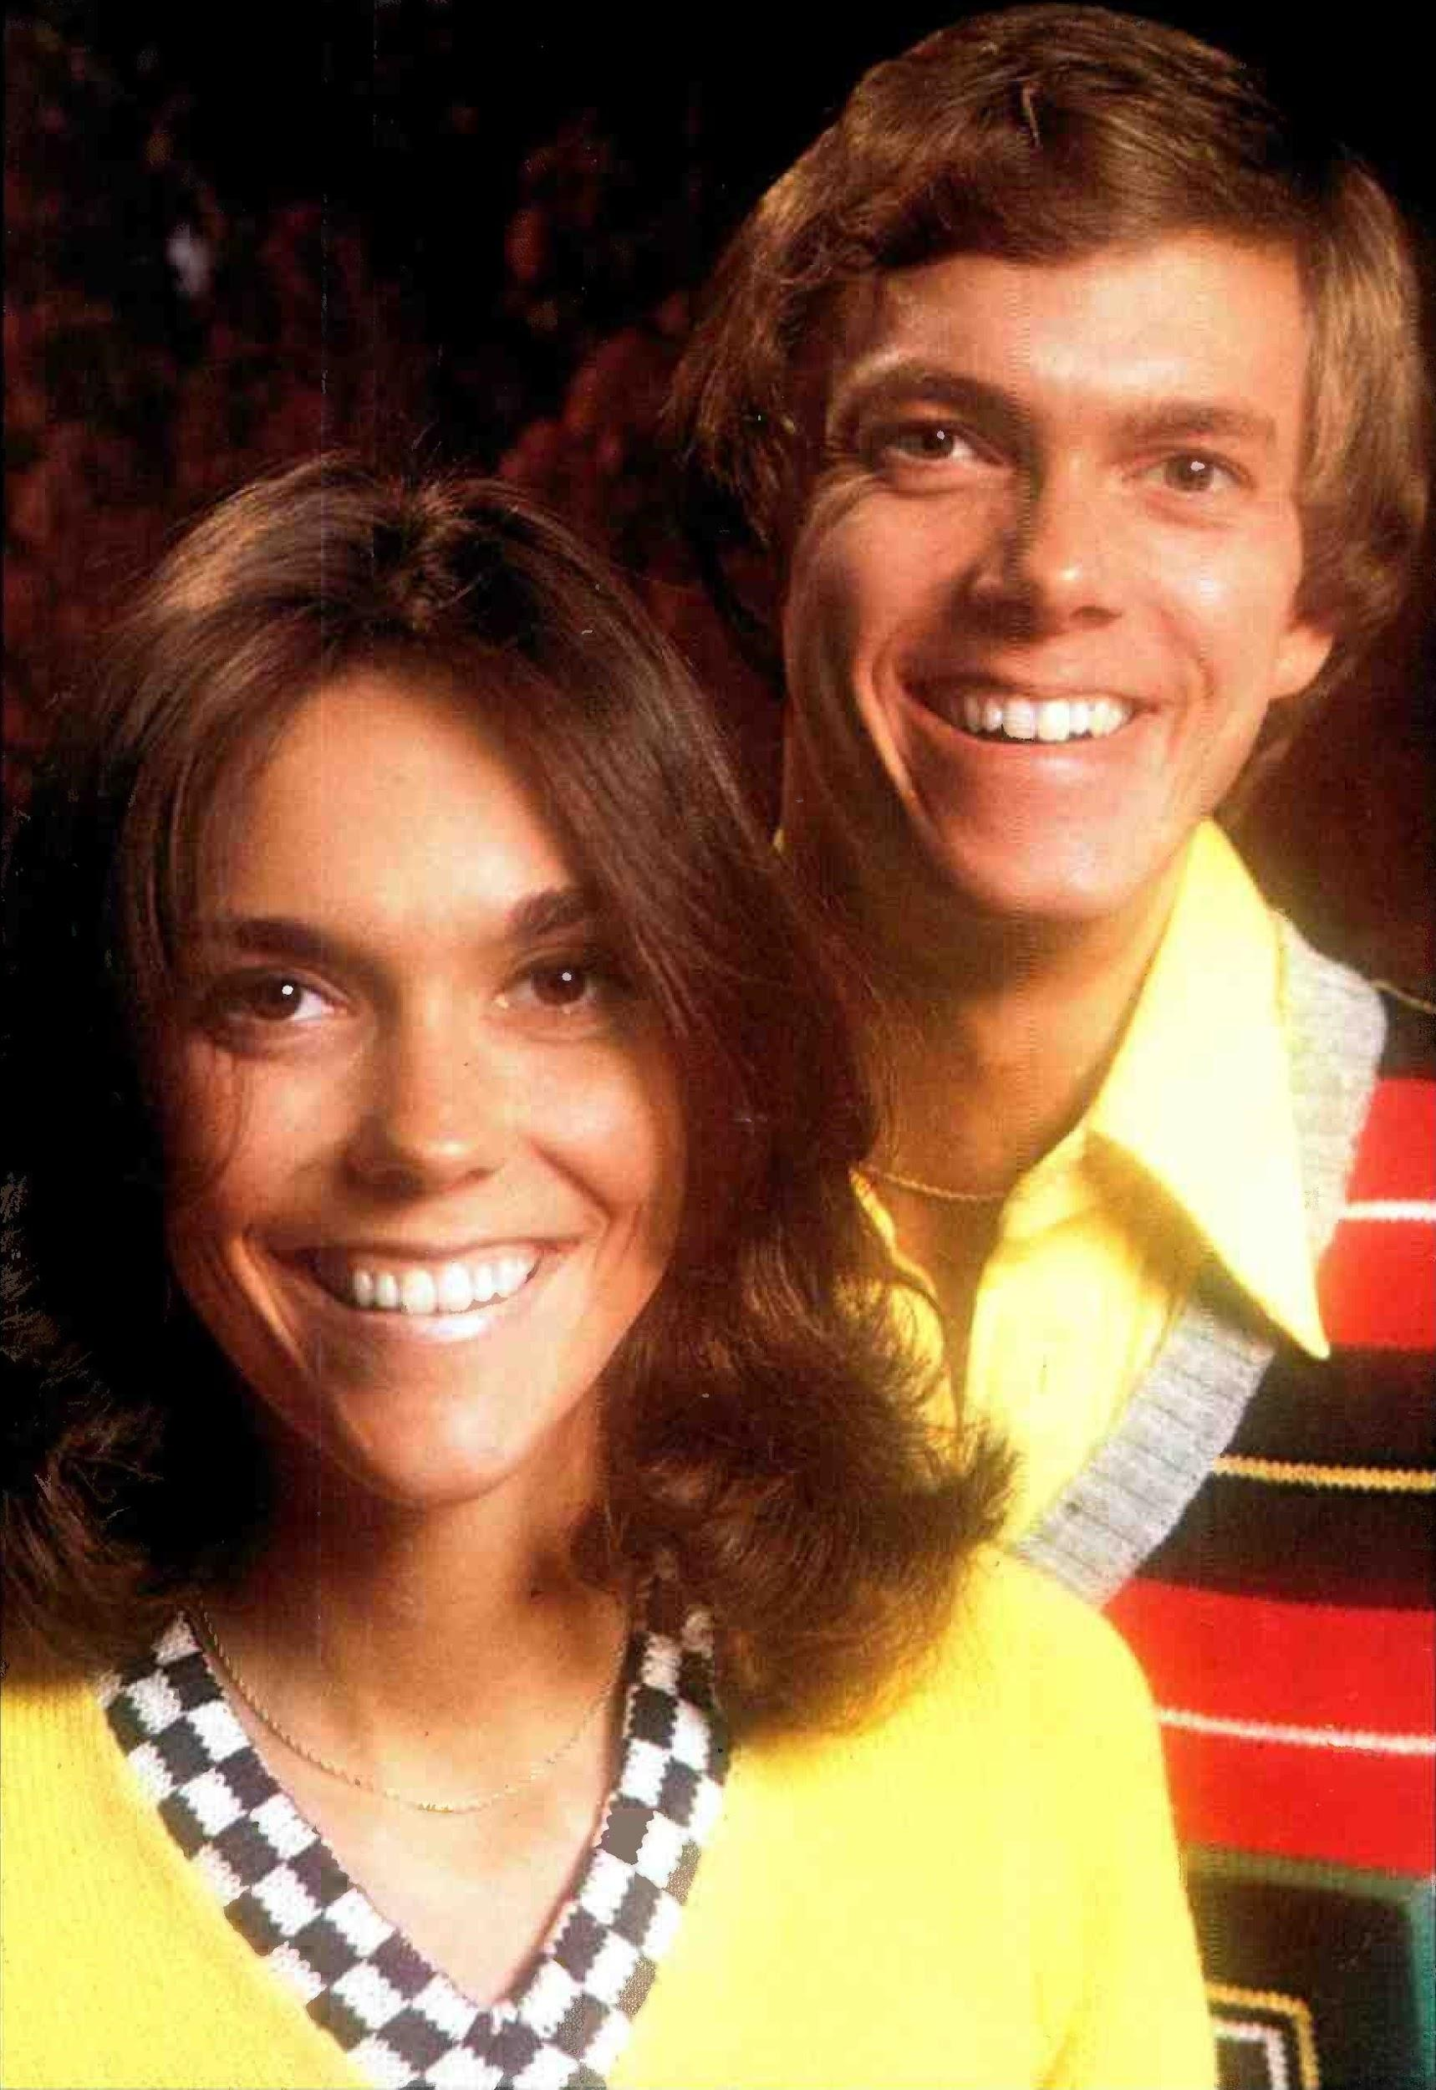

Vocals - what gender, how many singers? | Dynamics - volume?
Tempo - speed | How does this version make you feel?
Rating out of 10 and why | What is the main thing you notice about this version?

Version 3 - Taryn Szpilmann - cover version

Vocals - what gender, how many singers? | Dynamics - volume?
Tempo - speed | How does this version make you feel?
Rating out of 10 and why | What is the main thing you notice about this version?

Version 3 - The 5th Dimension - cover version

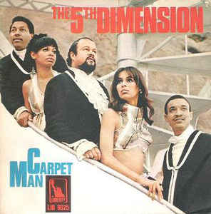

Vocals - what gender, how many singers? | Dynamics - volume?
Tempo - speed | How does this version make you feel?
Rating out of 10 and why | What is the main thing you notice about this version?

Now let’s sing the song together!

I think I'm gonna be sad
I think it's today, yeah
The girl that's driving me mad
Is going away

She's got a ticket to ride
She's got a ticket to ride
She's got a ticket to ride
But she don't care

She said that living with me
Is bringing her down, yeah
For she would never be free
When I was around

She's got a ticket to ride
She's got a ticket to ride
She's got a ticket to ride
But she don't care

I don't know why she's riding so high
She ought to think twice
She ought to do right by me
Before she gets to saying goodbye
She ought to think twice
She ought to do right by me

I think I'm gonna be sad
I think it's today, yeah
The girl that's driving me mad
Is going away, yeah

Oh, she's got a ticket to ride
She's got a ticket to ride
She's got a ticket to ride
But she don't care

I don't know why she's riding so high
She ought to think twice
She ought to do right by me
Before she gets to saying goodbye
She ought to think twice
She ought to do right by me

She said that living with me
Is bringing her down, yeah
For she would never be free
When I was around

Ah, she's got a ticket to ride
She's got a ticket to ride
She's got a ticket to ride
But she don't care

My baby don't care, my baby don't care
My baby don't care, my baby don't care
My baby don't care, my baby don't care (fade out)

Binary, Ternary and Pop Song Structure

Most pieces of music, whether they be classical or popular follow a structure or format.

Some musical structures include:
- Binary - one melody labeled ‘A’ is followed by a new melody labeled ‘B’ = AB melody form
- Ternary - one melody labeled ‘A’ is followed by a new melody labeled ‘B’ which then goes back to melody A = ABA melody form
- Pop Song which is typically ABABCB. A = the verse which is repeated later in the song but with different lyrics, B = the chorus, a repeated section and C = the bridge, a middle section.

Can you label the lyrics to the song with verse (A), chorus (B), bridge (C) and ending?

How did you do today? 😊 😕 😩

LESSON 6: Can I learn more about The Beatles?

Research Topic - The Beatles

You will need access to the internet for your lesson today.

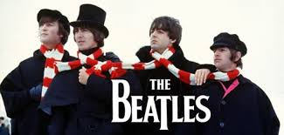

Use the internet to answer the following questions. These links may help you:
https://kids.kiddle.co/The_Beatles
http://www.softschools.com/facts/music/the_beatles_facts/2406/
http://news.bbc.co.uk/cbbcnews/hi/newsid_1680000/newsid_1684900/1684965.stm

- Name the four principal members of The Beatles and the instruments they played in the band.

- Which city in the United Kingdom do The Beatles come from?

- What was ‘The British Invasion’?

- Write the titles of 5 famous Beatles songs.

- What do you think was so special about The Beatles?

Now choose a song by The Beatles that you would like to study for the remainder of the lesson.
- Listen to the song then write sentences about what you like about it and how it makes you feel.
- Which album is the song from and in what year was it written?
- Write down things you notice about the music such as instruments, speed and volume.

How did you do today? 😊 😕 😩

LESSON 7: Can I use movement and dance to explore my feelings about music?

Study Piece:
‘Driving In My Car’ by Madness

I've been driving in my car, it's not quite a Jaguar
I bought it in Primrose Hill from a bloke from Brazil
It was made in fifty-nine in a factory by the Tyne
It says Morris on the door, the G.P.O. owned it before
I drive in it for my job, the governor calls me a slob
But I don't really care, give me some gas and the open air

It's a bit old but it's mine, I mend it in my spare time
Just last week I changed the oil, the rocker valves and the coil
Just last week I changed the oil
Last week it went round the clock, I also had a little knock
I dented somebody's fender, he learnt not to park on a bender, ha ha ha

I've been driving in my car, it don't look much but I've been far
I drive up to Muswell Hill, I've even been to Selsey Bill
I drove along the A45, I had her up to 58
This copper stopped me the other day, you're mistaken what could I say
The tyres were a little worn, they were O.K., I could have sworn
I like driving in my car, I'm satisfied I've got this far

I like driving in my car, it don't look much but I've been far
I like driving in my car, even with a flat tyre
I like driving in my car, it's not quite a Jaguar
I like driving in my car, I'm satisfied I've got this far

Who are Madness?
Along with the Specials, Madness were one of the leading bands of the ska revival of the late '70s and early '80s. As their career progressed, Madness branched away from their trademark "nutty sound" and incorporated large elements of Motown, soul, and British pop. Although the band managed one crossover American hit in 1983, they remained a British phenomenon, influencing several successive generations of musicians and becoming one of the most beloved groups the country produced during the '80s.
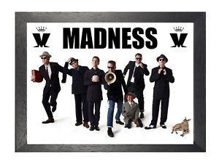
Today we are going to sing the song and explore ideas and feelings about music using movement, dance, expressive language and musical vocabulary.

- Is the song a serious or light-hearted song, why?

- Is it a happy or sad song, why?

- How should performers therefore perform this song to a public audience?

Now you are going to learn a choreographed version of the song with the street dancing company, ‘Urban Strides’ at https://www.youtube.com/watch?v=Q5prthW1Yqk with a full final version at https://www.youtube.com/watch?v=uuvGiOEOWnA

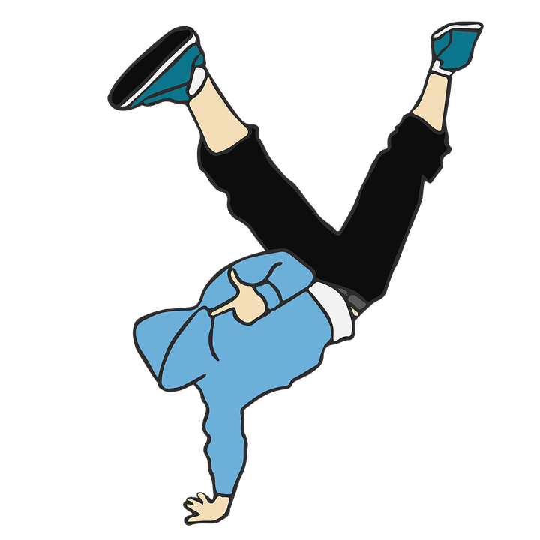

How easy or hard did you find the choreography?

What did you enjoy the most, or not enjoy?

Have you done any dancing before?

Would you like to perform this to the rest of the juniors, why or why not?

How did you do today? 😊 😕 😩

