GCSE English Language
PAPER 2

NON-FICTION

SECTION A: READING

Summary and Overview
In this section, you will analyse and compare two texts.
You will be assessed on:
AO1 | True/false statements…  - Identify and interpret explicit and implicit information and ideas  Write a summary…  - Synthesis of explicit and implicit ideas and information | So, you will be:  - identifying which statements about a text are true and which are false;  - summarising the main ideas of the text and explaining them;  - using evidence to back up what you say.
AO2 | How does the writer’s  use of language…  - Explain, comment on and analyse how writers use language and structure to achieve effects and influence readers.  - Use relevant subject terminology | So, you will be:  USING DETAILED PEE PARAGRAPHS, TRACKING THE TEXT.  - identifying techniques used by the writer;  - explaining why the writer used them;  - word analysis;  - explaining the effect on the reader.
AO3 | How the writers  present…  - Compare writers’ ideas and perspectives, and how they are conveyed | So, you will be:  - comparing the ideas and perspectives of the writers in both texts;  - showing that you understand the ideas and perspectives of the writers in both texts;  - comparing the methods the writers use to present their ideas;  - using evidence to back up what you say.

QUESTIONS OVERVIEW:
Q1. Choose four statements below which are TRUE……
You should:
- Read each statement very carefully;
- Some of them are not as obvious as others; they could be inferences;
- Shade the boxes of the statements that you think are true;
- Choose a MAXIMUM of four statements.
4 marks
Q2. Write a summary of......
e.g. The places which the writers visit in each text are very different.
Use details from both sources to write a summary of the differences.
You should:
- Use both texts;
- Choose quotations from both texts that show similarities and/or differences;
- Explain the similarities and/or differences;
- Use comparing / contrasting connectives.
8 marks
Q3. How does the writer use language to……
You should:
- Make sure you are looking at the correct text;
- Identify the methods/techniques the writer uses;
- Use subject terminology;
- Analyse the techniques;
- Do word analysis;
- Evaluate the effect of each method/technique on the reader.
12 marks
Q4. Compare how the writers have conveyed……
You should:
- Use both texts;
- Choose quotations from both texts that show the similarities/differences between the writer’s ideas and perspectives;
- Explain the similarities/differences;
- Identify and analyse some of the methods the writers use and compare them.
16 marks
LANGUAGE PAPER 2 SECTION A: READING NON-FICTION SAMPLE PAPER A
SOURCE A
In this extract, Bill Bryson describes his arrival in Dover, UK in 1973.
1

5

10

15

20

25

30

35

My first sight of England was on a foggy March night in 1973 when I arrived on the midnight ferry from Calais. For twenty minutes, the terminal area was a swarm with activity as cars and lorries poured forth, customs people did their duties, and everyone made for the London road. Then abruptly all was silence and I wandered through sleeping, low-lit streets threaded with fog, just like in a Bulldog Drummond movie. It was rather wonderful having an English town all to myself.
The only mildly dismaying thing was that all the hotels and guesthouses appeared to be shut up for the night. I walked as far as the rail station, thinking I'd catch a train to London, but the station, too, was dark and shuttered. I was standing wondering what to do when I noticed a grey light of television filling an upstairs window of a guesthouse across the road. Hooray, I thought, someone awake, and hastened across, planning humble apologies to the kindly owner for the lateness of my arrival and imagining a cheery conversation which included the line, `Oh, but I couldn't possibly ask you to feed me at this hour. No, honestly well, if you're quite sure it's no trouble, then perhaps just a roast beef sandwich and a large dill pickle with perhaps some potato salad and a bottle of beer.' The front path was pitch dark and in my eagerness and un- familiarity with British doorways, I tripped on a step, crashing face-first into the door and sending half a dozen empty milk bottles clattering. Almost immediately the upstairs window opened.

`Who's that?' came a sharp voice.
I stepped back, rubbing my nose, and peered up at a silhouette with hair curlers. `Hello, I'm looking for a room,' I said.
`We're shut.' `Oh.' But what about my supper? `Try the Churchill. On the front.' `On the front of what?' I asked, but the window was already banging closed. The Churchill was sumptuous and well lit and appeared ready to receive visitors. Through a window I could see people in suits in a bar, looking elegant and suave, like characters from a Noel Coward play. I hesitated in the shadows, feeling like a street urchin. I was socially and sartorially ill-suited for such an establishment and anyway it was clearly beyond my meagre budget. Only the previous day, I had handed over an exceptionally plump wad of colourful francs to a beady-eyed Picardy hotelier in payment for one night in a lumpy bed and a plate of mysterious chasseur containing the bones of assorted small animals, much of which had to be secreted away in a large napkin in order not to appear impolite, and had deter- mined thenceforth to be more cautious with expenditures. So I turned reluctantly from the Churchill's beckoning warmth and trudged off into the darkness.

Further along Marine Parade stood a shelter, open to the elements but roofed, and I decided that this was as good as I was going to get. With my backpack for a pillow, I lay down and drew my jacket tight around me. The bench was slatted and hard and studded with big roundheaded bolts that made reclining in comfort an impossibility. I lay for a long time listening to the sea washing over the shingle below, and eventually dropped off to a long, cold night of mumbled dreams in which I found myself being pursued over Arctic ice floes by a beady-eyed Frenchman with a catapult, a bag of bolts, and an uncanny aim, who thwacked me repeatedly in the buttocks and legs for stealing a linen napkin full of seepy food and leaving it at the back of a dresser drawer of my hotel room. I awoke with a gasp about three, stiff all over and quivering from cold.

SOURCE B
In this extract, Charles Dickens describes his first impressions of the city of Boston in the USA while travelling there in 1842.
1

5

10

15

20

25

30
To return to Boston. When I got into the streets upon this Sunday morning, the air was so clear, the houses were so bright and gay: the signboards were painted in such gaudy colours; the gilded letters were so very golden; the bricks were so very red, the stone was so very white, the blinds and area railings were so very green, the knobs and plates upon the street doors so marvellously bright and twinkling; and all so slight and unsubstantial in appearance—that every thoroughfare in the city looked exactly like a scene in a pantomime. It rarely happens in the business streets that a tradesman, if I may venture to call anybody a tradesman, where everybody is a merchant, resides above his store; so that many occupations are often carried on in one house, and the whole front is covered with boards and inscriptions. As I walked along, I kept glancing up at these boards, confidently expecting to see a few of them change into something; and I never turned a corner suddenly without looking out for the clown and pantaloon, who, I had no doubt, were hiding in a doorway or behind some pillar close at hand. As to Harlequin and Columbine, I discovered immediately that they lodged (they are always looking after lodgings in a pantomime) at a very small clockmaker’s one story high, near the hotel; which, in addition to various symbols and devices, almost covering the whole front, had a great dial hanging out—to be jumped through, of course.
The suburbs are, if possible, even more unsubstantial-looking than the city. The white wooden houses (so white that it makes one wink to look at them), with their green jalousie blinds, are so sprinkled and dropped about in all directions, without seeming to have any root at all in the ground; and the small churches and chapels are so prim, and bright, and highly varnished; that I almost believed the whole affair could be taken up piecemeal like a child’s toy, and crammed into a little box.
The city is a beautiful one, and cannot fail, I should imagine, to impress all strangers very favourably. The private dwelling-houses are, for the most part, large and elegant; the shops extremely good; and the public buildings handsome. The State House is built upon the summit of a hill, which rises gradually at first, and afterwards by a steep ascent, almost from the water’s edge. In front is a green enclosure, called the Common. The site is beautiful: and from the top there is a charming panoramic view of the whole town and neighbourhood. In addition to a variety of commodious offices, it contains two handsome chambers; in one the House of Representatives of the State hold their meetings: in the other, the Senate. Such proceedings as I saw here, were conducted with perfect gravity and decorum; and were certainly calculated to inspire attention and respect.
There is no doubt that much of the intellectual refinement and superiority of Boston, is referable to the quiet influence of the University of Cambridge, which is within three or four miles of the city. The resident professors at that university are gentlemen of learning and varied attainments; and are, without one exception that I can call to mind, men who would shed a grace upon, and do honour to, any society in the civilised world.

Q1. Read again the first part of Source A, lines 1-15.
Choose four statements below which are TRUE.
- Shade the boxes of the ones that you think are true.
- Choose a maximum of four statements.
[4 marks]
KEY TIPS:
PAY ATTENTION TO THIS – JUST 15 LINES!
- For each statement work of first if it is True or false and write T or F next to it.
- If you are unsure of one – leave it blank and go back to it at the end.
- ONLY shade in the boxes after EVERY statement has a T or F next to it.
- TASK: 5 MINUTES to COMPLETE

AO1 | THE LIE DETECTOR
Identify and interpret explicit and implicit information and ideas.

A. There is lots of pollution in Dover.

B. The terminal area is quiet.

C. The streets of Dover were sleepy and deserted.

D. It was a clear and beautiful night.
E. It was hard to find accommodation for the night.

F. Bryson caught a train to London.

G. Bryson was hungry and hoped to eat at his hotel.

H. Bryson walked quietly to his accommodation.

PROGRESS CHECK: HOW DID YOU DO?
Circle how many marks you got.
1 2 3 4

Q2. You need to refer to Source A and Source B for this question:
The places that Bill Bryson and Charles Dickens visit are very different.
Use details from both sources to write a summary of their differences.
[8 marks]
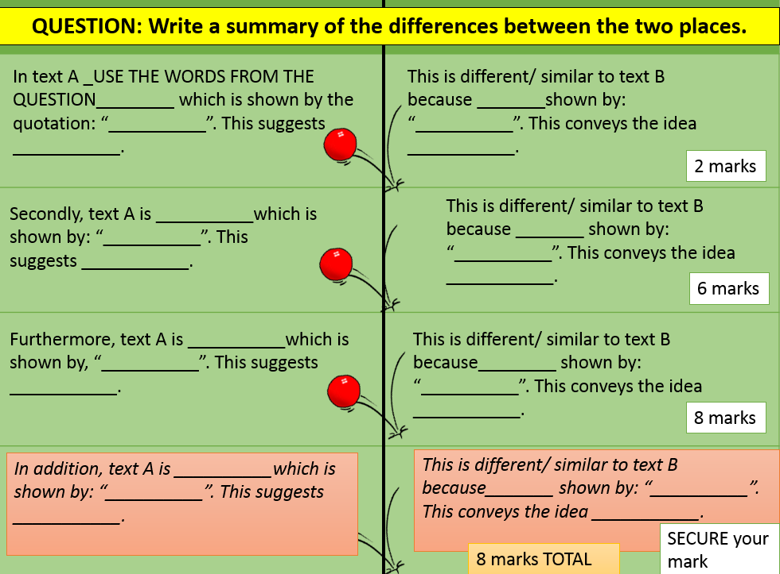
To start you off:
In Source A, Boston is presented as a vibrant city which is shown by “so bright and gay…gaudy colours” which shows that Dickens is struck by the care that seems to have been taken to make the city attractive and bright for visitors and residents. This is different to Source B because Bryson presents Dover as a somewhat dull place: “low-lit streets threaded with fog”. This conveys the idea that Dover is much duller and less lively as it is being smothered by mist which does not allow the visitor to view it clearly.
Secondly, __________________________________________________________________________________________________________________________________________ _____________________________________________________________________________________________________________________________________________________________________________________________________________________________________________________________________________________________________________________________________________________________________________________________________________________________________________________________________________________________________________________________________________________________________________________________________________________________________________________________________________________________________________________________________________________________________________________________________________________________________________________________________________________________________________________________________________________________________________________________________________________________________________________________________________________________________________________________________________________________________________________________________________________________________________________________________________________________________________________________________________________________________________________________________________________________________________________________________________________________________________________________________________________________________________________________________________________________________________________________________________________________________________________________________________________________________________________________________________________________________________________________________________________________________________________________________________________________________________________________________________________________________________________________________________________________________________________________________________________________________________________________________________________________________________________________________________________________________________________________________________________________________________________________________________________________________________________________________________________________________________________________________________________________________________________________________________________________________________________________________________________________________________________________________________________________________________________________________________________________________________________________________________________________________________________________________________________________________________________________________________________________________________________________________________________________________________________________________________________________________________________________________________________________________________________________________________________________________________________________________________________________________________________________________________________________________________________________________________________________________________________________________________________________________________________________________________________________________________________________________________________________________________________________________________________________________________________________________________________________________________________________________________________________________________________________________________________________________________________________________________________________________________________________________________________________

PROGRESS CHECK: HOW DID YOU DO?
Circle how many marks you got.
- 2 3 4 5 6 7 8

Q3. You now need to refer only to Source B, Charles Dickens’ account of his trip to Boston, from lines 1-16.

How does Dickens use language to convey his enjoyment of his visit to the reader?
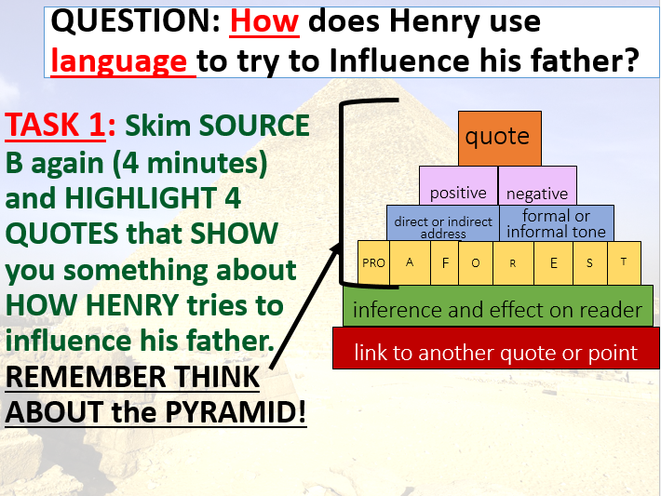
[12 marks]
To start you off…
In Source B, Dickens uses repetition to emphasise how invigorating it is to be in Boston. His use of the word “so” to do this, “so clear…so bright and gay” shows that he is really enjoying the fresh atmosphere and vibrant appearance of the city. This repetition makes the reader believe firstly that Boston would be an amazing place to visit in the mid-eighteenth century and secondly that Dickens is probably enjoying Boston so much that he almost feels giddy.
Also, _________________________________________________________________
________________________________________________________________________________________________________________________________________________________________________________________________________________________________________________________________________________________________________________________________________________________________________________________________________________________________________________________________________________________________________________________________________________________________________________
________________________________________________________________________________________________________________________________________________________________________________________________________________________________________________________________________________________
________________________________________________________________________________________________________________________________________________________________________________________________________________________________________________________________________________________
________________________________________________________________________________________________________________________________________________________________________________________________________________________________________________________________________________________
________________________________________________________________________________________________________________________________________________________________________________________________________________________________________________________________________________________
________________________________________________________________________________________________________________________________________________________________________________________________________________________________________________________________________________________
________________________________________________________________________________________________________________________________________________________________________________________________________________________________________________________________________________________
________________________________________________________________________________________________________________________________________________________________________________________________________________________________________________________________________________________
________________________________________________________________________________________________________________________________________________________________________________________________________________________________________________________________________________________
________________________________________________________________________________________________________________________________________________________________________________________________________________________________________________________________________________________
________________________________________________________________________________________________________________________________________________________________________________________________________________________________________________________________________________________
________________________________________________________________________________________________________________________________________________________________________________________________________________________________________________________________________________________
________________________________________________________________________________________________________________________________________________________________________________________________________________________________________________________________________________________
________________________________________________________________________________________________________________________________________________________________________________________________________________________________________________________________________________________
________________________________________________________________________________________________________________________________________________________________________________________________________________________________________________________________________________________
PROGRESS CHECK: HOW DID YOU DO?
Circle how many marks you got.
- 2 3 4 5 7 8 9 10 11 12

Q4. For this question, you need to refer to the whole of Source A together with the whole of Source B.

Compare how the writers have conveyed their different experiences and views about the places they visited.

In your answer, you could:
- compare their different views about the places they visit;
- compare the methods they use to convey their experiences and views;
- support your ideas with quotations from both texts.
[16 marks]
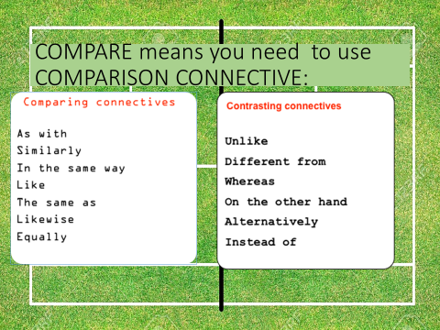

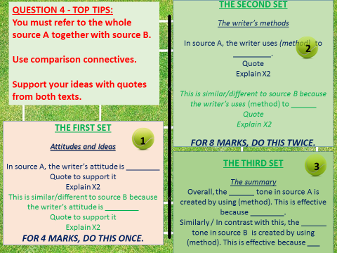

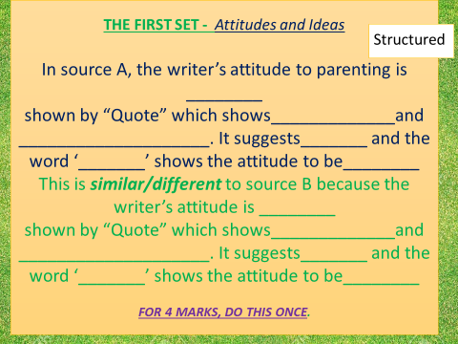
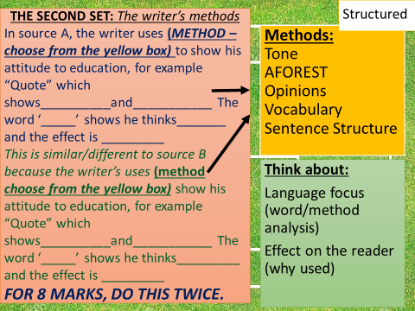

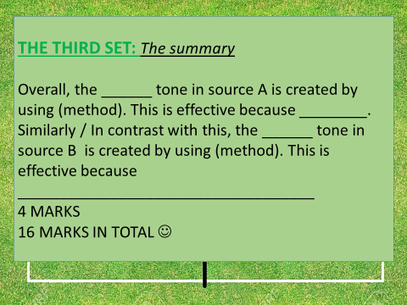

To start you off:
In Source A, Bryson is unimpressed by Dover when he first arrives because, although the port is busy, the town itself is dead. For example, “terminal area was a swarm with activity…abruptly all was silence”. This metaphor shows that the terminal is as busy as a hive of bees and that this contrasts with the quiet “sleeping, low-lit streets” of the main town. The word “swarm” also has the connotation that the people arriving have a nasty attitude towards getting through the crowds, as if they will sting each other. It contrasts with the “low-lit streets”. This suggests that he is probably relieved to get away from the terminal to the more relaxed atmosphere of the town.
This is different to Source B because Dickens’ attitude is much more positive. He thinks ___ ____________________________________________________________________________________________________________________________________________________________________________________________________________________________________________________________________________________________________________
________________________________________________________________________________________________________________________________________________________________________________________________________________________________________________________________________________________________________________________________________________________________________________________________________________________________________________________________________________________________________________________________________________________________________________________________________________________________________________________________________________________________________________________________________________________________________________________________________________________________________________________________________________________________________________________________________________________________________________________________________________________________________________________________________________________________________________________________________________________________________________________________________________________________________________________________________________________________________________________________________________________________________________________________________________________________________________________________________________________________________________________________________________________________________________________________________________________________________________________________________________________________________________________________________________________________________________________________________________________________________________________________________________________________________________________________________________________________________________________________________________________________________________________________________________________________________________________________________________________________________________________________________________________________________________________________________________________________________________________________________________________________________________________________________________________________________________________________________________________________________________________________________________________________________________________________________________________________________________________________________________________________________________________________________________________________________________________________________________________________________________________________________________________________________________________________________________________________________________________________________________________________________________________________________________________________________________________________________________________________________________________________________________________________________________________________________________________________________________________________________________________________________________________________________________________________________________________________________________________________________________________________________________________________________________________________________________________________________________________________________________________________________________________________________________________________________________________________________________________________________________________________________________________________________________________________________________________________________________________________________________________________________________________________________________________________________________________________________________________________________________________________________________________________________________________________________________________________________________________________________________________________________________________________________________________________________________________________________________________________________________________________________________________________________________________________________________________________________________________________________________________________________________________________________________________________________________________________________________________________________________________________________________________________________________________________________________________________________________________________________________________________________________________________________________________________________________________________________________________________________________________________________________________________________________________________________________________________________________________________________________________________________________________________________________________________________________________________________________________________________________________________________________________________________________________________________________________________________________________________________________________________________________________________________________________________________________________________________________________________________________________________________________________________________________________________________________________________________________________________________________________________________________________________________________________________________________________________________________________________________________________________________________________________________________________________________________________________________________________________________________________________________________________________________________________________________________________________________________________________________________________________________________________________________________________________________________________________________________________________________________________________________________________________________________________________________________________________________________________________________________________________________________________________________________________________________________________________________________________________________________________________________________________________________________________________________________________________________________________________________________________________________________________________________________________________________________________________________________________________________________________________________________________________________________________________________________________________________________________________

PROGRESS CHECK: HOW DID YOU DO?
Circle how many marks you got.
- 2 3 4 5 7 8 9 10 11 12 13 14 15 16

RECAP:

- Which do you think is the most important question on this paper? Why?
______________________________________________________________________________________________________________

- In what order do you think that you should do these questions? Why?
_____________________________________________________________________________________________________________________________________________________________________

- What is the focus of each question type? / What is the examiner looking for?

Q1. ___________________________________________________
_______________________________________________________

Q2. ___________________________________________________
_______________________________________________________

Q3. ___________________________________________________
_______________________________________________________

Q4. ___________________________________________________
_______________________________________________________

- For Q2 to Q4, what must you ALWAYS do?
__________________________________________________________________________________________________________________________
LANGUAGE PAPER 2 SECTION A: READING NON-FICTION SAMPLE PAPER B
Use the writing frames and help above to try this paper yourself.
SOURCE A:

This extract is taken from an online blog where the writer tells us about the experience of working in the “modern factory” – the call centre.
For me, being listened in to is never a nice experience. First there is the paranoia. Spotting a team-leader sat at a station, you start wondering how long since you were last monitored, then they glance over. Momentarily you catch each other’s eyes before you both turn away. Convinced you are under the microscope, you begin upping your work rate until your throat becomes sore with the exertion. You push, prod and cajole customers into buying more, upgrading or whatever it is the company wants you to do – what on paper you should do – but which under normal circumstances you wouldn’t care less about hassling people for. Worst of all you have to do everything by the book. No cutting corners the way you do to keep your average call time down, and absolutely no writing off of trifling amounts to neatly circumvent an argument with a customer.
1

5

10

15

20

25

…
In the call centre, talking to your co-workers is a forbidden fruit to be bitten into, to have its juices savoured. You talked whenever you had the chance. The reason for this is that when it is effectively the use of your vocal chords which is being paid for, the employer expects them to be used only for the pursuit of their objectives. Using them for mere idle chatter is wasting money.
In my last call centre managers would go to lengths to prevent chatter. Not content with waving monitoring reports at you in your six-monthly review, showing how much time you’d spent not on calls they’d seek to catch you red handed. Moving around the floor with stealth they used the wobbly grey partitions, stone pillars and over-sized pot-plants for cover. Observing for a few moments they’d then leap like a lion on their unsuspecting prey.
There was really nothing worse than getting the unpleasant tap on the shoulder followed by a rebuke of ‘get back on the phone’ so, against this threat, we deployed several defensive strategies. The first thing to do when coming on shift was to find a seat which faced the manager’s desk cluster. This enabled you to observe the observer, and prevented any unnoticed approach. Adjusting your chair to sit as low as possible was another strategy. Too high and your head is literally above the parapet. Managers’ sight-lines could also be blocked by careful positioning of a box-file.
Another trick is keeping your headset on and looking straight-ahead, never looking away from the screen, whilst conversing with your neighbour. It goes against all the usual norms of face-to-face conversation, but it’s much easier to conceal an illicit conversation. Finally there is teamwork, which involves warning each other with nudge, or a head nod that a manager is on the prowl.
In my final year at that particular call centre I only got tapped on the shoulder twice.
SOURCE B:

The following text is from an essay by P. Gaskell, titled ‘The Manufacturing Population of England’. London and was written in 1833. In this extract the writer describes the conditions of workers in a factory.
Any man who has stood at twelve o'clock at the single narrow door-way, which serves as the place of exit for the hands employed in the great cotton-mills, must acknowledge, that an uglier set of men and women, of boys and girls, taking them in the mass, it would be impossible to congregate in a smaller compass. Their complexion is sallow and pallid--with a peculiar flatness of feature, caused by the want of a proper quantity of adipose substance to cushion out the cheeks. Their stature low--the average height of four hundred men, measured at different times, and different places, being five feet six inches. Their limbs slender, and playing badly and ungracefully. A very general bowing of the legs. Great numbers of girls and women walking lamely or awkwardly, with raised chests and spinal flexures. Nearly all have flat feet, accompanied with a down-tread, differing very widely from the elasticity of action in the foot and ankle, attendant upon perfect formation. Hair thin and straight--many of the men having but little beard, and that in patches of a few hairs, much resembling its growth among the red men of America. A spiritless and dejected air, a sprawling and wide action of the legs, and an appearance, taken as a whole, giving the world but "little assurance of a man," or if so, "most sadly cheated of his fair proportions..."
1

5

10

15

20

25

Factory labour is a species of work, in some respects singularly unfitted for children. Cooped up in a heated atmosphere, debarred the necessary exercise, remaining in one position for a series of hours, one set or system of muscles alone called into activity, it cannot be wondered at--that its effects are injurious to the physical growth of a child. Where the bony system is still imperfect, the vertical position it is compelled to retain, influences its direction; the spinal column bends beneath the weight of the head, bulges out laterally, or is dragged forward by the weight of the parts composing the chest, the pelvis yields beneath the opposing pressure downwards, and the resistance given by the thigh-bones; its capacity is lessened, sometimes more and sometimes less; the legs curve, and the whole body loses height, in consequence of this general yielding and bending of its parts.

Q1. Read again the first part of Source A, lines 1-18.

Choose four statements below which are TRUE.

- Shade the boxes of the ones that you think are true.
- Choose a maximum of four statements.
[4 marks]
AO1 | THE LIE DETECTOR
Identify and interpret explicit and implicit information and ideas.

A. The writer likes to be listened to when on the phone.

B. Call centre work is very relaxing.

C. Your throat hurts during the work day in a call centre.

D. You are allowed to chat to your colleagues at work when you want.
E. Call centre work often involves doing telephone sales.

F. Call centre work gives you freedom to do your job how you want.

G. Managers keep records of how long you spend on calls.

H. Managers try to catch you out not doing your job properly.

PROGRESS CHECK: HOW DID YOU DO?
Circle how many marks you got.
- 2 3 4

Q2. You need to refer to Source and Source B for this question:

The workplaces in the blog and in the nineteenth century factory are similar in some ways and very different in others.
Use details from both sources to write a summary of their similarities and differences.
[8 marks]
________________________________________________________________________________________________________________________________________________________________________________________________________________________________________________________________________________________________________________________________________________________________________________________________________________________________________________________________________________________________________________________________________________________________________________
________________________________________________________________________________________________________________________________________________________________________________________________________________________________________________________________________________________
________________________________________________________________________________________________________________________________________________________________________________________________________________________________________________________________________________________
________________________________________________________________________________________________________________________________________________________________________________________________________________________________________________________________________________________
________________________________________________________________________________________________________________________________________________________________________________________________________________________________________________________________________________________
________________________________________________________________________________________________________________________________________________________________________________________________________________________________________________________________________________________
________________________________________________________________________________________________________________________________________________________________________________________________________________________________________________________________________________________
________________________________________________________________________________________________________________________________________________________________________________________________________________________________________________________________________________________
________________________________________________________________________________________________________________________________________________________________________________________________________________________________________________________________________________________
________________________________________________________________________________________________________________________________________________________________________________________________________________________________________________________________________________________
________________________________________________________________________________________________________________________________________________________________________________________________________________________________________________________________________________________
________________________________________________________________________________________________________________________________________________________________________________________________________________________________________________________________________________________
______________________________________________________________________
PROGRESS CHECK: HOW DID YOU DO?
Circle how many marks you got.
- 2 3 4 5 7 8

Q3. You now need to refer only to the whole of Source B, Gaskell’s account of the factory worker of the nineteenth century.

How does Gaskell use language to convey his concerns about the working conditions in factories of the nineteenth century?
[12 marks]
________________________________________________________________________________________________________________________________________________________________________________________________________________________________________________________________________________________
________________________________________________________________________________________________________________________________________________________________________________________________________________________________________________________________________________________
________________________________________________________________________________________________________________________________________________________________________________________________________________________________________________________________________________________
________________________________________________________________________________________________________________________________________________________________________________________________________________________________________________________________________________________
________________________________________________________________________________________________________________________________________________________________________________________________________________________________________________________________________________________
________________________________________________________________________________________________________________________________________________________________________________________________________________________________________________________________________________________
________________________________________________________________________________________________________________________________________________________________________________________________________________________________________________________________________________________
________________________________________________________________________________________________________________________________________________________________________________________________________________________________________________________________________________________
________________________________________________________________________________________________________________________________________________________________________________________________________________________________________________________________________________________
________________________________________________________________________________________________________________________________________________________________________________________________________________________________________________________________________________________
________________________________________________________________________________________________________________________________________________________________________________________________________________________________________________________________________________________
________________________________________________________________________________________________________________________________________________________________________________________________________________________________________________________________________________________
________________________________________________________________________________________________________________________________________________________________________________________________________________________________________________________________________________________
________________________________________________________________________________________________________________________________________________________________________________________________________________________________________________________________________________________
________________________________________________________________________________________________________________________________________________________________________________________________________________________________________________________________________________________
________________________________________________________________________________________________________________________________________________________________________________________________________________________________________________________________________________________
________________________________________________________________________________________________________________________________________________________________________________________________________________________________________________________________________________________
________________________________________________________________________________________________________________________________________________________________________________________________________________________________________________________________________________________
________________________________________________________________________________________________________________________________________________________________________________________________________________________________________________________________________________________
________________________________________________________________________________________________________________________________________________________________________________________________________________________________________________________________________________________
________________________________________________________________________________________________________________________________________________________________________________________________________________________________________________________________________________________
PROGRESS CHECK: HOW DID YOU DO?
Circle how many marks you got.
- 2 3 4 5 7 8 9 10 11 12

Q4. For this question, you need to refer to the whole of Source A together with the whole of Source B.
Compare how the writers have conveyed their different ideas and perspectives about the workplaces that they have seen.
[16 marks]
________________________________________________________________________________________________________________________________________________________________________________________________________________________________________________________________________________________
________________________________________________________________________________________________________________________________________________________________________________________________________________________________________________________________________________________
________________________________________________________________________________________________________________________________________________________________________________________________________________________________________________________________________________________
________________________________________________________________________________________________________________________________________________________________________________________________________________________________________________________________________________________
________________________________________________________________________________________________________________________________________________________________________________________________________________________________________________________________________________________
________________________________________________________________________________________________________________________________________________________________________________________________________________________________________________________________________________________
________________________________________________________________________________________________________________________________________________________________________________________________________________________________________________________________________________________
________________________________________________________________________________________________________________________________________________________________________________________________________________________________________________________________________________________
________________________________________________________________________________________________________________________________________________________________________________________________________________________________________________________________________________________
________________________________________________________________________________________________________________________________________________________________________________________________________________________________________________________________________________________
________________________________________________________________________________________________________________________________________________________________________________________________________________________________________________________________________________________
________________________________________________________________________________________________________________________________________________________________________________________________________________________________________________________________________________________
________________________________________________________________________________________________________________________________________________________________________________________________________________________________________________________________________________________
________________________________________________________________________________________________________________________________________________________________________________________________________________________________________________________________________________________
________________________________________________________________________________________________________________________________________________________________________________________________________________________________________________________________________________________
________________________________________________________________________________________________________________________________________________________________________________________________________________________________________________________________________________________
________________________________________________________________________________________________________________________________________________________________________________________________________________________________________________________________________________________
________________________________________________________________________________________________________________________________________________________________________________________________________________________________________________________________________________________
________________________________________________________________________________________________________________________________________________________________________________________________________________________________________________________________________________________
________________________________________________________________________________________________________________________________________________________________________________________________________________________________________________________________________________________
________________________________________________________________________________________________________________________________________________________________________________________________________________________________________________________________________________________
________________________________________________________________________________________________________________________________________________________________________________________________________________________________________________________________________________________
____________________________________________________________________________________________________________________________________________
PROGRESS CHECK: HOW DID YOU DO?
Circle how many marks you got.
- 2 3 4 5 7 8 9 10 11 12 13 14 15 16

