English Language - Transactional Writing Home Learning Booklet

Student: ………………………………………………..…………………………..
The only place that success comes before work, is in the dictionary.
Set: ………………… Staff: …………………………….

- All your questions will be based on writing for a specific audience, purpose and type.
- It will all be NON-FICTION writing.
- Each task should take around 60 minutes to complete.
- You must complete the pre-reading and vocabulary work for each new question.
- You must plan each question carefully with all of your ideas.
- You can use your knowledge organisers to help you – strong openings / trigger list / PEEEP structure etc.
Emotive Language - powerful words used to create emotions in the reader.

Eg: Speeding motorists are murderers.
Rule of Three - Using three adjectives to describe something is a powerful technique.
Eg: Footballers are overpaid, juvenile & egotistical.
STRUCTURE
‘Number’ or order your paragraphs in a logical order - ‘Firstly, I strongly believe… Finally…
Use of connectives - Furthermore, it is vital that… However, it is believed that… In addition…
Repetition - Using a particular word or phrase throughout your argument is a powerful tool.
Topic sentences - The opening sentence of your paragraph should indicate what your paragraph is focussing on. Eg: Plastic surgery has many dangers...
Directly addressing the reader - using words such as ‘you’, ‘we’, ‘our’ creates a bond and encourages your audience to agree with you.
Eg: Together we can do this. You wouldn’t want it to happen to you.
Facts & Statistics - used to support your point. You can just make them up, they don’t need to be real. But do state where they come from.
Eg: 40% of women are happy with their body.
Rhetorical questions - a question that doesn’t need a reply because the answer is obvious.
Eg: Are teenagers all hardened criminals?
Would you put shampoo in your rabbit’s eyes?
Use of present tense - Creates a sense of urgency as it is a current issue that needs addressing immediately.
Eg: Right now, millions of endangered species are being hunted by poachers.
Writing Tips:
You don’t have to agree with the statement. But, you should think carefully about your reasons for either agreeing or disagreeing. Sometimes the obvious opinion is harder to argue for.
Check what you are writing: a letter, article, speech?
Think about the structure of your writing and what order you will present your ideas. Don’t put all your strong points at the start, try to finish with some impact.
Remember the techniques which can help your writing be argumentative:

Task 1 (Writing viewpoints and perspectives):
- Vocabulary: Complete the exercise finding the alternative words for the vocabulary below. The first two have been done for you.
Ambitious word | Alternative word | Ambitious word | Alternative word
encompassing | including | abhorrent
vitriol | hatred |  | strange
jeopardy |  | eccentric
 | dangerous |  | trapped
egotistic |  | harbour (as a verb)

- Read the article on animal testing. Using two different colours highlight reasons for and against animal testing. Make a key on the text.
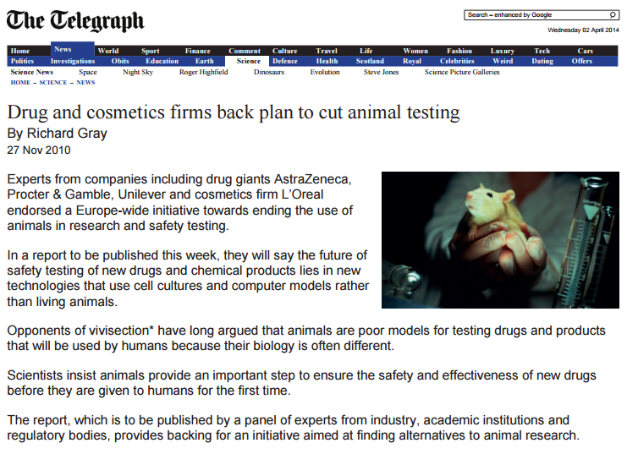
Source: An online newspaper article about companies reducing the amount of testing on animals called, ‘Drug and cosmetics firms back plan to cut animal testing’ by Richard Gray.

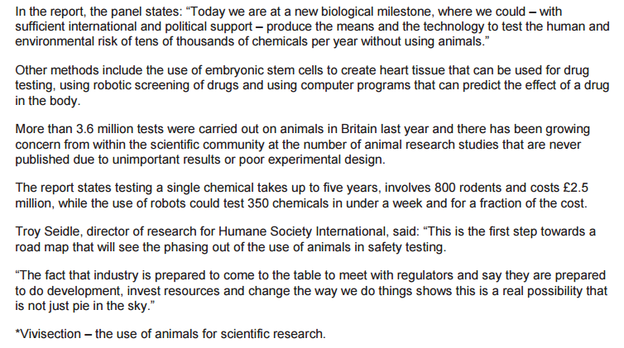

- Read the following statement and write a letter to your local MP in which you argue your case, for or against the use of animal testing.

‘Animal Testing is barbaric and should be made illegal no matter what the benefits.’

Plan all these elements before you write: (An example has been given for this first task)
Text Type Audience | What and to whom are you writing? |  | Letter – remember addresses, Dear/Yours Faithfully
Purpose | Agree or Disagree? | Agree
Point 1 |  | Animals aren’t the same as humans.
Reason 1 |  | Testing is ineffective & unreliable.
Benefit 1 |  | Animals don’t suffer pointlessly
Point 2 |  | Animals don’t lead natural life.
Reason 2 |  | Confined to cages. No natural daylight.
Benefit 2 |  | Animals aren’t bred simply for experiments.
Point 3 |  | Cosmetics don’t need to be tested on animals.
Reason 3 |  | Already successfully tested without using animals.
Benefit 3 |  | Money can be invested into non cruel ways of testing cosmetics.
What are the opposing ideas you will challenge? |  | Essential medical drugs need testing.  Testing on humans ineffective.  Less chance of it going wrong & harming humans.

Now complete your own plan.
Text Type Audience | What and to whom are you writing?
Purpose | Agree or Disagree?
Point 1
Reason 1
Benefit 1
Point 2
Reason 2
Benefit 2
Point 3
Reason 3
Benefit 3
What are the opposing ideas you will challenge?

Jump Start - Use one or more of these to get you started if you can’t think of your own way:
Start with a statistic | Start with a rhetorical question
Imagine life as a rat in a cage, never seeing the light of day. | Imagine your loved ones taking a drug that has never been tested.
Animal testing has long been debated but in a cancerous world how can we put the lives of animals before our own species? | Only the weak minded would put the lives of animals before those of humans.

Some techniques you should try to use if they are appropriate to your writing:
- Rhetorical Questions
- Facts & Statistics – say where the stats are from (eg Department of Education, Chief medical advisor to the Government)
- Direct Address
- Emotive vocabulary
- Rule of 3 – why not try 4?
- Repetition

……………………………………………………………………………………………………………………………………………………………………………………………………………………………………………………………………………………………………………………………………………………………………………………………………………………………………………………………………………………………………………………………………………………………………………………………………………………………………………………………………………………………………………………………………………………………………………………………………………………………………………………………………………………………………………………………………………………………………………………………………………………………………………………………………………………………………………………………………………………………………………………………………………………………………………………………………………………………………………………………………………………………………………………………………………………………………………………………………………………………………………………………………………………………………………………………………………………………………………………………………………………………………………………………………………………………………………………………………………………………………………………………………………………………………………………………………………………………………………………………………………………………………………………………………………………………………………………………………………………………………………………………………………………………………………………………………………………………………………………………………………………………………………………………………………………………………………………………………………………………………………………………………………………………………………………………………………………………………………………………………………………………………………………………………………………………………………………………………………………………………………………………………………………………………………………………………………………………………………………………………………………………………………………………………………………………………………………………………………………………………………………………………………………………………………………………………………………………………………………………………………………………………………………………………………………………………………………………………………………………………………………………………………………………………………………………………………………………………………………………………………………………………………………………………………………………………………………………………………………………………………………………………………………………………………………………………………………………………………………………………………………………………………………………………………………………………………………………………………………………………………………………………………………………………………………………………………………………………………………………………………………………………………………………………………………………………………………………………………………………………………………………………………………………………………………………………………………………………………………………………………………………………………………………………………………………………………………………………………………………………………………………………………………………………………………………………………………………………………………………………………………………………………………………………………………………………………………………………………………………………………………………………………………………………………………………………………………………………………………………………………………………………………………………………………………………………………………………………………………………………………………………………………………………………………………………………………………
……………………………………………………………………………………………………………………………………………………………………………………………………………………………………………………………………………………………………………………………………………………………………………………………………………………………………………………………………………………………………………………………………………………………………………………………………………………………………………………………………………………………………………………………………………………………………………………………………………………………………………………………………………………………………………………………………………………………………………………………………………………………………………………………………………………………………………………………………………………………………………………………………………………3. Don’t forget to proof read & tick off the basics as you do them.
Get the basics right & the rest will follow.
- Tick these when you’ve checked them.
- All my sentences have a capital letter & full stop.
- All my basic spelling is right & I’ve checked ones I don’t know.
- I’ve used a range of punctuation including commas, question marks and speech marks.
- I’ve varied the types of sentence starts and sentence lengths.
- I’ve used paragraphs correctly (change of Time, Topic, Place, Person).
- I’ve read through my work to make sure it makes sense.
- Spellings I’m not sure about:
-
-
-

Task 2 (Writing viewpoints and perspectives):
- Vocabulary: Complete the exercise finding the alternative words for the vocabulary below. The first two have been done for you.
Ambitious word | Alternative word | Ambitious word | Alternative word
emulate | copy |  | adventurous
endeavour | try | tenacious
crescendo |  |  | question (verb)
 | vengeful | narcissistic
retaliate |  |  | childish

- Read the article on the devastation caused by a hurricane in Australia.
Source: An online newspaper article about a hurricane in Australia called, ‘Homes and crops wrecked, but relief sweeps Queensland in Yasi’s wake’ by Adam Gabbatt.
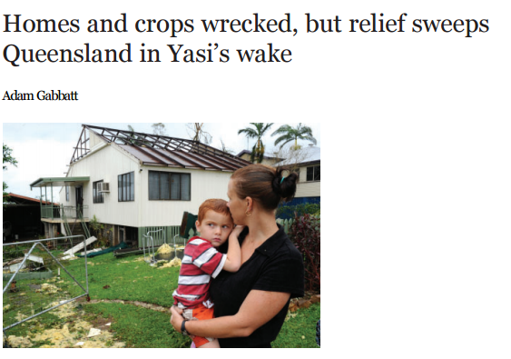

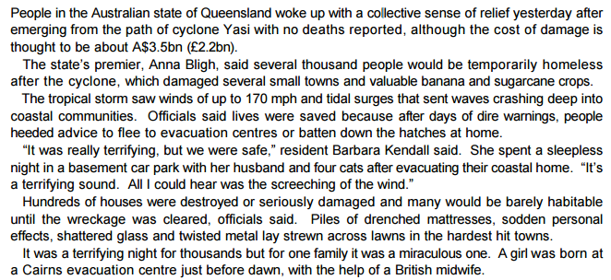

- TASK: Read the following statement and write a speech to your year group on the dangers of climate change.
‘Climate change is nonsense. We’ve been here before with the Ice Age. We’re worrying about nothing.’
Plan all these elements before you write:
Text Type Audience | What and to whom are you writing?
Purpose | Agree or Disagree?
Point 1
Reason 1
Benefit 1
Point 2
Reason 2
Benefit 2
Point 3
Reason 3
Benefit 3
What are the opposing ideas you will challenge?

Jump Start - Use one or more of these to get you started if you can’t think of your own way:
Start with a statistic | Start with a rhetorical question
Our planet is a living thing perfectly capable of dying when neglected. | Imagine living in a continual winter; rain, rain and more rain.
Ever heard of the Ice-Age? Climate change is just scare mongering. | Maybe we should learn from what happened to Noah and his ark?

Some techniques you should try to use if they are appropriate to your writing:
- Rhetorical Questions
- Facts & Statistics – say where the stats are from (eg Department of Education, Chief medical advisor to the Government)
- Direct Address
- Emotive vocabulary
- Rule of 3 – why not try 4?
- Repetition

…………………………………………………………………………………………………………………………………………………………………………………………………………………………………………………………………………………………………………………………………………………………………………………………………………………………………………………………………………………………………………………………………………………………………………………………………………………………………………………………………………………………………………………………………………………………………………………………………………………………………………………………………………………………………………………………………………………………………………………………………………………………………………………………………………………………………………………………………………………………………………………………………………………………………………………………………………………………………………………………………………………………………………………………………………………………………………………………………………………………………………………………………………………………………………………………………………………………………………………………………………………………………………………………………………………………………………………………………………………………………………………………………………………………………………………………………………………………………………………………………………………………………………………………………………………………………………………………………………………………………………………………………………………………………………………………………………………………………………………………………………………………………………………………………………………………………………………………………………………………………………………………………………………………………………………………………………………………………………………………………………………………………………………………………………………………………………………………………………………………………………………………………………………………………………………………………………………………………………………………………………………………………………………………………………………………………………………………………………………………………………………………………………………………………………………………………………………………………………………………………………………………………………………………………………………………………………………………………………………………………………………………………………………………………………………………………………………………………………………………………………………………………………………………………………………………………………………………………………………………………………………………………………………………………………………………………………………………………………………………………………………………………………………………………………………………………………………………………………………………………………………………………………………………………………………………………………………………………………………………………………………………………………………………………………………………………………………………………………………………………………………………………………………………………………………………………………………………………………………………………………………………………………………………………………………………………………………………………………………………………………………………………………………………………………………………………………………………………………………………………………………………………………………………………………………………………………………………………………………………………………………………………………………………………………………………………………………………………………………………………………………………………………………………………………………………………………………………………………………………………………………………………………………………………………………………………………………………………………………………………………………………………………………………………………………………………………………………………………………………………………………………………………………………………………………………………………………………………………………………………………………………………………………………………………………………………………………………………………………………………………………………………………………………………………………………………………………………………………………………………………………………………………………………………………………………………………………………………………………………………………………………………………………………………………………………………………………………………………………………………………………………………………………………………………………………………………………………………………………………………………………………………………………………………………………………………………………………………………………………………………………………………………………………………………………………………………………………………………………………………………………………………………………………………………………………………………………………………………………………………………………………………………………………………………………………………………………………………………………………………………………………………………………………………………………………………………………………………………………………………………………………………………………………………………………………………………………………………………………………………………………………………………………………………………………………………………………………………………………………………………………………………………………………………………………………………………………………………………………………………………………………………………………………………………………………………………………………………………………………………………………………………………………………………………………………………………………………………………………………………………………………………………………………………………………………………………………………………………………………………………3. Don’t forget to proof read & tick off the basics as you do them.
Get the basics right & the rest will follow.
- Tick these when you’ve checked them.
- All my sentences have a capital letter & full stop.
- All my basic spelling is right & I’ve checked ones I don’t know.
- I’ve used a range of punctuation including commas, question marks and speech marks.
- I’ve varied the types of sentence starts and sentence lengths.
- I’ve used paragraphs correctly (change of Time, Topic, Place, Person).
- I’ve read through my work to make sure it makes sense.
- Spellings I’m not sure about:
-
-
-

Task 3 (Writing viewpoints and perspectives):
- Vocabulary: Complete the exercise finding the alternative words for the vocabulary below. The first two have been done for you.
Ambitious word | Alternative word | Ambitious word | Alternative word
pandemic | widespread |  | powerful
adversity | hardship/obstacles | grandiose
visceral |  |  | try
 | succeed | humility
plethora |  |  | discipline

- Read the article on.
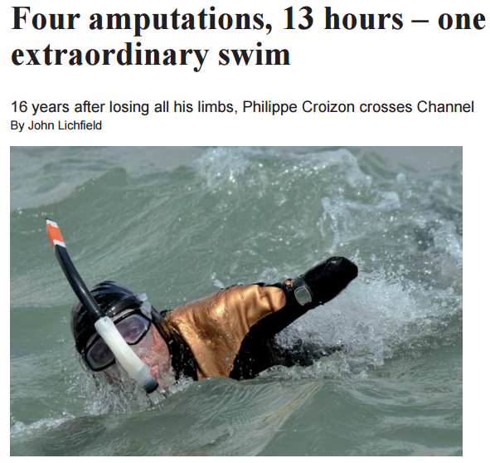
Source: A newspaper article about a quadruple amputee swimming the English Channel.

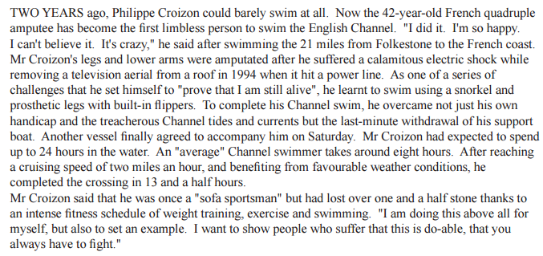

- TASK: Read the following statement and write an article for your school newspaper in which you persuade more students to take part in sports day.
‘Sportsmen are the ultimate humans, pushing themselves to the highest level of pain and endurance.’
Plan all these elements before you write:

Text Type Audience | What and to whom are you writing?
Purpose | Opinion?
Point 1
Reason 1
Benefit 1
Point 2
Reason 2
Benefit 2
Point 3
Reason 3
Benefit 3
What are the opposing ideas you will challenge?

Jump Start - Use one or more of these to get you started if you can’t think of your own way:
Start with a statistic | Start with a rhetorical question
Teenagers these days are lazy layabouts. | Disability is a word that should be banished.
How can you justify not running 100m because of an imaginary pain when…? | Have you ever considered just how lucky you are?

Some techniques you should try to use if they are appropriate to your writing:
- Rhetorical Questions
- Facts & Statistics – say where the stats are from (eg Department of Education, Chief medical advisor to the Government)
- Direct Address
- Emotive vocabulary
- Rule of 3 – why not try 4?
- Repetition

………………………………………………………………………………………………………………………………………………………………………………………………………………………………………………………………………………………………………………………………………………………………………………………………………………………………………………………………………………………………………………………………………………………………………………………………………………………………………………………………………………………………………………………………………………………………………………………………………………………………………………………………………………………………………………………………………………………………………………………………………………………………………………………………………………………………………………………………………………………………………………………………………………………………………………………………………………………………………………………………………………………………………………………………………………………………………………………………………………………………………………………………………………………………………………………………………………………………………………………………………………………………………………………………………………………………………………………………………………………………………………………………………………………………………………………………………………………………………………………………………………………………………………………………………………………………………………………………………………………………………………………………………………………………………………………………………………………………………………………………………………………………………………………………………………………………………………………………………………………………………………………………………………………………………………………………………………………………………………………………………………………………………………………………………………………………………………………………………………………………………………………………………………………………………………………………………………………………………………………………………………………………………………………………………………………………………………………………………………………………………………………………………………………………………………………………………………………………………………………………………………………………………………………………………………………………………………………………………………………………………………………………………………………………………………………………………………………………………………………………………………………………………………………………………………………………………………………………………………………………………………………………………………………………………………………………………………………………………………………………………………………………………………………………………………………………………………………………………………………………………………………………………………………………………………………………………………………………………………………………………………………………………………………………………………………………………………………………………………………………………………………………………………………………………………………………………………………………………………………………………………………………………………………………………………………………………………………………………………………………………………………………………………………………………………………………………………………………………………………………………………………………………………………………………………………………………………………………………………………………………………………………………………………………………………………………………………………………………………………………………………………………………… ………………………………………………………………………………………………………………………………………………………………………………………………………………………………………………………………………………………………………………………………………………………………………………………………………………………………………………………………………………………………………………………………………………………………………………………………………………………………………………………………………………………………………………………………3. Don’t forget to proof read & tick off the basics as you do them.
Get the basics right & the rest will follow.
- Tick these when you’ve checked them.
- All my sentences have a capital letter & full stop.
- All my basic spelling is right & I’ve checked ones I don’t know.
- I’ve used a range of punctuation including commas, question marks and speech marks.
- I’ve varied the types of sentence starts and sentence lengths.
- I’ve used paragraphs correctly (change of Time, Topic, Place, Person).
- I’ve read through my work to make sure it makes sense.
- Spellings I’m not sure about:
-
-
-

