La transición al español para el año 12.

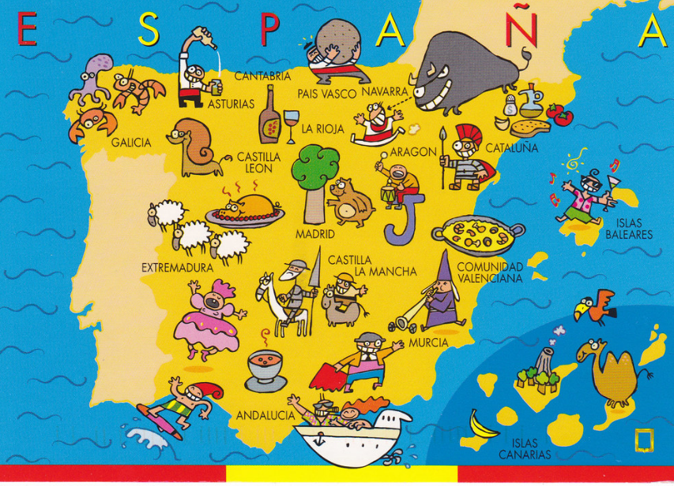

How to prepare for Spanish at A Level
You may be considering taking an A Level in Spanish and this booklet with give you details on how you can prepare for this. The leap from GCSE to A Level is significant. This booklet contains links to a huge range of media, most of which is available for free online as well as tasks to complete before the start of term. In order to keep pace, it is vital that you work through the tasks. Little and often…

Watch…

The news. Click on www.rtve.es/Noticias and then click on Telediario en 4 to watch four minute version of the news. Alternatively you can watch the entire news show which lasts 50 minutes.

MOVIES
Choose one of the following movies to watch over the summer:
- Volver (Pedro Almodóvar, 2006)
- Ocho Apellidos Vascos (Emilio Martínez-Lázaro, 2014)
- El Laberinto del Fauno (Guillermo del Toro, 2006)
- María llena eres de gracia (Joshua Marston, 2004)
- Abel (Diego Luna, 2010
- Las 13 Rosas (Emilio Martínez-Lázaro, 2007)

Read…
Keep your own vocabulary book for new expressions you come across. You could order it alphabetically, by topic area based on what we are going to study or just use it as a diary and scribble away your Spanish development in it.
NEWSPAPERS AND MAGAZINES
Read a foreign language newspaper – El País is available in larger paper shops. El País has its own website http://www.elpais.com/ so that you can read the paper online. You do not have to read the paper cover to cover, just scan the headlines and pick out ONE article that grabs your attention.
Websites
Switch to Spanish browsers such as and http://es.yahoo.com/ or www.yahoo.es as well as www.google.es. This way, you will read Spanish every time you log on and it will become part of your everyday activity.

Look at the www.bbc.com/mundo for BBC reporting in Spanish. Click on Videos for clips and reports in Spanish.
For Daily News:
News.yahoo.com/
www.abc.es
www.terra.es

Go to www.donbalon.com for football website and related articles.

Go to www.hola.com for a Spanish celebrity gossip magazine (note that some content requires subscription). This also has short clips in Spanish.

Websites for research
Once you actually start your A Level in September, you will realise that you are almost completing a Sociology A Level in Spanish. It is fascinating and you will learn all about the history and culture of Spanish speakers across the world, not just in Spain.

If you are searching for information, try switching to the Spanish www.es.wikipedia. Remember that anyone can write on Wikipedia so you
must validate your research elsewhere and never quote from it! It is a good place to start though.

British Council support available from http://schoolsonline.britishcouncil.org/

On-line dictionary
A good on-line dictionary is: http://www.spanishdict.com/
TIP When you look up a verb, click the Conjugation tab to see how the verb is conjugated in EVERY tense.

TOP TIP: Don’t look up every word you are not sure of when reading an article/ book

Yes… you read that right. When you are reading articles etc, try not to look up every word as it will take you forever. Skim and scan the text to get the gist. Remember to use the context or the article, cognates and common sense to figure out what the article is saying. Pick out a couple of words that you like the look of, that you feel may be real hurdles to getting the idea of the text, look them up carefully and add them to your vocab booklet. The aim at this stage is to get the gist of the article, not be able to translate it completely. Translation is a whole different ball game and you will learn it soon enough.

You will be surprised how much more enjoyable reading will be if you really pay attention to this tip.

What should I know by now?

This is a common question asked by students about to start their A level. You should be able to:

TOPIC | CONTENT
Recognise and use a range of tenses with regular verbs. | Regular –AR, -ER and -IR verbs:  Tenses: Present  Preterite  Imperfect  Near Future (form of ir + infinitive) Future (eg. Será)  Conditional (eg. sería)
Recognise and use a range of tenses with irregular verbs. | Common irregular verbs: ser, estar, ir, tener, hacer  Tenses: Present  Preterite  Imperfect  Near Future (form of ir + infinitive) Future (eg. Será)  Conditional (eg. sería)
Give opinions with reasons | • A range of opinion expressions  • Positive and negative reasons for opinions  • To be able to agree and disagree

Links to Grammar Practice Exercises •
- Languages on line: The Grammar Revision resources on
www.languagesonline.org.uk are great as you can then select what tense you want to revise, read the explanations and complete the exercises. You can do these as often as you like and it gives you a percentage. Another useful tactic is to translate the examples and exercises into English to ensure you understand the meaning of each tense.h some of the AS Resources.
• Conjuguemos: a great website for practicing your verb conjugations. Find it here: https://conjuguemos.com/k here to access the Spanish verb exercises.

Tasks
Complete the task log, or make your own one up but you will need to go through it with your Spanish teacher in September so make sure that it is clear and useful to you.
When you look at a website/ link on here, highlight it and note the date and what you thought about it. You can then put a couple of notes in your task log.

1. Create a Memrise account – your name or something that is very recognisable as you. You should aim to achieve 100,000 points by the first lesson – prizes for those who achieve it! You could start by joining the A-level group. Log into Memrise using your new log in and then click on: https://www.memrise.com/group/352141/ to join the group.

2. Summarise, in Spanish, 2 articles (that were in Spanish!) that you have read from one of the websites/ papers above and say why they interested you. If you cannot print the article, make a note of the website. Try and make these related to one of the topics we will study (listed below).

▪ Aspects of Hispanic Society: Modern and traditional values (changes in family, marriage and divorce, influence of the Catholic Church); Cyberspace (influence of the internet, risks and benefits of the internet, smart technology in our society); Equal rights (women at work, Machismo and feminism, LGBT rights)
▪ Multiculturalism in Hispanic Society: Immigration; Racism; Integration
▪ Artistic Culture in the Hispanic World: Modern Day Idols; Spanish regional identity; Cultural Heritage

3. Translate the blurb for Volver before watching it. Bring this along with you on paper to your first lesson:

Volver es la premiada película de 2006 sobre dos hermanas y su viaje para descubrir su pasado tras la muerte prematura de sus padres. La película era la obra cinematográfica número 16 del director español Pedro Almodóvar, y cuenta con un buen número de grandes actrices españolas como Penélope Cruz y Carmen Maura.
La película está ambientada en la región de La Mancha en España, donde nació almodóvar, y trata temas como la muerte, la soledad y la tradición. Aunque menos desmesurada que algunas de las obras anteriores de Almodóvar, Volver contiene varios de sus marcas de estilo cinematográficas: farsa, comedia, tragedia, melodrama, y realismo mágico.

4. Choose a Hispanic country and prepare a short presentation on an aspect of culture – this should last no longer than 5 mins. You can create a PPT if you want, but try and use headings rather than too much prose on the slide. This will be good practice for your IRP (Independent Research Project).

5. Look out for any items in the English or Spanish media relating to topics we will study – as above so that you have points to make in a discussion and opinions to give.

6. Go onto www.languagesonline.org.uk . Complete 10 exercises. Each exercise takes less than 5 minutes. Note down the exercise you did and your score.

7. Complete the grammar review (Appendix 1) so that you can target any areas you feel weak on and feel good about the areas you know.

8. Complete the tense worksheet (Appendix 2) to practice your tenses.

9. Read through the AQA A-Level Spanish course overview so that you have an idea of what we will be studying. This will also help you with task 4 above.

10. If you find any other websites/ links/ twitter feeds that you think are worth sharing, note them down too.

11. Each time you pass a second hand shop, pop in and see whether they have any large dictionaries or any Spanish books – either fiction or grammar. You can find old Spanish dictionaries worth £35 on sale for less than £5!

Task Log

Date | Website / source | Comments

Appendix 1: Grammar self-assessment

 |  | I DO NOT KNOW | NEED TO LEARN | QUITE CONFIDENT | FULLY  CONFIDENT
 | Nouns: gender, singular and plural forms
 | Articles: definite (el, la...), indefinite (un, una)
 | Adjectives: agreements (fem, pl...)
 | Position/word order
 | comparative and superlative (más, menos, el más.)
 | comparative and superlative irregular (mejor...)
 | indefinite (cada, algunos, algunas)
 | possessive (mi ti...)
 | interrogative (¿qué?, ¿cuál?, ¿cuáles?...)
 | Adverbs: comparative and superlative
 | interrogative (¿cómo? ¿cuándo?)
 | Quantifiers/intensifiers (muy, bastante...)
 | Pronouns: Subject (yo, tú...)
 | object: direct and indirect (lo, las, les...)
 | position and order (te veo)
 | reflexive (me, te...)
 | relative ( que,)
 | relative: lo que, la que (R)
 | object: direct and indirect
 | indefinite (alguien)
 | possessive (el mío, la mía...) (R)
 | interrogative (¿Quién? ¿quiénes?)
 | interrogative (¿qué?) (R)
 | Verbs: modes of address (tú, vosotros, usted)
 | verbs + infinitive
 | verbs + infinitive + preposition
 | Verbs + - me gusta/me interesa etc
 | Verbs + de ( acabo de)
 | negatives (no, nunca, jamás...)
 | Present (regular)
 | Present (irregular)
 | Perfect
 | Perfect with reflexives
 | Imperfect
 | Near Future (voy a + infinitive)
 | Future
 | Conditional
 | Future perfect (habrá hecho...) (R)
 | Conditional perfect (habría salido...) (R)
 | Pluperfect (había llegado..)
 | Present participle (comiendo...)
 | Subjunctive mood (how to form it)
 | Subjunctive mood (which expressions trigger it?)

My notes/comments

 |  | I DO NOT | NEED TO LEARN | QUITE CONFIDENT | FULLY  CONFIDENT
 | Indirect speech
 | Inversion after speech (R)
 | Prepositions: a/al/ a la...
 | with countries, towns, places
 | with month, dates, time
 | Desde hace, acabar de
 | Number, quantity and time
 | Conjunctions

REFERENCES: Internet

My notes/comments

www.languagesonline.org.uk http://www.languagesresources.co.uk/SpanishALGrammar.html

Reference books
Palabra por palabra
Practice in Spanish grammar

(R) recognise only
general site with an A Level section & GCSE revision (grammar very good) good site for grammar

Hodder
Nelson Thomas
Appendix 2: Grammar workout

Ejercicio 1
- Cuando llegué a casa, mi prima había _______ .
a) salir b) salido c) saliendo d) salía
- ¡Qué tiempo maravilloso! ¡Está ______ !
a) nevar b) nevando c) nevado d) nevó
- ¿Qué quiere ________ este niño?
a) dice b) decir c) diciendo d) dicho
- Álvaro, ¿cuándo vas a ______ el ruido?
a) terminar b) terminando c) terminas d) terminado
- No quiero ______ porque está lloviendo.
a) salgo b) salir c) saliendo d) sale
- ¿Quién ha ______ el premio?
a) ganado b) ganando c) gana d) ganó
- Este profesor me habla como si ______ un niño.
a) soy b) fuera c) fui d) fue
- Sí, sí. Yo he _____ con ella.
a) hablando b) hablado c) hablo d) hablé
- Yo se lo explicada a Juan para que lo _______ .
a) comprender b) comprende c) comprenderá d) comprendiera
- ¡Ojalá que ______ los niños mañana!
a) vienen b) vendrán c) vengan d) vendrían
Ejercicio 2: Change the following Present tense verbs into the Preterit.
- (Yo) hablo = _______________________
- (Yo) voy a casa = ____________________
- María y José comen = _________________
- (Yo) oigo la música = _________________
- El perro muerde = _________________
- Juana juega = ___________________
- (Ellos) piensan = _________________
- (Yo) estoy en casa = ________________
- Cristiana viene = __________________
- (Tú) tocas el piano =_________________

Ejercicio 3
Find the meanings of the following verbs.
- pedir = ______________
- gozar de algo = ______________
- fiarse de alguien = _______________
- quejarse de = _________________
- tropezar con = _______________
- carecer de = ________________
- rebajar = ________________
- acrecer = ________________
- denegar = _________________
- concebir = ________________

Ejercicio 4
Change the verbs from the Future Tense into the Conditional Tense.
- (Tú) beberás = _________________
- (Yo) me lavaré = ________________
- (Ellos) pondrán = ________________
- (Ud.) tendrá = __________________
- María querrá = _________________
- (Yo) estudiaré = _________________
- Los chicos comerán = ______________
- (Nosotros) seremos = _______________
- Alfonso leerá = ___________________
- (Ella) cantará = __________________

Ejercico 5:
Change the verbs in the following sentences to the Present Continuous.
- El hombre vende manzanas en el parquet.
_____________________________________________
- Corremos a la parada de autobuses.
_____________________________________________
- Yo leo el libro de inglés.
_____________________________________________
- ¿Regresas a casa?
_____________________________________________
- ¿Quién bebe gaseosa en el jardín?
_____________________________________________

Ejercicio: 6
Make the adjectives in the following agree with the noun…

- La hermana de Enrique es muy __________ . (simpático)
- Hay un estanque _________ en el Retiro. (famoso)
- El profesor tiene muchos amigos _________ . (inglés)
- Compramos manzanas en un puesto ________. (azul)
- Estamos estudiando unos libros muy ________ . (fácil)
- El padre de Manuel tiene árboles ________ en el jardín. (espléndido)
- Hay ______ botella de gaseosa en la sala. (otro)
- La madre de Mercedes compra flores _______ en la calle. (bonito)

What I need to revise

______________________________________________________________________________________

______________________________________________________________________________________

