Year 11
Bridging the Gap to Post 16
Home Learning Booklet

Summer Half-Term 1
(Monday 20th April to Friday 22nd May 2020)

Dear Students and Parents,
To support students to continue their learning at home over the next half-term, we have put together this ‘Home Learning’ booklet with more detailed and specific work/suggested courses for them to complete. Fundamentally, maintaining important learning routines is essential for students’ future success. For this reason, it is really important that students engage with work/courses that interest and inspire them and will give them an advantage over peers when commencing their next stage in education….be it A-levels, Vocational courses or Apprenticeships. This is an excellent opportunity for students to try out different courses and build on their essential skills set. There is also a Careers Advice section and College Correspondence which I’m sure you’ll find useful.
Each week, all Year 11 students should follow the Home Learning Timetable below to maximise their learning and keep a structured routine to their days whilst school is closed:
 | Monday | Tuesday |  | Wednesday | Thursday |  | Friday
Session 1  9.00am - 9.30am | Reading | Reading |  | Reading | Reading |  | Reading
Session 2  9.30am - 10.30am | A-level subject/ Vocational course prep. | Get inspired and learn something new |  | Functional Skills | Get inspired and learn something new |  | Life Skills
10.30am – 11.00am
BREAK
Session 3  11.00am - 12.00pm | Life Skills | A-level subject/ Vocational course prep. |  | Wellbeing | Life Skills |  | Get inspired and learn something new
12.00pm – 1.00pm
LUNCH
Session 4  1.00pm - 2.00pm | Get inspired and learn something new | Life Skills | A-level subject/ Vocational course prep. |  | Wellbeing | Functional Skills
2.00pm – 2.30pm
BREAK
Session 5  2.30pm - 3.30pm | Functional Skills | Wellbeing | Workout with Joe Wicks |  | A-level subject/ Vocational course prep. | Workout with Joe Wicks

Session 1 EVERY morning is dedicated to ‘Reading’.
You can choose from the following:
- Read a book you have at home – maybe one you bought on the Waterstone’s visit.
- Read an e-book using the ‘BorrowBox’ app [see login info section for details]
- For more information and support, please visit our ‘Home Reading’ section of the school website: https://www.newallgreenhigh.manchester.sch.uk/student-life/home-learning/school-closure-home-reading

‘A-level subject/Vocational course prep’
- MyTutor Online School:
Year 11 Students - Free Online Tuition
MyTutor Online School are offering free daily tutorials via the following link https://m.mytutor.co.uk/online-school/?dm_i=5PMK,W3T,4UMAF,328I,1
They will be sharing daily lunchtime live group webinar tutorials, as well as short explainer videos and written resources, covering common tricky topics across a range of GCSE subjects.
These are all completely free - students just need to register using the link above and join via Zoom video link.
The planned programme over coming weeks spans Maths, English, Physics, Chemistry and Biology topics, from how to analyse poem structure to understanding chemical bonds. This week, we’ll have 13 group tutorials, including daily Maths and Physics sessions.

- Maths
- For Pre A-Level Transition Course go to:
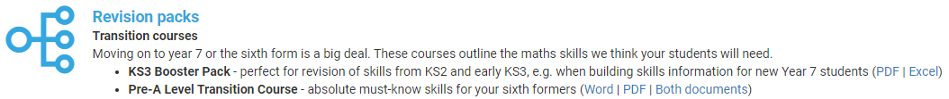
https://hegartymaths.com/help-resources

- Maths Question booklet: link on main website – NGHS School Closure.

- Spanish
Want to prepare for Spanish at A-Level?
- Check out the Spanish transition booklet: link on main website – NGHS School Closure.
Included are:
- Details of what movies to watch
- Details of what to read
- Links to useful websites
- Links to Grammar practice exercises

- Geography
Hoping to study Geography at A level? Or interested in just furthering your knowledge of Geography post the GCSEs?

- There are a number of things you can do:
- Developing as a geographer - Through general reading around/ watching videos/listening to podcasts etc the geography subject to develop your geography knowledge and understanding.
- Become a News Buff - Watch the news- BBC news between 6am-9am or at 6pm. Or get on the BBC news app? Other websites such as the Guardian, The Independent, The Times. Create a Geography in the News Diary of all things that are relevant to what you are studying / have studied?
- Preparing for the A Level Course - Starting to explore the topics and their foundations which will be studied in the A Level Course.
- Bridging the GCSE to A Level Geography Gap Booklet: link on main website – NGHS School Closure.

- Science
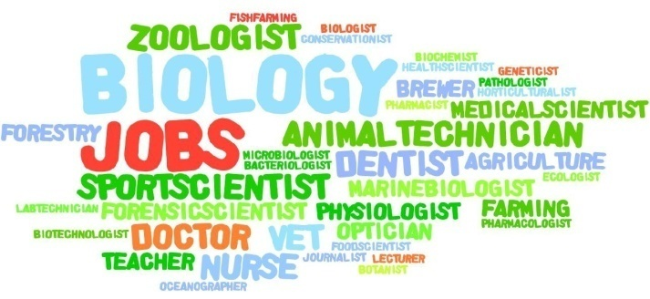
Hoping to pursue a career in Science or Engineering? Check out the following resources all on the main website – NGHS School Closure.
- A career for you in the NHS
- Vocational and Apprenticeships
- Engineering careers
- Jobs in STEM
- 10 reasons to become a Scientist or Engineer
- Science Career Wordies

- English
Want to prepare for English at A-Level? Check out the English transition booklet: link on main website – NGHS School Closure. Weekly tasks include:
- Research
- Reading a text/article
- Comprehension
- Extended Writing

- History
Useful resources on ‘War and Welfare’ and ‘Tsarist and Communist Russia’.
Link on main website – NGHS School Closure.
‘Life skills’
- Go to https://barclayslifeskills.com/young-people/ and sign up for free!
How LifeSkills can support you right now:

- The Covid-19 (‘coronavirus’) situation is understandably creating a lot of uncertainty. Despite the challenges we’re all facing, it’s important to use this time to keep building your skills, and there are lots things you can still do to be prepared for the future.
- Are you ready to think about the areas you might like to develop in further? Spin the Wheel of Strengths and reflect on not only your skills, but your interests and personality traits, and how to develop them further to support your future.
- LifeSkills helps you prepare for the future workplace
- Interactive tools, films and activities available will help you smarten up your CV; enhance listening and problem solving skills; help you building confidence and assertiveness plus loads more!
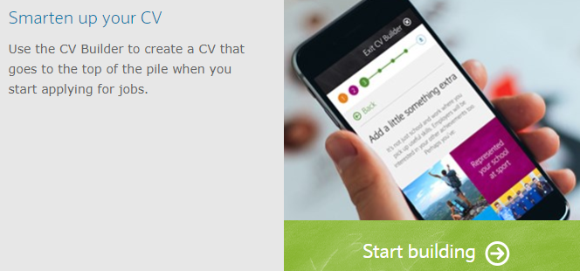

- Go to https://www.open.edu/openlearn/for-life
You will need to sign up by creating an account at https://www.open.edu/openlearn/ and then simply choose a course that suits you from:
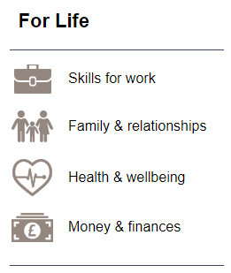
‘Get inspired and learn something new’
- OpenLearn has over 1000 free courses to choose from, you can brush up on your Spanish skills or learn a new language or perhaps you’d like to explore Forensic psychology?
Below are a few of the free courses you can complete (there are lots more to choose from!)
There are eight subject categories for you to explore containing thousands of free resources:
- Money and Business
- Education and Development
- Health, Sports and Psychology
- History and The Arts
- Languages
- Nature and Environment
- Science, Maths and Technology
- Society, Politics and Law
Go to https://www.open.edu/openlearn/subject-information to get inspired!
You will need to sign up by creating an account…go to https://www.open.edu/openlearn/

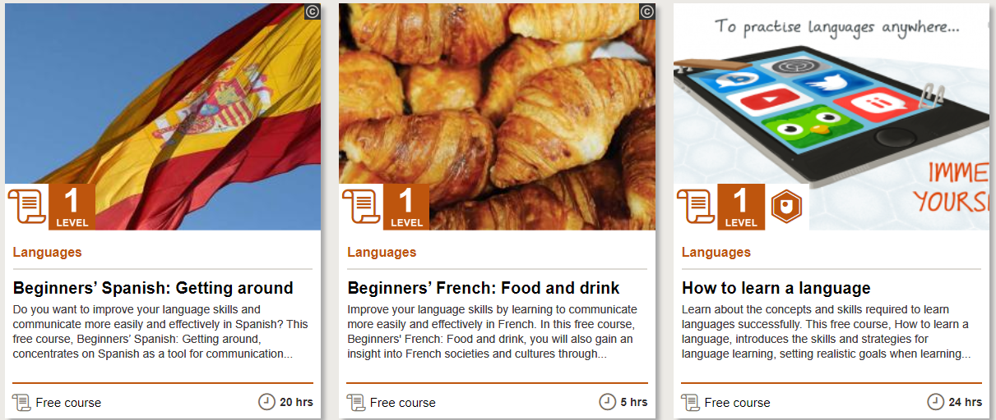

- You can also sign up to the British Sign Language course at www.british-sign.co.uk for £3. Or, search up the Exeter Deaf Academy on YouTube and watch some of their tutorial videos.

‘Functional skills’.
- BT Personal Skills Journey – Key skills training booklet: link on main website – NGHS School Closure. Exercises include:
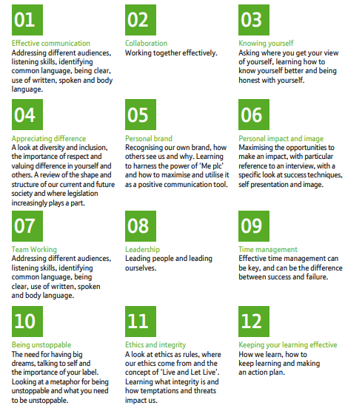

- https://www.youthemployment.org.uk/free-skills-careers-activities-booklet-for-young-people/
- OpenLearn has numerous Functional skills courses you can complete to get you work ready. Go to https://www.open.edu/openlearn/subject-information to get started!
You will need to sign up by creating an account…go to https://www.open.edu/openlearn/
Careers Advice
Just because we’re not in school, we’re still here for you!

A message from Emma Lees:

Due to the current situation, here is some information to support your next steps and decision making.
Please text or email me if you would like to chat on the phone and we can sort a time to do this……No matter how big or small your query is, I am here to help with this….

Emma Lees - Careers Adviser:
emma@empowergs.co.uk
077643 55536

I also have a Twitter account which I will be posting things on….
My Twitter name is emma@empowerguidance

Apprenticeships:
https://successatschool.org/advice/20
www.findapprenticeship.service.gov.uk
You can search for Apprenticeships and once you are registered you can apply.

Training and Work:
https://nationalcareersservice.direct.gov.uk
This provides information, advice and guidance to help you make decisions on learning, training and work.
A great feature of this website is the JOB PROFILES which enable you to find out more about the career you are thinking of.

Students who have applied or are planning on applying should contact College for advice.
Some of your local Colleges and Sixth Forms include;

Trafford College www.trafford.ac.uk 0161 886 7070
Manchester College www.mc.ac.uk 03333 222 444
Stockport College www.stockport.ac.uk 0161 296 5000
Salford College www.salfordcc.ac.uk 0161 631 5000
Cheadle College www.cmcnet.ac.uk 0161 486 4602
Access Creative College www.accesscreative.ac.uk 0800 28 18 42
Loreto College www.loreto.ac.uk 0161 226 5156
Xaverian College www.xaverian.ac.uk 0161 224 1781
Aquinas College www.aquinas.ac.uk 0161 483 3237
Connell College www.connell.ac.uk 0161 231 9200

Other Useful Websites for Careers Advice
There are a great many additional websites that offer valuable careers information:

https://nationalcareersservice.direct.gov.uk/ - this is the official government site and offers information on a wide range of careers, job roles and CV writing. There are a number of career tools that support choices about future routes.
https://www.gov.uk/education/apprenticeships-traineeships-and-internships/ – offers information about different apprenticeships and provides details of current vacancies.
http://theapprenticeshiphub.co.uk/apprenticeship-vacancies/ - the Greater Manchester Apprenticeship Hub brings together partners from across the city region, working together to increase the scale, breadth and quality of Apprenticeships in Greater Manchester.
https:/www.careersbox.co.uk - students can watch videos and films about a variety of jobs.
http://www.healthcareers.nhs.uk - Information on the wide range of careers within the NHS.
http://www.ucas.com – offers advice on course choices and options after doing GCSE’s. In addition, students can start thinking about universities and course entry requirements
http://www.icould.com - icould is an online charity providing career ideas and information for young people.
https://icould.com/buzz-quiz/?buzz_page=0 - take the Buzz Quiz
https://www.icanbea.org.uk/career-o-meter/ - The LMI for All project provides a tool which can be used to explore and compare key information about occupations to support the process of identifying potential careers. This tool helps you to compare national average wages and working hours for up to three occupations.

College Correspondence

Trafford College

Current Year 11 Pupils

We understand the uncertainty you must be feeling at this time around your future education options.

I would like to take this opportunity to reassure you that Trafford College has a large range of academic and vocational study programmes for all levels and abilities, and that if you haven’t yet heard from us we will be in touch shortly to make you an offer for a place of study at the college.
We will contact you about arrangements of enrolment over the summer and in the meantime you can also keep up to date with college news on our website, twitter, instagram and Facebook pages.

I look forward to welcoming you as a student in the future. I wish you and your family well at this time, and please remember to stay safe.

Lesley Davies OBE
Principal and Chief Executive

Loreto College
I am contacting you with an update as to how Loreto College will be supporting your year 11 students in the months ahead.
Each student has been contacted individually and been reassured that their offer of a place at Loreto is still available to them and secure.
We will be contacting students again after Easter to offer ideas and suggestions as to how they can best prepare to become a Loreto student.
Each subject area at Loreto has created a series of exciting and inspiring activities to enable all students to have an increased confidence in their subject area and engage with subject content and wider reading ahead of the new academic year.
At enrolment each student will receive personalised information, advice and guidance regarding their course choices, from a highly experienced enrolment team.
We are very much looking forward to supporting your students over the coming months and welcoming them to Loreto in August.
Should you have any further queries, do not hesitate to use the contact us function on the website or email office@loreto.ac.uk

Yours sincerely

Mrs A Pritchard
Deputy Principal
Admissions Manager

Login Information

- Hegarty Maths
www.hegartymaths.com
You will need to enter:
- School name
- Your first name
- Your surname
- Your date of birth
- Your own personal password set by you

- Borrow Box
Parents can also access the free Borrowbox service which is available online from your local library. It is a wonderful way of reading online and there are a huge number of ebooks and eAudiobooks for free accessible from a mobile phone or ipad.
1) Click on the link below to gain a temporary membership to Manchester City Council Libraries
https://manchester.spydus.co.uk/cgi-bin/spydus.exe/MSGTRN/wPAC/JOIN
It will give you a number which starts with UNREG.
2)Download the Borrowbox app on your mobile or device
https://www.borrowbox.com/
Log in using UNREG and the number and your pin (first 4 numbers of your date of birth eg2806)
There are more details about Home Reading and how to access reading materials on the School Closure Home Reading page.

Workout with Joe Wicks
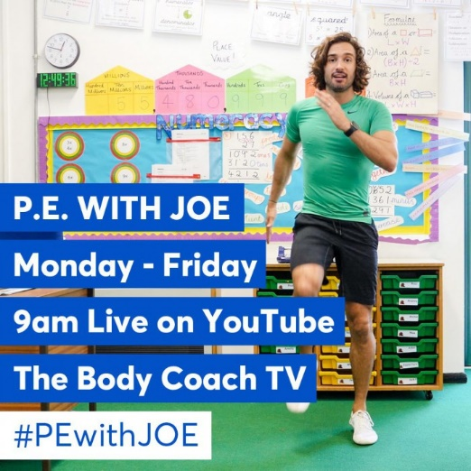
Every weekday, Joe Wicks aka The Body Coach is doing a
live PE workout session for 30 minutes.

Search for ‘The Body Coach TV’ on YouTube and you’ll see
a range of workout videos that you can follow. Join in the
fun and stay fit whilst you’re not in school!

Wellbeing/Mindfulness activities
Week | Tasks | What to do… | Done?
1  (w/b 20th April) | 1 | - Download the Calm app for free.  Sleep more. Stress less. Live better.  Activities include guided meditations and other practices to help relieve stress and anxiety.
 | 2 | - Talk or write about a time when you had to do something difficult and you got through it. Explore how you felt beforehand and how you overcame the challenge. Think about which character strengths you used to help you.
 | 3 | - Make a playlist of your favourite feel-good music. Keep adding to the playlist every day as you think or more music that makes you feel happy. Spend some time listening to these happy tunes.
2  (w/b 27th April) | 1 | - Think about someone you haven’t seen or spoken to in a while. It could be a friend or family member. Make contact with them through phone, text, What’s app, Skype etc to connect with them. Talk about what you both have been doing whilst at home. Talk about happy memories. Tell each other a joke.
 | 2 | - Watch your favourite film with a family member. Talk about the characters and the strengths you spot in them.
 | 3 | - Make a list of seven kind things you can do for someone else. This could be for people you live with (e.g. do the dishes, tidy your room, read with your brother or sister) or people you aren’t getting to see at the moment (send someone a compliment by text, draw a picture and send a picture of it to your grandparents etc). Each day, do one of the seven kind things from your list.
3  (w/b 4th May) | 1 | - Go for a 30 minute walk to get some fresh air and exercise. Remember to keep practising social distancing and stay 2 metres apart from others.
 | 2 | - Play a board game or do a jigsaw. If you haven’t got any at home, go to www.thejigsawpuzzles.com or www.helpfulgames.com for some online versions.
 | 3 | - Sign up to the British Sign Language course at www.british-sign.co.uk for £3. Or, search up the Exeter Deaf Academy on YouTube and watch some of their tutorial videos.
4  (w/b 11th May) | 1 | - Try a beginner’s yoga session at home using a YouTube video.
 | 2 | - Write a ‘bucket list’ of ten things you look forward to doing when Coronavirus is gone and we can all socialise and go out again.
 | 3 | - Learn a new language using YouTube videos. Try to learn how to say: hello, goodbye, how are you?, my name is, what time is it?, I live in…, my favourite colour is…
5  (w/b 18th May) | 1 | - Clean the inside and wash the outside of your family car. Or, find something else to clean. You could even have a bit of a clear out in your bedroom – sort your drawers out, tidy your wardrobe etc.
 | 2 | - Do a crossword or a word search. There are some at the back of this booklet, or you could find some online. Have a look at www.wordgames.com or www.kidspuzzlesandgames.co.uk
 | 3 | - Get out some old photo albums or look through photographs on your phone or computer. Could you make a scrapbook of the last 12 months?

Word Searches

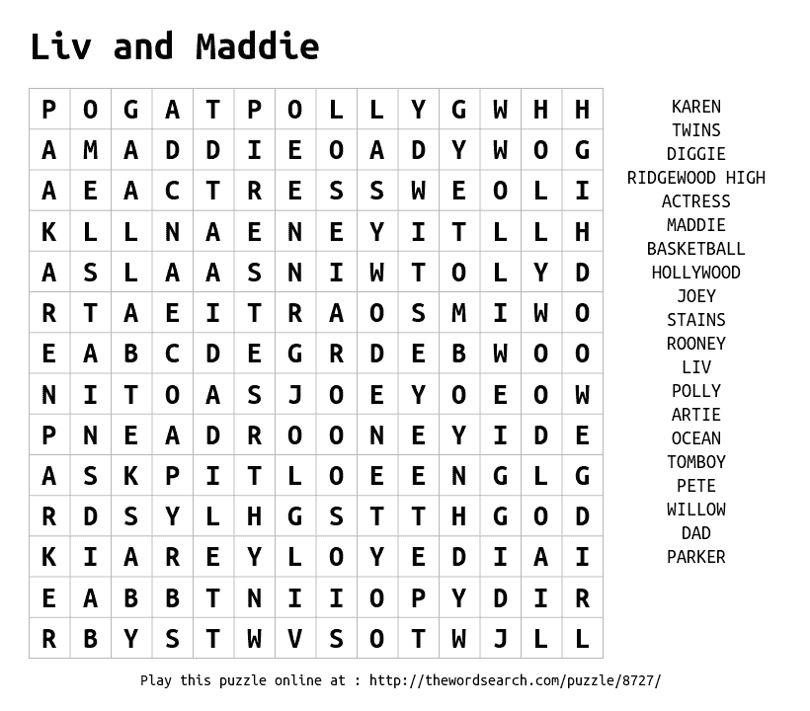

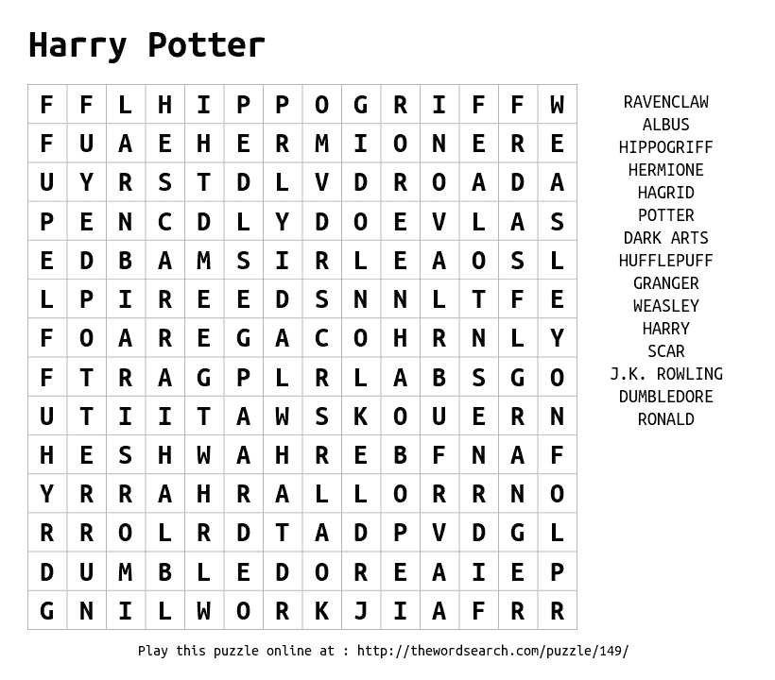

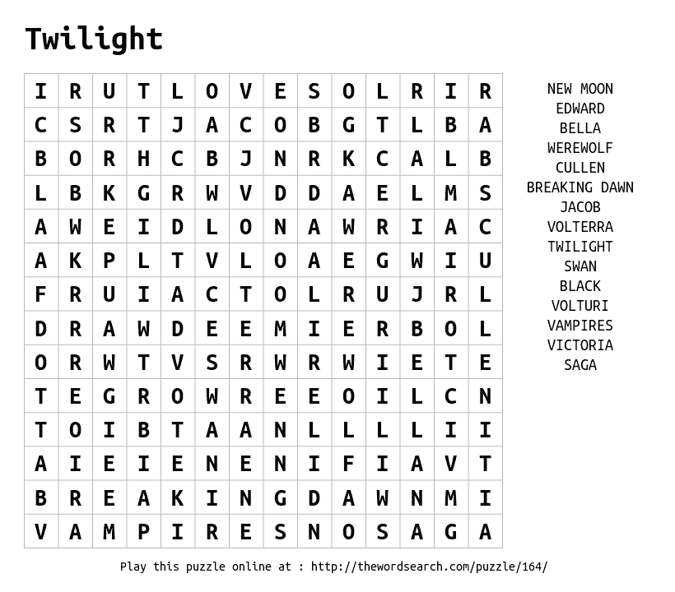

Crosswords

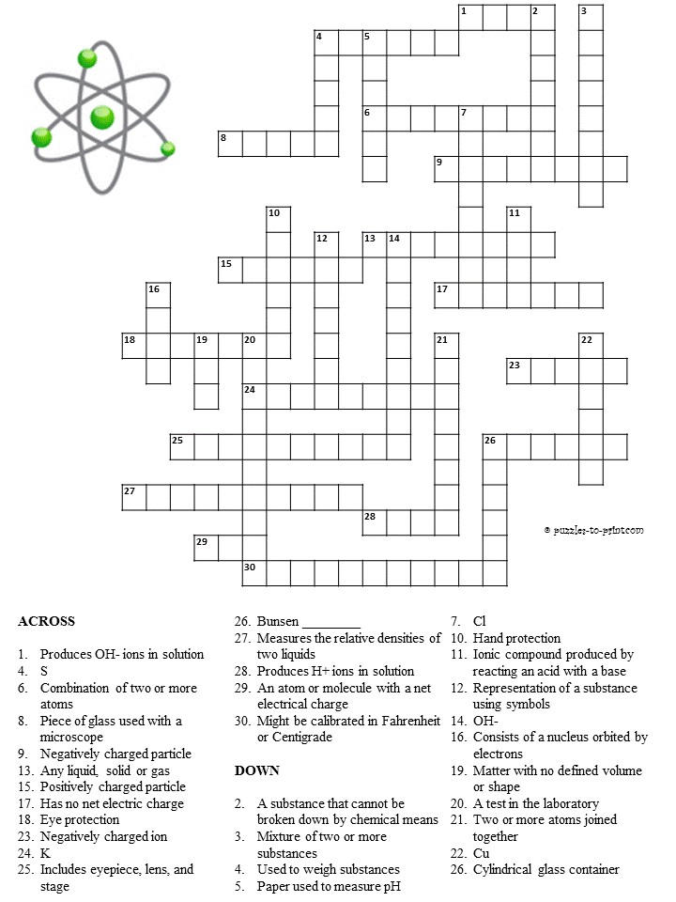
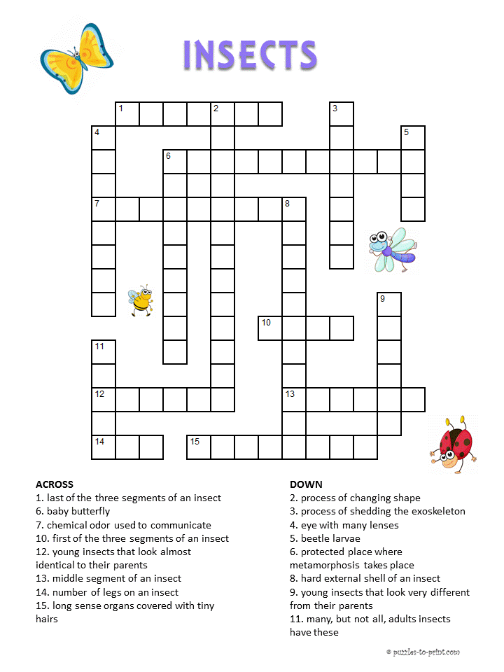

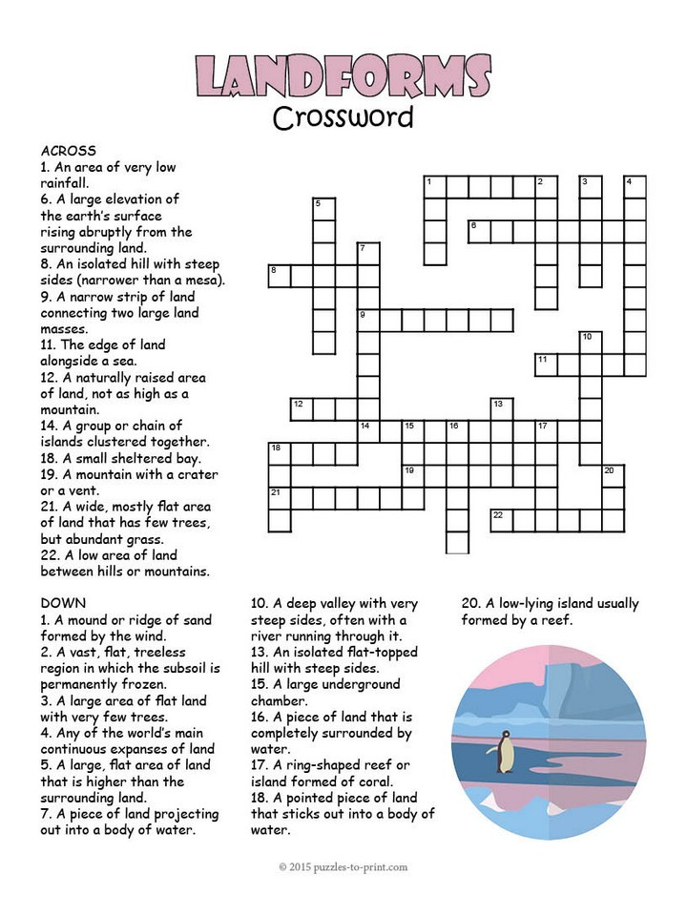

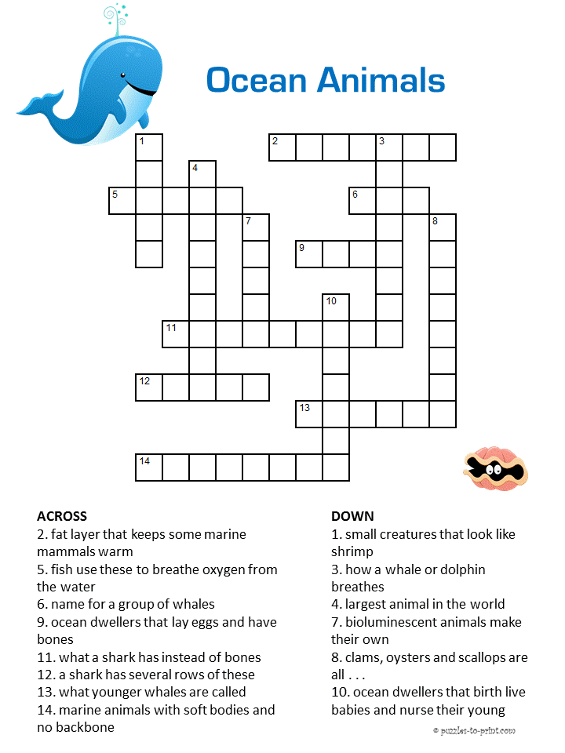

Colouring

