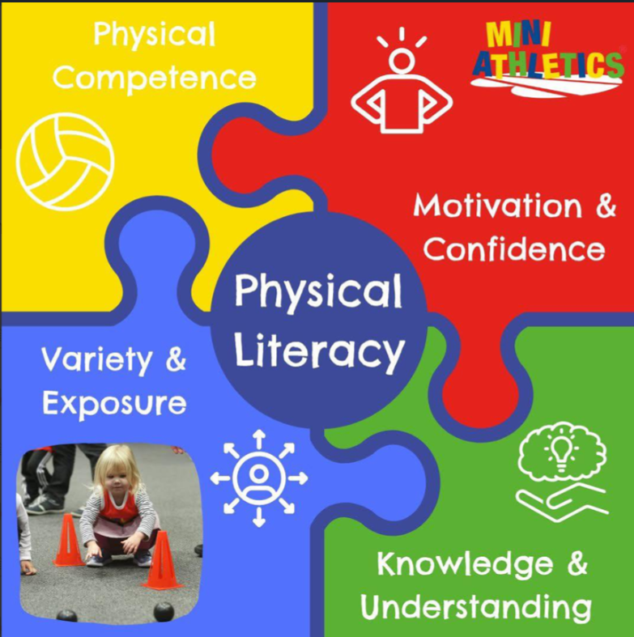

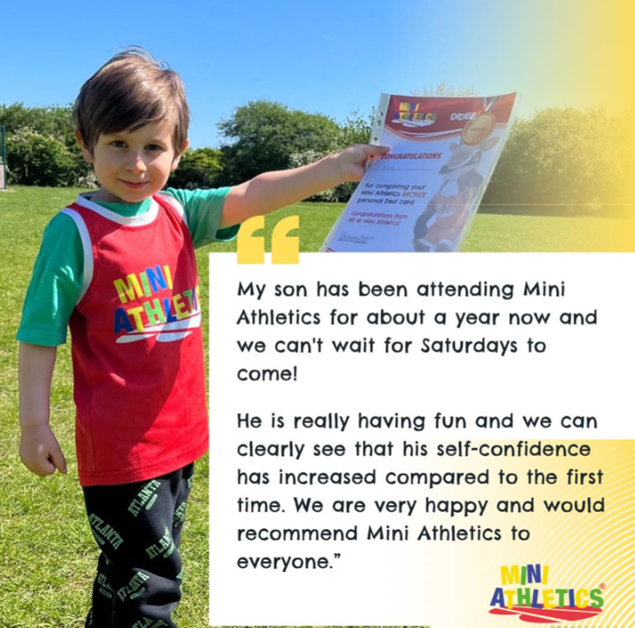

<https://www.miniathletics.com/find-a-class/?q=Bath> For bookings