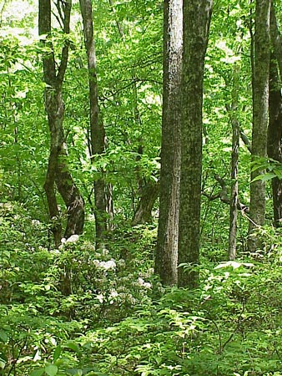

Dear Parents/Carers

RE: YEAR 5 FOREST SCHOOL CLUB

Year 5 Forest School (FS) club will take place on Tuesdays throughout Terms 5&6.

Due to the nature of the activities, the children will need:
- Long sleeved top and trousers - there are lots of brambles and nettles about (these items of clothing may get very dirty – please only send play clothes). Please ensure the clothing is thick enough to prevent scratches/stings
- A waterproof coat and trousers – we go out in all weathers apart from exceedingly high winds and/or lightning. Please send waterproof trousers for all sessions
- Footwear- Wellies are good for wet and mud but definitely not warm so please send extra socks in cold weather (children can wear other appropriate play shoes in dry weather)
- Sun hat if warm and sunny

Please contact me via email, copying the completed slip below by Friday 21st April, if you wish to book your child on to Forest School club. I will email confirmation. Contact details: valair1@hotmail.com

The cost is £8.00 per session running from 3.15pm – 5:00pm (8 sessions in total - £ 64.00 Please note that there is no club session on Tuesday 6th June) with a snack provided. The first session will be on Tuesday 2nd May and the last on Tuesday 4th July. All sessions will take place outdoors in the Conservation Area.

Mrs Sarah Webb
Forest School Leader
07825 610145

If your child would like to participate in Forest School, please email this slip to valair1@hotmail.com along with payment, preferably via BACS: Mrs S V Webb, Account No. 11051187 Sort: 08 92 86. Please ensure payment is made by the week beginning 24th April 2023.

Child’s name: Class:

Parent Email address: _______________________________________________

Medical and/or Dietary needs: ______________________________________________________

Emergency Contact Numbers: 1)___________________________2)_______________________

Is your child making their own way home? Yes/No

Signed_______________________________________ (Parent/Carer)

Thank you very much for your continued support of Forest School.

