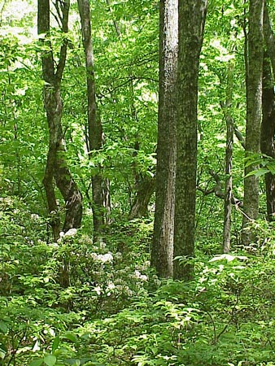

Dear Parents/Carers

RE: YEAR 6 FOREST SCHOOL CLUB

Year 6 Forest School (FS) club will take place on Wednesdays throughout Terms 5&6.

Due to the nature of the activities, the children will need:
- Long sleeved top and trousers - there are lots of brambles and nettles about (these items of clothing may get very dirty – please only send play clothes
- A waterproof coat and trousers – we go out in all weathers apart from exceedingly high winds and/or lightning. Waterproof trousers to all sessions please – there will be mud!
- Wellies/sturdy outdoor shoes – trainers are fine in dry conditions

Please contact me via email, copying the completed slip below by Wednesday 28th April, if you wish to book your child on to Forest School club. I will email confirmation. Contact details: valair1@hotmail.com

The cost is £6.50 per session running from 3.15pm – 5:00pm (8 sessions in total - £52.00) with snacks provided. The first session will be on Wednesday 5th May and the last on Wednesday 30th June. All sessions will take place outdoors in the Conservation Area.
Please note: Should the club be cancelled due to bad weather, I will contact the parents on the morning of the club.

Mrs Sarah Webb
Forest School Leader
07825 610145

If your child would like to participate in Forest School, please email this slip to valair1@hotmail.com along with payment, preferably via BACS: Mrs S V Webb, Account No. 11051187 Sort: 08 92 86. If unable to pay via BACs, then please send cash or a cheque payable to Mrs S V Webb. Please ensure payment is made by the week beginning 3rd May 2021.

Child’s name: Class:

Parent Email address: _______________________________________________

Medical and/or Dietary needs: ______________________________________________________

Emergency Contact Numbers: 1)___________________________2)_______________________

Is your child making their own way home? Yes/No

Signed_______________________________________ (Parent/Carer)

