

Newbridge

Primary School

Play Policy

Author: Play Team
Date written: November 2024
Reviewed: April 2026

- Commitment

Newbridge Primary School undertakes to refer to this play policy in all decisions that affect children’s play. Our school is committed to providing the strategic and operational leadership needed to provide and maintain quality play provision for all of our children.

- Rationale
Newbridge Primary School believes that all children need opportunities to play that allow them to explore, manipulate, experience and affect their environment. We believe play provision should be welcoming and accessible to every child, irrespective of gender, sexual orientation, economic or social circumstances, ethnic or cultural background or origin, or individual abilities.
Pupils play as part of the Early Years Curriculum and active learning is encouraged throughout the school. Play is essential for children’s development, building their confidence as they learn to explore, relate to others, set their own goals, and solve problems. Children learn by leading their own play, and by taking part in play and learning that is guided by adults. (EYFS Statutory Framework).

To support play opportunities for all pupils at playtimes, the school is guided by the OPAL Primary Programme whose rationale is that “… better, more active and creative playtimes can mean happier and healthier children, and having happier, healthier, more active children usually results in a more positive attitude to learning in school, with more effective classroom lessons, less staff time spent resolving unnecessary behavioural problems, fewer playtime accidents, happier staff and a healthier attitude to life.”

This philosophy aligns with our school values: Learning and Communication, Creativity and Imagination, Personal Development, Collaboration and Citizenship.
- Definition and value of play
Play is defined as a process that is intrinsically motivated, directed by the child and freely chosen by the child. Play has its own value and provides its own purpose. It may or may not involve equipment or other people.

We believe play has many benefits, including:

- Play is critical to children’s health and wellbeing, and essential for their physical, emotional, social, spiritual and intellectual development.
- Play enables children to explore the physical and social environment, as well as different concepts and ideas.
- Play enhances children’s self-esteem and their understanding of others through freely chosen social interactions, within peer groups, with individuals, and within groups of different ages, abilities, interests, genders, ethnicities and cultures.
- Play requires ongoing communication and negotiation skills, enabling children to develop a balance between their right to act freely and their responsibilities to others.
- Play enables children to experience a wide range of emotions and develop their ability to cope with these, including sadness and happiness, rejection and acceptance, frustration and achievement, boredom and fascination, fear and confidence.
- Play encourages self-confidence and the ability to make choices, problem solve and to be creative.
- Play maintains children’s openness to learning, develops their capabilities and allows them to push the boundaries of what they can achieve.

  - Aims
In relation to play our school aims to:

- Ensure play settings provide a varied, challenging and stimulating environment.
- Allow children to take risks and use a common-sense approach to the management of these risks and their benefits.
- Develop children who are Responsible, Respectful and Safe
- Provide opportunities for children to develop their relationships with each other.
- Enable children to develop respect for their surroundings and each other.
- Aid children’s physical, emotional, social, spiritual and intellectual development.
- Provide a range of environments that will encourage children to explore and play imaginatively.
- Provide a range of environments that will support children’s learning across the curriculum and learning about the world around them.
- Promote independence and teamwork within children.
- Build emotional and physical resilience.

Our aims for play fit with our overall school vision. Newbridge Primary School’s aim is to offer an engaging and inclusive environment, with the highest standards of teaching and the most inspiring opportunities for learning, facilitated by the whole school community working together.
Our vision is that Newbridge Primary School pupils will be academically and socially confident and will take their next steps as caring, creative and healthy young people who will actively and responsibly make a difference to our world.
  - Rights
Our school recognises the UN Convention on the Rights of the Child, which includes the right to play, recreation and leisure (Article 31) and the right of children to be listened to on matters important to them (Article 12). We acknowledge that we have a duty to take these rights seriously and listen to children’s views on their play.

  - Benefit and Risk
‘Play is great for children’s wellbeing and development. When planning and providing play opportunities, the goal is not to eliminate risk, but to weigh up the risks and benefits. No child will learn about risk if they are wrapped in cotton wool.’
Managing Risk in Play Provision: An Implementation Guide (Play Safety Forum, 2012)

The school will use the Health and Safety Executive guidance document Children’s Play and Leisure – Promoting a Balanced Approach (September 2012) as the principal value statement informing its approach to managing risk in play. In doing so, the school will adopt a risk-benefit approach as detailed in Managing Risk in Play Provision: An Implementation Guide (Play Safety Forum, 2012).

Risk-taking is an essential feature of play provision and of all environments in which children legitimately spend time at play. Play provision aims to offer children the chance to encounter acceptable risks as part of a stimulating, challenging and managed play environment. As outlined in the play sector publication ‘Best Play’, play provision should aim to ‘manage the balance between the need to offer risk and the need to keep children and young people safe from harm’.

In addition to standard risk-benefit assessments the school will practice dynamic risk management with children, encouraging them to identify and manage risks in an environment where adults are present to support them.

  - Supervision
The law requires that children in school have supervision but for primary school playtimes there are no stated ratios. During the school day there should be one or more adults present outdoors. The school recognises OPAL’s three models of supervision: Direct, Remote and Ranging. Except for new children in reception, whose skills and orientation in the school environment need to be assessed, the school does not believe direct supervision is possible or beneficial. Supervisors will use ranging and remote supervision models, so that children can quickly find an adult and adults can patrol large sites to gain an awareness of the kinds of play and levels of risk likely to be emerging.

  - The adult’s role in play
The school will help children maximise the benefits they can gain from play by the provision of trained staff who are informed by and work in accordance with the Playwork Principles. Staff will use and refer to these principles when appropriate interventions are needed, and ultimately will strive for facilitating an environment that nurtures children’s self-directed play.

The playworker’s core function is to create an environment that will stimulate children’s play and maximise their opportunities for a wide range of play experiences. A skilled and experienced playworker is capable of enriching the child’s play experience both in terms of the design and resources of the physical environment and in terms of the attitudes and culture fostered within the play setting. Playworkers are a channel of access to new materials and tools and they can act as a stimulus to children to explore and learn. They are also available to participate in the play if invited.

  - Equality and diversity
Through providing a rich play offer meeting every child’s needs we will ensure all children, regardless of age, gender, race, disability or other special needs, can develop and thrive, build strong relationships and enjoy school.

  - Environment

Outdoor play helps children develop a love and enjoyment of the outdoors, which is a key foundation for caring for the environment.
We believe that a rich play setting should ensure that all children have access to stimulating environments that are free from unacceptable or unnecessary risks and thereby offer children the opportunity to explore for themselves through their freely chosen play.

We will strive to continually improve the quality and diversity of our school’s grounds to enhance play. We will use the document ‘Best Play’ to guide us on what a quality play environment should contain. www.freeplaynetwork.org.uk/pubs/bestplay.pdf

Appendices:
HSE Managing Risk Statement (Doc 4.6) Microsoft Word - Document2
Opal Playwork Principles
This policy should be read alongside the following policies:
Equality and diversity policy
Behaviour Policy

PLAYWORK ESSENTIALS
An introduction to essential playwork skills and knowledge for all adults working in schools


Based on work by Louise Scott-McVie and Theresa Casey. Adapted by Michael Follett.


Table of contents
Playwork essentials
Introduction |  | 3
Who is this booklet for? |  | 4
The definition of play |  | 5
Key considerations |  | 6
The benefits of play |  | 7
Playing and learning |  | 7
The play cycle |  | 8
The playwork principles |  | 9

Understanding the play types
Creative play |  | 12
Exploratory play |  | 13
Mastery play |  | 14
Object play |  | 15
Communication play |  | 17
Dramatic and socio-dramatic play |  | 18
Role play |  | 19
Social play |  | 20
Rough and tumble play |  | 22
Locomotor play |  | 23
Deep play |  | 25
Fantasy and imaginative play |  | 26
Recapitulative play |  | 27
Symbolic play |  | 28
Schematic play |  | 29

Playwork skills and knowledge
Loose parts |  | 30
Risk-benefit assessment |  | 31
Playwork intervention styles |  | 32
Being a member of the play team |  | 33
Ranging supervision |  | 34
Playwork pointers |  | 35
Conflict resolution |  | 36

Resources
Play types observation |  | 37
Further reading |  | 38
Acknowledgments |  | 39
Play types poster |  | 40

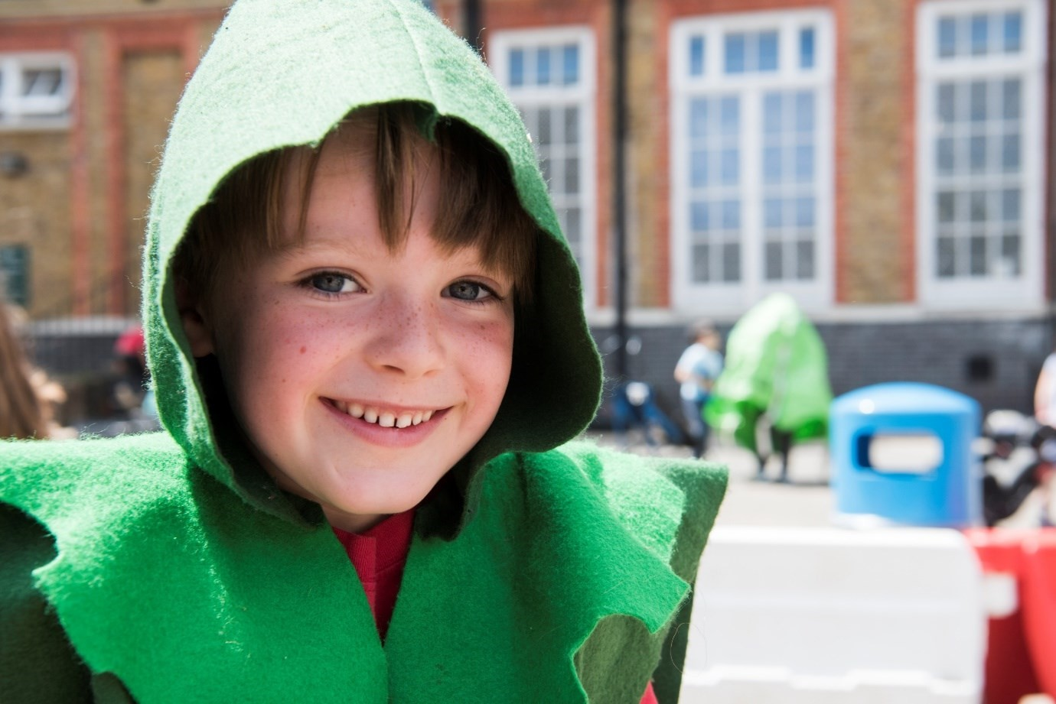
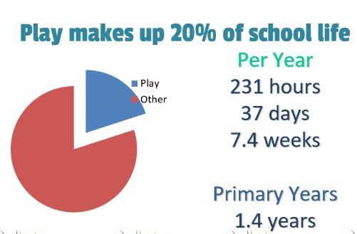
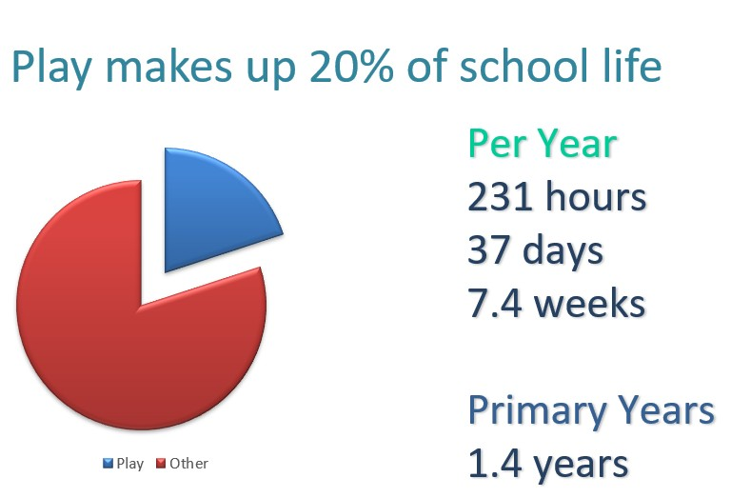

Introduction

Your school has decided that play is amazing, important, fun and good for
children in so many ways.
They are one of hundreds of schools that are using
the OPAL Outdoor Play and Learning programme.

Play takes up a significant
amount of time,
in fact it is
equivalent

to
1.4

years of a
child’s
primary
school
life.

OPAL schools call the people who are in charge of play ‘The Play Team’
,
because
supporting children to play is what the job is all about.

Changing from being as a supervisor to
thinking and acting like a playworker takes
time, knowledge
, reflection and
practice
. The play team in OPAL schools should
have time to meet and learn together, study the online playwork essential course
on the OPAL website and use this book as a basis for

learning and reflection.

We hope that
learning about playwork and
understanding play better will enable
you to improve how you provide play
for

your children, i
ncrease

their wellbeing,
happiness and learning and make your job more enjoyable and fulfilling
.

Michael Follett

OPAL Founder

There is no better
activity for learning
and development
than play

Doherty and Hughes,
(
2014)

Who is this booklet for?
If you spend any part of the school day managing or supervising children’s outdoor play, then this booklet is for you. Playwork is the profession which specialises in the relationship between the child and the adult in play, and the playwork essentials set out in this booklet will help you to learn some of the main ideas which inform playwork. The booklet and OPAL’s online course only form a very brief introduction. If you are inspired, you may find many books and courses which support a much fuller understanding of playwork. Further reading is suggested below.
What is playwork?
Playwork is the profession which specialises in the theoretical knowledge and practical application of skills which optimise the most fulfilling and rich play opportunities possible for children and explores the relationship of the adult and child in play.
What do we mean by play types?
Play types can simply be described as the different behaviours we can see when children are playing. There have been numerous attempts to categorise different types of play.
This toolkit uses the play types from play theorist Bob Hughes (2006) Play Types –
Speculations and Possibilities in which he explains that ‘each play type is both distinctly and subtly different from the others’. It is useful to be able to recognise them since ‘engaging in each one is a necessary corollary for a child’s healthy development’.

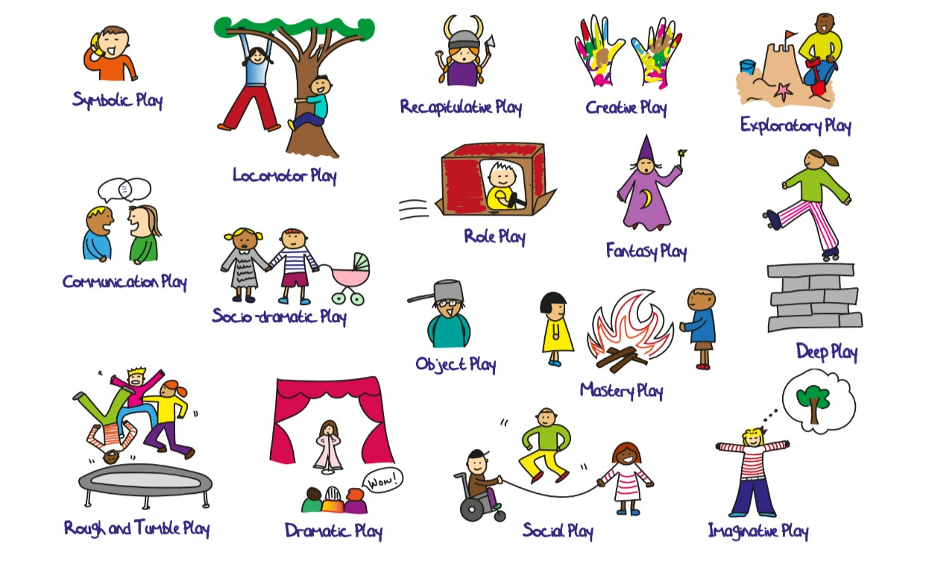

But we already play in school…
Play opportunities are generally available to children in UK schools at breaktimes and lunchtimes, but this may total as little as 35 minutes of daily ‘activity’ if you factor in time spent eating, putting on coats and shoes, aimlessly standing around or queueing/lining up. The extent to which children play in class time varies greatly, with opportunities for play tending to decrease sharply after the early years, lessening further throughout their time in primary school, and by secondary school has almost completely disappeared.
As well as time for play, evidence shows us that the physical environment has a significant impact on children’s play experiences. A stimulating and varied environment which makes playful resources (loose parts) available to children supports more varied and complex play opportunities, both indoors and out.
The attitude of adults has an equally important effect. Adults can unwittingly constrain and undermine children’s play through a negative attitude towards it, or they can enthusiastically support play to deepen and become ever more complex. When adults understand and value play, they are more able to recognise the benefits children are deriving from it (such as learning, physical activity, enjoyment, wellness and resilience) and are therefore able to provide suitable opportunities and resources.
If children appear not to be engaging with the whole range of play types, we might ask whether that is because they choose not to, because of something lacking in the environment, or because the attitude of adults is stopping them. Or perhaps something else is happening that it would be useful to try to understand?

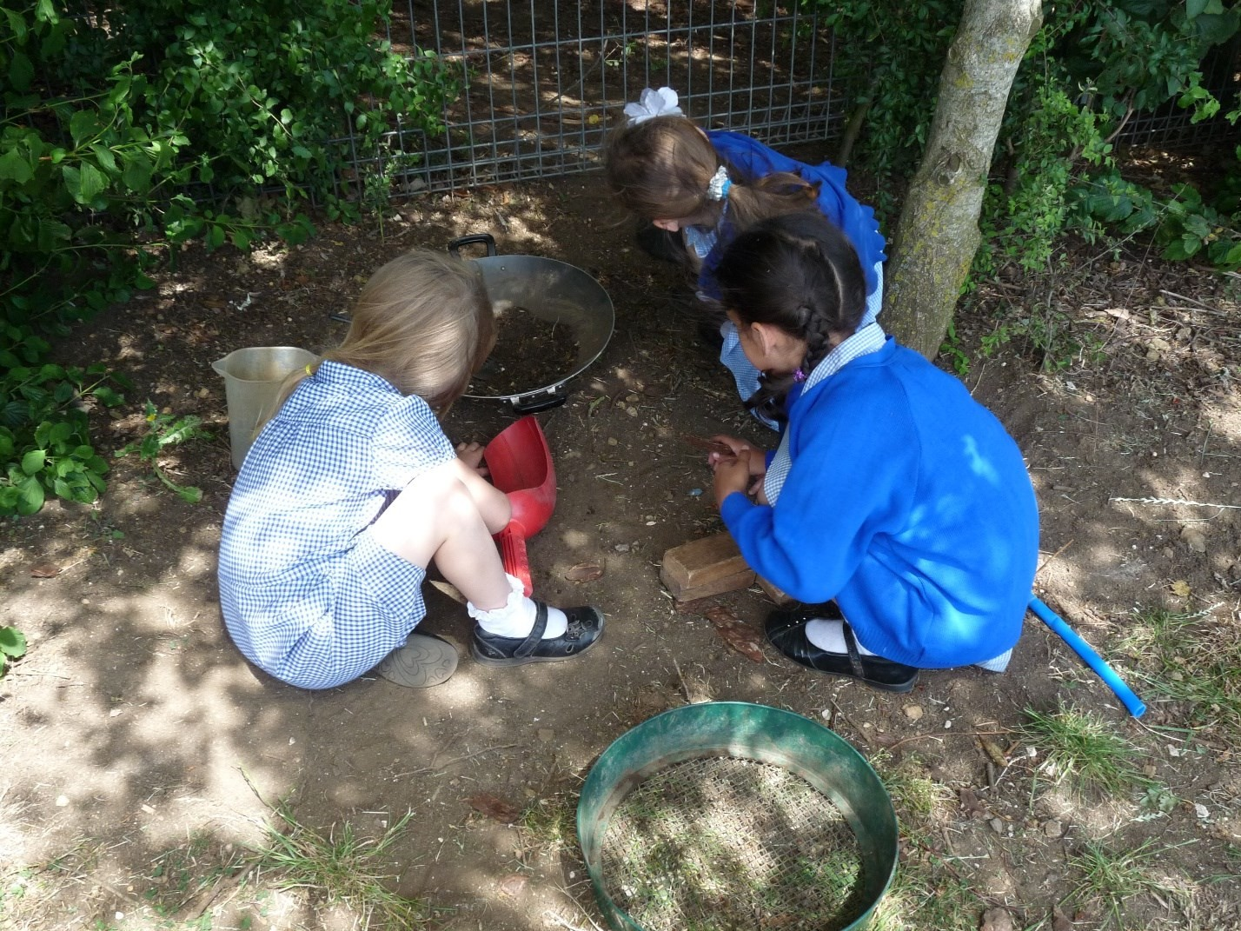

How playworkers define play
. A process which is…

1.

Freely chosen by the child

2.

Directed

by the child

3.

For the child’s own motivations and reasons

If the above are not true, whatever is happening
is probably not play

Key considerations
Whether you are a class teacher, head teacher, play team member or teaching assistant, the following considerations are helpful to bear in mind. Putting them into practice might require small changes to routines and resources or wider changes to school policy and the environment. These are all steps to success.

Without two clear leadership roles in schools, play will Leadership never be of a sustained good quality. All schools need strategic leadership from the Curricular Lead for Play and operational leadership from the Play Coordinator

As well as needing short play breaks at regular intervals Time throughout the day, children benefit greatly from
opportunities to immerse themselves in play for more extended periods of time, ideally 60 uninterrupted mins.

The outdoor environment is the perfect platform for play.
Children need places that they can use in ways of their Environment own choosing and which offer them variety, adaptability, challenges, space and access to the natural world.

Resources
Suitable resources for playing, such as loose parts, natural
materials
,

etc. enable children to extend and elaborate
their play
exponentiall
y
.

Permission
Children play in environments where experimentation and
learning are valued and permitted by adults. Being allowed
to figure things out for yourself, to collaborate with peers,
take calculated risks and get a bit dirty, should all be allowed.

The benefits of play
How do you think you benefited from your play as a child?
The gap in educational outcomes, particularly for those children from areas of multiple deprivation and, increasingly, for boys highlights the need for interventions that address the social, emotional and physical needs of pupils as well as their academic needs.
The benefits of play are broad, encompassing:
- Health and wellbeing  - Early childhood development  - Cognitive development  - Physical activity & literacy  - Mental health | - Emotional wellbeing  - Social development  - Learning about risk and challenge  - Play as therapy  - Resilience and character

Playing and learning

The great play you provide at playtimes is important to the school
Playing contributes greatly to such diverse areas as language, arts, culture, science, maths and technology. Furthermore, play supports self-regulation as a key developmental mechanism: this ability is increasingly shown to be vital to academic success.
Play in all its rich variety is
one of the highest
achievements of the
human
species, alongside language,
culture and technology.

(
Whitebread,
2012)

Research provides considerable evidence that play can develop the cognitive abilities needed for formal learning: play aids development of problem-solving capabilities, creativity, representational skills and memory. Another important consideration is the emotional literacy and control needed to learn in school.
Playing aids the development of concentration and attention. Playing in outdoor environments with natural features has been shown to be particularly helpful to this.
Moyles (1989) demonstrated that for every aspect of children’s development, there is a form of play behind it. In combination, these forms of play support all aspects of physical, intellectual and social-emotional growth. Therefore, a balance of experience of each of these types of play is essential in bringing key developmental and learning benefits to all children.

The play cycle
The play cycle is the way playworkers explain what is happening in play within the child, and what impact the adult has on the child. It is a very valuable tool for supporting reflective practice whenever adults are intervening in the play process.

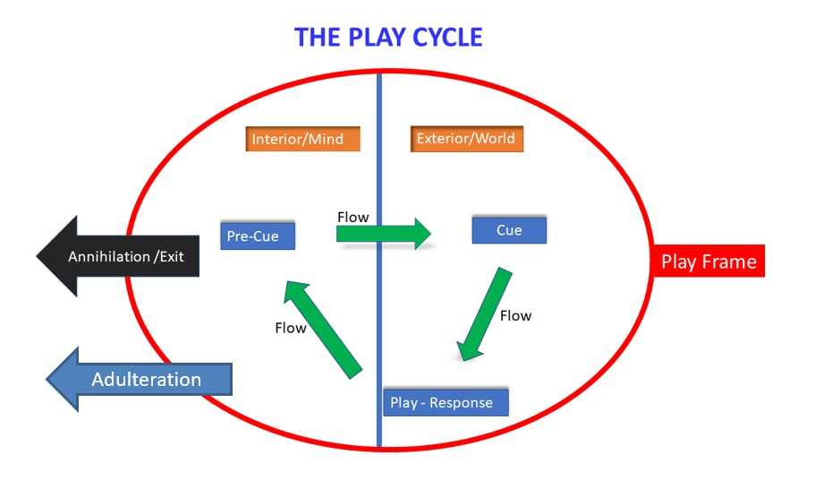








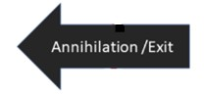
The moment when a playful thought, idea or urge forms in the child’s mind

What is happening in the child’s head

What is happening in the real world

The moment when a playful movement, noise or act becomes external
The feedback the child gets from people, environment or their senses
The deepening loop of action, reaction and understanding in play
The conditions which hold the flow of play together
The destruction of flow through imposed adult values or presence
The point at which the child leaves, or is forced to leave the cycle

Playworkers strive to create environments and situations where there are lots of opportunities for children to become deeply engaged in the flow of their own self-directed play. The playworkers’ job is then to maintain the frame of the play, and not to intervene, adulterate or unintentionally annihilate the play with their presence or interruptions.
You will find more information on how playworkers value play on the page The playwork principles, on how to recognise different types of play in the Understanding the play types and Schema in play, and on how they intervene in play in the Intervention styles.

The playwork principles

Keep a reflection diary to understand how you do these things

1. Understand Need

All children and young people need to play.
The impulse to play is innate. Play is a biological, psychological and social

necessity, and is fundamental to the
healthy development and well-being of individuals.

3. Support Process

The prime focus and essence of playwork is to support and facilitate the play process and this should inform the development of play policy, strategy, training and education.

5
. C
reate Spaces

The role of the playworker is to support all
children and young people in the creation
o
f a space in which they can play.

7. Understand Impact
Playworkers recognise their own impact on the play space and also the impact of children and young people’s play on the playworker.

2. Understand Process
Play is a process that is freely chosen, personally directed and intrinsically motivated.
Children and young people determine and control the content and intent of their play, by following their own instincts, ideas and
interests, in their own way for their own reasons.

4. Advocate for Play
For playworkers, the play process takes precedence and playworkers act as
advocates for play when engaging with adult led agendas.

6. Learn and Reflect
The playworker's response to children and young people playing is based on a
sound up to date knowledge of the play process, reflective practice.

8. Choose Intervention Styles
Playworkers choose an intervention style that enables children and young people to extend their play. All playworker
interventions must balance risk with the
developmental benefit and well-being of children.

Understanding the play types

Build your learning through written observations and reflections
This section aims to:
- highlight the range of types of play children experience
- highlight their vital contribution to learning and development
- make integration of play into the curriculum simpler
This section should help you to identify, understand and provide the play types. In the following pages, you will find each of Bob Hughes’ play types set out with:
- what this type of play might look like
- examples of what children gain through engaging in this type of play
- in-school opportunities
- links to the 2019 OFSTED framework
Because the differences between some play types such as Dramatic play and Socio-dramatic play, Fantasy play and Imaginative play are often subtle, for the purposes of this toolkit we have grouped them together.

These pages are intended to provide a straightforward reference point to assist you in integrating play into your day. While links are made to children’s development and to the curriculum, it is not suggested you prioritise one set of play types to the exclusion of others – they are all equally beneficially important and, for maximum enjoyment, children should be able to make their own play choices.

Once you are aware of each of the play types, you should discuss with your play team how you can continually improve the quality of your play offer.

You can learn more about the 16 play types by looking on the free resources section of the OPAL website outdoorplayandlearning.org. Just register for free and you can access the playwork essentials course and the 16 playtypes videos.

Where do I start?
Begin by allocating some time to observing children at play, and practice recognising each play type (see the template on p37). This will help you to understand the range of

play available to the children in your setting, which types of play are particularly
prominent, which are observed rarely, and whether children have sufficient time, space, resources and permission for play.

This exercise is useful for everyone who spends time with children in the playground;

classroom assistants, site support staff, playground supervisors, teachers, etc.
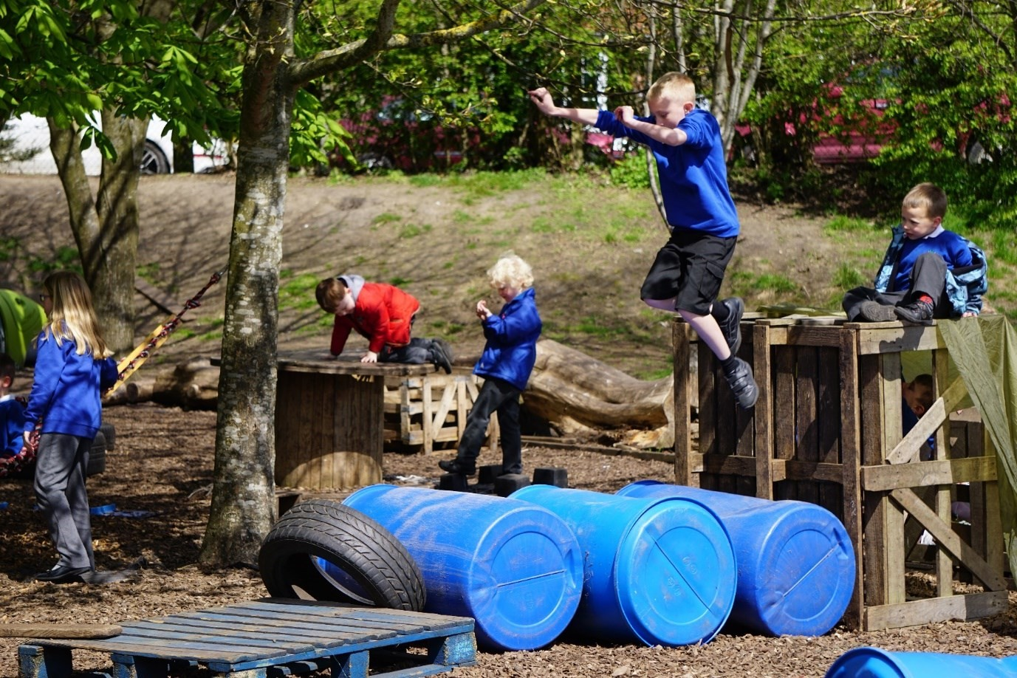

Learning about

the physical world

• Creative play

•
Exploratory play

• Mastery play

• Object play

Creative Play


What does it look like?

Making, painting, manipulating materials

Using imagination and inventiveness
with materials and ideas

Use of any medium for its own sake
often in new combinations

Original expression of emotions, feelings
and ideas

Playing with ‘loose parts’

What do children gain through this type of play?
Enjoyment, self-expression, mastery of skills particular to specific contexts, development of motor skills and
integration of concepts appearing in different fields.

In school opportunities

Expressive arts time

Play time, lunch time and after school

Teachers’ approach to both: valuing the time spent creating without a focus on the end product and providing plentiful

supplies of novel and non-standard
materials.
OFSTED Criteria

Quality of Education
-

Knowledge and
Skills

Behaviours and Attitudes
–

Employability

Leadership and Management
-

Vision
and Ethos

Personal Development

Some of the skills and dispositions developed

Thinking, sensitivity to and appreciation of colour, texture, shapes, smells, etc.
Problem solving, ‘private speech’, self- regulation, confidence, fine motor skills,
hand-eye coordination.

Over-management by adults isn’t conducive to creativity: we should give children plenty of time, access to changing supplies of materials and tools, and permission to experiment in a creative atmosphere. Don’t be boring!

For creative play, it is critical that the child has control over their own experience.

Exploratory Play
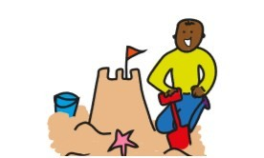
What do children gain through
this type of play?

Emotional satisfaction, access to
information, may reduce uncertainty and
stress around novel or complex situations.

Some of the skills and
dispositions developed

Thinking, reasoning, problem
-
solving,
assessing risk, readiness to encounter new
experiences, creativity, ‘private speech’,
self
-
regulati
on.

What does it look like?

Physically exploring an environment
–

goi
ng higher, further, jumping over,
jumping on, feeling, tasting, swinging
from.

Testing ‘what happens if…?’

Manipulating objects or environment
and assessing their properties

Exploring fire, puddles, earth, etc.

In school opportunities

Any kinaesthetic environments or
subjects

PE

Science

Technology

ICT

Play time, lunch time, before and after
school

OFSTED Criteria

Quality of
Education

-
Knowledge and
skills development
-
Intent
-
Curriculum
design

Behaviours and Attitudes

-
Attitudes to
learning, discovery

Student Experience

-

Leadership and
Management

The environment must be navigable but also worth exploring,
i.e.,

offer the possibility of discovery,
surprise, novelty, challenge.

Key questions: ‘What if?’ ‘I wonder what...?’ ‘What would happen if…?’ ‘Why not?’

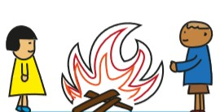
Mastery Play
What does it look like?

Digging holes

Building moats in sand in the path of the
tide

Fire building and setting things alight

Changing course of streams (building
dams)

Growing
things

Blocking drains to create puddles

Demolition and construction

Some of the skills and
dispositions developed

Respect for the natural environment,
deeper understanding of elemental
forces and natural phenomena,
satisfaction, motor skills, pr
oblem
solving, logical reasoning, planning,
communication skills when playing with
others

In school opportunities

Eco projects

School grounds projects

Science

Technology

Play time, lunch time, before and after
school

OFSTED Criteria

Quality of Education

-

Intent
-

Coverage
and appropriateness

Behaviour and Attitudes

-

Attitudes to
learning

Personal Development

-

Enrichment

-

Health and wellbeing

Leadership and Management

-

Safeguarding

What do children gain through this type of play?
Understanding of their relationship with
the physical properties of the world

around them (limits, balance, respect,
control, power), understanding of affective ingredients in the environment
(what impact does it have on them?)

Engaging in Mastery Play is how children begin to understand and develop a power relationship with the
physical environment that surrounds them. That relationship is constructed from an evolving knowledge
of what the environment will allow the child to do
to it, and what it will not.”

(
Hughes,
2006)

Object Play
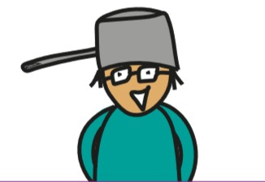

Some of the skills and
dispositions developed

Flexibility of thinking and ideas, fine
motor skills, thinking, reasoning,
problem
-
solving, creativity, ‘private
speech’, self
-
regulation, foundations for
abstract mathematical

concepts
.

What do children gain through
this type of play?

Infinite and interesting sequences and
combinations of hand
-
eye manipulations
and movements which bring about new
and wider understanding of the
possibilities of everyday objects.

What does it look like?

Simply playing with objects!

The object itse
lf is the focus of the play
and may be used in unexpected or
unconventional ways

Testing, discovering the possibilities of
an object

Can involve any object e.g.

-

sticks and stones

-

household items

-

treasures

-

a puzzle

In school opportunities

Technology Literacy: particularly
describing things
.

Expressive arts and
creative activities
.

Sc
ience
.

Play time,
lunch time, before and after school
.

Playful ethos in the classroom:
introducing rotating supplies of intriguing
objects available for play, showing
appreciation of unconventional uses and
ideas

while

holding back the impulse to
show what

it can do.

OFSTED Criteria

Quality of Education

-

Implementation
-

Curriculum delivery
-

Pedagogy

Personal Development

-

Enrichment

Leadership and Management

-

Student
experience

Object play allows children to discover the innumerable qualities, uses and functions of an object.
Children are left to discover uses and functions without significant adult intervention or guidance.
Suggesting the ‘correct’ use
of an object can destroy the play.

The Paperclip Test (See Sir Ken Robinson’s short explanation of Divergent Thinking)

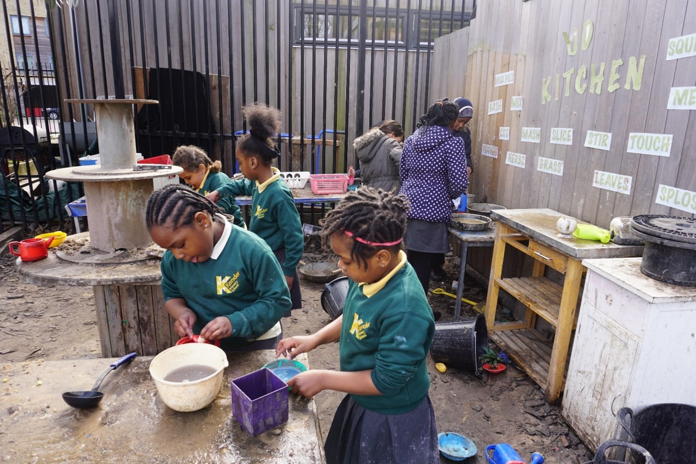

Learning about

myself

and how

to

be in the world

•
Communication play

•
Dramatic and
Socio
-
dramatic play

•
Role

play

•
Social

play

Communication Play

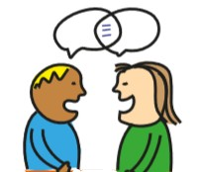

What do children gain through
this type of play?

Vocabulary, nuances, dual meanings,
pleasure to be found in language,
including
fun/rude words and sounds,
body language and facial looks. Empathy.

Some of the skills and
dispositions developed

Oral language development, expansion of
vocabulary and social skills. Preparation
for more formal language concepts such
as
rhyme, poetry and onomatopoeia.

What does it look like?

Mickey
-
taking

Imitation for comic effect

Singing

Rhyming

Talking in slang or ‘street’

Non
-
verbal communication: gesture,
hands and body language

The ‘pla
y face’ (giving the message that
‘this is play’) and other signals of
intention.

In school opportunities

Literacy activities

Drama activities

Play time, lunch time, before and after
school

Playful ethos in the classroom
–

some
acceptance and enjoyment of silly jokes,
rude sounds and funny face
s.

OFSTED Criteria

Quality of Education

-

Progress
-

Knowledge and skills development

Personal Development

-

Enrichment
-

Citizenship
-

Health and Wellbeing

The emphasis here is on the process
–

and joy
-

of communication. It can be
between children,
children and adults, other living creatures, puppets, dolls, any other inanimate objects. Maybe even
with the sky or a passing cloud!

Communication play often shows high degrees of subtlety and sophistication, even when words or
gestures
are crude or would be unacceptable or hurtful outside a playful context

Dramatic Play and Socio-dramatic Play

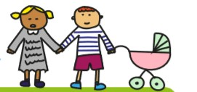
What do children gain through these types of play?
What does it look like?

Making plays
,

s
ong and dance routines
.

Miming
,

pretending to be famous.
Dramatisation of conversation.
Dramatis
ation of everyday events
, e.g.
parent

taking child to school
.

In front of
an audience or ‘for’ an audience
.

I
n a looser sense
,

Socio
-
dramatic play
.

Use of adult phrases or language in play
situations
.

Re
-
enactment of social situations to
understand or gain control
.

Recognised
by their ‘real life’ contexts and
exaggeration of emotions.

OFSTED Criteria

Quality of Education

-

Curriculum
delivery
-

Knowledge and skill
development

Behaviours and Attitudes

-

Employability
-

Fostering British Values
-

Citizenship

A sense of the ‘dramatic’, reaction of an audience, self-expression, adopting

identities, ego boost, cathartic effect.
Socio-dramatic play may involve real and potential experiences of an intense personal, social, domestic or
interpersonal nature. Events enacted might have happened or be yet to

happen but may be difficult for the child
to understand.

In school opportunities

Drama

Dance

Play time, lunch time, before and after
school
Features of the play environment: platforms, stages, amphitheatres and
gathering areas or more private spaces
for enactment.

Some of the skills and dispositions developed

Language development, performance, expression, communication, literacy, narrative, artistic and creative skills

Playing in scenarios which

represent real, possible or desired domestic, social or cultural situations
provides children with a useful way to pre
-
empt, play through and rehearse situations and reactions.
It gives the opportunity to engage in understanding the everyday behaviour of
others.

Role Play
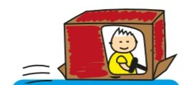

Role play is a way to ex
plore identity. It enables caricature and amplification of particular traits,
imitation of accents, change of gender, culture and race.

In school opportunities

Word games

Literacy time
–

poetry/rap, language use

Drama

Play time, lunch time, before and after
school

What do children gain through
this type of play?

Access different ways of being,
interpreting them from their own frame
of reference. May be of an intense
personal social, domestic or interpersonal
nature (though not
always).

What does it look like?

Child enacts adult, or other, behaviours
e.g. driving, cooking

Plays a family character, community
person or celebrity.

Takes on different state e.g. dead or
asleep

Mimicking and imitation of mannerisms,
voice, dress
and actions.

Some of the skills and
dispositions developed

Narrative skills, point of view, observation,
social and groupwork, language
development, communication skills.

OFSTED Criteria

Quality of Education

-

Intent
-

Appropriateness
-

Delivery
-

Knowledge
and skills development

Behaviour and Attitudes

-

Attitudes to
learning
-

Respect

Personal Development

-

Enrichment
-

Fostering British values
-

Health and
wellbeing
-

Citizenship

Leadership and Management

-

Vision
and ethos
-

Student experience

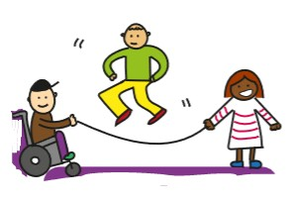

Children need the opportunity to explore and experiment with differ
ent forms of interaction with
other human beings. Among adults, children are often taught and corrected, whereas whilst playing,
children learn as a result of what they decide. This inevitably includes aspects of argument, debate,
repression and control, a
s well as fun.

Social Play

Some of the skills and
dispositions developed

Emo
tional intelligence, social and
groupwork, language development,
communication skills.

What do children gain through
this type of play?

Engagement with social dynamics, how
children/adults/groups react to various
situations, verbal cues, looks, food,
customs etc.

Experiences in which the rules and
criteria for social engagement and
interaction can be revealed, explored
and amended

What does it look like?

Any social or

interactive experience.

Negotiation of rules and social norms.

Board games.

Conversation/negotiation.

Locomotor games.

Running the tuck shop and other playful
enterprises.

Creating things together.

OFSTED Criteria

Quality of Education

-

Appropriateness
-

Curriculum design

Behaviours and Attitudes

-

Attitudes to
learning
-

Respect

Personal Development

-

Enrichment
-

Citizenship

In school opportunities

Collaborative work in any area
,

p
lay time,
lunch time, before and after school
.

Playful ethos in the classroom: valuing
the time taken negotiating rules and

agreed

‘norms’, avoiding micro
-
ma
nagement by adults, allowing

children
to sort things out together.

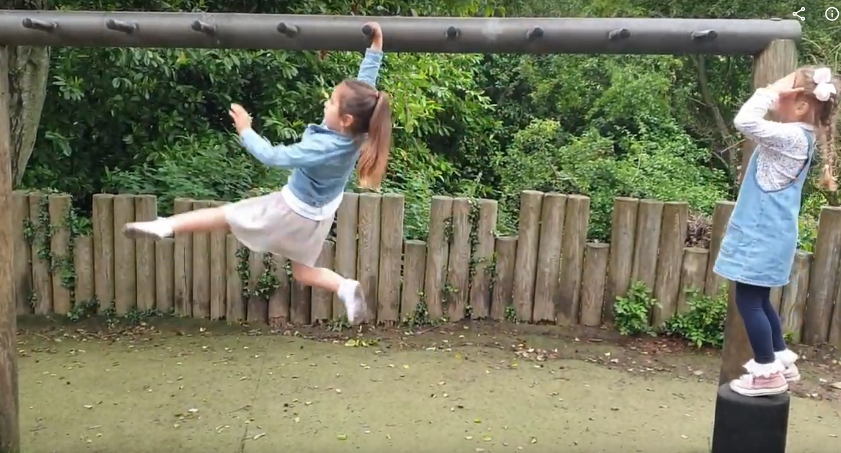

Learning about

m
y

body and limits

•
Rough and tumble play

•
Locomotor play

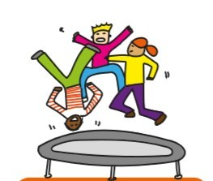
Rough and Tumble Play

What do children gain through
this type of play?

Experiences of close encounters, social
bonding, physical activity, insights about
yourself in relation to others, fun.

Some of the skills and
dispositions developed

Emotional and social skills, judgement,
respect for others, foundations for
physical, personal and interpersonal
relationships.

Empathy, self
-
regulation, control.

What does it look like?

‘Play face’ and body language make play
fighting distinct from actual fighting.

Tests of strength.

Physical contact games.

Wrestling.

Playful pushing, shoving and jostling.

Often pulling back, retreating or
‘feinting’ to rebalance power between
players.

In school opportunities

PE

Wider school contexts

Play time, lunch time, before and after
school

Playful ethos in the playground: not
being too quick to intervene or prohibit
rough and tumble play, encouraging
children to respect boundaries and to
exercise their choice to participate or
not.

OFSTED Criteria

Behaviours and Attitudes
-

Behaviour
-

Respect

Personal Development

-

Health and
wellbeing

This is a much misunderstood but very important and well researched play type. In a scho
ol context,
universal prohibitions of forms of rough and tumble play aren’t uncommon. A middle ground should
be found so that there is some agreement over times and places where rough and tumble play is or
isn’t allowed, or a school code agreed by pupils,
to indicate one’s willingness to participate.

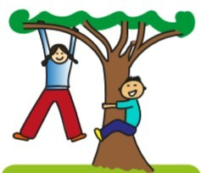
Locomotor Play
What does it look like?

Chase, Tig, hide and seek, throw/catch.

Climbing, jumping, swinging,

Ball games, Hula hoops, skipping, racing.

In school
opportunities

PE

Play time, lunch time, before and after
school

Features of the play environment: open
space as well as a varied landscape with
opportunities to climb, jump, throw,
slide, crawl, spin, run, kick a ball, etc.

OFSTED Criteria

Quality of Education

-

Knowledge and
skills development

Personal Development

-
Health and
wellbeing

Leadership and
Management

-

Student
Experience

Some of the skills and
dispositions developed

Strength, physical literacy and stamina

Whole body coordination, agility

Raised heart rate, confidence

Communication, teamwork and social
skills

This often is the dominant play type in school playgrounds, so it’s important to ensure that
locomotor play doesn’t push all other types of play to the margins. Locomotor play also offers
children the
chance to develop a sense of themselves, familiarity with their environment, learning
where is safe and where must be avoided, the properties of objects, and a sense of ability to escape
(
up a tree, over a wall, out of sight
).

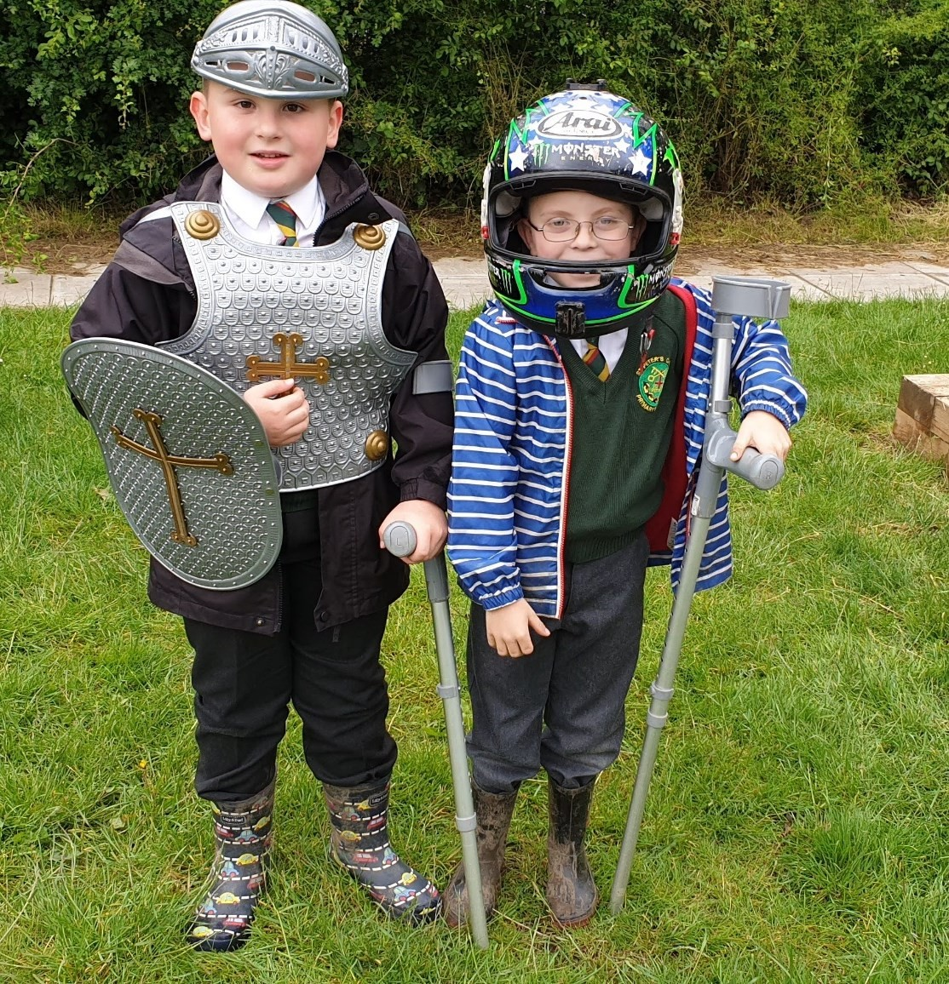

Learning about

What it is to be human

•

Deep play

•

Fantasy play and imaginative play

•

Recapulative play

•

Symbolic play

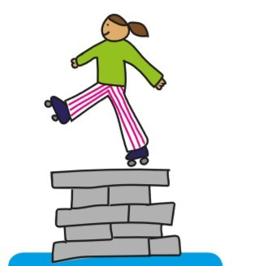

W
hat does it look like?

Jumping off, climbing up, moving fast

Pushing boundaries, almost out of
control

Imaginary monsters or scary
animals

‘Heart in mouth’ moments

Achievement, confidence, need

Laughter, screaming with pleasure

Deep Play

What do children gain through this type of play?
Encounters with risky and even potentially life-threatening experiences, thrills and exhilaration, engaging with
ideas of life and death.

Some of the skills and dispositions developed

Risk assessment, focus and concentration, confronting fears, calibration of movement, common sense. Learning to be safe enough.

In school opportunities

Elements of deep play may
sometimes be
seen in PE, outward bound activities and
in the playground when children make
their own decisions to tackle something
which makes them fearful. Knowledge of
deep play as a type of play can help
inform understanding of, and responses
to, childr
en’s behaviour in and out of
school.

OFSTED Criteria

Quality of Education

-

Intent
-

Coverage

Personal Development
-

Health and
wellbeing,
c
itizenship

Leadership and Management

-

Safeguarding

This is not a play type likely to be routinely encouraged in most schools, although it may happen
anyway, with or without the knowledge of adults!

Children do however have an undeniable need for risk, challe
nge and adventure. The play
environment should accommodate that within a framework of good risk
-
benefit assessment.

Fantasy Play and Imaginative Play

What does it look like?

Being a fire
breathing dragon

Casting spells and ‘doing magic’

Unconventional use of props

Being a tree/ship

Patting invisible animals/ eating invisible
food

Use of objects as other objects, e.g. using
a bench as a bus

What do children gain through this type of play?
Access to other realities, enabling children to access experiences with a potentially
high impact in a manner which is controlled and gradual.

Creation of alternative outcomes, emotional equilibrium.

Some of the skills and dispositions developed

Language development, vocabulary and rhyme, communication, literacy, artistic and creative, social and groupwork skills.
Also forms the basis for figurative language.

In school opportunities

Literacy contexts
OFSTED
Criteria

Quality of Education

-

Knowledge and
skills development

Behaviour and
A
ttitudes

-

Attitudes to
learning

Personal development

-

Enrichment
-

Health and wellbeing
-

Equality and
diversity

Drama

Expressive arts

Play time, lunch time, before and after school
Playful ethos in the classroom: showing delight at eating an imaginary sweet,

accepting the existence of a talking
goldfish, enquiring after the health of an
uncle who is a superhero, etc.!

In this play type, children are
playfully engaged in situations created entirely from imagination and
where the conventional rules which govern the physical world do not apply
.

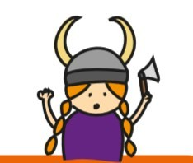
Recapitulative Play

What does it look like?

Rituals

Fires

Playing with/in the elements

Body paint, shields and face markings

Dens, camps, homes and caves

Growing and cooking things

Playing war
games and with weapons

Animal husbandry.

In school opportunities

Science

Literacy

RME

Social subjects (particularly history)

Play time, lunch time, before and after
school

Features of the play environment: earth,
soil, clay and water, varied terrain and
heights, fire bowls, outdoor
cooking,
natural building materials.

OFSTED Criteria.

Personal Development

-

Enrichment
-

Fostering British Values

-

Citizenship

Quality of Education

-

Curriculum d
esign

-

Delivery
-

Knowledge

Leadership and Ethos

-

Vision and ethos

What do children gain through this type of play?

Accessing the behaviour of earlier human

evolution, enormous satisfaction and comfort.

Some of the skills and dispositions developed
Recapitulative play may involve benefits

shown across all play types but in particular is associated with elemental forces and deep human instincts and drives.

“If you look at some of what children do when they play, you will see reflected in that, some of what
human beings did in the ancient past.” (Hughes, 2006)

Symbolic Play

What do children gain through
this type of play?

The ability to
use words, gestures or
images to represent actual objects, events
or actions. Opens up endless possibilities
for play scenarios.

Some of the skills and
dispositions developed

Abstract thought, visual representation,
language development, communication,
literacy, numeracy, artistic and crea
tive
skills.

What does it look like?

Props given specific symbolic meaning

Camps to symbolise ‘home’

Spray hearts to denote love

Flags to denote a tribe

Rope to represent an area of water.

In school opportunities

Social Studies

Drama

PE games

Play time, lunch time, before and after
school.

OFSTED Criteria

Quality of Education

Teaching
-

Pedagogy

-

Knowledge and skills
development

Behaviour and attitudes

-

Attitudes to
learning

Personal Development

-

Enrichment
-

Health and wellbeing

Leadership and management

-

Student
experience

To some extent, all play can be described as symbolic. Symbolic play allows children to represent an
abstract idea, a feeling, something that isn’t there or isn’t seen. It enables children to access
experiences which feel important but whose potential significance can only be guessed.

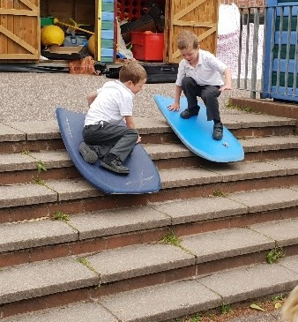
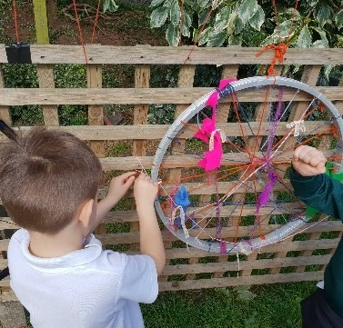
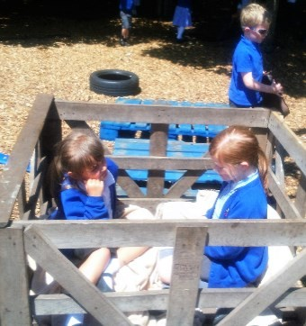
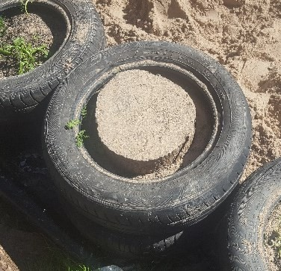
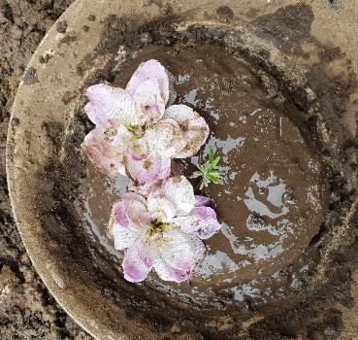
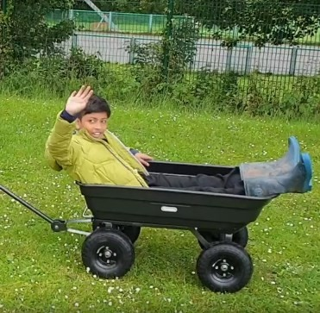
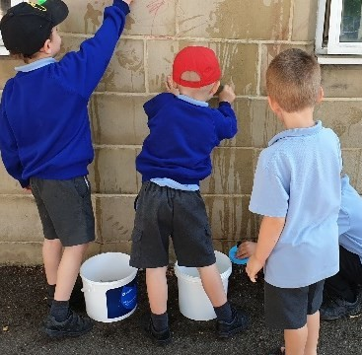
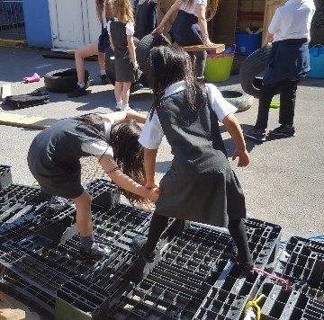



Schema in play

Make an observation sheet and try
and spot these
,

then think how you
can add more and more
opportunities
.

Schema are common patterns of enquiry children are drawn to explore through their play.
All good play environments will support deep exploration of all schema for all ages.

Trajectory
is all
:
about movement in
a clear direction,
including running,
riding, and throwing.

Rotation
:

is the

exploration of
anything circular,
especially anything
that rotates
.

Enclosing:

is about
being enclosed in
cosy and
comfortable spaces
or enclosing others.

Enveloping:

is similar
to enclosing but is
about wrapping up,
or placing objects
inside other objects.

Positioning
:

is the
placement of
objects or
themselves in lines
patterns or
sequences

Transporting
the
:
movement of
everything from one
place to another

Connecting
:

exploring how to
join objects, people
and materials
together.

Transforming
:

how materials or
people can
change
their nature and
appearance.

Loose parts

Nearly all play requires stuff to play with
Loose parts refer to anything in the play environment that is not fixed and that children can use as part of their play. They can be natural materials like logs and stones, or man-made stuff like tyres, crates or planks. We can think about loose parts being like ingredients for a cook. However good your kitchen is, nothing great is going to be created unless you have a varied choice of ingredients!
Nearly all play requires stuff to play with, as well as places to play in. In schools, because there are a lot of children, an awful lot of stuff is required to play with. Schools which give their children lots and lots of varied loose parts to play with will always have much betterquality play than those that don't.
There are some important golden rules to providing loose parts;
- Plentiful - Lots of children require lots of stuff. Around four pieces per child is a good guide.
- Varied - It does not really matter what it is but there should be lots of different stuff.
- Accessible - Children should always be able to get out and put away the loose parts themselves.
- Safe Enough - Adults should check and monitor the suitability and condition of loose parts.
- Replaced - When things are played with every day they’ll get worn out or break.
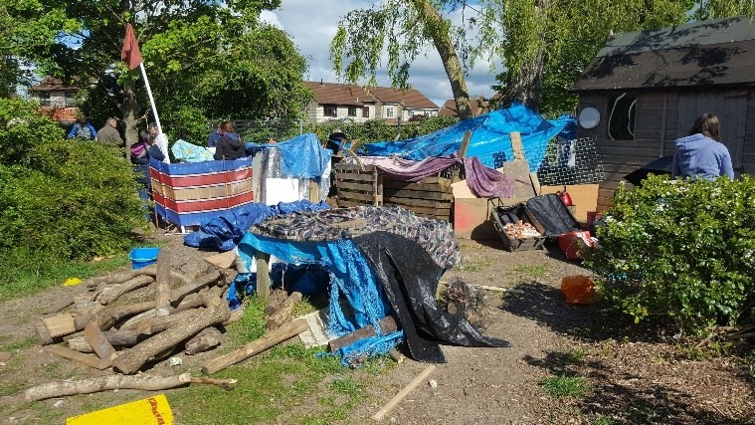
Children are incredibly inventive and will find ways of using loose parts in ways that adults cannot imagine! However, a good playworker can always add some inspiration by setting up some loose parts in a new place or in a new way, and then step back to see what happens.
The things children make when they
play are important to them. Near ‘tidy-up time’, give children some warning and, if possible, record important creations with a camera, or let them remain in place to be returned to another day.
Finally, the only way to manage tidy-up is for every child to pick up two or three things, take them to the loose parts store and chuck them in. The maximum time spent tidying up should be four minutes! This works especially well when accompanied by ‘tidy-up’ music.

The 'Theory of Loose Parts' (Nicholson

1971
)
says that the more moveable things
there are
in a play environment
,

the greater the number of p
ossibilities there will be for invention,
creation and imagination.

The R.A.P.I.D approach to risk

Schools must practice RAPID if they are to have OPAL play
Risk-benefit Your school should have written risk-benefit assessments on file. These set out how the school manages identified common and serious risks in play. You should know what is in these assessments. If you have worries, your Play Coordinator and Curriculum Play Lead need to know immediately about any issues related to risk, that you think should be discussed by the team.
Assemblies Every school should hold regular play assemblies where risk management and mitigation are discussed with the children and records kept.
Policy All OPAL schools have a play policy, where they state that risk and challenge are essential for children's learning and development and that enabling children to learn how to identify and manage risks in a supported environment is a good thing. This approach is supported by both the Health and Safety Executive (HSE) and the Department for Education (DfE).
Inspection It is the duty of all play team members to constantly inspect the play environment to keep it free of hazards such as broken glass, broken objects and litter. Dynamic Risk Management Play team members in OPAL schools should practice
'dynamic risk management' when on duty. This means they should be constantly aware of the changing nature of the play taking place in their allocated zone. Staff should have an idea of where all children are in their zone, how risky their play appears to be, and what resources they are using. Staff should support children to assess and manage their risks as much as possible for themselves, but they should also be vigilant and take immediate action, if ever they think that a risk of serious harm is becoming unacceptably likely.
For most of the time staff will simply need to practice 'relaxed vigilance', meaning that adults should always appear calm and confident, whilst constantly being alert and aware of the risks the children are taking.
Staff should always be prepared to intervene, if necessary. Intervention should balance the management of risks with preserving as much of the benefit of play as possible. Children should be empowered to gradually manage their own risks, as they steadily mature.

When to intervene
- If staff think that serious harm (meaning death, life-long debilitating injury or hospitalisation) is imminent, or probable, they should intervene to manage/stop the risky play immediately.
- If they think that serious harm is possible but not probable, they should remain vigilant and observe from close by. Do not allow yourself to become distracted!
- If serious harm is very unlikely, then they should focus their attention elsewhere, or act to improve the quality of the play offer, using their playwork skills.

Playwork intervention styles

How will you apply them as a team, to enable a consistent

approach?

W
ait

to be invited to play
–

this doesn’t
have to be verbally, it can be a
gesture or other action by the
child (play cue)

L
eave

the content/intent of play to
children
-

let them decide what
they want to do and how to do it

Support

children to explore their own
values as far as possible - they learn more about right and
wrong from their peers than
from playworkers

Let
children decide why they play - there’s no need for rewards or end products or even to get involved if they don’t want you to
E
nable

play to occur uninterrupted
–

don’t interfere, manipulate or
take over

Allow
children to decide what is appropriate behaviour – as far as practicable taking into account age, culture and setting

Only
organise when children want you to - you don’t need to organise ‘entertainment’ for children unless they specifically ask you for ideas

Permit
children to improve their own performance- don’t constantly offer to help, unless something is detrimental to their well being

Being a member of the play team

From policing to playwork
In OPAL schools, the people in charge of lunchtime play are referred to as ‘the play team’. They may have been referred to as lunchtime supervisors or teaching assistants before. In

OPAL schools, the focus of these roles changes from one which is mainly about stopping bad things happening, such as accidents and misbehaviour, to one of mainly supporting amazing things to happen, in the form of better play.

The play team does a very important job in schools. They are responsible for 20% of school

life. OPAL schools recognise that good quality play is hugely important to the health, happiness, development and well-being of all children and effective running of the school.
The play team’s job, led by the play coordinator, is to enrich and diversify play without taking the ownership of play away from the children. A good play team will all work

together to ensure children have plenty of resources and are supported to be independent and creative. They will also need to regularly discuss;
- What are we trying to achieve in our work?
- How well have we done recently?
- How are we going to do it better in the future?
Doing this is called ‘reflective practice’.
- Work with your play coordinator to make up some observation and reflection sheets.
- Choose a play type, schema, principle or intervention type and keep a record over a

week of examples you see or what you have done.
- At your next meeting discuss how you can make things even better.

Most of the improvements to play in a school should come from the play team.

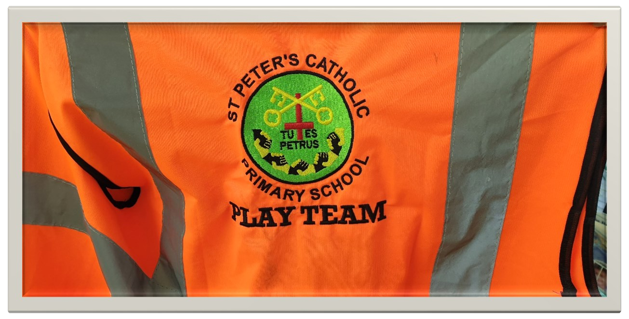

Ranging supervision of play

Use all of your grounds all of the year
Under UK law there must be some supervision, but there is no recommended ratio for how many adults should supervise play, nor is there any guidance to what form supervision should take. This is left to the discretion of the school leadership.
Ranging supervision has been introduced into OPAL schools because schools have been underusing much of their grounds (typically for just 17% of available days) because of confusion about the purpose and style of supervision, or because of appearance issues.
If you are being asked to practice ranging supervision you will need to include the following;
- Understand your range. How big is it? Are there areas that are hidden or have greater potential risk? How do you communicate with colleagues in a hurry?
- Where are your children? What are they doing? You will need to be walking your range for much of your shift. You should know who is playing in the different parts of it, what and who they are playing with, and how risky the play is.
- You should, with help from children, keep your range free of hazards and litter. Are there any planks with nails, are there sharp bits of plastics or are there glass bottles in the bushes? Are there any really sharp branches just at child eye level?
Rope play requires special vigilance and care (see the OPAL guidance sheet) and wires and twine should be removed altogether.

‘Heads up’ playwork
You can effectively patrol your range and practice good playwork so long as you keep your eyes ‘up’ at all times. You are not there to entertain or chat to children (or colleagues) when on duty unless your play coordinator tells you otherwise, e.g., for delivery of playwork.
You can take a resource from one place to another, you can observe the play that is unfolding and you can ask children what they need in order for it to develop, all while remaining vigilant. You can set up resources in a new and inviting way for children to find and adapt and still keep your ‘eyes on the prize’ – child safety.
The skill inherent in your job is the ability to balance involvement in playwork with alertness and awareness. Even if you are deeply involved in some playwork intervention, you will also need to keep your ‘head up’, so you know what is happening elsewhere in your zone.

Dynamic risk management
When children are able to take managed risks, supported by adults who are looking out for them and supporting them in their judgements, they will eventually end up having fewer accidents. However, OPAL is not about a free-for-all, anything-goes attitude to risk: it is about you using your common sense, skill and judgement to balance the needs of children to experience beneficial, challenging play with your responsibility to protect them from unnecessary, serious harm.

Playwork pointers

Try to do each of these every day

Intention When you go into the playground each day, do so with the intention that you

will do something to improve the quality of play

Action Do something with loose parts or the environment that makes a change to how it was before. – Draw out the rooms of a house in chalk - Put resources in a place they have not been before – Use loose parts to build a scene, e.g., vets, shop, hospital, hair salon

Observation Watch what children are doing and ask what you can do to help make it better or more fun. Can we make it stronger, safer? Do you need more of certain resources?
Example

Do something playful and interesting yourself and watch children join in, then
slowly leave and let the children get on with it.

–

Make a model stick and leaf house

–

Invent and play a new game

–

Start building something with loose parts

Invitation When you are observing play, be alert to whether you are being invited to join or leave the play (play cue). If you are invited to join, then try to follow, not lead or take over.

Consistency

Talk to your colleagues, so that you are all a
greed about how you do things
and so that the messages you give to children are consistent.

Respect Children are sensitive, and will copy adult behaviours much more than words. If you need to address an issue, always be respectful, come down to their level, and don’t point or raise your voice. Always praise in public and reprimand in private.

Conflict resolution

Give children the tools to make things better
When children are arguing over something, telling tales and falling out, the best way that adults can support them is to give them a clear method to follow, so that they can resolve most issues for themselves.
With the support of your OPAL leadership, try talking through this method from Peace First. If all of the play team use this approach consistently, you will find that over time, children become more competent at the skills of resolving conflict, and therefore need less adult intervention.
Before you start;
- Come up close to the children, speak in a quiet voice and come down to their level.
- Allow a bit of ‘cooling off time’ if tempers are up.
- Try to avoid having an audience. Only deal with the parties involved, not spectators.
Once children have had some practice, it is OK to ask them;
- Do you feel that you can sort this out by yourself?
- If not, could you sort it out with another child helping you?
- If not, then should I come over? We can go through the conflict resolution steps together.
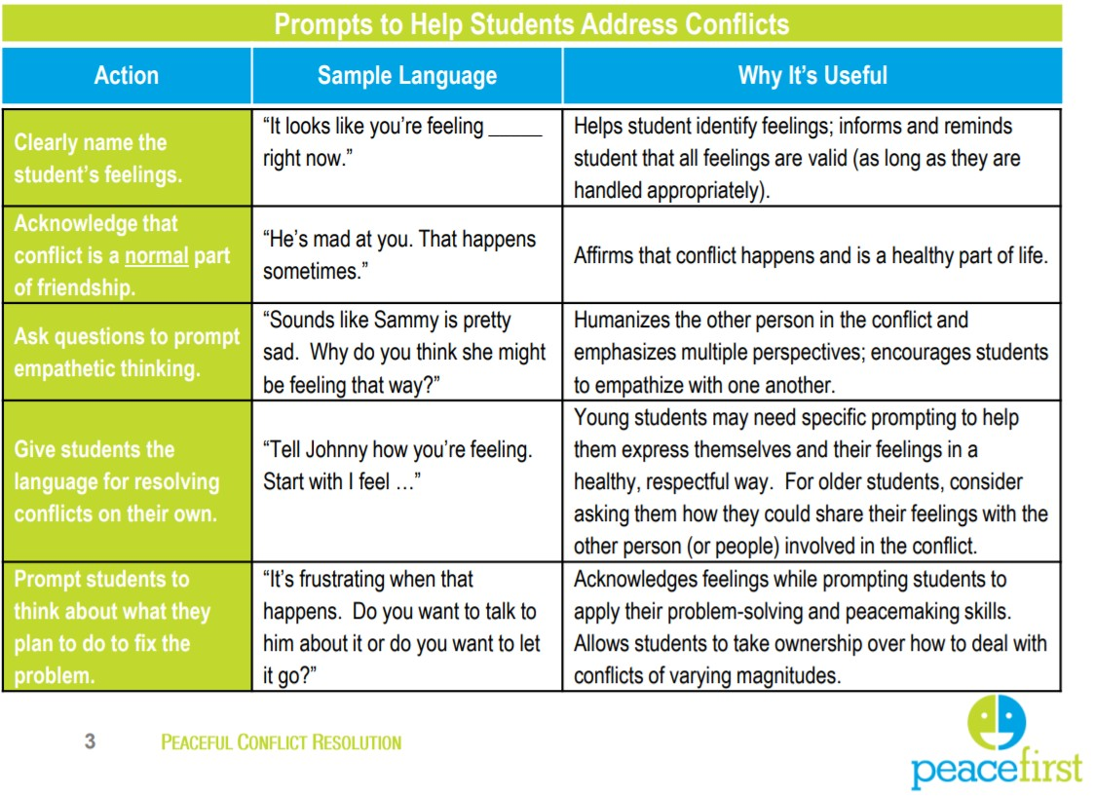

Play types observation template

Written observations are essential in good playwork practice
Children do not display all 16 of the play types all of the time. However, if the range of play appears to be limited to just a few play types, this would suggest a need to consider widening the range available, so every child can benefit. We can do this by changing the environment, the available resources, the policy on play, the amount of time for play or the attitude of the adults present. Use this sheet regularly or make your own in your play team to assess how rich your play environment really is!
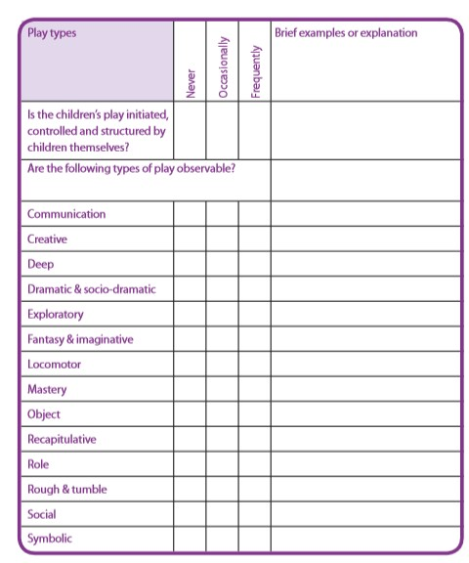

Further reading
Bennet, N., Wood, L. and Rogers, S. (2001) Teaching Through Play: Teachers’ thinking and classroom practice. Buckingham: Open University Press
Briggs, M. and Hansen, A. (2012) Play-Based Learning in the Primary Classroom. London: SAGE Publications
Bunker, L.K., (1991) The Role of Play and Motor Skill Development in Building Children’s SelfConfidence and Self-Esteem. The Elementary School Journal, 91(5), pp.467–471.
Care Inspectorate (2016) My World Outdoors. Dundee: Care Inspectorate.
http://hub.careinspectorate.com/media/279348/my-world-outdoors-sharing-good-practicein-howearly-years-services-can-provide-play-and-learning-wholly-or-partially-outdoors.pdf
Casey, T. (2010) Inclusive Play (2nd edition) Practical strategies for children from birth to eight. London: SAGE Publications.
Else, P. (2009) The Value of Play. London: Continuum.
Hughes, B. (2006) Play Types. Speculations and Possibilities. London: The London Centre for Playwork Education and Training.
Hromek, R. & Rofey, S., (2009) Promoting Social and Emotional Learning With Games: “It’s Fun and We Learn Things.” Simulation & Gaming, 40(5), pp.626–644. Available at: http://sag.sagepub.com/cgi/doi/10.1177/1046878109333793 [Accessed January 17, 2014].
Jeavons, M. (2017) Quintessential Play Patterns in Schools: The interface of space, materials and play behaviours in Masiulanis, K. and Cummins, E. (eds.) How to Grow a Playspace: Design and Development. Abingdon: Routledge.
Learning through Landscapes (n.d. The Playtime Revolution [Online] Available: https://education.gov. scot/improvement/Documents/OUT1PlaytimeRevolutionGroundsforLearningResource.pdf
Mellou, E. (1994) Play Theories: A Contemporary Review. Early Child Development and Care. Vol 102, pp.91-100.
Pellegrini, A.D. & Smith, P.K., (1998) The Development of Play During Childhood: Forms and Possible Functions. Child and Adolescent Mental Health, 3(2), pp.51–57. http://doi.wiley.com/10.1111/1475-3588.00212
Roskos, K. A. and Christie, J.F. (2007) Play and Literacy in Early Childhood. Oxon: Taylor Francis

Acknowledgements
We would like to thank the following groups and individuals for their assistance in developing this resource:
Photo credits
Max Alexander Theresa Casey Lesley Creevy Malcolm Cochrane/Grounds for Learning
Mark Jackson/East Lothian Council Sharon McCluskie Play Midlothian
Graham Brett Elphinstone Primary School, East Lothian Grounds for Learning Kirsten Lawson Steph Mackie Tracey McKie
Play Midlothian Possibilities for East End Kids (PEEK) St Mary’s RC Primary School, East Lothian
Michael Follett
Play types illustrations: emeroleary.com Design: votepedro.co.uk

About the authors
Theresa Casey is a freelance play consultant and author. She works in Scotland and internationally on advocacy and actions for children’s right to play. She has special interests in inclusion, children’s rights and the environment.
Louise Scott-McKie is a lecturer in Primary Education at the University of the West of Scotland. She has particular interest in ‘opening up’ education for those who often slip through the margins. This has led to her focus on play and outdoor learning.

About Play Scotland
Play Scotland delivers the child’s right to play in Scotland. Play Scotland is the national organisation for play in Scotland, working to promote the importance of play for all children and young people and campaigning to create increased play opportunities, to ensure all children and young people #playeveryday
This toolkit was produced by Play Scotland in support of the Play Strategy for Scotland, valuing play, every day. © 2017 ISBN 978-0-9930625-3-7
Play Scotland registered Company Number: 017885 PlaySTAC registered Company Number:
SC471146 Scottish Charity Number: SC029167 Play Scotland, Level 1, Rosebery House, 9
Haymarket Terrace, Edinburgh EH12 5EZ Email: info@playscotland.org Adapted by OPAL
Outdoor Play and Learning with permission from Play Scotland 2019

Adapted by OPAL Outdoor Play and Learning with permission from Play Scotland 2019

