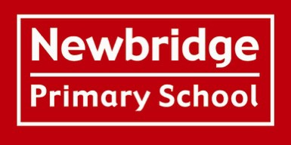

Personal, Social, Health and Economic Education (PSHE)

Policy

Author: Laura O’Gara
Role: PSHE Subject lead
Date written: November 2023
Review date: Spring 2026

The Jigsaw scheme of work for PSHE/ RSHE (Relationships, Sex, and Health Education) is currently aligned with existing government guidance. However, recent changes in government policy mean that some elements of the scheme will need to be updated to ensure full compliance with the revised statutory requirements. A comprehensive review and full update of the Jigsaw scheme will be completed by Spring 2026, ensuring that our RSHE provision remains current, relevant, and in line with national expectations.

Rationale

Our Personal, Social, Health and Economic (PSHE) programme promotes children's personal, social and economic development, as well as their health and wellbeing. It helps to give children the knowledge, skills and understanding they need to lead confident, healthy, independent lives and to become informed, active, responsible citizens. We teach this through the JIGSAW programme of learning.

Definition
PSHE is concerned with the total well-being of the individual towards others and the environment. It is concerned with:

  - Mental, emotional and physical well- being of the individuals
  - The responsibility of the individual towards others and the environment
  - The education and understanding of the mental, physical, emotional, spiritual, environmental and cultural and social influences that shape the community and the interactions of individuals within it.

Within PSHE we explicitly recognise:
Health Education, which involves engaging the children in activities that promote their physical well- being and encouraging an adventurous approach to exercise, daily living, fresh air and exploration both in and out of school.
Citizenship, which involves encouraging children to take a responsible role in society. It includes developing children’s awareness of their personal safety and the processes by which they can seek help and information as well as learning the behaviour expected of them as members of society including developing respect for others
Drug Education which involves educating the children in the safe handling of medicinal drugs as well as the consequences of misusing substances such as alcohol, tobacco and illegal drugs.
Relationships, Sex and Health Education, which is defined as the information by which a child is enabled to become more aware of themselves as a person and understand the process of development and reproduction. (Relationships, Sex and Health Education Policy)

Purposes, Aims and Objectives
At Newbridge Primary School, we aim through implicit and explicit learning experiences to:
- Promote the spiritual, moral, cultural, mental, emotional, social and physical development of pupils at the school and in society
- Prepare pupils for the opportunities, responsibilities and experiences of adult life
- Acknowledge and inform pupils about their rights as children and their responsibility for the rights of others
- Entitle all children to receive sound information about keeping healthy and safe, emotionally and physically
- Develop an awareness of social, economic, political and ecological issues
- Nurture mutual trust and respect between individuals and groups
- Develop understanding and tolerance
- Encourage the development of informed and responsible healthy life choices
- Develop positive attitudes towards health
- Foster self-respect and self-esteem among all members of the community
- To develop emotional literacy skills
Within the taught and hidden curriculum i.e. the whole school environment, pupils should be given frequent and regular opportunities to work on feelings and to practice personal and interpersonal skills.
We value and respect the learning that occurs in the community and in homes, believing that these, alongside school links, are essential dimensions of health education. The Scheme of Work is related to the real world and the children’s experiences.
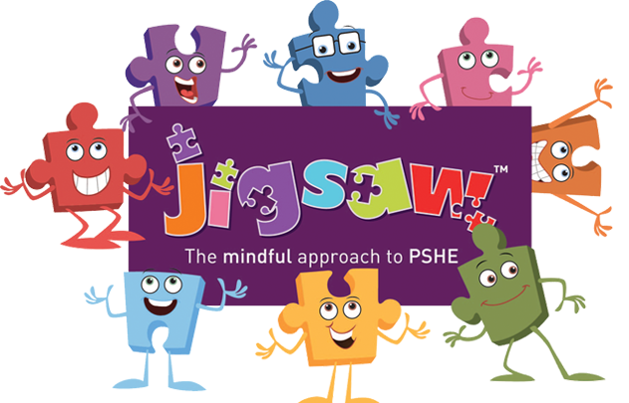

What is Jigsaw, the mindful approach to PSHE, and how does it work?
Jigsaw is a whole-school approach and embodies a positive philosophy and creative teaching and learning activities to nurture children’s development as compassionate and well-rounded human beings as well as building their capacity to learn.
Jigsaw is a comprehensive and completely original PSHE Education programme (lesson plans and teaching resources) for the primary school from ages 3-11. Written by teachers and grounded in sound psychology, it also includes all the statutory requirements for Relationships, Sex and Health Education and is included in the Changing Me Puzzle (unit).
Jigsaw has two main aims for all children:
• To build their capacity for learning
• To equip them for life
Jigsaw brings together PSHE Education, compulsory Relationships, Sex and Health Education, emotional literacy, mindfulness, social skills and spiritual development. It is designed as a whole school approach, with all year groups working on the same theme (Puzzle) at the same time at their own level.
There are six Puzzles (half-term units of work) and each year group is taught one lesson per week. All lessons are delivered in an age and stage appropriate way so that they meet children’s needs.
In each school year, we will solve 6 puzzles. We will explore one each half term.
1. Being Me in My World
Includes understanding my place in the class, school and global community as well as devising Learning Charters.

2. Celebrating Difference
Includes anti-bullying (cyber and homophobic bullying included) and diversity work.

3. Dreams and Goals
Includes goal-setting, aspirations for yourself and the world and working together.

4. Healthy Me
Includes drugs and alcohol education, self-esteem and confidence as well as healthy lifestyle choices.

5. Relationships
Includes understanding friendship, family and other relationships, conflict resolution and communication skills.

6. Changing Me
This puzzle includes relationships and sex education in the context of coping positively with change. It includes age-appropriate sex education.

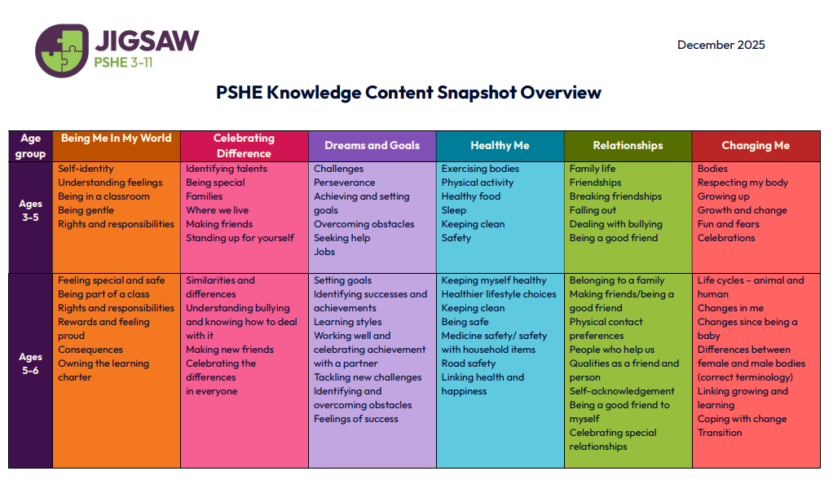

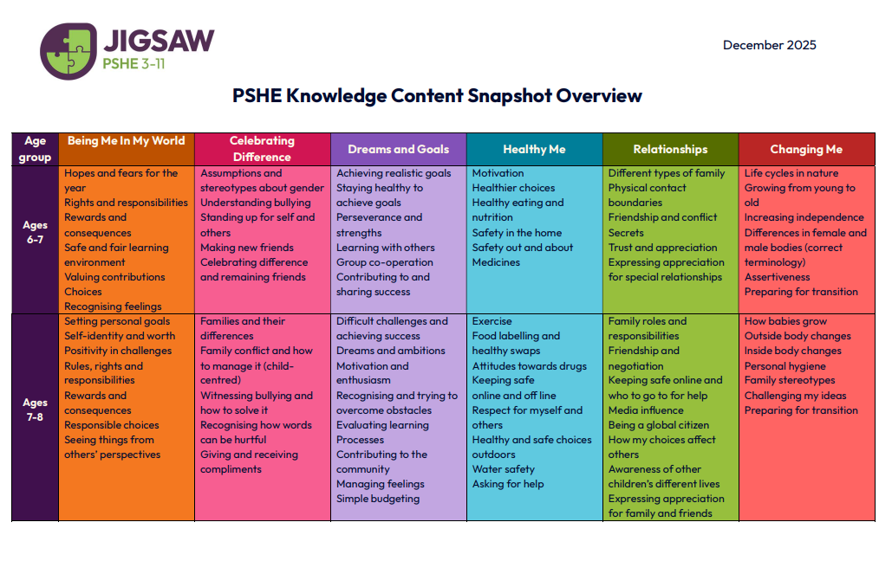

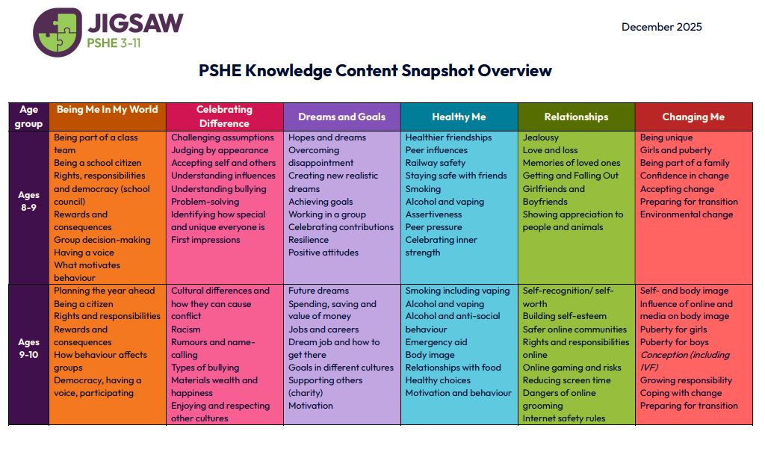

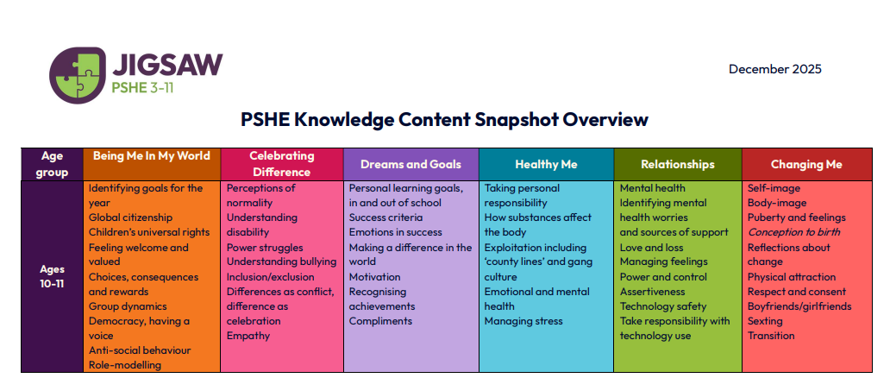

Jigsaw incorporates British Values through the units.
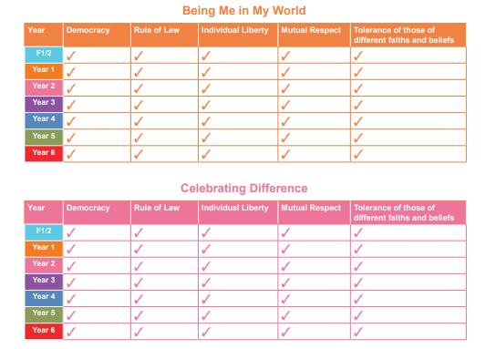

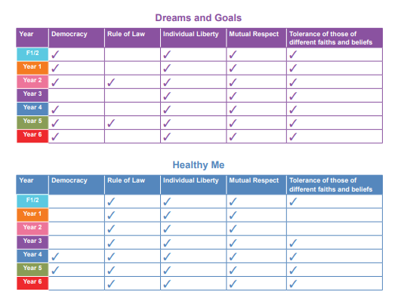

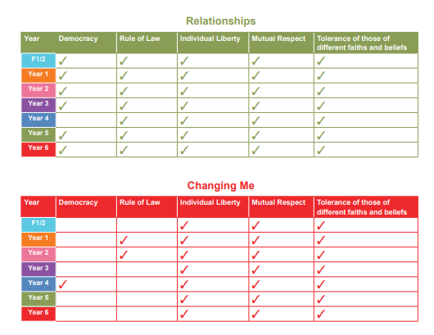
Jigsaw is more than a PSHE Scheme of Work. It provides a structured programme of personal development to nurture the ‘whole child’ and increase learning capacity, underpinned by mindfulness philosophy and practice.

Every Jigsaw lesson from Early Years to upper primary offers opportunities for the children’s spiritual, moral, social and cultural (SMSC) development, and this is clearly mapped and balanced across each year group.

Likewise, Jigsaw is designed to provide structured opportunities in every lesson to practise and enhance the five skills associated with the emotional literacy (self-awareness, social skills, empathy, motivation and managing feelings).

