

Newbridge Primary
School

Relationships, Sex and Health
Education (RSHE) Policy

Author: Laura O’Gara
Role: RSHE subject lead
Date ratified: March 2021
Review date: Spring 2026

Policy Review dates
Review Date | Changes made | By whom | Date Shared with staff
March 2020- March 2021 | Policy redrafted in consultation with parents working party. | Laura O’Gara
March 2021 | Policy written ratified by governors | Laura O’Gara/Gill Kennaugh | 23rd April 2021
Spring 2026

The Jigsaw scheme of work for PSHE/ RSHE (Relationships, Sex, and Health Education) is currently aligned with existing government guidance. However, recent changes in government policy mean that some elements of the scheme will need to be updated to ensure full compliance with the revised statutory requirements. A comprehensive review and full update of the Jigsaw scheme will be completed by Spring 2026, ensuring that our RSHE provision remains current, relevant, and in line with national expectations.

Introduction
Newbridge Primary School considers that Relationships, Sex and Health education (RSHE) to be an integral part of our Personal, Social, Health and Economic Education (PSHE) (Jigsaw) curriculum. We aim to give children the knowledge and understanding they need to lead safe, confident, healthy and independent lives and to become informed responsible citizens. We believe it is the duty of our school to give our pupils the learning that will enable them to live life well including giving them all the skills they will need to thrive in the modern world. We aim to offer pupils a carefully planned programme on human sexual development, relationships and family life within a safe, comfortable environment and in a well-established relationship between teacher and pupil.

Schools must provide Relationships Education, Health Education and Sex Education as defined by the Department for Education. Lessons are predominantly taught through our PSHE program Jigsaw as well as elements of the National Curriculum for Science (Health, Growth and lifecycles, reproduction, and puberty) and our Physical Education Curriculum. In addition, themes relating to RSHE may be covered in assemblies or special events.

The programme is set to the age and stage of the child and matched to the pupil’s level of maturity. This policy covers our school’s approach and attitude towards PSHE and RSHE. It is available on our school website and in printed form on request. It has been written using Department for Educations guidance on Relationships Education, Relationships and Sex Education (RSE) and Health Education Statutory guidance for governing bodies, proprietors, head teachers, principals, senior leadership teams, teachers (2020) At Newbridge Primary School, children’s wellbeing, happiness and safety are our first priority, and PSHE (and RSHE within it) is the key vehicle through which we share this with children.

What is Relationships, Sex and Health Education?
Relationships, Sex and Health Education (RSHE) as a subject can be summarised as learning about the emotional, social and physical aspects of growing up, relationships, sex, human sexuality and health. It should equip our pupils with the information, skills and values to have safe, fulfilling and enjoyable relationships and take responsibility for their health and well-being. At Newbridge it is taught through our PSHE programme, Jigsaw.

Good quality RSHE is taught through a spiral curriculum which develops with the child. For example, teaching children about friendships, appropriate behaviour, safety and basic understanding of their bodies in the early years and KS1, sets a good foundation for learning about healthy and unhealthy relationships and puberty in KS2. Pupils need to be given accurate information and helped to develop skills to enable them to understand difference and respect themselves. We teach a curriculum that builds upon prior age-appropriate information in a careful and sensitive way. It teaches the skills they need to fully manage the natural physical and emotional changes that will happen to them as they grow and mature into healthy, confident, and responsible adults. We aim to provide accurate information and to help to develop skills to enable them to understand differences.

Our school values are:

Learning and Communication
Creativity and Imagination
Personal Development
Collaboration
Citizenship
These are also integral to our school curriculum including RSHE.
RSHE should always be taught in partnership with home and school. We hold annual meetings with parents to enable a dialogue about RSHE to be established. We are very happy to recommend resources you may wish to use with your own children. We also aim to work in collaboration to support your child if they have specific needs, for example struggling with friendships.

Defining Relationships Education at Newbridge Primary School
At our school we believe that Relationships Education should promote equal, safe and enjoyable relationships. Relationships Education at Newbridge covers ‘Families and people who care for me’, ‘Caring friendships’, ‘Respectful relationships’, ‘Online relationships’, ‘Being safe’ as outlined in the DFE RSHE guidance as well as the content on Jigsaw PSHE 3 to 11 content overview for ‘Relationships.’ (pages 8 and 9 of this policy).

In line with the Equalities Act (2010) information about relationships will be taught in a way which fosters LGBT+ and gender equality. Children are also taught about their right to bodily autonomy and the importance of respecting the bodily autonomy of others (laying the foundations for understanding about consent). They will be taught how to recognise abusive behaviour and to know how to seek help if they are worried about abuse or experience it. Parents cannot withdraw their children from Relationships Education as it is a statutory part of the curriculum.

Defining Health Education at Newbridge Primary School
Health Education at Newbridge Primary School is about teaching the characteristics of good physical health and mental wellbeing. This includes information on mental wellbeing, internet safety and harms, Physical health and fitness, drugs, alcohol and tobacco, health and prevention, basic first aid, changing adolescent body including correctly naming body parts, puberty and menstrual wellbeing, as appropriate to their age - as outlined in the DFE RSHE guidance as well as the content on Jigsaw PSHE 3 to 11 content overview for ‘Healthy me and Changing me.’ (pages 8 and 9 of this policy).
Parents cannot withdraw their children from Health Education as it is a statutory part of the curriculum.

Defining Sex Education at Newbridge Primary School.
Basic elements of reproduction are taught as part of the Science National Curriculum including information about how sperm fertilises an egg and how a baby grows. This is covered initially as part of our Jigsaw
Changing Me unit taught in Year 5 and 6.

Information about sex and sexuality may come up in RSHE sessions as part of anonymous question box questions. We are aware that older pupils may accidentally or deliberately have seen sexualised material online and have questions about this and it is important that we provide a safe space for their questions to be answered. Children of the same age may be developmentally at different stages, leading to differing types of questions or behaviours. Depending on the question, any question about sex and sexuality will be answered in whole class, small group or 1:1 sessions or some questions we may refer back to parents. This will be down the discretion of the class teacher.

In certain circumstances parents can choose to withdraw their child from the Sex Education element of the curriculum apart from that within the Science National Curriculum (Reproduction) and the Puberty component of Health Education which are both statutory.
If you would like to withdraw your child from the sex education element of PSHE, please email the school address to make and make an appointment to discuss with the senior leadership team.

The aims of Relationships, Health and Sex Education
Jigsaw PSHE will support the development of the skills, attitudes, values and behaviours, which enable pupils to:
- Value self and others including developing their skills of compassion and empathy
- Manage emotions and relationships confidently and sensitively.
- Form healthy safe and equitable relationships
- Make and act on informed decisions
- Communicate effectively
- Manage conflict and seek effective solutions to problems
- Become healthy and fulfilled individuals
- Develop confidence in relationships
- Provide children with necessary skills to keep them happy, healthy and safe.

  - be able to name parts of the body and describe how their bodies work
  - be able to protect themselves and ask for help and support
  - be prepared for puberty
  - to be able to recognise unsafe situations and be able to protect themselves and ask for help and support
  - learn skills to manage peer pressure
  - understand their right to bodily autonomy and the importance of respecting the bodily autonomy of others.
  - challenge media stereotypes, oppression and prejudice and promote equal opportunities
  - to understand the role the media and internet plays in informing attitudes and keeping safe
  - develop the confidence to seek help, support and advice

Why should RSHE be taught?
Children are naturally interested in 'where babies come from' and what makes boys and girls different from a young age. It is normal for children to be curious and ask these questions. In a world where children receive information about relationships sex and health from a variety of sources, many of which are inaccurate or inappropriate for their age, RSHE aims to counterbalance these messages by providing accurate information as part of a supportive programme. RSHE is about helping children to develop and maintain successful relationships, about providing them with information that will support them with the process of puberty and helping them understand age-appropriate information about sex and reproduction.

RSHE is about demonstrating to children that matters relating to the body and sex can be spoken about in a sensitive and positive way. This helps children feel more comfortable communicating about these matters, making it easier for them to bring up similar topics as they are growing up.

How is RSHE provided?
In line with national recommendations, RSHE at Newbridge Primary School is delivered through our PSHE programme JIGSAW and the Science National Curriculum. This is a planned, progressive programme of RSHE, which is age and stage appropriate.

RSHE is taught to each year group, starting in Reception and comes mainly under the Healthy Me, Relationships and Changing Me elements of the Jigsaw Curriculum.

1. Being Me in My World
Includes understanding my place in the class, school and global community as well as devising Learning Charter.

2. Celebrating Difference
Includes anti-bullying (cyber and homophobic bullying included) and diversity work.

3. Dreams and Goals
Includes goal-setting, aspirations for yourself and the world and working together.

4. Healthy Me
Includes drugs and alcohol education, self-esteem and confidence as well as healthy lifestyle choices.

5. Relationships
Includes understanding friendship, family and other relationships, conflict resolution and communication skills.

6. Changing Me
This puzzle includes relationships and sex education in the context of coping positively with change. (includes age-appropriate sex education)

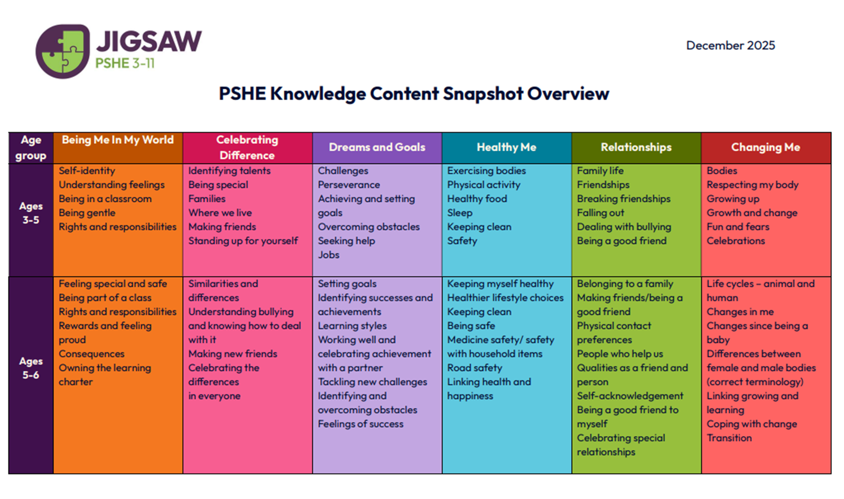

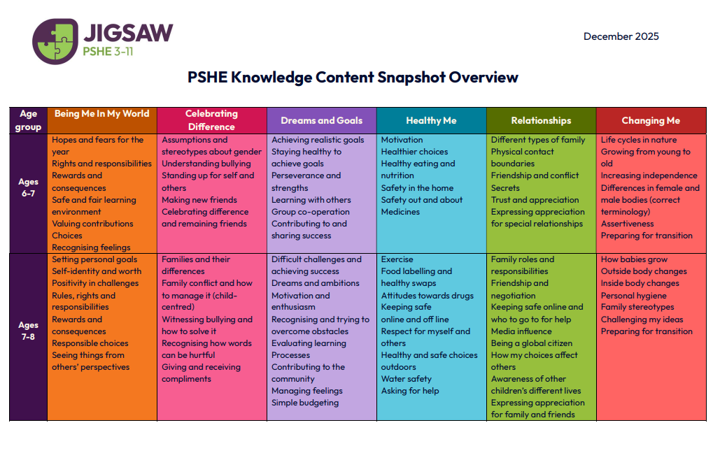

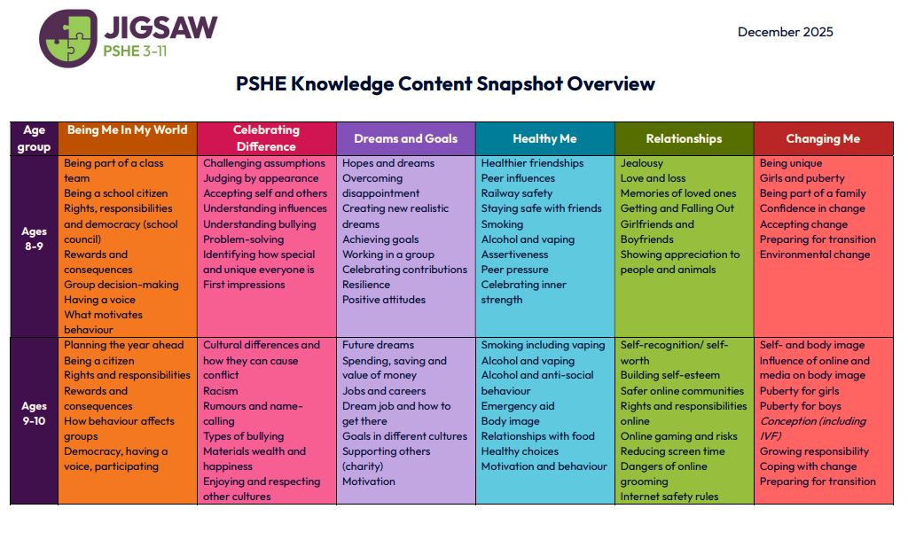
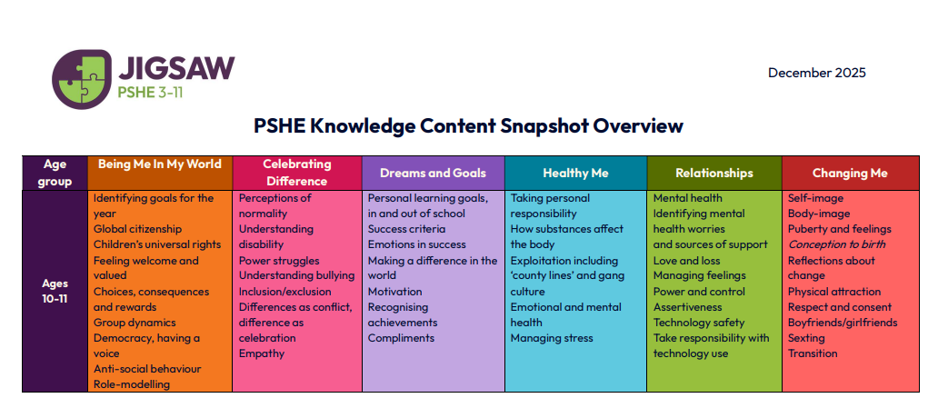

Working in Partnership with Parents:
The school recognises that it is vital that Relationships, Sex and Health Education is taught in partnership with parents and that parents and carers have a primary role in this. We wish to build a positive and supporting relationship with the parents of the children at our school through a mutual understanding, trust and co-operation.

In promoting this objective, we will:
- Inform parents about the School’s Relationships, Health and Sex Education Policy, its practice and the vocabulary used in its teaching;
- Inform parents by letter when pupils will be studying RSHE. Parents are invited to contribute to RSHE consultation opportunities.
- Answer any questions that parents may have about the relationships, sex and health education of their child;
- Work in partnership with parents and pupils to develop our RSHE curriculum offer;
- Take seriously any issues that parents raise with teachers or governors about this policy or the arrangements for relationships, sex and health education within the school;
- Inform parents about the best practice known with regard to relationships, sex and health education so that the teaching in school supports the key messages that parents and carers give to children at home. We believe that, through this mutual exchange of knowledge and information, children will benefit from being given consistent messages about their changing body and their increasing responsibilities.

RIGHT OF WITHDRAWAL If despite this partnership work, a parent still wishes to withdraw their child from the Sex Education component of the curriculum (Relationships and Health Education cannot be withdrawn from) then this right will be upheld.

Working with the Wider Community
Elements of relationship and sex education can also be provided by a range of people in the wider community including health professionals, social workers, youth workers and visitors. This enhances our provision. If people other than school staff support RSHE provision, they will be made aware of and agree to abide by our RSHE polity before any support is given. It is important that visitors and external agencies do not take over this provision, as it is important a classroom teacher delivers as much content as possible, to highlight that PSHE and RSHE are things we can talk about at school. Furthermore, class teachers know their children, and will be best placed to support additional needs, or scaffold difficult and sensitive topics which may make a child feel vulnerable. Where possible, the class teacher should be the lead provider of PSHE and RSHE lessons.

Confidentiality, Safeguarding and Child Protection
RSHE will take place in a secure and supportive environment; however, the children will be made aware that teachers cannot offer unconditional confidentiality. All staff involved in delivering and supporting RSHE should be alert to the signs of abuse, neglect and exploitation.

Safeguarding - RSHE may bring about disclosures of safeguarding issues and all staff are conversant with the procedures for reporting their concerns. In these cases please refer to the school’s safeguarding policy. If this person believes that the child is at risk or in danger, they talk to the named Designated Safeguarding Lead (DSL) or deputy (DDSL) who will take the appropriate action.

Staff Training and Development

All staff are supported in the delivery of RSHE and specific opportunities for continuing professional development are available . As a minimum we commit to training all staff in specific elements of RSHE on a three yearly cycle.

Review and Monitoring
The Relationships and Sex and Health Education Policy is reviewed every year until 2026 by governors while statutory RSHE is embedded across the school. The RSHE programme is monitored and evaluated by the PSHE co-ordinator. This is done via lesson observations, staff and pupil consultation and review of children’s work.

Equal Opportunities
The school is committed to the provision of RSHE to all of its pupils. Our programme aims to respond to the diversity of children’s cultures, faiths and family backgrounds and meet any additional educational needs.

Chair of Governors ________________________ Date: _______________

Chair of Curriculum Committee ________________________ Date: _______________

Headteacher ________________________ Date: _______________

