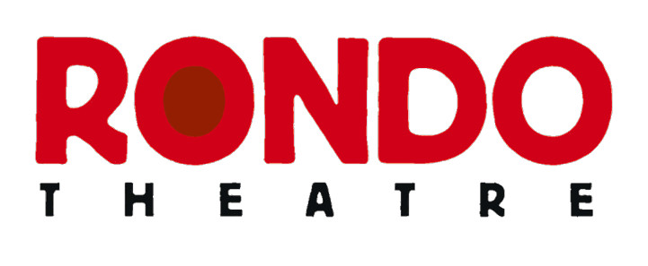


speaktomegabriel@gmail.com

RONDO DRAMA
AT NEWBRIDGE Yr3 - Yr8 Autumn 2026

Platforms Drama Club is teaming up with The Rondo Theatre to bring you an exciting
opportunity. You’ll get to devise a play in weekly sessions and then get to perform it under the lights of the Rondo stage in front of your family and friends.

Platforms is run by Paulo Baigent, Rondo Youth Director and Newbridge Primary School’s former specialist Drama teacher.

Thursday afternoons from 4.20 – 5.50pm in the Blue Room. There are a

maximum of 24 places and the first session is Thurs 9th September.

Safeguarding - I will bring the children to the gate beside the office when the club finishes to be handed over to parents. Parents are not permitted to wait on the school grounds until the end of the club or enter the hall/classroom where the club is taking place. If your child's club starts after the end of the school day, please leave the site and return at the appropriate time.

If your child has an EHCP or any additional needs, please get in touch with me
before booking to check whether this club will be suitable for them.

The cost is £90 for the Summer terms. The final session at Newbridge will be on
Thurs 26th Nov.

The dress rehearsal and show at The Rondo will be on Mon. 30th Nov. from
4 – 7pm. NB. If you sign up you must be available for the Monday performance.

To book places follow this link:

https://rondotheatre.co.uk/education/

