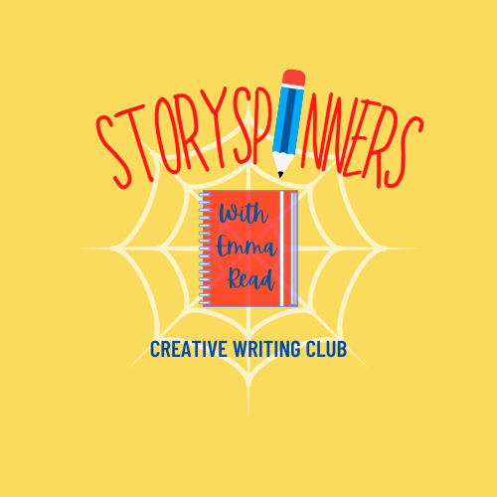
StorySpinners Creative Writing Club
Yr 4 – 6, Spring/Summer 2023

Join Emma Read, author of Milton the Mighty and The Housetrap, for a weekly burst of creativity!

StorySpinners is all about giving your child the space, the tools, and the permission to think creatively.
Over the course of the term, we will look at why we tell stories, and how. Where ideas come from and how to catch them. We’ll make people, worlds and exciting events. Retell history, and find our own stories, with an aim to building your child’s confidence in their own ideas and their ability to express them.

We meet weekly after school, and welcome creators of all abilities – so if you love writing stories, or want to be a writer, join us! Each session is led by me, Emma Read; as well as being a children’s author I am also a professional writing tutor, mentor and freelance editor, specialising in children’s fiction.

Sessions run on Friday afternoons from 3.15 – 4.15 in the spare classroom, from 5th May, running until the last session on 7th July. There are a maximum of 20 places

Safeguarding – I hold a current DBS certificate. I will bring the children to the gate beside the office when the club finishes, to be handed over to parents. Those in year 5 and 6 may make their own way home with parental permission. Parents are not permitted to wait on the school grounds or enter the classroom where the club is taking place.
Payment must be made in advance for the full amount (nine weeks). Please pay £67.50 by BACS to:
Emma Dykes
HSBC Sort Code 40-18-04 Account no. 21548670

To book places, please contact Emma directly at emdash_ed@outlook.com and include the following:

- name of child and class,
- whether they will be picked up or will make their own way home (year 5/6 only)
- two emergency contact numbers
- Any medical conditions, accessibility requirements, or special needs

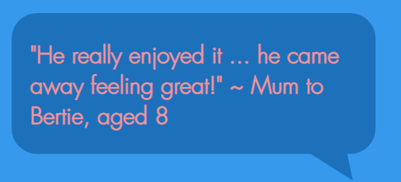
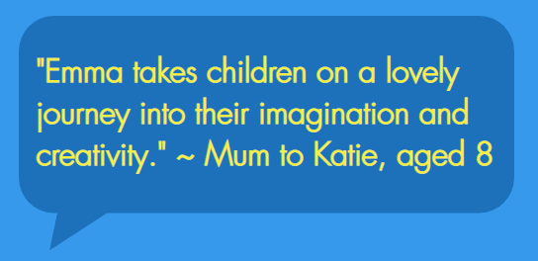
Emma will contact you to confirm the place by return email. All information is held in accordance with UK GDPR legislation. Find me at: https://www.emmareadauthor.com/

