
Newbridge Primary
School
Behaviour Policy

Author: Alex Bacon
Role: SENDCo, Mental Health and Behaviour Lead
Review date: May 2026
To be reviewed: Annually
Review date: May 2027

1

Rationale
At Newbridge Primary School, we encourage mutual respect, care and concern for others. As a school we want our pupils to develop a clear view of right from wrong and to feel safe, secure, and valued. We want them to appreciate the needs of others and of the community around them. The School Values underpin all school life and are used as a way of encouraging and rewarding children for:

Learning and Communication Creativity and Imagination Personal Development Collaboration
Citizenship

AIMS
At Newbridge Primary School, we aim to ensure that every member of the school community feels valued, respected and treated fairly. We are a caring and inclusive community, built on mutual trust and respect. This policy has been developed in consultation with staff, parents and pupils and complies with Section 89 of the Education and Inspections Act.
We recognise that behaviour is influenced by a range of factors, including special educational needs and disabilities (SEND). We work in partnership with parents and carers to support pupils whose behaviour may be affected by additional needs, ensuring appropriate support and reasonable adjustments are in place.
We have high expectations of behaviour because they promote positive relationships and enable all members of the school community to work together successfully. We expect everyone to act with respect, responsibility and consideration, contributing to a positive and purposeful environment.
This policy supports pupils to develop into confident, responsible and independent individuals within a safe and secure setting. We prioritise the recognition and reinforcement of positive behaviour, while responding to inappropriate behaviour in a fair and consistent way.
Our approach is focused on teaching and promoting positive behaviour, rather than simply deterring negative behaviour. The strategies and resources used to support this are outlined in the appendices.

EXPECTATIONS
All pupils are taught our Newbridge Primary School Behaviour Expectations. We refer to our Behaviour Buddies: Respectful Robin, Responsible Ravi and Safe Sam in Assemblies and as part of a taught behaviour Curriculum: Newbridge Primary School Routines

STATUTORY FRAMEWORK AND LEGAL DUTIES
This policy is informed by and must be applied in line with the following legislation and guidance.

Key statutory and non-statutory guidance:
- DfE: Suspensions and permanent exclusions guidance (August 2024) Suspension and permanent exclusion guidance
- DfE: Behaviour in Schools: advice for headteachers and school staff (February 2024). Behaviour in Schools Advice for headteachers and school staff February 2024.
- DfE: Searching, screening and confiscation: advice for schools (July 2022). DfE Searching, Screening and Confiscation Advice for Schools

- DfE: Use of reasonable force: advice for headteachers, staff and governing bodies (July 2013; reviewed July 2015). Use of Reasonable Force: advice for headteachers, staff and governing bodies
- Keeping Children Safe in Education (statutory safeguarding guidance; updated annually). Keeping Children Safe in Education
- Working Together to Safeguard Children (statutory guidance). Working Together to Safeguard Children
- Working Together to Improve School Attendance (guidance). Working Together to Improve School Attendance
- Trauma Informed Behaviour Policy Guidance produced by the Local Authority

Key legislation:
- Education Act 2002 (as amended by the Education Act 2011).
- Education and Inspections Act 2006.
- Education Act 1996.
- School Discipline (Pupil Exclusions and Reviews) (England) Regulations 2012.
- Education (Provision of Full-Time Education for Excluded Pupils) (England) Regulations 2007 (as amended).
- Equality Act 2010.
- Children Act 1989 and Children Act 2004.
- Mental Health and Behaviour in Schools

All behaviour decisions at Newbridge Primary School are made in line with these duties, with safeguarding and equality at the centre of practice.

POLICIES TO READ IN CONJUNCTION
This policy should be read alongside the school policies:
- Safeguarding and Child Protection Policy
- SEND Policy and Information Report
- Anti-Bullying Policy
- Positive Handling
- Equality and Inclusion Policy
- Attendance Policy
- Online Safety Policy
- PSHE/RSE Education Policy.
- Complaints Procedure
- Health and Safety Policy

RECOGNITION AND REWARDS
All staff follow the agreed system of day-to-day recognition that is part of our Behaviour Expectations. Across the whole school staff use these Expectations, the Behaviour Buddies and the Newbridge Routines to affirm positive behaviour and learning or demonstration of the school values. In the lower school, pupils can receive a sticker as a reward. Positive behaviour is not rewarded by the giving of gifts and presents.

Staff can send children to members of the Senior Leadership Team in recognition of demonstrating the school values, good learning or positive behaviour.

Celebration Certificates are awarded to two children per class per week at weekly celebration assemblies. These certificates are in line with the school values and/or learning behaviour that we promote. Class teachers keep a record of who receives a certificate to ensure that all children are recognized throughout the year.

House Points

Pupils are divided into four school houses.

House points are given as a reward to children when they demonstrate the school values. House points are totalled on a weekly basis.

The winning house will be celebrated in assembly.

House points can be given at any point during the school day, including break times.

In Lower School Classes, the House Point system will be supported visually by Class Dojo.

Focusing on Positive Behaviour

The management skills of all staff are crucial to the achievement of positive standards of behaviour. At Newbridge we place emphasis on positive relationships between all staff and pupils and use positive affirmation (describing the behaviour we expect to see, rather than focussing and singling out a pupil for a more negative behaviour).

The Newbridge Behaviour Expectations system is followed to support behaviour. See Appendix 1.

Recording Behaviour Incidents

Behaviour incidents will be communicated between staff. Incidents will be recorded on SIMS and discussed by the Senior Leadership Team on a weekly basis. This system is a guide and will be applied flexibly. Staff will use professional judgement, taking into account context, individual needs (including SEND), and safeguarding considerations

MANAGING MISBEHAVIOUR
The following misbehaviours are unacceptable. This list is illustrative and not exhaustive:

Low-level disruption: persistent calling out, interrupting, distracting others, ignoring instructions, running indoors, unsafe play.

Rudeness, unkindness or disrespect towards others; deliberate disruption of learning.

Refusal to follow reasonable instructions; leaving supervised areas without permission.

Swearing or offensive language; repeated inappropriate language.

Damage to property (school or personal), theft or bringing prohibited items.

Bullying behaviour including online bullying; discriminatory language or behaviour (racist, sexist, homophobic, transphobic, disablist, religious intolerance).

Child-on-child abuse including sexual harassment or harmful sexual behaviour (always addressed via safeguarding procedures).

Physical aggression, fighting, threats, intimidation or behaviour that places others at risk.

Any behaviour that seriously compromises the safety or welfare of pupils or staff.

DISCRIMINATORY BEHAVIOUR AND CHILD-ON-CHILD ABUSE
At Newbridge Primary School we do not accept any discriminatory behaviour and any child-on-child abuse, including sexual harassment, will not be tolerated. All staff will log on My Concern any incidents of discriminatory behaviour and pupils will be supported to understand that this behaviour is unacceptable. We recognise that children can abuse their peers, including online abuse. It is important that incidents of abuse and harm are treated in line with the Safeguarding Policy.
Discriminatory behaviour is related to the protected characteristics set out in the Equality Act 2010: race, disability, sex, religion or belief, sexual orientation, gender reassignment, pregnancy or maternity.
At Newbridge Primary School incidences of discriminatory behaviour are viewed as a serious incident however
consideration will be given to the pupils age, stage and circumstance when dealing with cases of discriminatory
behaviour.

BULLYING
Definition of Bullying: ‘The repetitive, intentional hurting of one person or group by another person or group, where the relationship involves an imbalance of power. Bullying can be physical, verbal or psychological. It can happen face- to-face or through cyberspace.’
If there are concerns that a pupil is being bullied, staff will refer to the school’s Anti Bullying Policy and follow the appropriate procedures.

BEHAVIOUR OUTSIDE SCHOOL
The school may respond to behaviour outside the school site where it has repercussions for the orderly running of the school, poses a threat to another pupil or member of the public, or could adversely affect the reputation of the school.
Conduct outside the school premises, including online conduct, that the school might sanction pupils for include misbehaviour:

when taking part in any school-organised or school-related activity;

when travelling to or from school;

when wearing school uniform;

when in some other way identifiable as a pupil at the school;

that could have repercussions for the orderly running of the school;

that poses a threat to another pupil; or

that could adversely affect the reputation of the school.

The decision to sanction a pupil will be lawful if it is made on the school premises or elsewhere at a time when the pupil is under the control or charge of a member of staff of the school.

INVESTIGATING INCIDENTS AND DECISION-MAKING
Incidents must be investigated fully, by the member of staff who is best placed to gather this evidence.
This information must be shared with a senior leader. In all cases:

Incidents are investigated promptly, fairly and proportionately.

Pupils are given the opportunity to give their account (appropriate to age and needs).

The school considers context, patterns, SEND, trauma and safeguarding information.

The school considers whether reasonable adjustments are required.

The school considers alternative strategies and support before deciding on suspension where possible.

Decisions are based on the balance of probabilities and recorded with rationale.

The school will ensure that any sanction is reasonable, proportionate and lawful.

USE OF REASONABLE FORCE
All school staff have the power to use reasonable force to prevent a pupil from committing an offence, injuring themselves or others, or damaging property, and to maintain good order. Force will never be used as a punishment. All staff must be aware of and respond in line with DfE Use of reasonable force: advice for headteachers, staff and governing bodies (July 2013; reviewed July 2015).
All staff receive appropriate training in behaviour management, de-escalation and, where relevant, positive handling
Any use of force will be the minimum necessary, proportionate and recorded in line with the school’s Positive Handling Policy.

Note: DfE has announced that new guidance on restrictive interventions will come into effect on 1 April 2026; the school will update policies and training accordingly. This is still not available.

In line with Use of Reasonable Force: advice for headteachers, staff and governing bodies trained staff may use reasonable force where necessary to:

Prevent injury to a pupil or member of staff

Prevent serious damage to property

Prevent serious disruption to the learning environment

UNDERSTANDING BEHAVIOUR - A Behaviour Curriculum

All behaviour is a form of communication and has a function behind it. We are mindful that a pupil's behaviour may be impacted upon by special needs, disabilities & other factors. We will account for this in our decision making. Staff will also consider any emotional and mental health needs that may be impacting on a child’s behaviour.

Positive learning behaviours help pupils to be ready, focused and to rise to the challenges of learning. They also help to keep us safe at times, for example when we move around school using Fantastic Walking

We work with staff, pupils and families to better understand the function of behaviour and what the child is trying to communicate. We link this to neuro-science and teach it to pupils in an age-appropriate way. Pupils and adults are aware of the Triune Brain and how, when under stress, the creation of cortisol results in us ‘flipping our lids’.

Staff will also consider whether behaviour may indicate a safeguarding concern, including child-on-child abuse, and respond in line with safeguarding procedures.
The SENDCo and appropriately trained staff advise staff on knowing and understanding particular needs. (See Appendix 2.)

THE ROLE OF STAFF

It is the responsibility of all staff to ensure that the school’s expectations are upheld so that children behave in a responsible manner. Pupils are expected to be respectful, be responsible, and be safe.

Staff will talk to pupils to coach and support them to understand the different emotions they experience, why they occur and how to self-regulate. Adults will recognise, empathise, validate and label feelings whilst setting limits on behaviour and problem solving with the pupil.

Teachers should inform parents of incidents of inappropriate behaviour in line with the Newbridge Primary School Behaviour Expectations

The class teacher or appropriate staff will liaise with external agencies as required.
At playtimes, staff follow the agreed Newbridge Primary School Routines.

THE ROLE OF THE HEADTEACHER

It is the responsibility of the Headteacher, under the School Standards and Framework Act 1998, to implement this policy consistently throughout the school, and to report to the Governors, when requested, on the effectiveness of the policy. It is also the responsibility of the Headteacher to ensure the health, safety and welfare of all children in the school and staff.

The Headteacher supports the staff by implementing the policy, setting the standards of behaviour and by supporting staff in their implementation of the policy.

The Headteacher keeps records of all reported serious incidents of misbehaviour.

The Headteacher has the responsibility for giving suspensions to individual children for serious incidents. For repeated or very serious acts of anti-social behaviour, the Headteacher may permanently exclude a child. These actions are taken only after the school governors have been notified.

ROLE OF PARENTS/CARERS

We work collaboratively with parents/carers to support pupils to uphold the school’s values and expectations. We encourage supportive dialogue between home and school. Expectations are included on the Home School Agreement.

We expect parents/carers to support and reinforce the school’s Behaviour Policy and the Anti-Bullying Policy by demonstrating appropriate behaviour, both physical and verbal. Where parents/carers use inappropriate behaviour on school premises, the school may take appropriate action, including restricting access to the site, in line with DfE guidance on managing abusive behaviour from adults

If the school has to use reasonable sanctions as a result of a child’s behaviour, we expect parents/carers to support the actions of the school. If parents/carers have any concerns they should raise it with the Senior Leadership Team in the first instance. If the concern remains, they should contact the Headteacher and, thereafter, the school governors. If these discussions cannot resolve the problem, a formal grievance or appeal process can be implemented.

Parents/carers who are concerned that their child might be being bullied, or who suspect that their child may be the perpetrator of bullying, should contact their child’s class teacher immediately. Depending on the severity of the alleged offence, it may be appropriate for parents to contact the Phase Leader, Deputy Head or Headteacher. Parents/carers have a responsibility to support the school’s Anti-Bullying Policy and to actively encourage their child to be a positive member of the school.

THE ROLE OF GOVERNORS

The Headteacher has the day-to-day authority to implement the school’s Behaviour Policy and the Anti-Bullying Policy, but the Governors may give advice to the Headteacher about particular disciplinary issues. The Headteacher must take this into account when making decisions about matters of behaviour.

The Governing Body monitors the incidents of bullying that occur (see 8.4), and reviews the effectiveness of the school policy regularly. The Governors require the Headteacher to keep accurate records of all incidents of bullying and to report to the governors on request about the effectiveness of school anti-bullying strategies.

The Governing Body should respond within ten days to any request from a parent to investigate incidents of bullying. In all cases, the governing body notifies the Headteacher and asks him/her to conduct an investigation into the case and to report back to a representative of the governing body.
An overview of significant behaviour incidents will be reviewed at link governor meetings with the safeguarding team.

SUSPENSIONS: PROCESS AND PARENTAL INFORMATION

Suspensions and permanent exclusions are used in line with Suspension and Permanent Exclusion Guidance and will always be:

Lawful, reasonable and fair

Used as a last resort

Considerate of pupils’ SEND, vulnerability and circumstances

Only the Headteacher (or acting Headteacher) can decide to suspend a pupil. Any suspension must be in line with DfE: Suspensions and permanent exclusions guidance (August 2024) Suspension and permanent exclusion guidance

Definition

Suspension: a temporary removal from school for disciplinary reasons, for a fixed number of school days.

Internal isolation (sometimes referred to as internal exclusion) is not a formal suspension and does not count towards statutory suspension limits.

Permanent exclusion: a pupil is no longer allowed to attend a school (unless the pupil is reinstated by the Governing Body).

When a suspension is issued, the school will:

Inform parents/carers without delay (by phone where possible) and provide written notification in line with B&NES model letters found here.

State the reason(s), the length of suspension (start/end dates), and the expectations for behaviour.

State that the pupil must not be in a public space, unless authorised.

Provide work for the pupil and explain arrangements for marking/feedback as appropriate.

Explain parents’ right to make representations to the governing board and how to do so.

Notify the governing board and local authority as required by statutory guidance.

Education during suspension: the school will ensure appropriate work is set from day 1. Where a pupil is suspended for more than 5 school days in a term, or in cases of permanent exclusion, the local authority has a duty to arrange suitable full-time education from the sixth school day. The school will cooperate fully with the local authority and any alternative provision.

A decision to suspend a pupil should only be taken:

in response to a serious breach or persistent breaches of the school's behaviour policy; and

where allowing the pupil to remain in school would seriously harm the education or welfare of the pupil or others in the school.

Exclusion is appropriate where it is the final step in a process for dealing with disciplinary offences following a wide range of other strategies used without success. There will be some exceptional circumstances where, in the Headteacher’s judgement, it is appropriate to permanently exclude on a first offence. These are:

serious actual or threatened violence against another pupil or member of staff

sexual abuse or assault

supplying or in possession of an illegal substance

carrying an offensive weapon

In such cases the Secretary of State would not normally expect the PDC or an Independent Appeal Panel to reinstate the pupil.

Length of suspension:
The Headteacher may suspend for one or periods up to a maximum of 45 days in one school year.
- Short suspensions are often effective; however, the length of any suspension will be determined on a case-by-case basis.
- The school must set learning for the pupil during a suspension of more than one day, and a teacher should mark this.

Where a much longer suspension has been imposed, e.g., 15 days or more, the Headteacher must consider:
- how the child’s education will continue during this time. The school, under DfE guidelines, must provide and pay for alternative educational facilities from the sixth day of exclusion
- how the time can be used to address the child’s needs
- how best the child can be reintegrated to the school

Lunchtime suspension
Children can be suspended for the duration of the school’s lunchtime, especially if it is disruptive behaviour at lunchtime that is the cause of the problem. This equates to a suspension of one-half school day. Parents/carers have the same rights of appeal. Arrangements may need to be made for children who have free school meals.

Parental cooperation
Where a parent/carer refuses to comply with a suspension, whether at lunchtime or for longer periods, the
- school must consider the child’s safety in deciding what action to take.
- If the school is unable to resolve the situation it may be necessary to contact other support agencies), or contact the Local Authority for advice.

The Role of the Headteacher

Before deciding to suspend the Headteacher must:
- ensure that an appropriate investigation has taken place
- consider all the facts and firm evidence to support the allegation and consider the appropriate school policies.
- allow the child an opportunity to give their version of events
- check whether an incident was provoked, especially by either racial, homophobic, or sexual
- harassment
- if necessary, consult with other people, but not with anyone who may be later involved in a review of the decision, e.g., a member of the PDC.
Decisions will be made on the balance of probabilities. Where there is insufficient evidence, suspension will not be used.
Once the decision to suspend has been made, the Headteacher must immediately inform the governing body’s PDC (through the Chair of Governors if necessary or appropriate) and the Local Authority in the following circumstances:
- suspensions that result in the child missing more than 5 days in total in a term
- suspensions that result in the child not being able to take a public examination.

18. REINTEGRATION FOLLOWING SUSPENSION

Following a suspension, the school will hold a reintegration meeting with parents/carers and the pupil (where appropriate) to support a successful return. This meeting will: review what happened, restore relationships, agree support and targets, and ensure the pupil understands expectations and next steps. A model reintegration meeting letter can be found here.

PERMANENT EXCLUSION

Permanent exclusion is used only as a last resort, for the most serious breaches or persistent breaches where allowing the pupil to remain in school would seriously harm the education or welfare of others. The Headteacher will follow statutory guidance, DfE: Suspensions and permanent exclusions guidance (August 2024) Suspension and permanent exclusion guidance. They will ensure all notifications are made, and provide evidence to the governing board. The governing board will review the decision within statutory timescales and parents will be informed of the right to an Independent Review Panel where applicable. The school will use the model letters found here.

Neither the full governing body, nor the Pupil Discipline Committee (PDC) excludes pupils. Section 52 (1) of the Education Act 2002 states that only the Headteacher of a school can exclude a pupil. This is defined as including anyone who is acting as Headteacher on a temporary basis, for example, when the Headteacher is away from the school. The Headteacher should make it clear to everyone in the school who is in control when s/he is not on the premises.

It is the job of the PDC, following their Committee’s Terms of Reference, to decide if the Headteacher has taken
the right action in excluding the pupil, and whether the length of the exclusion is appropriate in the circumstances.

MANAGED MOVE AND DIRECTION OFF SITE

A managed move is an immediate move to another school where the child must be placed immediately on the roll of that school, and removed from the sending school roll. A managed move can only take place if the school has a place with no waiting list for that year and can take the child immediately.
Managed Move protocol can be found here: Exclusions: Advice and Guidance (August 2024) .

Off-site direction may only be used as a way to improve future behaviour and not as a sanction or punishment for past misconduct. Off-site direction should only be used where in school interventions and/or outreach have been unsuccessful or are deemed inappropriate and should only be used to arrange a temporary stay in Alternative Provision. Direction off Site protocol can be found here: Exclusions: Advice and Guidance (August 2024) .

SPECIAL EDUCATIONAL NEEDS AND DISABILITIES (SEND)

In some situations, the use of sanctions may be appropriate in order to support pupils to behave appropriately
enabling them to access the learning environment in a positive way but these will be purposeful, proportionate
and with the legitimate aim to protect the whole school community while taking account of a child's SEND. The adjustments needed for those pupils with Special Educational Needs and/or Disability (SEND), whose condition may at times affect their behaviour, are set out in Behaviour in Schools Advice for headteachers and school staff February 2024. ‘Behaviour expectations and pupils with Special Educational Needs and/or Disability (SEND)’.

The school can have children with a wide range of SEND. On occasions there may be children in the school with needs which cannot be met by the Behaviour Policy and Anti-Bullying Policy and it is not in their best interests to follow it. In situations such as this the school will use reasonable adjustments to ensure that something more individual is put in place. The school will make reasonable adjustments for pupils with SEND in accordance with the Equality Act 2010 to ensure fair and equitable treatment.

At Newbridge Primary School we are committed to helping every child thrive in their emotional and social development. We use the Emotional Literacy Support Assistant approach (ELSA) to help identify and support children that may need further help developing in these areas.
The school has two trained ELSA Teaching Assistants who are able to develop plans to work with parents, teachers and support staff to support pupils. Further information can be found in the school’s Mental Health Offer.

SEARCHING, SCREENING AND CONFISCATION
The school follows Searching, Screening and Confiscation Advice. Staff may search pupils (with or without consent where appropriate) for prohibited items, including:
- Knives or weapons
- Alcohol
- Illegal drugs
- Stolen items
- Tobacco and vaping products
- Fireworks
- Pornographic images
- Any item likely to be used to commit an offence or cause harm
Confiscated items will be disposed of safely and appropriately in line with DfE guidance.

23. DRUG AND ALCOHOL RELATED INCIDENTS

It is the policy of this school that no child should bring any drug, legal or illegal, to school. If a child will need prescribed medication during the school day the parent/carer should notify the school and ask permission for the medication to be brought. This should be taken directly to the office for safekeeping. Any prescribed medication needed by a child while in school must be taken under the voluntary supervision of a teacher or other adult worker. (See Medical Needs Policy)

The school will take very seriously misuse of any substances such as glue, other solvents, or alcohol. The parents/carers of any child involved will always be notified. Any child who deliberately brings substances into school for the purpose of misuse may receive a suspension, depending on the circumstances, in line with statutory guidanceIf the offence is repeated, the child will be permanently excluded, and the police and social services will be informed. Support will be given by the school nurse/other local services (early help) to ensure that children in this situation understand the physical, emotional and legal consequences of substance misuse.

If any child is found to be suffering from the effects of alcohol or other substances, arrangements will be made for that child to be taken home.

It is forbidden for anyone, adult or child, to bring onto the school premises illegal drugs. Any child who deliberately brings substances into school for the purpose of misuse may receive a suspension, depending on the circumstances, in line with statutory guidance The child will not be readmitted to the school until a parent/carer of the child has visited the school and discussed the seriousness of the incident with the Headteacher.

If the offence is repeated, permanent exclusion may be considered, depending on the circumstances.

If a child is found to have deliberately brought illegal substances into school and distributed them to others, permanent exclusion is likely to be considered, in line with statutory guidance.The police and social care will also be informed.

24. MOBILE PHONES/MOBILE DEVICES

Pupils are not permitted to bring a mobile phone or mobile device to school, this includes for any before/after school activity. In exceptional circumstances, and only by permission of the Headteacher, it may considered that a pupil can bring a phone to school. In this case, clear boundaries will be discussed between the Headteacher and the parent/carer. If these boundaries were breached, the Headteacher has the right to take necessary action in line with the Behaviour Policy, and revoke the permission.

25 MONITORING AND REVIEW
The Headteacher monitors the effectiveness of this policy on a regular basis. They also report to the Governing Body on the effectiveness of the policy and, if necessary, makes recommendations for further improvements.
Behaviour incidents will be:
- Recorded on SIMS and/or MyConcern
- Monitored regularly by the Senior Leadership Team
- Analysed to identify patterns, including for vulnerable groups (e.g. SEND and Pupil Premium pupils)
- Used to inform early intervention and support strategies

The Senior Leadership Team and Headteacher review records of misbehaviours.
It is the responsibility of the Governing Body to monitor the rate of suspensions and exclusions, and to ensure that this policy is administered fairly and consistently. The Governing Body will pay particular attention to matters of equality; it will seek to ensure that the school abides by the Equality Act and Schools advice from the Department for Education and that no member of the school community is treated unfairly because of race, religion or belief, gender, disability or sexual orientation.

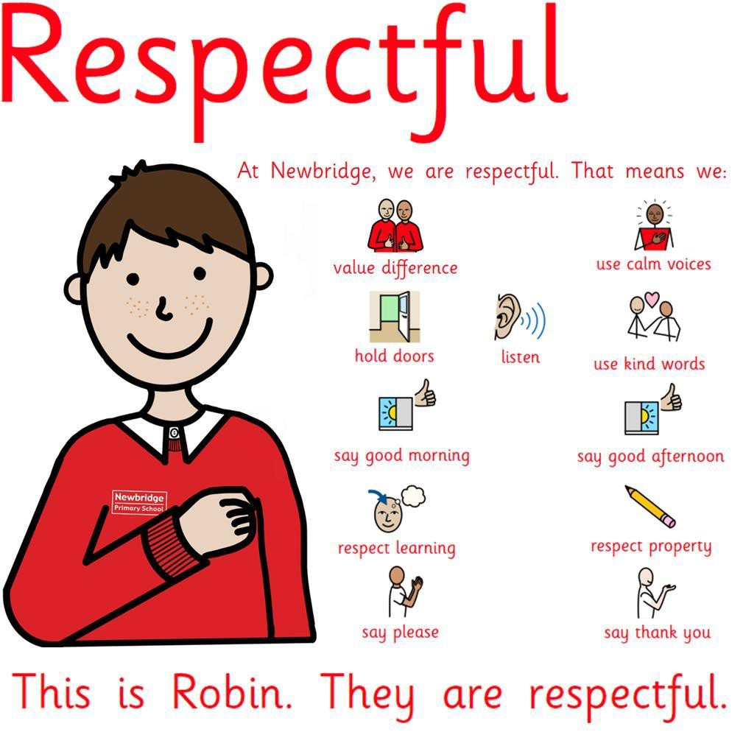
Appendix 1. Behaviour Buddies

10

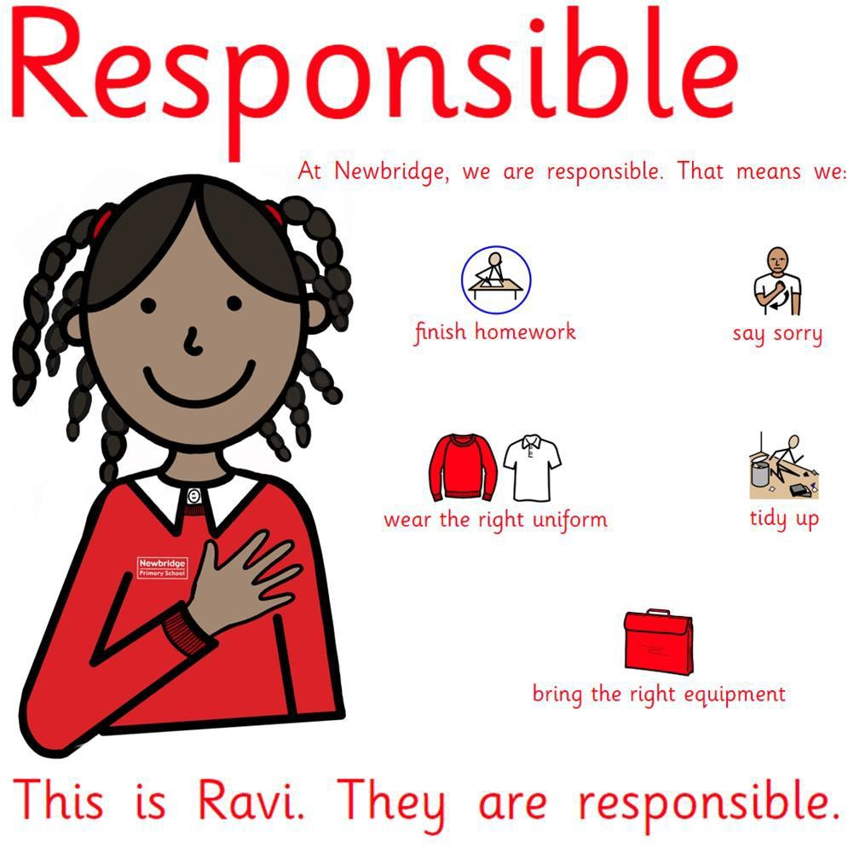

11

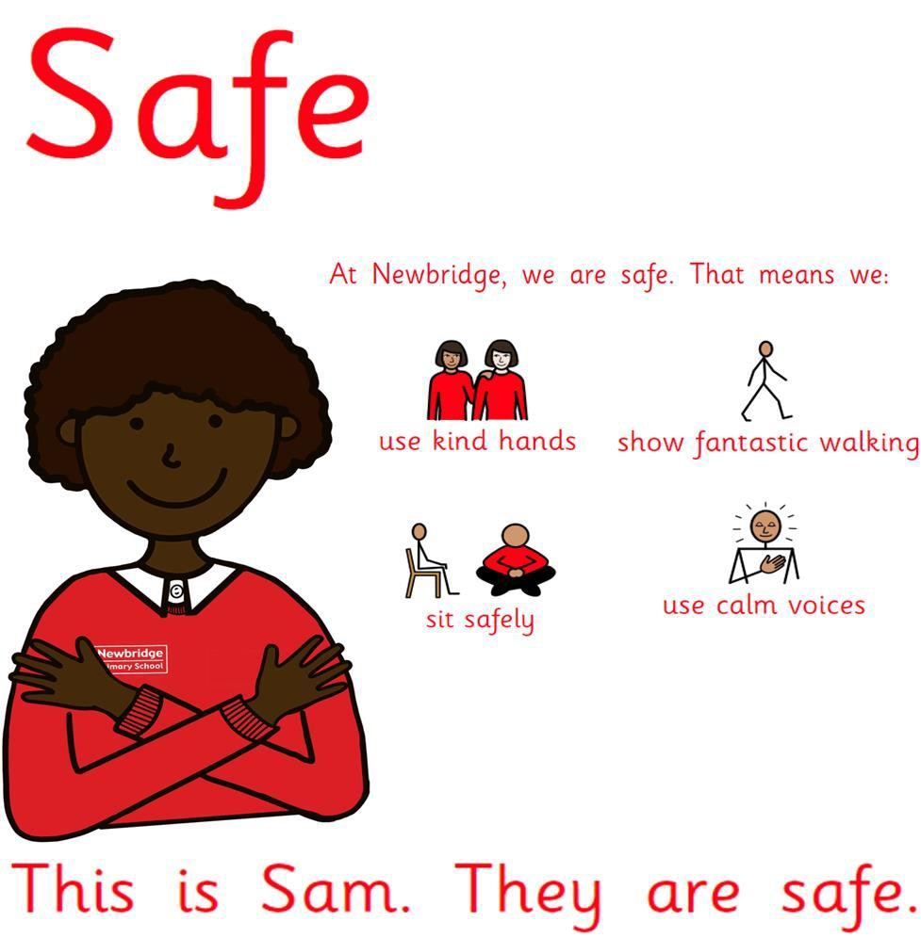

12


Appendix 2.**

Newbridge Primary School - Behaviour Consequences

Behaviour | Consequence | What staff need to do  Playground, Office / Class
One incident of breaking a routine or expectation | – Redirected to correct behaviour. Warning provided | Reminder of correct behaviour – positive affirmation of appropriate behaviours: being  respectful, being responsible and being safe
Second incident of breaking a routine or expectation  or  Rudeness to staff | – Child reminded of the expectation and asked to reflect on this for up to 5 minutes. | Facilitate a restorative conversation “At Newbridge, we…”  Add incident to SIMS/record in behaviour book Parent informed if behaviour persists
Continued incidents of breaking a routine or expectation  or  Aggressive or intimidating behaviour towards others, including the use of discriminatory language. | Removal from the classroom or playground | Telephone for ELSA, SENDCo or Senior Leadership Team (SLT) to remove the pupil from the classroom  Pupil completes work outside of the classroom  Teacher follows up with a restorative conversation at the next break/lunchtime  Add incident to SIMS/record in behaviour book  Parent informed with behaviour records to support conversation
Serious disruption to learning or the smooth running of the school – Refusing to follow any adult instruction, attempting to leave the school site, tipping tables, throwing objects, anything preventing the class teacher from teaching, Fighting with other pupils | Internal Suspension | Telephone Call for ELSA, SENDCo or SLT to remove the pupil from the classroom  Teacher or member of staff involved follows up with a restorative conversation  Pupils completes work outside of the classroom for the whole morning or afternoon  Teacher or a member of SLT informs the parents the same day  Add incident to MyConcern (if there are issues with pupil safety)
Continued serious disruption of learning, violence or abuse to an adult or other pupil, behaving in a way that puts the pupil or others at risk of harm  Bringing prohibited* items in to school including: Drugs/Alcohol/Solvents/Weapons/Mobile Devices | Suspension | Immediate removal from classroom or playground or removal of other children if child’s behaviour is putting them at risk.  Phone call home/discussion with Headteacher to inform them of the decision to exclude and their requirement to pick the child up from school.  Reintegration meeting the next day with a member of SLT, pupil and parent/carer.  Support from outside agencies if required.

Next Steps: Actions by Class Teacher or SLT Member

If a child accrues 5 Behavioural Points… Class Teacher Meets with the Child If a child accrues 10 Behavioural Points… Class Teacher Speaks to Family
If a child accrues 20 Behavioural Points… Phase Leader (SLT) Speaks to the Family

If a child accrues 25 Behavioural Points… Deputy or Headteacher Speaks to the Family

**It is important to note that all decisions around the next steps to support children at these stages will be taken after weekly discussion by SLT, taking contextual factors and timeframes around the incidents into account. If an incident or incidents are deemed serious, then action may be escalated.

Newbridge Primary School - Behaviour Expectations

There are three behaviour expectations in school. These are to be Respectful, Responsible and Safe.
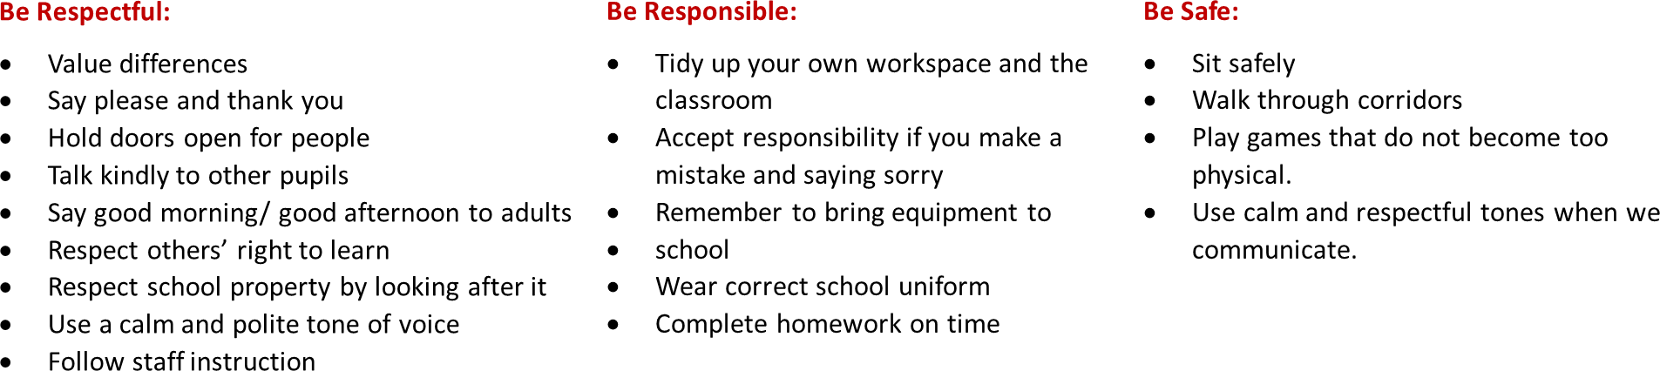

It is better to support pupils’ understanding through using positive affirmation, rather
than drawing attention to the negative behaviour. “At Newbridge, we…”

Appendix 3

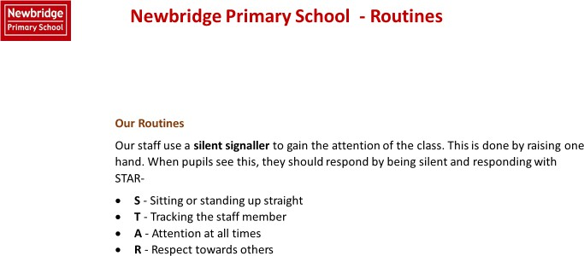


Newbridge Primary School - Routines

Fantastic Walking
Know that we walk around school using Fantastic Walking
Know that Fantastic Walking means -
- Facing forward
- Walking in a straight line
- Hands by side
- Without talking
- Without leaning on walls whilst waiting
- Know that we use Fantastic Walking to keep everyone safe in school and to make sure the learning of other children is not disrupted as people move around school.


Newbridge Primary School - Routines

Fantastic Listening
Know that we use Fantastic Listening in class. This means that we use STAR -
- S – Sitting or standing up straight
- T - Tracking the staff member
- A -Attention at all times
- R - Respect towards others
- Know that we all do Fantastic Listening to ensure everybody is able to learn without distractions.
- Know that pupils who do not follow school rules will have a consequence for this.


Newbridge Primary School - Routines
Fantastic Contributing
Know that we expect everyone to contribute in class. Fantastic Contributing means:
- Listening to the class teacher or whoever is speaking
- Considering my responses before sharing

Building on what others have said

Arriving at school at the beginning of the day

- Know that I arrive on me to school.
- Know that I walk calmly to our classrooms.
- Know that I greet staff with a smile and a ‘good morning’.
- Know that I hang my coat up, put my lunchboxes on the trolley and water bottle in the box.

Know that once I have entered the classroom, I do not leave again unless I have asked a
member of staff.
- know that I sit down in my seat as soon as I have entered the classroom and begin the morning task.

Newbridge Primary School - Routines

Transitioning within a lesson and at the end of a lesson

  - Know that when the staff member signals (1) I should stop what I am doing.
  - Know that when the staff member signals (2) I should tuck my chair in if seated and
stand up if sat down.
  - Know that when the staff member signals (3) I should move to my table/line up.
  - Know that when I am lining up, I should be quiet.

Completing work in books

  - Know that I should date every piece of work.
  - Know that if I am writing a title, I must underline it with a ruler.
  - Know that I should always write neatly and clearly, with joined up handwriting.
  - Know that I should always start writing from the margin.
  - Know that in Maths, I should use one digit per box.
  - Know that in Maths, I should always leave a one square space between calculations
  - Know that whenever I am drawing lines, I should use a ruler.
  - Know how to correct mistakes by drawing a straight line through your work, using a ruler.


Newbridge Primary School - Routines

End of the day routine

- Know that when a staff member signals (1), I should collect my things for home and return to the classroom immediately and either sit on the carpet or at my table.
- Know that when the staff member signals (2) I should stand up and tuck my chair in or stand up if on the carpet.
- Know that when the staff member signals (3) I should move to my line space quietly.
- Know that I should wait quietly whilst my class is dismissed.

General classroom expectations

- Know that I should stay in my seat during lessons unless asked to leave it.
- Know that I should use the toilet at break and lunchtime so as not to interrupt learning time.
- know that my table should be clear of objects to help me to focus on my learning and manage my distractions.
- Know that I have a responsibility to ensure that the classroom is kept tidy.
- know that I should be an active listener when a member of staff or another pupil has been asked to talk, making sure I am fully focused at all times.

Newbridge Primary School - Routines

Using good manners

  - Know that I should always say 'please' when I am asking for something.
  - Know that I should always say 'thank you' when I receive something or someone does something nice for me.
  - Know that I should say 'Good morning/afternoon' to adults if spoken to.
  - Know that it is important to show gratitude to others by thanking people for what they have done for me.
  - Know that a calm and polite tone is respectful.

Newbridge Primary School - Routines

Playtime Behaviour
- Know that I must walk from my classroom to the playground using Fantastic Walking
- Know that I must play safely without hurting anyone.
- Know that I do not 'play fight' because I may hurt someone by accident.
- Know that I must be kind, by including people in my games and sharing equipment.
- Know that someone who Is kind behaves in a gentle, caring, and helpful way towards other people.
- Know that, when called, I must line up in my lining up order straight away.
- Know that I must walk to my classroom using Fantastic Walking.

Lunchtime
- Know that I use Fantastic Walking when walking to the dining hall.
- Know that I collect my food and sit down straight away, after saying 'thank you' to staff members
- Know that I should use anormal talking volume when in the dining hall. I should not be raising my voice.
- Know that I should use a knife and fork correctly.
- Know that I use good manners by saying 'please' and 'thank you' when someone gives me my food or a drink.
- Know that I should not leave my seat once I have sat down.
- Know that once I have finished, I clear any wrappers from my table and empty any left-over food into the correct bin.
- Know that I use Fantastic Walking when walking from the dining hall to the playground.

Appendix 4 Understanding Behaviour

How our brains respond to stress – Flipping our Lids How can this hand show us how our brains work?

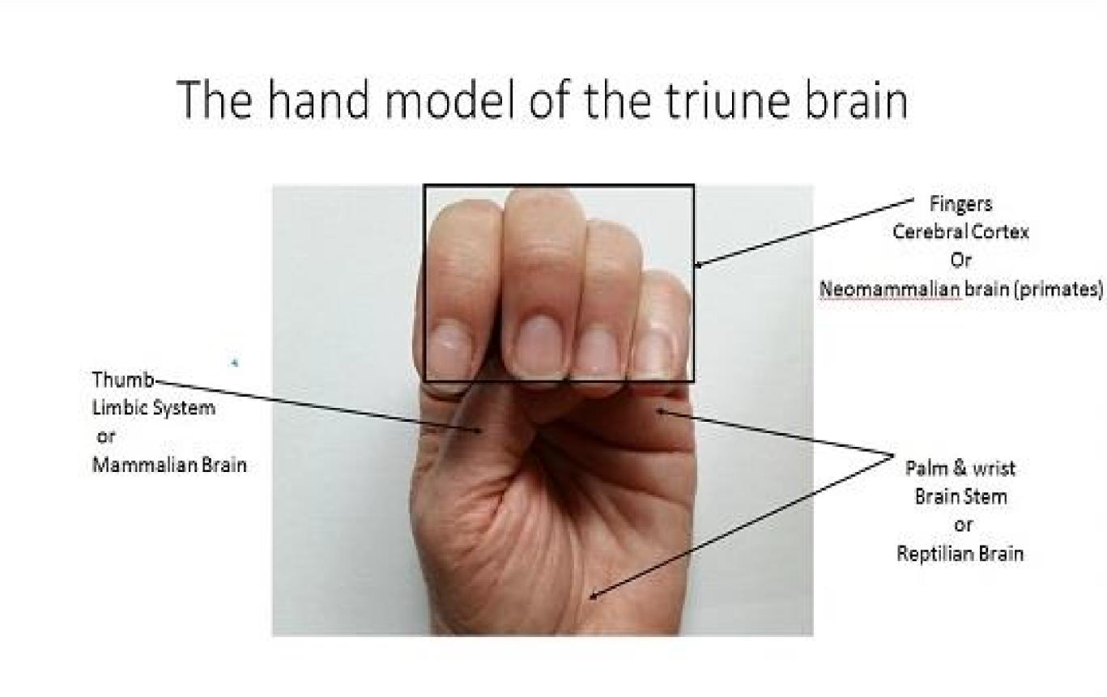

What happens to our brains when we flip our lids? Click on the link to watch this video. Triune
Brain.mp4

