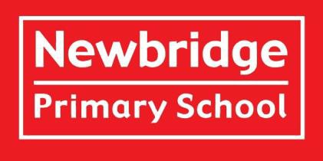

**Welcome to Year 1!**

**Meet the Teachers:**

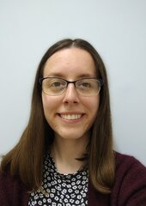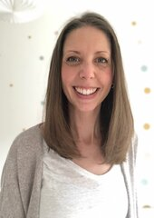

**Miss Hill**

1H

**Mrs Berridge**

1DB

**Mrs Derrien**

1DB

**Meet the Teaching Assistants:**

**Mrs Kamal**

1H

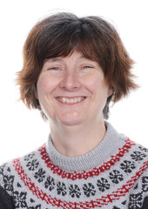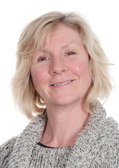

**Ms Hill**

1DB

**Welcome**

Welcome to Newbridge Primary School’s Year 1! We are excited to get to know your child/children. Please contact the school via telephone or email if you have something you wish to discuss with your class teacher.

**Meet the Team**  
**Class** 1DB is taught by **Mrs Derrien** (Mon – Wed AM) **and Mrs Berridge** (Wed PM – Fri).   
**Class** 1H is taught by **Miss Hill**.  
Our teaching assistants in Year 1 are **Ms Hill and Mrs Kamal.**

**Learning in Year 1**  
In Term 1, our enquiry is ‘What makes a hero?‘

This means we will be learning about ourselves and our heroes. You may like to ask your child about what they think makes a hero.

Our enquiries for the year include:

• How can we keep safe?

• Whatever next?

• Can you see it?

• How can we look after our planet?

• Why is this place special?

**Planning, Preparation and Assessment (PPA)**  
All teachers are entitled to 10% Planning, Preparation and Assessment (PPA) time. In term 1, this time will be taken on Wednesday morning and Mrs Hansard and Ms Auld will teach in year 1, alternating between 1H and 1DB each week.

**Overview of a Regular Day in Year 1**

In the mornings, we focus on teaching handwriting, Guided Reading, Maths, English and Phonics. We have break time at 10.20am followed by snack time at 10.35am. In the afternoons, we start by teaching Quick Maths, and then move on to other subjects such as Art, P.E, R.E, Science and P.S.H.E (Personal, Social & Health Education). We also teach Drawing Club, which encompasses many of the skills taught throughout the curriculum, through the love of stories. We have a break towards the end of the afternoon, and then either a class assembly or story.

**Drinks and Snacks**  
Please send your child in with a bottle filled with water every day.  
Snacks are provided every morning by the school.

**P.E.**

Our P.E. days are Tuesday and Friday. Children should come to school in P.E. kit on these days.

Long hair must be tied back and earrings must be removed or covered with tape provided from home.

**Toilets**  
The children can use the toilets in the classroom at any time during the school day.

**Behaviour and Rewards**  
At Newbridge Primary School, we use the *Behaviour Buddies* to model positive behaviour and share social stories with the children. Their names are Safe Sam, Responsible Ravi, and Respectful Robin.  
House points are used daily to reward children for modelling our school values and following behaviour expectations.   
Each week, two *Star of the Week* certificates are awarded in Assembly to children who have consistently demonstrated our school values and tried hard in their learning.

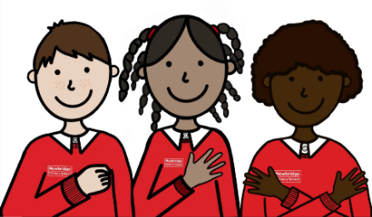

**Supporting Your Child’s Learning at Home**

**Reading at home** – As a school we place a high emphasis on reading. Please continue to read regularly with your child at home. Our aim is that every child reads at least 3 times a week at home, although daily is even better. The key thing to remember is little and often is best. It is also essential that you ask your child to retell what they have read and for you to ask them some questions about it. Comprehension skills are equally as important as decoding skills, to be a good reader your child must have both. Please look out for further information regarding the reading packs that will be sent out after the first few weeks of term 1.

**Reading Records and Phonics Logs** - The purpose of this book is to record a short, positive comment after reading with your child. Books will be changed every Monday, after a comment has been recorded. Please ensure that the Reading Record and reading books are kept in book bags and brought to school every day as we use these during Guided Reading and if we have reading volunteers. If you have any questions about your child’s reading, or their progress, please email the class teacher rather than writing comments in the book.

**Phonics** – Children will continue to have daily phonics sessions. All children will take part in the Phonics Screening Assessment at the end of Year 1. More information on this will follow later in the year.

**Maths** – We encourage children to practice their recall of number bonds to 10 and 20 (e.g. 7+3 = 10 and 17+3 = 20), along with reading and writing numbers to 100 and spelling numbers as words to 20. There is no requirement to record any of this home learning, simply discussing numbers and identifying them in the real world will help support their learning.

**What to Bring to School**  
Water bottles, waterproof coats, and book bags should be brought to school every day. Please ensure all items of clothing and belongings are named. We kindly ask that children do not bring toys or personal items from home. All stationery equipment is provided by the school.

**Inhalers**  
If your child requires an inhaler, please ensure there is an in-date one in school and that you have completed an indemnity form. This can be found on the school website by [clicking here].

**Volunteers**  
We are really pleased to be able to welcome volunteers into school starting in Term 2. If you would like to support with reading, maths, or have other skills you feel could benefit the children’s learning, please let us know. We would greatly appreciate the extra help and know from experience that the children benefit enormously from additional adult support.

**Contacting Us**  
If you wish to contact us about any concerns, however small, please get in touch via the school office using the email address: [**enquiries@newbridge.bathnes.sch.uk**](mailto:enquiries@newbridge.bathnes.sch.uk)

**Recommended Reads**

Again, this year, we are working on fostering a love of reading throughout the school. To this end we have chosen six books that we would like every child to read or have read to them over the year. These books have been carefully chosen by their class teachers and it is hoped that every child will, by July, have read every one.

Thank you very much for your anticipated support!

*The English team*

