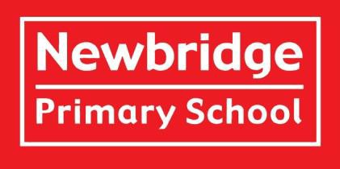

**Welcome to Year 5!**

**Meet the Teachers:**



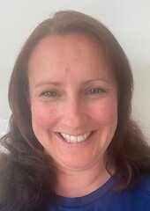



**Mrs Keep**

Class 5HK

**Mr Free**

Class 5F

**Mr Handson**

Class 5HK

**Meet the Teaching Assistants:**

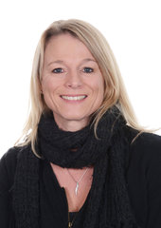

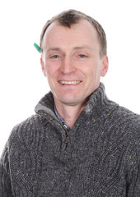

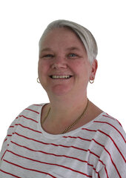

**Mr Ward**

Class 5F

**Mrs Van Gelderen**

Class 5F

**Mrs Dennis**

Class 5HK and 5F

**Welcome**

Welcome to Newbridge Primary School’s Year 5! We are excited to get to know your child/children. Please contact the school via telephone or email if you have something you wish to discuss with your class teacher.

**Meet the Team**  
**Class 5HK** is taught by **Mr Handson** (Monday, Tuesday and Wednesday mornings)and **Mrs Keep** (Wednesday afternoons, Thursday, Friday).  
**Class 5F** is taught by **Mr Free**.  
Our teaching assistants in Year 5 are **Mrs Dennis, Mr Ward and Mrs Van Gelderen.**

**Learning in Year 5**

In Term 1, our enquiry is ‘When is a robot better than a human?’ where we investigate the history and impact of robotics and technology.

In Term 2, our enquiry is, ‘Do you have what it takes to be an astronaut?’ where we take an in-depth look at our Solar System.

In Term 3, our enquiry is, ‘How did the Ancient Egyptians Make their mark?’ where we immerse ourselves in the history of Ancient Egypt.

In Term 4, our enquiry is, ‘Why is water important?’ where we learn about the journey of a river and the River Avon.

In Term 5, our enquiry is ‘When should we take risks? where we reflect on our time at Great Wood and navigate challenges.

In Term 6, our enquiry is “What does it mean to be British” where we explore the history of Britain through the Anglo-Saxons and Vikings.

**Planning, Preparation and Assessment (PPA)**  
All teachers are entitled to 10% planning, preparation and assessment time (PPA).

PPA time for Year 5 teachers is on Wednesday afternoon during terms 1, 2 and 3. During these sessions your children will be taught by Mr Wallace (P.E.) and Mrs Davies (Music) and will need to come to school in their P.E. kits.

**Overview of a Regular Day in Year 5**

When children arrive in the morning, they should come straight to the classroom for 8.45am. They will be completing ‘Quick Maths’ activities before the register. This will be followed by Maths and English every morning and foundation subjects in the afternoon. Morning break is at 10.15-10.30am. Lunch is 12 -1.00pm. Packed lunches then have their lunch in the Upper School Hall, while the children opting to eat school dinners, go to the Lower School Hall. The school day ends at 3.15pm and children are collected from outside the black gate.

**Drinks and Snacks**  
Please send the children with water and either fruit or vegetable as a snack for morning playtimes. Please name any snack pots or bags.

**P.E.**

Our P.E. days are Wednesday and Thursday when the children should come to school wearing full PE kit. Long hair must be tied back and earrings must be removed or covered with tape provided from home.

**Toilets**  
We encourage the children to use the toilet at playtimes although at the start of Year 5 we are more flexible with this. The children wash/sanitise their hands regularly throughout the day. Please let us know if there are any specific needs if you haven’t done so already.

**Behaviour and Rewards**  
At Newbridge Primary School, we use the *Behaviour Buddies* to model positive behaviour and share social stories with the children. Their names are Safe Sam, Responsible Ravi, and Respectful Robin.  
The star is used daily to reward children for modelling our school values and following behaviour expectations. At the end of the day, children will receive a sticker if they are on the star.  
Each week, two *Star of the Week* certificates are awarded in Assembly to children who have consistently demonstrated our school values and tried hard in their learning.

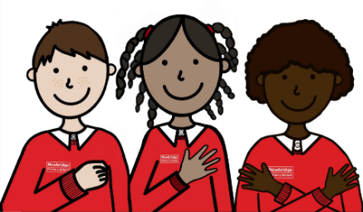

**Supporting Your Child’s Learning at Home**

**Reading at home**

Reading is an essential skill and we strongly encourage children to read on a daily basis. While we set time aside to read at school, we feel reading at home is essential. Therefore, we would like your child to read at least four times a week and record it in their Reading Record. Some children like to read independently, which is absolutely fine.

However, we do ask that adults take time to ask their children about the book they are reading and encourage them to discuss the characters and plot. We are also happy if children read aloud or to another sibling - every little helps.

**Spellings and Times Tables**

The list of this term’s spellings can be viewed on our website. Please look closely at these and support your child in learning the spelling patterns and words from the Year 5/6 spelling list. The children will be tested each Friday.

Please continue to practise times tables every week. Times tables are the foundations to many areas within mathematics and will support your child as the curriculum objectives become increasingly complex. We cannot stress enough how valuable knowing your tables to 12 x 12 is - so please help your child in learning those specific tables they have trouble with.

Please [click here](https://newbridge.bathnes.sch.uk/key-information/policies) find our Homework policy and our [class page](https://newbridge.bathnes.sch.uk/classes) on the website.

**What to Bring to School**  
Water bottles, waterproof coats, reading books and reading logs should be brought to school every day. The children will still be going into the playground if it is light rain. Please ensure all items of clothing and belongings are named. In Year 3, children do not need to bring in their own pencil cases as equipment is provided.

**Inhalers**  
If your child requires an inhaler, please ensure there is an in-date one in school and that you have completed an indemnity form. This can be found on the school website by [clicking here].

**Volunteers**  
We are really pleased that we will be able to have volunteers in school. If you would like to support with reading, maths (including times tables) or have any other skills that you feel would support the children’s learning, then please let us know. We would really appreciate the extra help and know from first-hand experience, that children benefit greatly from extra input from an adult. If you do have time to volunteer, please could you get in touch with Mrs Phillips in the office as we need to ensure that all DBS checks are up to date.

**Contacting Us**  
If you wish to contact us about any concerns, however small, please get in touch via the school office using the email address: [**enquiries@newbridge.bathnes.sch.uk**](mailto:enquiries@newbridge.bathnes.sch.uk)

**Recommended Reads**

Again, this year, we are working on fostering a love of reading throughout the school. To this end we have chosen six books that we would like every child to read or have read to them over the year. These books have been carefully chosen by their class teachers and it is hoped that every child will, by July, have read every one.

Thank you very much for your anticipated support!

*The English team*

