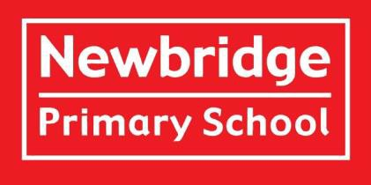

**Welcome to Year 6!**

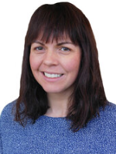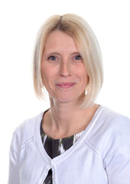**Meet the Teachers:**

**Mrs Ross**

Class 6KR

**Mrs Keynes**

Class 6KR

**Mrs Bartlett**

Class 6B

**Meet the Teaching Assistants:**

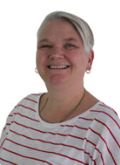

**Mrs Dennis**

**Welcome**

Welcome to Newbridge Primary School’s Year 6! We are excited to get to know your child/children. Please contact the school via telephone or email if you have something you wish to discuss with your class teacher.

**Meet the Team**  
**Class 6B**  is taught by **Mrs Bartlett**  
**Class** 6KR is taught by **Mrs Keynes (Mon, Tues, Wed) and Mrs Ross( Thursday, Friday)**.  
Our teaching assistants in Year 6 are **Mrs Dennis, Mrs Auld, Mrs Van Gelderen**.

**Learning in Year 6**  
In Term 1 and Term 2 our enquiry is ‘How can we learn from the past?’

This means we are learning about WW2 and how Britain coped with the onset of war.

In Term 3, our enquiry is ‘What makes us Human’ and we learn about our bodies and Human and Physical aspects of Scandanvia

In Term 4, our enquiry is ‘How do we celebrate culture and diversity’ and we learn about the ancient Mayan civilization.

In Term 5, our enquiry is ‘What makes us Newbridge’ where we learn about our local area and what makes us unique.

In Term 6, our enquiry is “What a performance” where we prepare for our production and moving on to secondary school.

**Planning, Preparation and Assessment (PPA)**  
All teachers are entitled to 10% Planning, Preparation and Assessment time (PPA).

PPA time for Year 6 teachers is on Thursday afternoon in Terms 1, 2 and 3. During these sessions your children will be taught by Mr Wallace (P.E) and Mrs Best – currently on maternity leave (Music).

**Overview of a Regular Day in Year 6**

When children arrive in the morning, they should come straight to the classroom for 8.45am. They will be completing ‘Quick Maths’ activities before the register. This will be followed by Maths and English every morning and foundation subjects in the afternoon. Morning break is at 10.15-10.30am. Lunch is 12 -1.00pm. Packed lunches then have their lunch in the Upper School Hall, while the children opting to eat school dinners, go to the Lower School Hall. The school day ends at 3.15pm and children are collected from outside the black gate.

**Drinks and Snacks**  
Please send the children with water and either fruit or vegetable as a snack for morning playtimes. Please name any snack pots or bags.

**P.E.**

Our P.E. days are Tuesday and Thursday and the children should come to school wearing full PE kit. Long hair must be tied back and earrings must be removed or covered with tape provided from home.

**Toilets**  
We encourage the children to use the toilet at playtimes. The children wash/sanitise their hands regularly throughout the day. Please let us know if there are any specific needs if you haven’t done so already.

**Behaviour and Rewards**  
At Newbridge Primary School, we use the *Behaviour Buddies* to model positive behaviour and share social stories with the children. Their names are Safe Sam, Responsible Ravi, and Respectful Robin.  
The star is used daily to reward children for modelling our school values and following behaviour expectations. At the end of the day, children will receive a sticker if they are on the star.  
Each week, two *Star of the Week* certificates are awarded in Assembly to children who have consistently demonstrated our school values and tried hard in their learning.

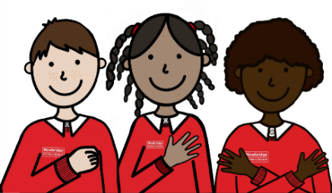

**Supporting Your Child’s Learning at Home**

**Reading at home**

Reading is an essential skill and we strongly encourage children to read on a daily basis. While we set time aside to read at school, we feel reading at home is essential. Therefore, we would like your child to read at least five times a week and record it in their Reading Record. Some children like to read independently, which is absolutely fine.

However, we do ask that adults take time to ask their children about the book they are reading and encourage them to discuss the characters and plot. We are also happy if children read aloud or to another sibling - every little helps.

**Spellings and Times Tables**

The list of this term’s spellings can be viewed on our website. Please look closely at these and support your child in learning the spelling patterns and words from the Year 5/6 spelling list. The children will be tested each Friday.

Please continue to practise times tables every week. Times tables are the foundations to many areas within mathematics and will support your child as the curriculum objectives become increasingly complex. We cannot stress enough how valuable knowing your tables to 12 x 12 is - so please help your child in learning those specific tables they have trouble with. You can use Times Table Rockstars to aid this.

**Year 6 Homework Expectations**

In Year 6, **Maths and English homework will be set every Monday** and should be handed in by the following Monday. Each piece of homework is designed to take around **30–45 minutes** and will help prepare the children for the demands of secondary school.

To help everyone stay organised and develop good habits, **any homework not completed and handed in on time will need to be finished during a lunchtime session.** We appreciate your support in helping the children build confidence and independence as they get ready for secondary school.

Please [click here](https://newbridge.bathnes.sch.uk/key-information/policies) find our Homework policy and our [class page](https://newbridge.bathnes.sch.uk/classes) on the website.

Children are encouraged to set up a ring binder folder at the start of the year, with dividers to separate different homework and assessments. This is used as a tool for revision in preparation for end of year SATs Assessments.

**What to Bring to School**  
Water bottles, waterproof coats, reading books and reading logs should be brought to school every day. The children will still be going into the playground if it is light rain. Please ensure all items of clothing and belongings are named. In Year 6, children do not need to bring in their own pencil cases as equipment is provided.

**Inhalers**  
If your child requires an inhaler, please ensure there is an in-date one in school and that you have completed an indemnity form. This can be found on the school website by [clicking here].

**Volunteers**  
We are really pleased that we will be able to have volunteers in school. If you would like to support with reading, maths (including times tables) or have any other skills that you feel would support the children’s learning, then please let us know. We would really appreciate the extra help and know from first-hand experience, that children benefit greatly from extra input from an adult. If you do have time to volunteer, please could you get in touch with Mrs Phillips in the office as we need to ensure that all DBS checks are up to date.

**Contacting Us**  
If you wish to contact us about any concerns, however small, please get in touch via the school office using the email address: [**enquiries@newbridge.bathnes.sch.uk**](mailto:enquiries@newbridge.bathnes.sch.uk)

**Recommended Reads**

Again, this year, we are working on fostering a love of reading throughout the school. To this end we have chosen six books that we would like every child to read or have read to them over the year. These books have been carefully chosen by their class teachers and it is hoped that every child will, by July, have read every one.

Thank you very much for your anticipated support!

*The English team*

