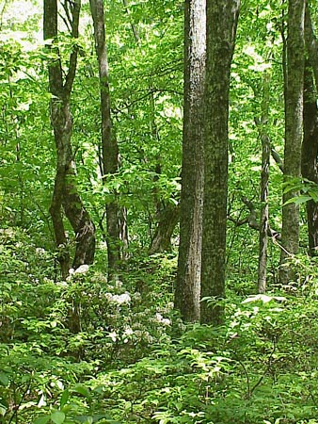

Dear Parents/Carers

**YEAR 5 FOREST SCHOOL CLUB**

**Year 5** Forest School (FS) club will take place on **Tuesdays** Term 5, April to May.

**What**: Forest school is a wonderful opportunity for your child to experience nature and the outdoor environment in a fun, creative and hands on way. The children are encouraged to play, make, explore and further their interest and wonder for the natural world.

A snack is provided, often cooked over fire, as well as a hot drink on cooler days.

**Where**: Forest School club takes place in the Wild Wood (although we may explore other areas of the school grounds from time to time).

on the school grounds.

**When**: Timings- 3.15pm – 5pm

**Dates**: Tuesdays 29th April, 6th, 13th, and 20th May

**Cost:** £38 for the term

**To Book**: please go to [cpforestschool.co.uk](https://www.cpforestschool.co.uk/) and click on ‘Book an Afterschool Club’ tab on top right hand of the page. Then click on ‘Newbridge Primary **Tuesday** Club’

*Please don’t hesitate to contact me with any queries, my email address is:*[pickmanclaire@gmail.com](mailto:pickmanclaire@gmail.com)

Many thanks indeed!

Claire Pickman

Forest School Leader

**07814028636**