Dear Parents/Carers

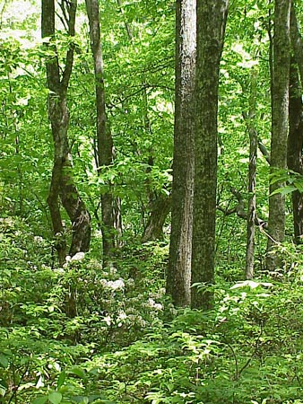

**YEAR 6 FOREST SCHOOL CLUB**

**Year 6** Forest School (FS) club will take place on **Thursdays** Term 5, April to May.

Just to note- this club is primarily open to yr 6, although if spaces are available, it will be opened up to year 5 as well.

**What**: Forest school is a wonderful opportunity for your child to experience nature and the outdoor environment in a fun, creative and hands on way. The children are encouraged to play, make, explore and further their interest and wonder for the natural world.

A snack is provided, often cooked over fire, as well as a hot drink on cooler days.

**Where**: Forest School club takes place in the Wild Wood (although we may explore other areas of the school grounds from time to time).

on the school grounds.

**When**: Timings- 3.15pm – 5pm

**Dates**: Thursdays 1st, 8th, 15th and 22nd May

**Cost:** £38 for the term

**To Book**: please go to [cpforestschool.co.uk](https://www.cpforestschool.co.uk/) and click on ‘Book an Afterschool Club’ tab on top right hand of the page. Then scroll down and click on ‘Newbridge Primary **Thursday** Club’

*Please don’t hesitate to contact me with any queries, my email address is:*[pickmanclaire@gmail.com](mailto:pickmanclaire@gmail.com)

Many thanks indeed!

Claire Pickman

Forest School Leader

**07814028636**