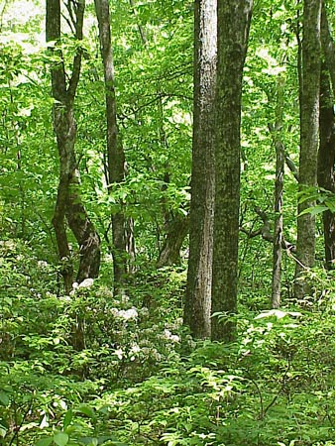

Dear Parents/Carers

RE: YEAR 6 FOREST SCHOOL CLUB

Year 6 Forest School (FS) club will take place on Wednesdays throughout Term 4 only.

Due to the nature of the activities, the children will need:
- Long sleeved top and trousers - there are lots of brambles and nettles about (these items of clothing may get very dirty – please only send play clothes). Please ensure the clothing is thick enough to prevent scratches/stings
- A waterproof coat and trousers – we go out in all weathers apart from exceedingly high winds and/or lightning. Waterproof trousers to all sessions please – there will be mud!
- Wellies/sturdy outdoor shoes- Wellies are good for wet and mud but definitely not warm so please send extra socks in cold weather (children can wear other appropriate play shoes in dry weather)

Please contact me via email, copying the completed slip below, if you wish to book your child on to Forest School club by Friday 20th Jan. I will email confirmation once the deadline has passed. Contact details: valair1@hotmail.com

The cost is £ 8.00 per session running from 3.15 – 5:00pm (4 sessions in total - £ 32) with snacks provided. The first session will be on Wednesday 22nd Feb and the last on Wednesday 15th March.

At the end of the session, I will bring the children out of the woodland side gate onto the pavement adjacent to the carpark.

Mrs Sarah Webb
Forest School Leader
07825 610145

If your child would like to participate in Forest School, please email this slip to valair1@hotmail.com along with payment via BACS: Mrs S V Webb, Account No. 11051187, Sort: 08 92 86. If unable to pay via BACs, then please contact me to arrange a cash payment. Please ensure payment is made by the week beginning 6th Feb.

Child’s name: Class:

Parent Email address: _______________________________________________

Medical and/or Dietary needs: ______________________________________________________

Emergency Contact Numbers: 1)___________________________2)_______________________

Is your child making their own way home? Yes/No

Signed_______________________________________ (Parent/Carer)

