Northbrook Primary
Academy

Mathematics Policy

Date of policy: September 2021
Review Date: September 2022

Northbrook Primary Academy
Mathematics Policy 2021

At Northbrook Primary Academy School, we want to ensure our children have access to a high-quality maths curriculum that is both challenging and enjoyable. We provide our children with a variety of mathematical opportunities, which will enable them to make the connections needed to enjoy greater depth in learning. We want to make sure children are confident mathematicians who are not afraid to take risks and fully develop independent learners with inquisitive minds who have secure mathematical foundations and an interest in self-improvement. We believe mathematics is an important part of children’s development throughout school, right from an early age.

Aims
Our school curriculum for mathematics aims to ensure that all pupils:
• Become fluent in the fundamentals of mathematics, including through varied and frequent practice with increasingly complex problems over time, so that pupils develop conceptual understanding and the ability to recall and apply knowledge rapidly and accurately.
• Reason mathematically by following a line of enquiry, conjecturing relationships and generalisations and developing an argument, justification or proof using mathematical language.
• Can solve problems by applying their mathematics to a variety of routine and non-routine problems with increasing sophistication, including breaking down problems into a series of simpler steps and persevering in seeking solutions.
These aims are in line with the Key stage one and two National Curriculum aims.
The national curriculum states ‘Mathematics is an interconnected subject in which pupils need to be able to move fluently between representations of mathematical ideas.’ However, pupils should make rich connections across mathematical ideas to develop fluency, mathematical reasoning and competence in solving increasingly sophisticated problems.

Approach to Maths teaching
At Northbrook Primary Academy our vison is:
•To promote a positive attitude towards mathematics in all pupils.
• To ensure all pupils are engaged in and are enjoying exploring Mathematics
• To enable all pupils to find links between mathematics and other areas of the curriculum, including Science
• To ensure all pupils progress in mathematics and are challenged appropriately through an in depth understanding
• To use a wide range of concrete, pictorial and abstract representations to develop all pupils’ relational understanding of mathematics
• To ensure all pupils are confident using mathematical vocabulary when reasoning about mathematics
• To promote a growth mind set in all pupils, particularly when Problem Solving

Implementation
The teaching and learning of Mathematics at Northbrook Primary academy follows a mastery approach.
We aim to embed a deep understanding of maths by employing a concrete, pictorial, abstract approach – using objects and pictures before numbers and symbols so that pupils understand what they are doing rather than just learning to repeat routines without grasping what is happening. We also ensure that we are teaching fluency, reasoning and problem solving to connect all Mathematical concepts.
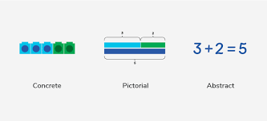

CONCRETE
Concrete is the “doing” stage, using concrete objects to model problems. Instead of the traditional method of mathematics teaching, where a teacher demonstrates how to solve a problem, the CPA approach brings concepts to life by allowing pupils to experience and handle physical objects themselves. Every new abstract concept is learned first with a “concrete” or physical experience. For example, if a problem is about adding up four baskets of fruit, the pupils might first handle actual fruit before progressing to handling counters or cubes which are used to represent the fruit.
PICTORIAL
Pictorial is the “seeing” stage, using representations of the objects to model problems. This stage encourages pupils to make a mental connection between the physical object and abstract levels of understanding by drawing or looking at pictures, circles, diagrams or models which represent the objects in the problem. Building or drawing a model makes it easier for pupils to grasp concepts they traditionally find more difficult, such as fractions, as it helps them visualise the problem and make it more accessible.

ABSTRACT
Abstract is the “symbolic” stage, where pupils are able to use abstract symbols to model problems. Only once a child has demonstrated that they have a solid understanding of the “concrete” and “pictorial” representations of the problem, can the teacher introduce the more “abstract” concept, such as mathematical symbols. Pupils are introduced to the concept at a symbolic level, using only numbers, notation, and mathematical symbols, for example +, –, x, / to indicate addition, subtraction, multiplication, or division.

What is Fluency?
Fluency comes from deep knowledge and practice.
This is the first stage of pupils’ understanding. When assessing pupils, if a child is fluent in a concept.
Fluency includes: conceptual understanding, accuracy, rapid recall, retention and practice Accuracy – Pupils carefully completing calculations with no or few careless errors.
Pace – Pupils are able to quickly recall the appropriate strategy to solve the calculation and progress through a number of questions at an age appropriate pace.
Retention – Pupils will be able to retain their knowledge and understanding on a separate occasion to when the concept was first introduced.
The key to fluency is deep knowledge and practice and making connections at the right time for a child.

What is Reasoning?
Verbal reasoning demonstrates that pupils understand the mathematics. Talk is an integral part of mastery as it encourages students to reason, justify and explain their thinking. This is tricky for many teachers who are not used to focusing on verbal reasoning in their mathematics lessons. You might, for example, get young learners to voice their thought processes. Older students could take part in class debates, giving them the space to challenge their peers using logical reasoning.

Mathematical Talk
A mastery classroom should never be a quiet classroom. The way pupils speak and write about 5 mathematics transforms their learning.
Mastery approaches use a carefully sequenced, structured approach to introduce and reinforce mathematical vocabulary.
To encourage talk in mathematics, teachers may introduce concepts by including sentence structures (stem sentences). Pupils should be able to say not just what the answer is, but how they know it’s right. This is key to building mathematical language and reasoning skills. This gives pupils the confidence to communicate their ideas clearly, before writing them down.
Example Stem Sentences: The denominator is 5 because the whole has been divided into 5 equal parts. The numerator is 3 because 3 equal parts have been shaded/circled.
Teachers then maintain a high expectation upon pupils to repeat and use the correct mathematical vocabulary to explain their understanding verbally and in their reflection comments. By also displaying the vocabulary during the lesson, pupils will be able to use this independently.

What is Problem Solving?
Mathematical problem solving is at the heart of the Mastery Approach. Pupils are encouraged to identify, understand and apply relevant mathematical principles and make connections between different ideas. This builds the skills needed to tackle new problems, rather than simply repeating routines without a secure understanding.

Planning
At Northbrook Academy we use the White Rose Maths hub for our long and medium term plans.

Long term plans
There is a termly overview for each year group from Year 1 to Year 6. Each term is split into twelve weeks. These overviews are designed to support a mastery approach to teaching and learning and support the aims and objectives of the 2014 National Curriculum. The overviews have number at their heart.

This is an example of Year 5 Long term plan/ yearly overview. It is arranged into blocks.

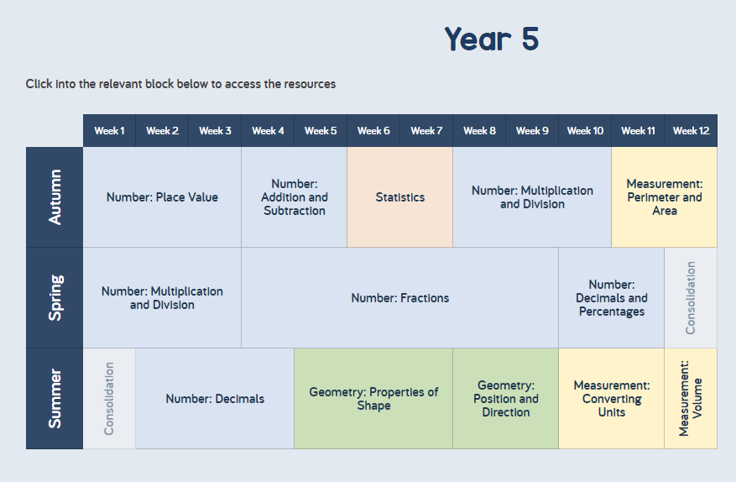

Medium Term plans
The White Rose Term by Term Objectives plan outlines all of the National Curriculum objectives that should be taught during each topic. The objectives outlined in the medium-term planning should directly inform the short term planning.

Short term Plans
Daily lesson plans should identify the purpose of the lesson - teach/practice/apply/assess and the content of the lesson should reflect this. The objective should be derived from the medium-term planning in line with the Primary Curriculum for mathematics 2014.Short term planning should be progressive, ensuring fluency and providing opportunities for reasoning and problem solving. The purpose and objective of the lesson should be based on the teacher’s ongoing assessment and should be adjusted whenever necessary to ensure progress.
A range of questions should be taken from the teacher’s guidance documents for each half term. Within the planning documents, there are notes and guidance, Mathematical Talk (including Stem Sentences) and examples of how to show Varied Fluency, Reasoning and Problem Solving.
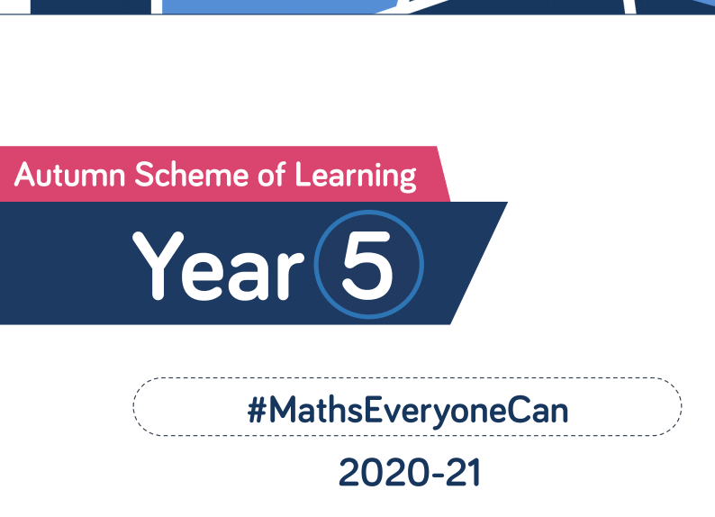
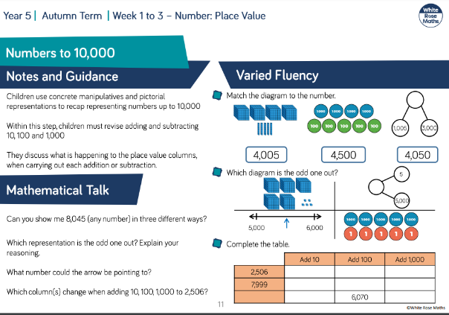

Maths in the Early Years
Teachers of the EYFS ensure the children learn through a mixture of adult led activities and child initiated activities both inside and outside of the classroom. EYFS planning is based on Development Matters and the Early Learning Goals (Number, Shape Space & Measure). Planning is based on the medium-term plans and delivered as appropriate to individual children with thought to where the children are now and what steps they need to take next.

Assessment and Tracking
Teachers will assess children’s work daily to ensure learning and teaching is adjusted for the needs of the children. Lancashire KLIPs form the basis of regular assessment. This formative assessment provides evidence for a termly review of the child’s attainment and progress. This means that the children’s progress is continually and accurately being reviewed against National Curriculum expectations across all of the attainment targets. The White Rose termly assessments will be used to support teachers’ judgments. NCETM Assessments will also give teachers additional evidence of progress.

Inclusion and Equality of opportunities
Our aim is to present a differentiated curriculum that extends and fulfils the needs and potentials of every learner. Our school aims to be an inclusive school. Within the teaching of Maths, we aim to ensure that all pupils regardless of gender, ethnic origin, cultural background or ability have full access to the Maths curriculum. Teachers respond to diverse learning needs so that pupils are appropriately supported and challenged to experience success in learning and achieve as high standard as possible. Through our Maths teaching, we provide learning opportunities that enable all children to reach their full potential. As part of our vision to enable each child to reach their full potential, children who, through teachers’ ongoing assessment, are considered at risk of not achieving their target will take part in maths interventions. These will take place in addition to the daily maths lesson. When appropriate, all children are exposed to their year group expectations. However, when progress falls significantly outside the expected range, the child may have special educational needs. In this instance, the child will be taught from the year group objectives appropriate to the needs of that particular child.
Differentiation is provided through:
• The modification of tasks and activities that take into account individuals’ strengths and weaknesses and enable them to participate at an appropriate level. All children are appropriately challenged throughout each topic.
• The provision of support by a teacher or TA
• The expectations of outcomes of tasks and valuing individual achievements and contributions.

Monitoring and review
Monitoring is carried out regularly by the Maths subject leader in the following ways:
• Informal discussion with staff and pupils
• Scrutiny of planning or books / lesson observation and informal drop-ins
• Observation of displays/ challenges
• Pupil Progress discussions and analysis of data Feedback is provided to senior managers following monitoring. It is used to inform CPD needs.
Any resource requirements are also identified and purchased according to needs and budget as stated in school development plan. This policy is a practical working document for the teaching and learning of Maths throughout the school. It is therefore subject to regular review in the light of experience, monitoring and changes.

Policy written by H. Hall

