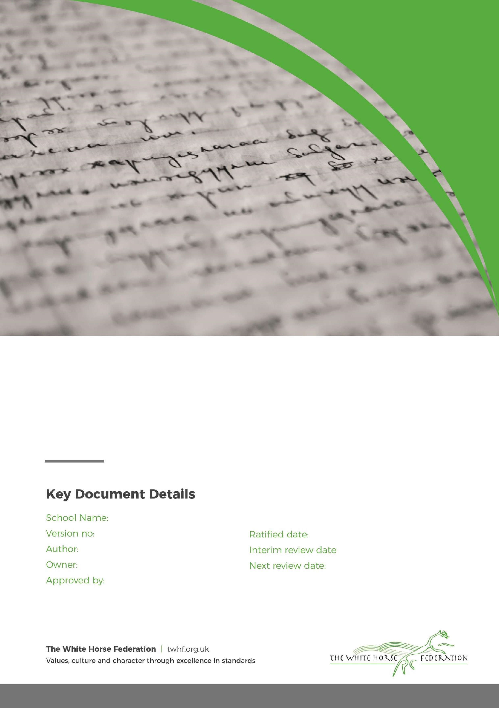

Special Education Needs (SEN)

Information Report

1

Georgina Birkett

Tim James

September 2024

September 2025

Paul Holroyd

Nyland School

March 2025

# **Dear Parents and Carers,**

The aim of this information report is to explain how we implement our SEND policy. We want to show you how SEND support works in our school.

If you would like to know more about our arrangements for supporting pupil with Special educational needs and disabilities (SEND), please read our SEND policy. You can find it on our website -[Click here for the link](https://www.nyland-pri.swindon.sch.uk/about-us/policies-procedures)

**Note:** If there are any terms we have used in this information report that you are unsure of, please see the Glossary at the end of this report.

# **1. What types of SEN does the school provide for?**

# Nyland School is a specialist school commissioned by Swindon Local Authority to address the social, emotional, and mental health (SEMH) needs of pupils. It caters to students from Nursery age up to Year 6, providing tailored support for children whose primary needs relate to SEMH challenges. The school offers various provisions, including:

1. **Full-time Classes**: The main school has six full-time classes for pupils with Education, Health, and Care Plans (EHCPs), specifically designed for students whose primary requirement is SEMH support.
2. **Short-term Alternative Provision**: Nyland School also runs a short-term class offering two-day placements. This service is available through an application process and provides interim support to pupils before they transition back to their mainstream school or other placements.
3. **Pupil Referral Unit (PRU)**: The school includes a PRU for students who have been permanently excluded from mainstream education, offering an focused environment to address their behavioural and emotional needs.

The admission arrangements for Nyland Special School, as outlined, work through a structured process involving SENRAP (Special Educational Needs Resources and Assessment Panel), which makes the key decisions about placing pupils at the school. The role of the school governors is to assess if the school can meet the specific needs of a child. If they feel the school is unable to do so, the matter is referred back to SENRAP for a final decision regarding the child’s placement.

(2-day placements) Referral Process. Any school in Swindon are able to refer pupils who are at risk of exclusion for a 2-day placement. A referral panel meets six times a year to allocate places.  Placements commence at the start of Term 1, 3 and 5 and last for the duration of two terms, in some circumstances an extension may be agreed by panel, but schools need to re-refer for this to be considered.

The placement panel for 2024-2025 is made up of local headteachers, representatives from Swindon Borough Council, SEMH outreach team representative and members of Nyland School staff.

All referrals for PRU placements can be made through [pruplacements@nyland-pri.swindon.sch.uk](mailto:pruplacements@nyland-pri.swindon.sch.uk) using the Nyland form (not the Swindon Borough Council FAP form) with signed consent.

Role in Assessments: Nyland Special School does not independently identify pupils with SEN, but they do contribute to statutory assessments when asked. They can also refer pupils for specific disability assessments, such as for Dyspraxia, Dyslexia, or ADHD, which may coexist with their SEMH (Social, Emotional, and Mental Health) needs.

Nyland school supports pupils with the following needs:

|  |  |
| --- | --- |
| **Area of need** | **Condition** |
| **Communication and interaction** | Autism spectrum disorder |
| Speech and language difficulties |
| **Cognition and learning** | Moderate learning difficulties |
| Severe learning difficulties |
| Specific learning difficulties, including dyslexia, dyspraxia, dyscalculia |
| **Social, emotional and mental health** | Attention deficit hyperactive disorder (ADHD) |
| Attention deficit disorder (ADD) |
| **Sensory and/or physical** | Visual impairment |
| Multi-sensory impairment |
| Physical impairment |
| Hearing impairments |

# **2. Which staff will support my child, and what training have they had?**

The school’s Special Educational Needs Coordinator (SENCO) is Georgina Birkett, she is an experienced and qualified SENCO With over 8 years’ experience in the role at Nyland School and has the National Award in Special Educational Needs Co-ordination, she has a deep understanding of the needs of students requiring additional support and brings both her teaching qualifications and her specialised knowledge in SEN to the role since 2016, helping to create an inclusive and supportive learning environment.

The first point of contact for SEND is Mrs. Georgina Birkett. She works five days a week can be contacted via phone on 07713669876 or by email on [gbirkett@nyland-pri.swindon.sch.uk](mailto:gbirkett@nyland-pri.swindon.sch.uk)

**Class teachers**

Our teachers are equipped with the necessary skills to support the diverse range of SEND in their classrooms. This is achieved through a combination of in-school training and external professional development opportunities. For situations that require specific interventions, staff are trained to deliver evidence-based programs that focus on supporting students in key areas such as reading, writing, and mathematics.

Our staff regularly receive training from external professionals to ensure they can meet the individual needs of students in their classes. Recent training has included the **Speech and Language therapist (SALT), school nurse medical needs training**, and **Attention Autism**.

Teaching assistants (TAs)

We have a team of approximately 22 Teaching Assistants who are trained to provide SEN (Special Educational Needs) support. All of our TAs are trained to deliver interventions that are appropriate for the key stage they work within, ensuring tailored support for students’ needs.

Throughout the school, a range of interventions is offered to support student development. Some of the interventions we deliver are:

* **Emotional Quotient**- (EQ) **Curriculum-** Supporting emotional intelligence
* **Zones of Regulation** – Developing emotional literacy
* **Precision Teaching**- Reinforcing learning in key areas
* **Read Write Inc- Phonics** – Implemented in EYFS, KS1, and KS2
* **Welcomm Speech and Language** – Promoting language skills
* **Reading Comprehension** – Improving understanding of texts
* **Times Tables** – Enhancing multiplication skills
* **Maths Fluency** – Increasing speed and confidence in math skills
* **One to one psychotherapy sessions**- Supporting pupils wellbeing

External agencies and experts

At times, additional support is necessary to ensure that our pupils receive the appropriate care and guidance. Whenever it is needed, we collaborate with external support services to address the individual needs of pupils with Special Educational Needs (SEN) and to provide comprehensive support to their families

These include:

* Speech and language therapists
* Educational psychologists
* SEMH outreach team
* ASD / SCIN outreach time
* Hearing Impairment Advisory teacher
* Visual Impairment Advisory teacher
* Physical disability Advisory teacher
* Diabetic nurse
* Occupational therapists
* GPs or pediatricians
* School nurses
* Child and adolescent mental health services (Be U Swindon, TAMHS & CAMHS)
* Education welfare officers
* Social services and other LA provided support services
* Young Carers
* Voluntary sector organisations

# **3.What should I do if I think my child has SEN?**

If you believe that your child may have Special Educational Needs (SEN), please schedule a meeting with the Class Teacher to discuss your concerns.

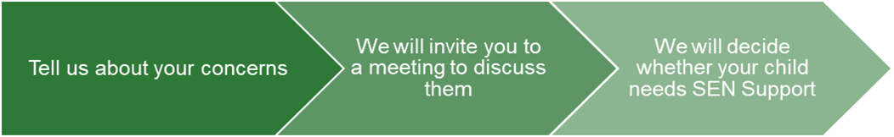

|  |  |  |
| --- | --- | --- |
| If you think your child might have any additional SEN needs, the first person you should tell is your child’s teacher. Please call or email the school to request a call back to discuss this with you.  They will pass the message on to our SENCO, Georgina Birkett who will be in touch to discuss your concerns.  You can also contact the SENCO directly. | We will meet with you to discuss your concerns and try to get a better understanding of what your child’s strengths and difficulties are.  Together we will decide what outcomes to seek for your child and agree on next steps.  We will make a note of what’s been discussed and add this to your child’s record. You will also be given a copy of this. | If we decide that your child needs any further SEN support, we will formally notify you in writing. |

# 

# **4. How will the school measure my child’s progress?**

We will follow the ‘graduated approach’ to meeting your child’s SEN needs.

The graduated approach is a 4-part cycle of **assess, plan, do, review**.

**Assess**

**If your child is not making the expected level of progress, we will make an assessment to find out what strengths and difficulties your child has.** **We will ask for you and your child’s input, as well as getting help from external professionals where necessary.**

**Review**

**We will assess how well the support we put in place helped the pupil to meet the outcomes we set. We will use our improved understanding of   
your child’s needs to improve the support we offer.**

**Plan**

**In discussion with you and your child, we will decide what outcomes we are hoping to achieve. We will make a plan of the support we will offer your child to help them meet those outcomes. We will make a record of this and share it with you and all relevant school staff.**

**Do**

**We will put our plan into practice.**

**The class teacher, with the support of the SENCO, will be responsible for working with your child on a daily basis, and making sure the support we put in place is having the impact we intended.**

As a part of the planning stage of the graduated approach, we will set outcomes that we want to see your child achieve.

Whenever we run an intervention with your child, we will assess them before the intervention begins. This is known as a ‘baseline assessment’. We do this so we can see how much impact the intervention has on your child’s progress.

We will track your child’s progress towards the outcomes we set over time and improve our offer as we learn what your child responds to best.

This process will be continual. If the review shows a pupil has made progress, they may no longer need the additional provision made through SEN support. For others, the cycle will continue and the school's targets, strategies and provisions will be revisited and refined.

# **5. How will I be involved in decisions made about my child’s education?**

We will provide an annual report on your child's progress. Your child’s class teacher will also facilitate an annual review of the pupils EHCP and meet you regularly to review progress towards those outcomes in addition to this your child’s teacher will

* Discuss the support we will put in place to help your child make that progress
* Identify what we will do, what we will ask you to do, and what we will ask your child to do
* Identify what we will do, what we will ask you to do, and what we will ask your child to do

The SENCO may also attend these meetings to provide extra support.

We recognise that you are the expert when it comes to your child’s needs and aspirations. That's why we want to ensure you have a complete understanding of how we are addressing those needs. Your insight is invaluable, and we encourage you to share what you believe will work best for your child as we work together to support their growth.

We also want to hear from you as much as possible so that we can build a better picture of how the SEN support we are providing is impacting your child outside of school. If your child’s needs or aspirations change at any time, please let us know right away so we can keep our provision as relevant as possible.

After each discussion, we will document all agreed-upon outcomes, actions, and support measures. This record will be shared with all relevant staff members, and you will also receive a copy for your reference.

If you have concerns that arise between these meetings, please contact your child’s class teacher by calling the office and leaving a message or emailing directly.

# 

# **6. How will my child be involved in decisions made about their education?**

The level of involvement will be tailored to your child’s age and level of competence. We understand that every child is unique, so we will approach each situation on a case-by-case basis, incorporating your input to ensure the best support for your child.

We may seek your child’s views by asking them to:

* Attend meetings to discuss their progress and outcomes
* Prepare a presentation, written statement, video, drawing, etc.
* Discuss their views with a member of staff who can act as a representative during the meeting
* Complete a survey

**7. How will the school adapt its teaching for my child?**  
Your child’s class teacher is responsible for their progress and development, ensuring that each child receives the necessary support tailored to their individual needs.

The school places a strong emphasis on high-quality teaching as the foundation for responding to individual student needs, teachers are well-trained and use effective methods to engage students.

The school ensures that all students have access to a well-rounded education, covering a wide range of subjects and skills, regardless of any challenges they may face.

The school recognises that every student is unique and that there isn’t a "one-size-fits-all" approach. Instead, they assess each child’s needs and adapt their teaching methods accordingly. This personalised approach makes the learning experience more meaningful and effective for each student. This inclusive and flexible teaching philosophy ensures that all students, including those with special needs or learning differences, can succeed.

These adaptations include:

* Adapting our curriculum to make sure all pupils are able to access it, for example, by grouping, 1-to-1 work, adapting the teaching style or content of the lesson, etc.
* Adapting our teaching, for example, giving longer processing times, pre-teaching of key vocabulary, reading instructions aloud, etc.
* Adapting our resources and staffing
* Using recommended aids, such as laptops, coloured overlays, visual timetables, larger font, etc.
* Teaching assistants will support pupils on a 1-to-1 basis when needed
* Teaching assistants will support pupils in small groups when

We may also provide the following interventions:

|  |  |  |
| --- | --- | --- |
| **Overview of interventions**  (This is not an exhaustive list of support and interventions that are provided at Nyland School) | | |
| **Area of need** | **Condition** | **Interventions** |
| **Communication and interaction** | Autism spectrum disorder | EQ Curriculum  Zones of regulation  Visual timetables  Social stories  Speech and language therapy  Intensive interaction  Visuals (including timetable/checklists)  Colourful semantics  Welcomm Speech and Language  Communication Boards  1:1 / small group speech therapist interventions  Adapted curriculum and timetable to meet specific needs  OT intervention/support |
| Speech and language difficulties |
| **Cognition and learning** | Specific learning difficulties, including dyslexia, dyspraxia and dyscalculia | EQ Curriculum  Zones of regulation  Writing slope  Precision teaching  Read Write Ink- phonics intervention  Coloured overlays  Timetable Rockstars  Maths Fluency  Reading comprehension  Adapted curriculum and timetable to meet specific needs  OT intervention/support |
| Moderate learning difficulties |
| Severe learning difficulties |
| **Social, emotional and mental health** | ADHD, ADD | Quiet workstation  Zones of regulation  Nurture groups  Refection time  Drawing and Talking sessions  Movement breaks  Timetable adaptations |
| Adverse childhood experiences and/or mental health issues |
| **Sensory and/or physical** | Hearing impairment | Handwriting  Fine motor (including Dough-disco)  OT intervention/support  Quiet spaces  Sensory breaks |
| Visual impairment |
| Multi-sensory impairment |
| Physical impairment |

These interventions are part of our contribution to [Swindon’s local offer](https://www.swindon.gov.uk/sendlocaloffer).

# **8. How will the school evaluate whether the support in place is helping my child?**

Monitoring and Evaluation by Leadership:

The Head Teacher, the SENCO and the leadership team are actively involved in regularly assessing the quality of education and support for all students. This ensures that the school’s practices align with the SEND policy and meet the needs of all pupils.

The SEND Governor has a key responsibility in overseeing the school's implementation of its SEND Policy. By meeting regularly with the SENCO, the governor ensures that the school is meeting its legal and moral obligations for SEND provision. This includes reviewing the progress and outcomes of students with SEND, ensuring they receive the appropriate support to thrive academically and socially.

We will evaluate the effectiveness of provision for your child by:

* Reviewing their progress towards their goals each term
* Reviewing the impact of interventions regularly
* Using pupil questionnaires
* Monitoring by the SLT
* Holding an annual review (if they have an education, health and care (EHC) plan)

# **9. How will the school resources be secured for my child?**

The school acknowledges the importance of working with external agencies and professional services to identify and provide the right support for children with SEND. This collaboration ensures that any additional equipment or facilities are tailored to the child's specific needs. Depending on the individual needs of the child, the school will source and provide equipment that can help remove physical barriers to learning.

Examples include:

* Noise-cancelling headphones: To help students who are sensitive to sound.
* Writing slopes: To improve posture and writing comfort.
* Pencil grip adaptations: To assist with fine motor skills.
* Use of ICT: Such as tablets or computers to assist with learning.
* Reading frames: To help with visual tracking while reading.

Additional Funding:

If the required resources for a child exceed the school's allocated SEND budget, the school will take steps to apply for additional funding from the Local Authority. Parents or guardians will be involved in this process through a meeting where the child's needs and the funding application will be discussed.

# **10. How will the school make sure my child is included in activities alongside pupils who don’t have SEND?**

# Nyland School is committed to ensuring that all students, regardless of their needs, can participate in school activities together. This whole-school approach supports a sense of community and belonging for all learners.

The school ensures that all extra-curricular activities, including school visits and residential trips, are accessible to every pupil. No child is excluded due to their SEN or disability, and effort is made to accommodate their specific needs, so they can participate fully in these enriching experiences.

All students are encouraged to be involved in every aspect of school life, such as Outdoor pursuits, Physical Education (PE) lessons, whole-school assemblies and productions.

This inclusive approach ensures that no child is left out of important social, cultural, or physical aspects of school life..

# **11. How does the school make sure the admissions process is fair for pupils with SEN or a disability?**

Children can be referred to the school if they are accommodated by the Local Authority or if they have an Education, Health and Care Plan. All applications to school are applied for through the Local Authority.

# **12. How does the school support pupils with disabilities?**

# At Nyland School, we recognize that every pupil has unique needs and that it is our responsibility to create an inclusive learning environment. To this end, we will engage in open communication with parents and work closely with external agencies to understand and implement the necessary adjustments tailored to your child’s specific requirements.

# Each pupil with a disability will receive a personalized assessment to identify their needs and the adjustments that can be made. This may include modified teaching strategies, access to specialised equipment, and tailored learning resources. We are committed to ensuring that our school buildings and facilities are accessible to all students. This includes physical access to classrooms, recreational areas, and other school facilities. We will regularly review the progress of pupils with disabilities to ensure that the support provided is effective and adjust strategies as necessary. Please refer also to the school accessibility plan (link below).

[Accessibility plan](https://www.nyland-pri.swindon.sch.uk/about-us/policies-procedures)

# **13. How will the school support my child’s mental health and emotional and social development?**

# At Nyland School, we are dedicated to fostering the emotional and social development of our pupils through the following approaches:

**Promoting a Positive School Environment:** We aim to create a nurturing and supportive atmosphere where children feel safe, valued, and able to express their thoughts and emotions freely. Encouraging open dialogue about emotions and mental health to reduce stigma and promote healthy coping strategies.

**Social and Emotional Learning (EQ) support**: EQ outcomes are integrated into the curriculum, helping children develop essential skills such as empathy, self-regulation, resilience, and effective communication. Structured activities teach students how to manage their feelings, build positive relationships, and resolve conflicts in constructive ways.

**Targeted Interventions:** For children who need additional emotional support, interventions are available, such as one-on-one sessions or small group around Zones of regulation, focusing on specific challenges like anxiety, anger management, or self-esteem building. These interventions are led by trained staff who use evidence-based approaches to support pupils’ emotional well-being.

**Access to Trained Staff:** Trina Sejournant the schools Psychotherapist and Mental Health Lead, provides specialised support and guidance for children facing social, emotional, or mental health difficulties. Trina will collaborate with class teachers, parents and carers to ensure that individual needs are recognized and addressed within the classroom environment.

**Support Through Extracurricular Activities:** A range of extracurricular activities are designed to promote teamwork, self-confidence, and a sense of belonging, helping children to build relationships and experience personal growth outside of the academic curriculum.

**Parental and Community Involvement:** We work closely with parents and carers to keep them informed about their child’s emotional development and offer guidance on how they can support their children at home. We also connect families with external agencies or mental health services when further support is needed.

**Regular Wellbeing Check-ins:** We implement regular wellbeing check-ins to monitor the emotional health of pupils, identifying early signs of distress and responding promptly with appropriate support.

**Staff Training and Wellbeing:** Staff undergo continuous training to better understand and support mental health in the school setting. We also prioritise the wellbeing of our staff, recognizing that their mental health is crucial to providing the best support for the children.

These efforts reflect our commitment to promoting a whole-school approach to mental health, ensuring that every pupil has the support they need to thrive emotionally and socially.

# **14. What support will be available for my child as they transition between classes or settings, or in preparing for adulthood?**

**Between years**

To help pupils with SEND be prepared for a new school year we will provide:

* Designated time for the children’s current teacher to meet their new teacher to discuss their individual needs and the support that is needed
* When appropriate, additional transition sessions between a child and new teacher will take place during Term 6.
* When appropriate meetings will take place between parents, identified external professionals and the new teacher to ensure that individual needs and support required can be shared and discussed.
* If appropriate, we will provide opportunities for the child to see what their new environment will look like, they may take home a photographs of their new class and teachers.
* If appropriate, we will provide opportunities for the child to say goodbye to their current teacher

**Between phases**

The SENCO of the secondary school will meet with Teachers and the SENCO at Nyland school to discuss the needs of the pupils.

The SENCO will ensure that all SEN paperwork is shared securely and swiftly and that there is a sufficient handover.

Many of the above strategies used to support between year transitions may also still apply for between school transitions. Where possible, the two schools will work together to organise visits and information sharing.

# **15. What support is in place for looked-after and previously looked-after children with SEN?**

Lisa Stead is the designated teacher for looked-after children and previously looked-after children at Nyland School. Lisa will work with the SENCO, to make sure that all teachers understand how a looked-after or previously looked after pupil’s circumstances and their SEN might interact in school, and what the implications are for teaching and learning. Children who are looked-after or previously looked-after will be supported much in the same way as any other child who has SEND. However, looked-after pupils will also have a personal education plan (PEP). We will make sure that the PEP and any SEN support plans or EHC plans are consistent and complement one another.

# **16. What should I do if I have a complaint about my child’s SEN support?**

# If you are unhappy with the SEND provision for your child in the first instance, please **speak to the Class Teacher**. They may be able to provide insight or make adjustments immediately. If the issue isn’t resolved after talking to the class teacher, you can request a meeting with the SENCO and if you are still not satisfied after meeting with the SENCO, you can escalate the matter by requesting a meeting with the headteacher. This gives you the opportunity to discuss the issue at a higher level within the school. If the problem remains unresolved, you can formally escalate the complaint following [the school’s Complaints Policy](https://www.nyland-pri.swindon.sch.uk/about-us/policies-procedures). which will provide a detailed procedure for addressing unresolved issues related to SEND provision.

Please also see a full explanation of suitable avenues for a complaint, see pages 246 and 247 of the [SEN Code of Practice.](https://www.gov.uk/government/publications/send-code-of-practice-0-to-25)

If you feel that our school discriminated against your child because of their SEND, you have the right to make a

discrimination claim to the first-tier SEND tribunal. To find out how to make such a claim, you should visit:

<https://www.gov.uk/complain-about-school/disability-discrimination>

You can make a claim about alleged discrimination regarding:

* Admission
* Exclusion
* Provision of education and associated services
* making reasonable adjustments, including the provision of auxiliary aids and services

Before going to a SEND tribunal, you can go through processes called disagreement resolution or mediation, where you

try to resolve your disagreement before it reaches the tribunal. Further information on Swindon’s disagreement resolution and mediation services can be found on Swindon’s Local Offer.

# **17. What support is available for me and my family?**

At Nyland School, we understand that navigating the complexities of SEND can be challenging, and we are here to help. Our dedicated team is available to provide guidance, answer any questions, and discuss any concerns you may have when possible. However, please also see what support is available to you locally, [The Swindon Local Offer.](https://www.swindon.gov.uk/sendlocaloffer)

Local charities that offer information and support to families of children with SEND are:

* [IPSEA](https://www.ipsea.org.uk/)
* SIAS
* [SEND family support](https://sendfs.co.uk/)
* [NSPCC](https://www.nspcc.org.uk/keeping-children-safe/support-for-parents/)
* [Family Action](https://www.family-action.org.uk/what-we-do/children-families/send/)
* [Special Needs Jungle](https://www.specialneedsjungle.com/)

# **18. Glossary**

* **Access arrangements** – special arrangements to allow pupils with SEND to access assessments or exams
* **Annual review** –an annual meeting to review the provision in a pupil’s EHC plan
* **Area of need** – the 4 areas of need describe different types of needs a pupil with SEND can have. The 4 areas are communication and interaction; cognition and learning; physical and/or sensory; and social, emotional and mental health needs.
* **CAMHS** – child and adolescent mental health services
* **Adapt** – when teachers adapt how they teach in response to a pupil’s needs
* **EHC needs assessment** – the needs assessment is the first step on the way to securing an EHC plan. The local authority will do an assessment to decide whether a child needs an EHC plan.
* **EHC plan** –an education, health and care plan is a legally-binding document that sets out a child’s needs and the provision that will be put in place to meet their needs.
* **EQ- emotional Quotient –** refers to an individual's ability to understand, manage, and express emotions effectively
* **First-tier tribunal/SEND tribunal** – a court where you can appeal against the local authority’s decisions about EHC needs assessments or plans and against discrimination by a school or local authority due to SEND
* **Graduated approach** – an approach to providing SEN support in which the school provides support in successive cycles of assessing the pupil’s needs, planning the provision, implementing the plan, and reviewing the impact of the action on the pupil
* **Intervention** – a short-term, targeted approach to teaching a pupil with a specific outcome in mind
* **Local offer** – information provided by the local authority which explains what services and support are on offer for pupils with SEN in the local area
* **Outcome** – target for improvement for pupils with SEND. These targets don't necessarily have to be related to academic attainment
* **Reasonable adjustments** – changes that the school must make to remove or reduce any disadvantages caused by a child’s disability
* **SENCO** – the special educational needs co-ordinator
* **SEN** – special educational needs
* **SEND** – special educational needs and disabilities
* **SEND Code of Practice** – the statutory guidance that schools must follow to support children with SEND
* **SEN information report** – a report that schools must publish on their website, that explains how the school supports pupils with SEN
* **SEN support** – special educational provision which meets the needs of pupils with SEN
* **Transition** – when a pupil moves between years, phases, schools or institutions or life stages