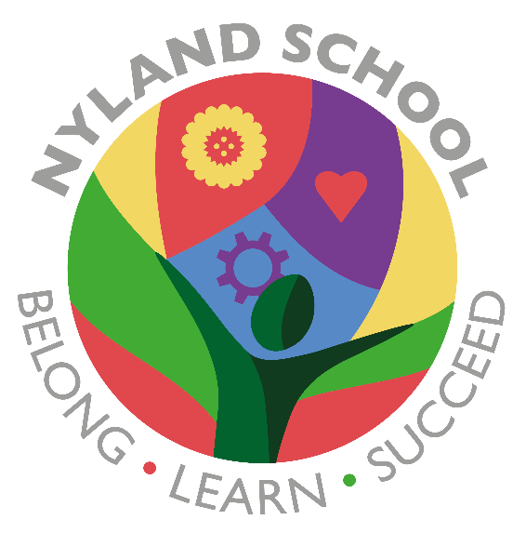

Nyland School
Policy for:
Personal, Social and Health Education (PSHE)
Emotional Quotient (EQ)
Sexual Education and Relationships (RSE)

Key Document details:
Author: Paul Holroyd |  | Approver: Simon Cowley
Owner: Nyland |  | Version No.: 1
Date: 01/09/23 |  | Next review date: July 2025
Ratified: TBC

Ethos
At Nyland School we aim to build an ethos of emotional awareness and understanding, known as emotional quotient. We believe that emotional quotient should have emphasis over intellectual quotient, in order to promote relevant and sustained development of the ‘whole child’. This facilitates the outcome of nurturing valued and productive members of communities and society.
This is underpinned by creating an environment that promotes a feeling of belonging, of being connected to others and of ‘relatedness’. Staff build and model secure, healthy relationships that pupils can learn from and recreate in their lives and beyond school. On this foundation, pupils can build their learning.
Both our academic and emotional curriculum are designed to support motivation, engagement and thinking in order to promote learning and progress.
We have overarching Emotional Quotient (EQ) themes each term including feeling safe, resilience, confidence/self-esteem, empathy, self-regulation and managing relationships. Through these, we explore the vocabulary, language and comprehension of emotional quotient.
Statutory requirements
We must provide relationships education to all pupils as per section 34 of the Children and Social work act 2017. However, we are not required to provide sex education but we do need to teach the statutory elements of sex education contained in the science curriculum. In teaching RSE, we must have regard to guidance issued by the secretary of state as outlined in section 403 of the Education Act 1996. At Nyland School we teach RSE as set out in this policy.
Teaching Sensitive and Controversial Issues
We have developed the curriculum in consultation with parents, pupils and staff, taking into account the age, needs and feelings of pupils. Teachers will be prepared to handle personal issues arising from the work, to deal sensitively with, and to follow up appropriately, disclosures made in a group or individual setting.
Teachers will take all reasonable, practical steps to ensure that, where political, faith based or controversial issues are brought to pupils’ attention, they are offered a balanced presentation of opposing views. Teachers will adopt strategies that seek to avoid bias on their part and will teach pupils how to recognise bias and evaluate evidence. Teachers will seek to establish a classroom climate in which all pupils are free from any fear of expressing reasonable points of view that contradict those held either by their class teachers or their peers.
Answering Difficult Questions and Sensitive Issues
Staff members are aware that views around PSHE and RSE related issues are varied. While personal views are respected, all PSHE and RSE issues are taught without bias using Jigsaw. Discussion and questioning is encouraged in the teaching of PSHE and RSE however, if pupils ask questions outside the scope of this policy but closely related to the content of the lesson, teachers will respond in an appropriate manner so pupils are fully informed and don’t seek answers online. If any questions are asked that are not related to the content of the lesson and are not age appropriate (as prescribed by this policy), the teacher will talk to individual parents so that they are able to make a choice to discuss the question with their child at home or not.
Statutory Teaching: RSE is taught within the personal, social, health and economic (PSHE) education curriculum. Biological aspects of RSE are combined with the science curriculum, and other aspects are included in religious education (RE). Pupils also receive age appropriate lessons on the differences between boys and girls and puberty. Relationships education focuses on teaching the fundamental building blocks and characteristics of positive relationships including: Families and people who care for me Caring friendships Respectful relationships Online relationships Being safe
Roles and responsibilities
- The local board of governors
The local board of governors will approve the PHSE/SRE/EQ policy, and hold the Principal to account for its implementation.
- The Principal
The Principal is responsible for ensuring that PHSE/SRE/EQ is taught consistently across the school
- Staff
Staff are responsible for: Delivering PHSE/SRE/EQ in a sensitive way Modelling positive attitudes to RHE Monitoring progress responding to the needs of individual pupils Informing DSL / DDSL of any safeguarding concern/s arising from teaching RSE as per the Child Protection and Safeguarding Policy. Staff do not have the right to opt out of teaching RSE. Staff who have concerns about teaching RHE are encouraged to discuss this with the Principal.
- Pupils
Pupils are expected to engage fully in RSE and, when discussing issues related to RSE, treat others with respect and sensitivity.

The E.Q. curriculum
A bespoke curriculum has been developed at Nyland School focused on the Emotional Quotient. It considers the understanding that the majority of our pupils have gaps in their emotional literacy and pragmatic language. Our curriculum encourages pupils to be in charge of their feelings and to participate in managing and regulating their feelings. We have daily activities in classrooms, where pupils are presented with EQ themes focused on feeling safe, resilience, confidence/self-esteem, empathy, self-regulation and managing relationships.
By offering reflection as a self-assessment tool, we allow them a voice and support them, to take charge of their EQ. During School council meetings elected pupils also have the opportunity to be part of the school’s development. By integrating these subjects with the core curriculum and educational visits, we have opportunities for practical application of what they are learning.

The Personal, Social and Health Education (PSHE) curriculum
Our PSHE curriculum is tailored to suit our pupil’s individual needs focused on emotional literacy. The curriculum encompasses the core EQ knowledge, Zones of Regulation, British Values and it allows pupils to have a voice and link their discoveries to their own experiences.
By offering daily circle times we create consistent and structured opportunities for the development of pupil’s emotional literacy using an array of strategies, such as role play, games or debates.

Sexual Education and Relationships (RSE) curriculum
Our Sexual education and relationships (SRE) curriculum aim to provide a PSHE/RSE curriculum focused on meeting our pupil’s needs. We are currently implementing a bespoke RSE curriculum at Nyland School due to an amendment to the Children and Social Work Act 2017 that made Relationships and Health Education at primary level a requirement. By providing weekly cross-curricular lessons (DT, PE and PSHE) focused on positive relationships, with particular reference to friendships, relationships with other children, with adults and with self, complementing our current EQ curriculum.
By proving an allocated time and safe and respectful space with teachers, taking into consideration all backgrounds and pupils will be able to discuss and learn about friendship and relationships. We aim to prevent misguided advice from outside sources such as the internet.
Parents/carers have the right to opt-out pupils from sexual education lessons except those parts required in the National Curriculum. Parents/carers wishing to exercise this right can contact the Principal or the PSHE lead to discuss concerns and the impact this may have. Once a pupil has been withdrawn, they can only take part in sexual education lessons again once the withdrawal has been removed. Our curriculum has been reviewed and approved by our school’s senior leadership and PSHE lead. It takes into consideration parental views and concerns. We also aim to tailor our curriculum to current data concerning young pupils’ health to target topics pertinent to their communities. Our curriculum is delivered on a weekly basis and is mindful of the school’s ethos, being attuned with our pupil’s needs and emotional maturity. We also provide a safe environment for pupils to ask questions and share concerns while also being mindful of their safety at all times.
EQ/PSHE/RSE curriculum
Intent
- Giving children the knowledge, vocabulary and understanding of Emotional Quotient
- Provide language and tools for children to begin to manage their feelings and emotions and reflect on and restoring their actions when appropriate
- Support SEMH need and the addressing of targets set out in EHCP’s.
Implementation
- Linking E.Q. and PSHE areas to core subjects to show real-life applicability.
- Taking our learning to the outdoors, where pupils can develop EQ language by using it and writing from experience, allowing them to be protagonists of their learning.
- Through reflection and restoration, we offer pupils the possibility of being in charge of their choices and through a reflective, rather than punitive approach, we allow them to reflect on and restore relationships.
- Offering daily circle time opportunities where pupils can link their experiences to the key skills and knowledge taught
- Promoting RSE lessons on a weekly basis across all Key Stages focusing on positive relationships, healthy bodies and mental well-being.
Impact
- Promote the understanding that mistakes can be restored and we can do things in a different way next time.
- Use the 6 overarching skills in their daily lives, creating opportunities to transfer and applying their E.Q. knowledge.
- Knowledge will be embedded so that it can be used confidently in their current and future life.

