Self-regulation, Being me in the world, Zones, PASS, Individual liberty
Geography

The children will be learning about:
Rainforests.
The children will learn about the world’s rainforests by covering their importance (oxygen, medicines, biodiversity), their key features such as their location and the unique animals and insects that inhabit them. We will investigate the threats Rainforests face such as deforestation.

Science
The children will be learning about: Electricity
- The children will sort appliances in accordance with whether thy run-on electricity or not.
- The children will investigate toys and whether they run by electricity or are manual.
- The children will learn about safety around electrical items and appliances in the home and school.
Emotional Quotient
The children will be learning about:
Building my self-esteem

PSHE
The children will be learning about:
Living in the wider world: Belonging to a community; Media literacy; Money and work.

Literacy
The children will be reading: ‘The Day the Crayons Quit’
- Skills: Using full stops, capital letters, exclamation and question marks correctly.
- Writing outcomes: To ask and write a question using the correct punctuation. To independently write or illustrate a postcard and letter using annotations, capital letters and full stops.
- Read Write Inc, Fresh start and RWI spelling

Computing
The children will be learning about:

~ Programming
~ Online reputation
Art
The children will be learning about:
Drawing
We will be using pencils of different grades, crayons, chalk and pastels to sketch.
PE
The children will be learning about:

- Swimming
- Tennis
DT
The children will be learning about:
Electronic models.
The children will create a Harry Potter book with a cauldron and stirrer with support.

RE
The children will be learning about:
Judaism:
The children will listen to the stories of David and Goliath, Moses and his time on Mount Sinai and Joseph and his coat of many colours.

Savernake Class
Term 3 2026
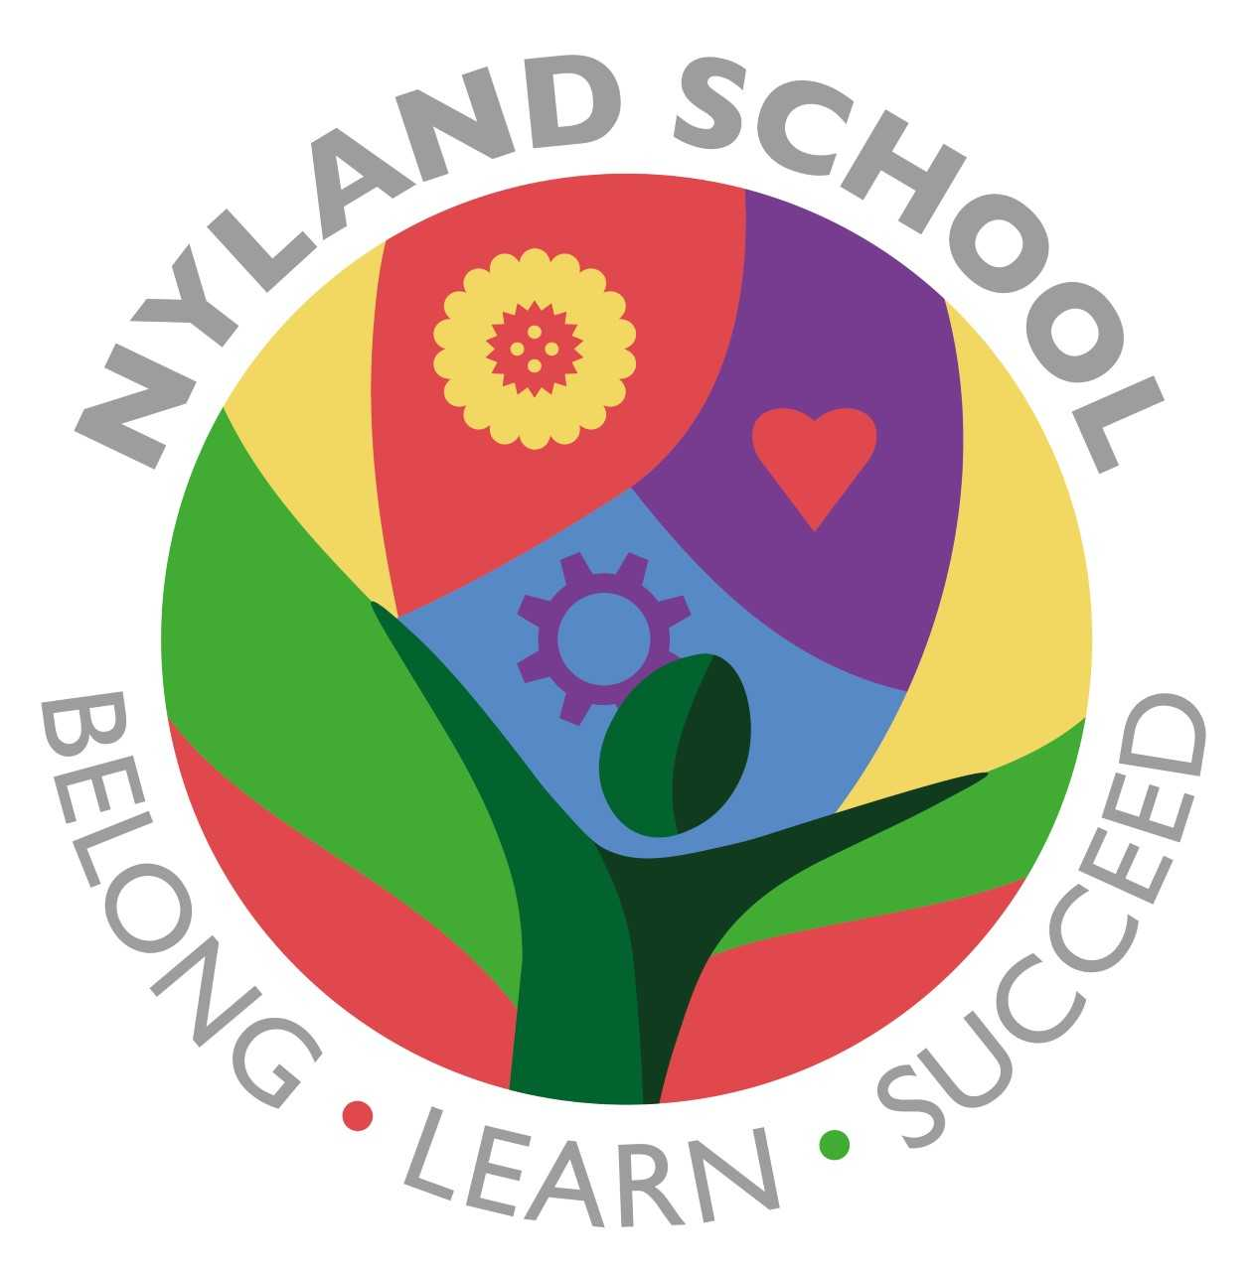

Maths
The children will be learning about:
Addition and Subtraction
Number and Place Value
Addition and Subtraction

