Self-regulation, Being me in the world, Zones, PASS, Individual liberty
History

The children will be learning about:
The Tudors
Children will explore life in Tudor times, comparing the past with today. They learn about Henry VIII and why he is remembered, discover what homes were like, and look at differences between rich and poor people. Pupils investigate Tudor clothes, food and schools, and find out how we know about the past through portraits and artefacts. Learning develops historical vocabulary, questioning skills, and an understanding of how life has changed over time.
Science
The children will be learning about: Materials
Children will learn about everyday materials and their properties through hands-on investigation and exploration. They identify and name common materials such as wood, plastic, glass, metal, water and rock, and begin to describe their simple properties. Pupils compare and group materials based on what they observe and test which materials are suitable for different purposes.
Emotional Quotient
The children will be learning about:
Building my part in the community

PSHE
The children will be learning about:
Living in the wider world:
- Belonging to a community
- Media literacy
- Money and work

English
The children will be reading ‘Tidy’ by Emily Gravett and the traditional tale, The Enormous Turnip
- Skills: Capital letters, full stops, past tense & capital letters for proper nouns.
- Writing outcomes: Recount of the story, Environmental poster, innovation of traditional tail.
- Read Write Inc for Reading and Spelling

Computing
The children will be learning about:

- Data and information
- Managing online information
- Copyright and ownership
Art
The children will be learning about:

- Collage
PE
The children will be learning about:

- Gymnastics
- Fitness
DT
The children will be learning about:
- Electronic models
RE
The children will be learning about:
- Christianity: Why is Easter important?

Savernake Class
Term 4 2026
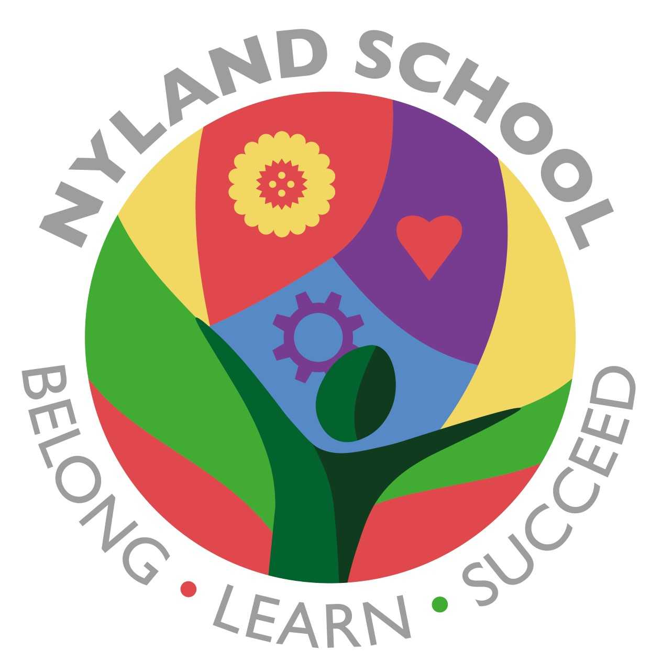

Maths
The children will be learning about:
Addition and Subtraction (2weeks)
Multiplication and Division (3weeks)

