Self-regulation, Being me in the world, Zones, PASS, Individual liberty

Geography

The children will be learning about:

Where in the world am I?

* To locate the U.K on a world map.
* To begin to identify the seven continents and five oceans of the world,
* To investigate the equator and the poles.

Science

The children will be learning about: Humans including animals

* Begin to make sense of their own life story and the history of their families.
* Understand the key features of the life cycle of a plant and an animal.

Emotional Quotient

The children will be learning about:

Building trusting relationships

PSHE

The children will be learning about:

Relationships:

* Families and friendships
* Safe relationships
* Respecting ourselves and others

Literacy

The children will be reading ’Leaf’ by Sandra Dieckmann and ‘The Tiger who came to tea’ by Judith Kerr.

* Skills: To retell the story and create story maps independently with a start, middle and end.
* Writing outcomes: To begin to form recognisable letters using their sound mat.
* Read Write Inc, spelling and grammar

Computing

The children will be learning about:

~ Data and information

~ Online relationships

Art

The children will be learning about:

Painting: Using different methods to create art using paint.

PE

The children will be learning about:

Team games: Turn taking in hockey, waiting patiently and working together.

DT

The children will be learning about:

Mechanical toys, how they operate and create one themselves.

RE

The children will be learning about:

Buddhism: Who Buddha was, how he became ‘Buddha’ and where Buddhism originated.

**Savernake Class**

**Term 1 2025**

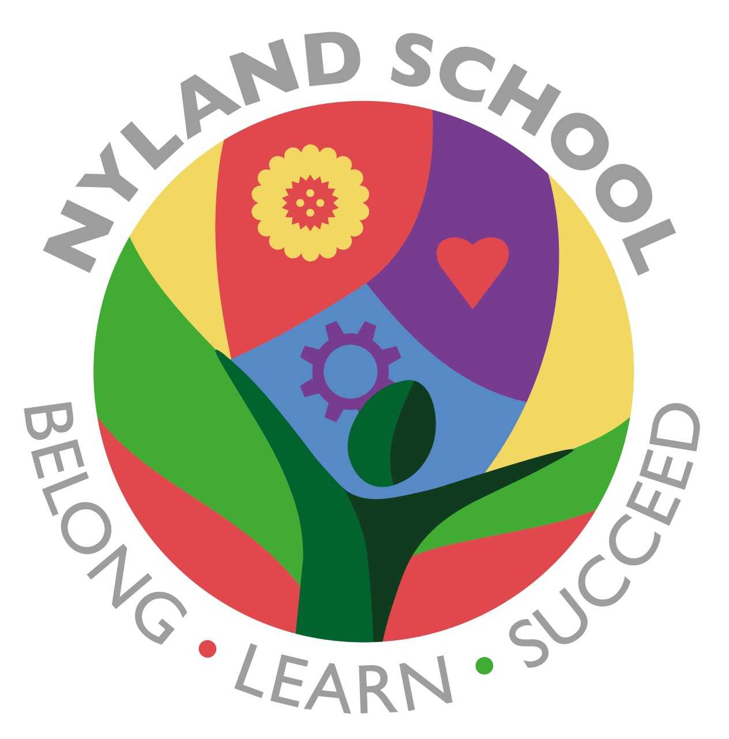

Maths

The children will be learning about:

 Baselines (2weeks)

Number and Place Value (3weeks)

Addition and Subtraction (3weeks)