Self-regulation, Being me in the world, Zones, PASS, Individual liberty
Science
The children will be learning about:
Animals including Humans.
Animal Groups: Children will name and identify fish, amphibians, reptiles, birds, and mammals.
Diets: Children will classify animals as carnivores, herbivores, and omnivores.
The Human Body: Children will label or discuss basic body parts, face parts, and link them to the five senses.
Survival and Growth: Children will explore basic needs like water, food, and air, alongside how offspring grow into adults.

Geography

The children will be learning about:
Where in the world am I?
The children will look investigate where they are in the world with support from staff and Atlases. The children will draw and discuss their home and how they are different to other homes around the world.
Emotional Quotient
The children will be learning about:
Building trusting relationships

PSHE
The children will be learning about:
Relationships:
- Families and friendships
- Safe relationships
- Respecting ourselves and others

Computing
The children will be learning about:

~ Data and information
~ Online relationships
Art
The children will be learning about:
Painting: Using different methods to create art using paint.
PE
The children will be learning about:
Basketball.
They will use their bodies to negotiate space safely, how to throw and catch and how to share.
DT
The children will be learning about:
Mechanical toys, how they operate and create one themselves.
Literacy
Children will re-enact, retell and role play
around stories focused on using familiar books, traditional tales, and interactive storytelling. This will support and promote vocabulary, comprehension, and a lifelong love of reading.

RE
The children will be learning about:
Buddhism: Who Buddha was, how he became ‘Buddha’ and where Buddhism originated.

Savernake Class
Term 1 2026
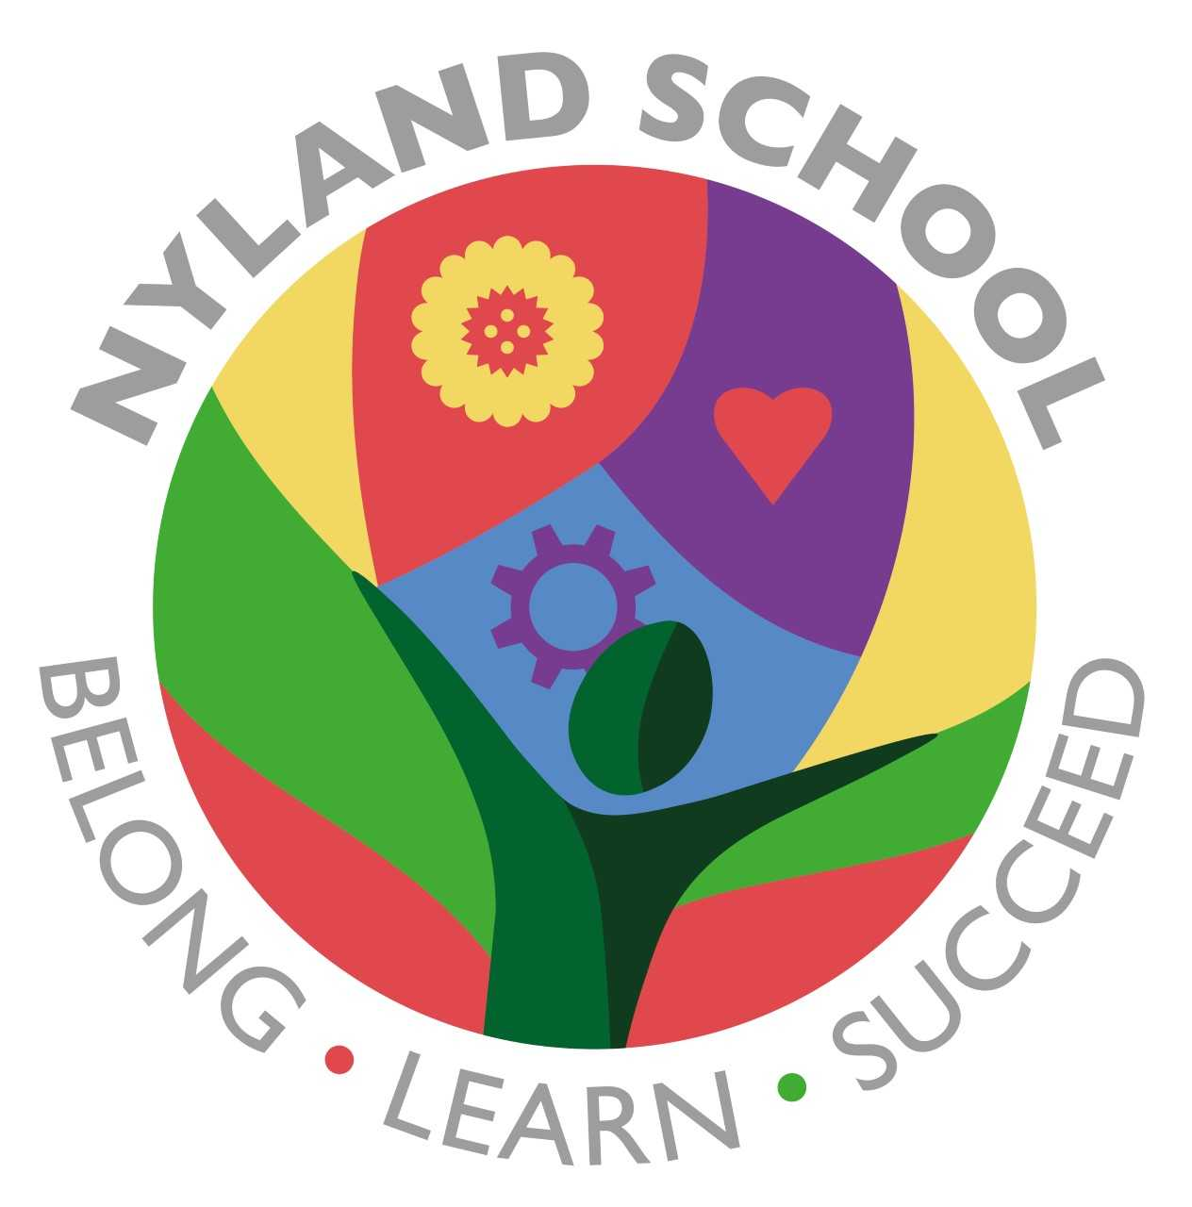

Maths
The children will be learning about:
Baselines (2weeks)

