English

The children will be learning about:

* Skills: Phonics, spelling and grammar, using the Read Write Inc programme
* Sentence-writing and comprehension activities through group reading
* Individual reading
* Class story time each day
* Class texts – Zog, Pumpkin Soup

Rainbow Class

Term 1 2025-26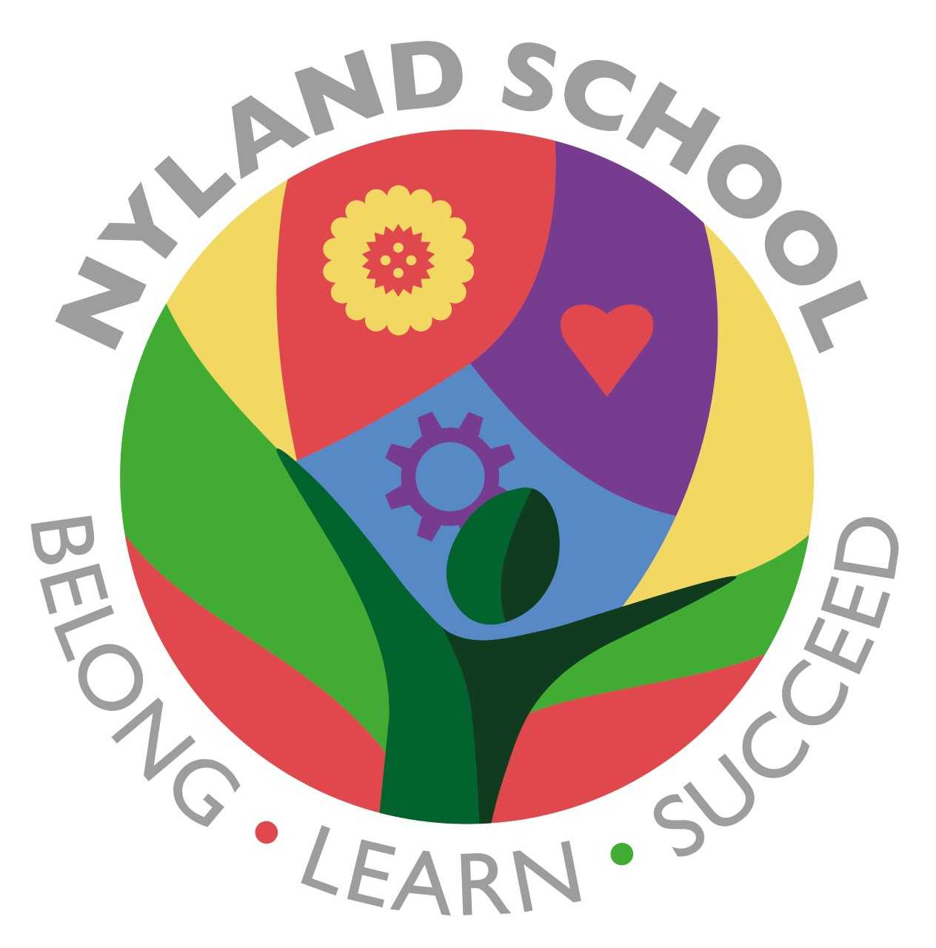

Maths

The children will be learning about:

* Number and Place Value
* Ordering numbers
* Counting
* Addition and subtraction

They will practise recall of number bonds as well as recall of multiplication (and division facts where appropriate) depending on their age

Computing

The children will be learning about:

* Online safety
* Privacy and security
* Completing activities online, including Purple Mash

PSHE/British Values

The children will be learning about:

* Our school values or RRS –
* Be respectful
* Be responsible
* Be safe
* Zones of Regulation

Emotional Quotient

The children will be learning about

all aspects of EQ:

* Learning to Play
* Understanding my Feelings
* Understanding other People’s Feelings
* Building trusting Relationships
* Building my Self-Esteem
* Building my Part in the Community.