Self-regulation, Being me in the world, Zones, PASS, Individual liberty

Science

The children will be learning about: Seasonal Changes/Light/

Earth and Space – To understand light and seeing and the Earth’s Movement in Space

Choose which pathway your class is studying

Emotional Quotient

The children will be learning about:

Learning to learn

PSHE

The children will be learning about:

History

The children will be learning about:

Inspirational people

Literacy

The children will be reading ‘XXX’ by XXX and ‘XXX’ by XXX

* Skills:
* Writing outcomes:
* Read Write Inc, spelling and grammar

Computing

The children will be learning about:

~ Digital Literacy

~ Online bullying

Art

The children will be learning about:

Printing

PE

The children will be learning about:

Team Games – Focus on attacking and defending

DT

The children will be learning about:

RE

The children will be learning about:

Hinduism: Hindus Home and Mandir

**XXX Class**

**Term 2 2024**

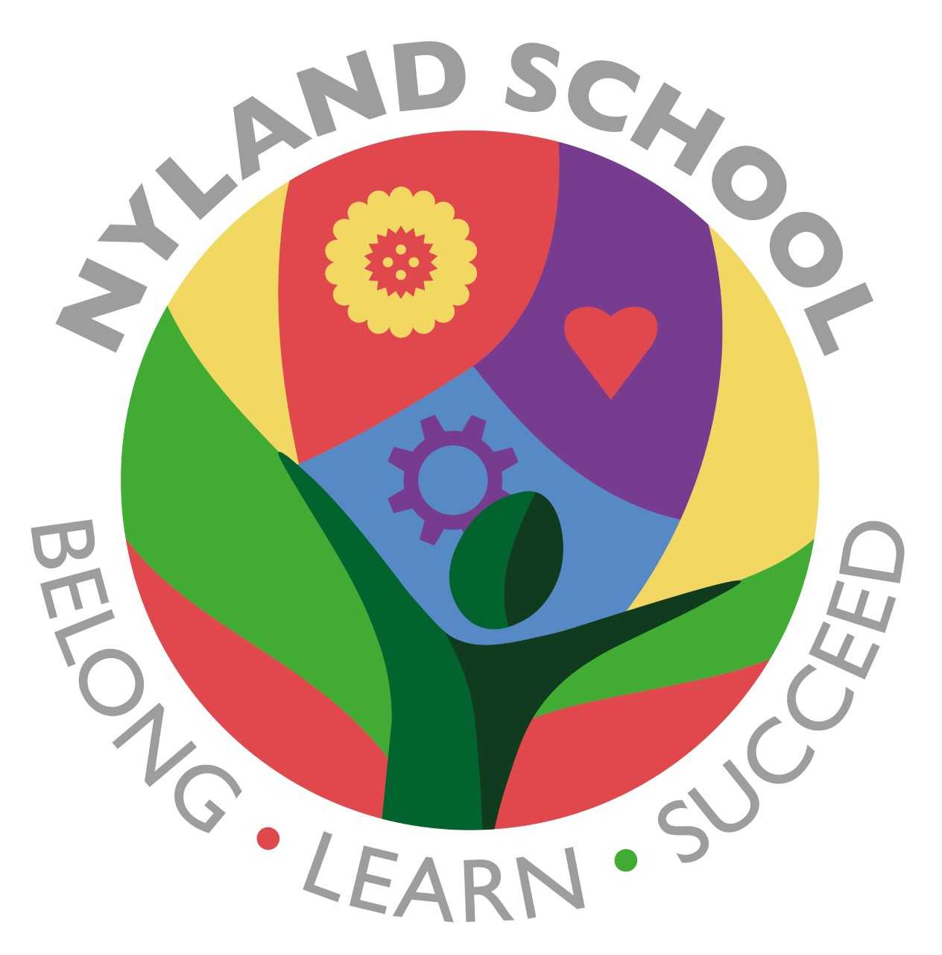

Maths

The children will be learning about:

Number and place value (2 weeks)

Addition and subtraction (2 weeks)

Multiplication and division (3 weeks)