Self-regulation, Being me in the world, Zones, PASS, Individual liberty
History

The children will be learning about:
World War 2
- The significance of Remembrance day
- How WW2 started
- The Evacuation of Dunkirk
- The Battle of Britain
- The Normandy Landings
Science
The children will be learning about: Movement, forces and magnets
- How friction affects movement & speed
- How gravity works
- How air resistance affects movement
- How water resistance works
- Investigate parachutes
Emotional Quotient
The children will be learning about:
Learning to Play

PSHE
The children will be learning about:
Relationships
- Families and friendships
- Safe relationships
- Respecting ourselves and others

Literacy
The children will be reading
The Barnabus Project by The Fan Brothers &
The Bear and the Piano by David Litchfield
- Skills: noun phrases, co-ordinating conjunctions, apostrophes
- Writing outcomes: Character description , informal letter
- Read Write Inc, spelling and grammar

Computing
The children will be learning about:

~ Creating media
~ Online bullying
Art
The children will be learning about:
Printing; from finger printing to print block making
PE
The children will be learning about:
Team Games: Netball
and Basketball
DT
The children will be learning about:
Paper Clay Models
RE
The children will be learning about:
Christianity: The Bible
Bible Stories
Different books
Messages in stories

Avebury Class
Term 2 2025
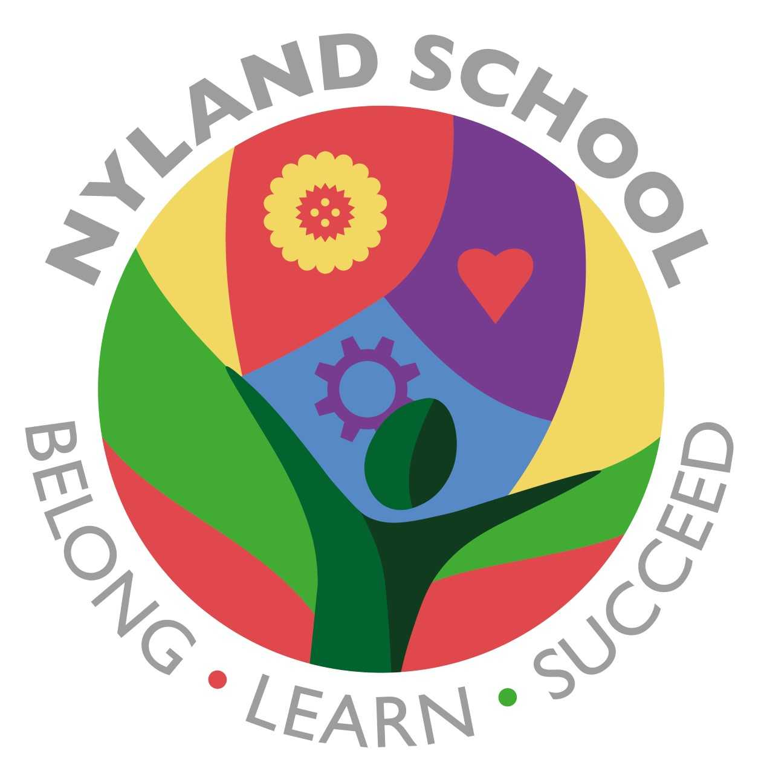

Maths
The children will be learning about:
Multiplication and Division
Number and Place Value
Addition and Subtraction

