English
The children will be learning about:

- Skills: Phonics, spelling and grammar, using the Read Write Inc programme
- Sentence-writing and comprehension activities through group reading
- Instructions
- Individual reading
- Class story time each day
- Class texts –Pumpkin Soup, A Pipkin of Pepper,

Rainbow Class
Term 2 2025-26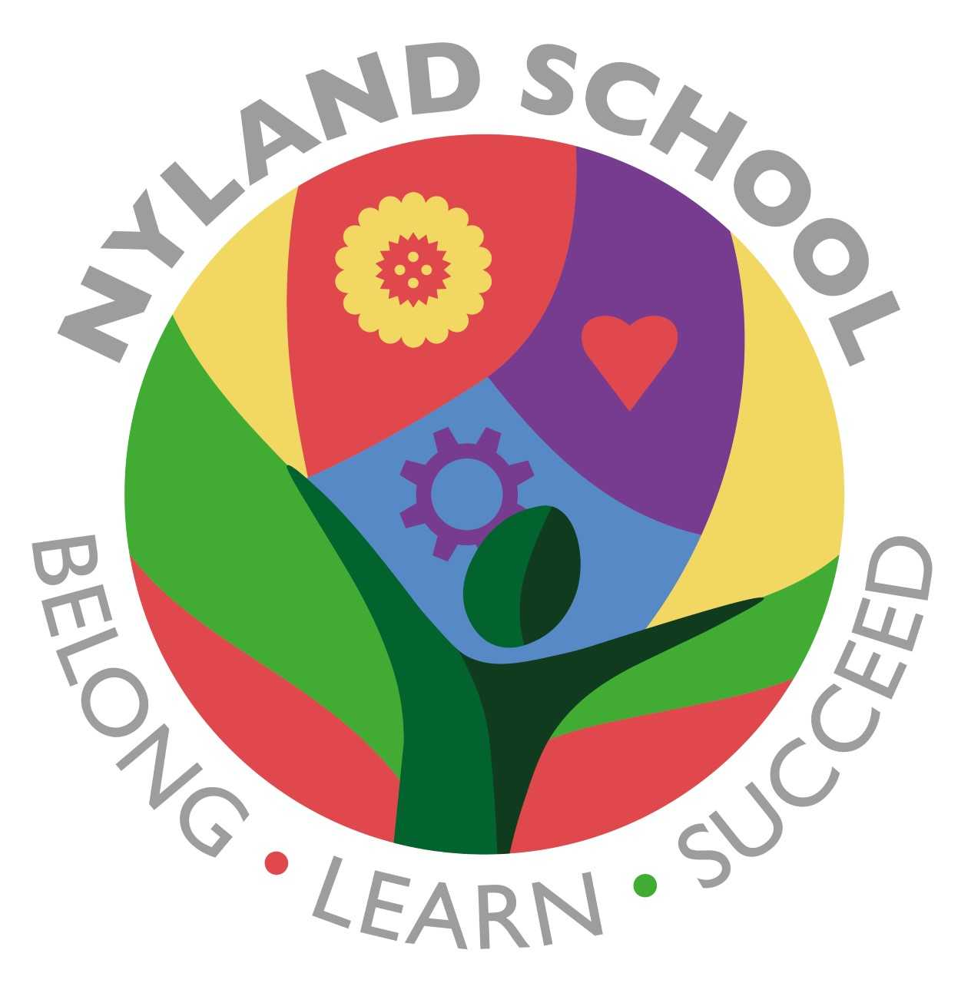

Maths
The children will be learning about:

- Multiplication and Division
- Addition and subtraction

They will practise recall of number bonds as well as recall of multiplication times tables (and division facts where appropriate) depending on their ability

Computing
The children will be learning about:

- Online bullying
- Completing activities online, including Purple Mash

PSHE/British Values
The children will be learning about:

- Our school values or RRS –
- Be respectful
- Be responsible
- Be safe
- Zones of Regulation
- We will be working together to complete the sports challenge

Emotional Quotient
The children will be learning about
all aspects of EQ:

- Learning to Play
- Understanding my Feelings
- Understanding other People’s Feelings
- Building trusting Relationships
- Building my Self-Esteem
- Building my Part in the Community.

