Self-regulation, Being me in the world, Zones, PASS, Individual liberty

Science

Children will use all their senses in hands-on exploration of natural materials. Children will make predictions about the ways in which they think ice will melt. The children will then carry out experiments and time the ice melting. As a class, we will talk about and discuss the differences between materials and changes they notice.

Emotional Quotient

The children will be learning about:

Building their part in the community

PSHE/British values

The children will be learning about:

Exercise

Diet

Sugar

Dental health

Sun protection

Personal hygiene

Geography

Children will look at and learn about life in this country compared to others. We will investigate where food comes before it comes on to our plate e.g. farm, factory, supermarket

We will taste food from other countries and discuss how they are different to the traditional foods we eat in this country

Literacy

Children will continue to use their sound mats and pictorial support to write sentences. Children will continue to look at nouns, verbs and adjectives and begin to use and recognise these in their writing. Children will recall that we need a capital letter, full stop and finger spaces to create a sentence that is plausible. Children will be able to correctly sequence a sentence.

Computing

The children will continue to learn about staying safe online before lessons. We will create posters and label features of the characters we have created.

Art

Children will begin to draw lines of different thickness and colour in pictures neatly whilst following the lines and create different tones and shades using colours.

PE

Children will learn to throw and catch an object using both hands and balance a ball/ shuttlecock with increasing control.

DT

Children will work on their fine motor skills to create Dream Catchers. They will look at and learn about different materials they will need to create these.

RE

The children will be learning about Judaism and exploring the stories of David and Goliath, Moses, Noah and his Ark and Joseph with his coat of many colours

**Savernake**

**Term 3 2025**

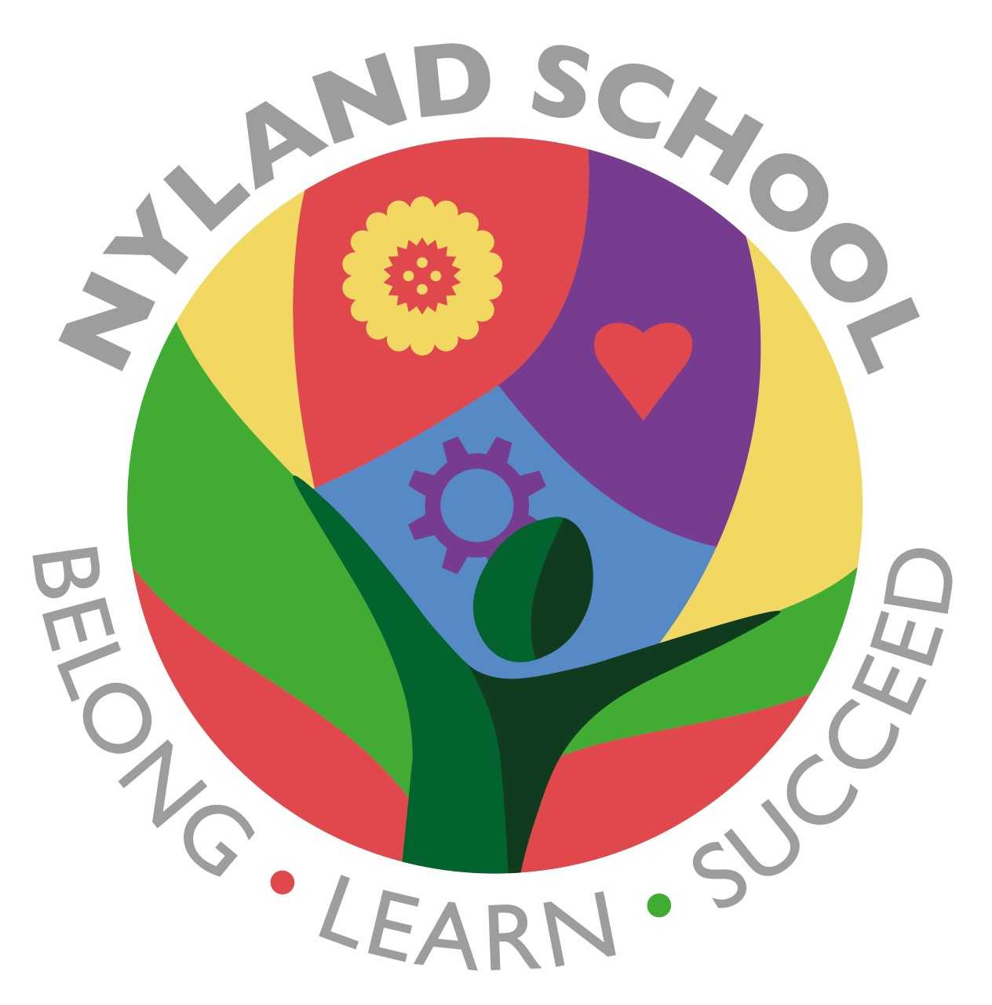

Maths

The children will be looking at and learning about number place and value. Children will be taught how to find one less and one more than by using pictorial and abstract support. They will be shown how to count forwards and backwards using a number line.