Self-regulation, Being me in the world, Zones, PASS, Individual liberty
Geography

The children will be learning about:
Rainforests
- To know where rainforests are
- To describe the layers of the rainforest
- To understand the climate in a rainforest
- To describe the people and tribes of the rainforest
- To understand why the rainforests are under threat

Science
The children will be learning about: Electricity
- The different sources of electricity
- Renewable and non-renewable sources
- The impact on the environment of energy sources
- Comparison of energy sources
- Know how electricity gets to the home
Emotional Quotient
The children will be learning about:
Building my self-esteem

PSHE
The children will be learning about:
Living in the wider world: Belonging to a community; Media literacy; Money and work.

Literacy
The children will be reading ‘
- Skills: subordinating clauses, co-ordinating clauses, noun phrases
- Writing outcomes: character description, diary entry, story retelling
- Read Write Inc, Fresh start and RWI spelling

Computing
The children will be learning about:

~ Programming
~ Online reputation
Art
The children will be learning about:
Pencil drawing
Sketching
PE
The children will be learning about:

- Swimming
- Tennis
DT
The children will be learning about:
Cookery
Healthy Eating

RE
The children will be learning about:
Judaism: Worship and beliefs

Avebury Class
Term 3 2026
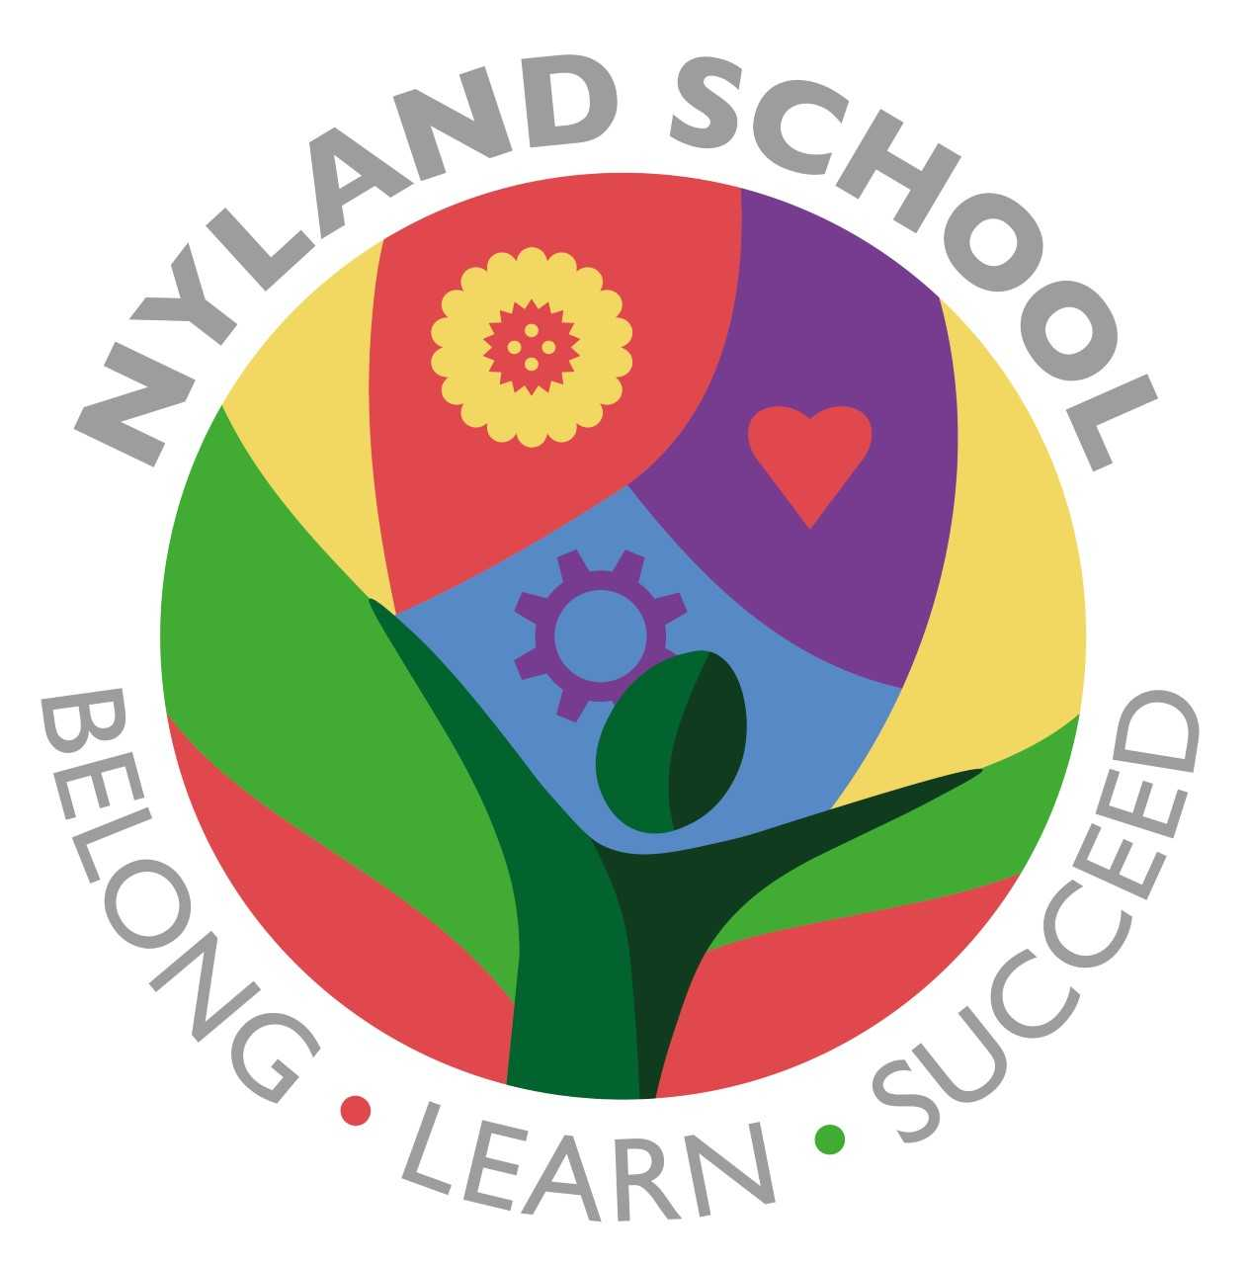

Maths
The children will be learning about:
Addition and Subtraction
Number and Place Value
Addition and Subtraction

