Self-regulation, Being me in the world, Zones, PASS, Individual liberty

Science

The children will be learning about: Living things and their Habitats

* Classifying plants
* Classifying animals
* Food chains
* Animal habitats and danger
* Threats of extinction

Emotional Quotient

The children will be learning about:

Understanding other people’s feelings

PSHE

The children will be learning about: Living in the wider world

ZONES

The children will be learning about: strategies and tools to move between each zone

History

The children will be learning about:

The Aztecs

* To know who they were
* What life was like
* Where they lived
* The clothes they wore
* Their schools
* The type of food they ate

Literacy

The children will be reading

The Lighthouse Keepers Lunch and The Lighthouse Keepers Cat by Ronda & David Armitage

* Skills: apostrophe for possession, expanded noun phrases, co-ordinating conjunctions
* Writing outcomes: writing narrative, letter writing
* Read Write Inc, spelling and grammar

Computing

The children will be learning about:

Internet Safety Health, well-being and lifestyle

Data Logging over timer

Art

The children will be learning about:

Collage

Children will begin to understand what collage is and use different types of materials from the class, paint, paper, decoupage and their natural environment to create beautiful pieces of art.

PE

The children will be learning about:

Fitness and gymnastics

Children will learn to negotiate space and obstacles safely whilst building on their fine and gross motor skills. They will begin to coordinate different parts of their bodies through fun and educational activities.

DT

The children will be learning about:

Mechanical models

The children will be learning about moving toys. They will demonstrate the correct and accurate use of measuring, marking out, cutting, joining and finishing skills.

RE

The children will be learning about:

Rites of Passage and the Meaning of Easter

Children will begin to understand stories from different cultures. They will begin to understand the story of Jesus and his death and resurrection.

**Avebury Class**

**Term 4 2025**

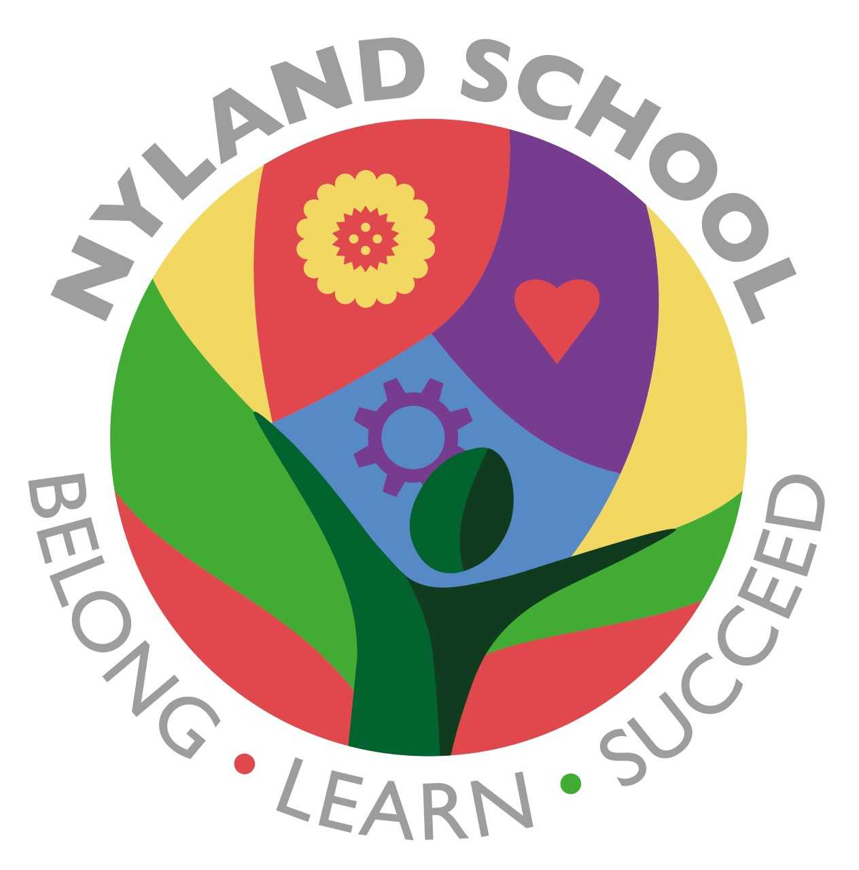

Maths

The children will be learning about:

Addition and Subtraction (2 weeks)

Multiplication and division (2 week)

Fractions (1 week)

Geometry (1 week)