Self-regulation, Being me in the world, Zones, PASS, Individual liberty
History

The children will be learning about:
The Tudors
- Exploring artefacts
- Placing Tudors on a timeline
- Describe Henry VIII and name his wives
Science
The children will be learning about: Materials
- Compare solids, liquids & gases
- Observe changes to state through heating and cooling
- How temperature is linked to changes
- How some materials melt quicker than others
- How liquids change state through evaporation
Emotional Quotient
The children will be learning about:
Building my part in the community

PSHE
The children will be learning about:
Living in the wider world:
- Belonging to a community
- Media literacy
- Money and work

English
The children will be reading Kites by Simon Mole and The Promise by Nicola Davies
Skills: exclamatory sentences, subordination (because, when, if), possessive apostrophe, and punctuation (capital letters, full stops, commas, exclamation marks and question marks).
Writing outcomes: Retell the story, write an innovated version of the story, write persuasive sentences, create a persuasive poster to encourage people to visit the town and to write a persuasive letter to invite the king to come to visit the city
Read Write Inc, Fresh start and RWI spelling

Computing
The children will be learning about:

- Data and information
- Managing online information
- Copyright and ownership
Art
The children will be learning about:
- Collage
Experiment with a range of paper techniques
PE
The children will be learning about:

- Gymnastics
- Fitness
DT
The children will be learning about:
- Electronic models
RE
The children will be learning about:
- Christianity: learn to describe & explain rites of passage

Avebury Class
Term 4 2026
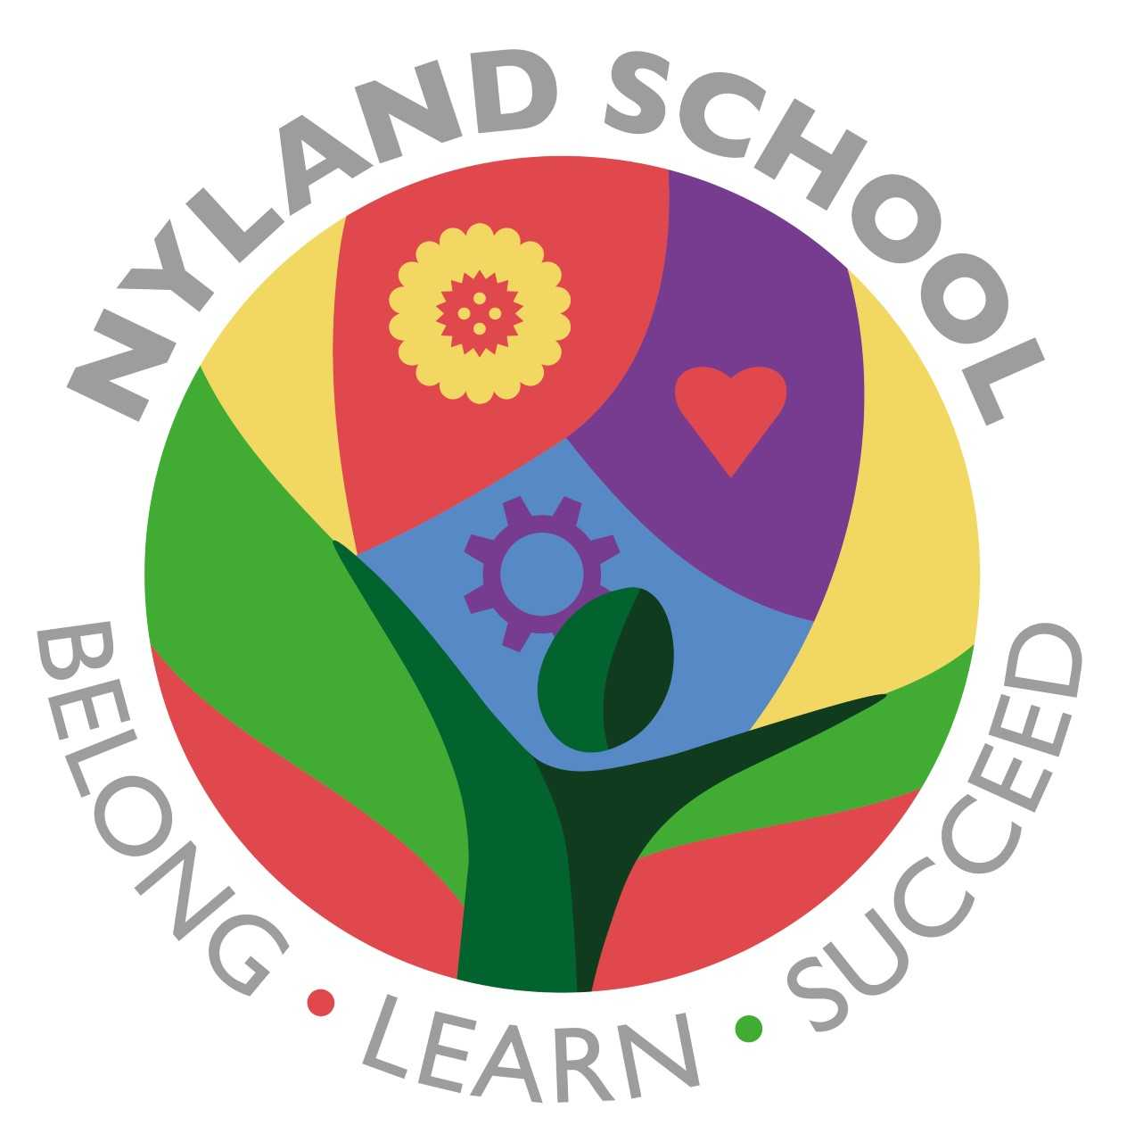

Maths
The children will be learning about:
Addition and Subtraction (2weeks)
Multiplication and Division (3weeks)

