English
The children will be learning about:

- Skills: Phonics, spelling and grammar, using the Read Write Inc programme
- Sentence-writing and comprehension activities
- Handwriting and letter formations
- Individual reading
- Class story time each day
- Continuing the class text –The Owl Who was Afraid of the Dark

Rainbow Class
Term 4 2025-26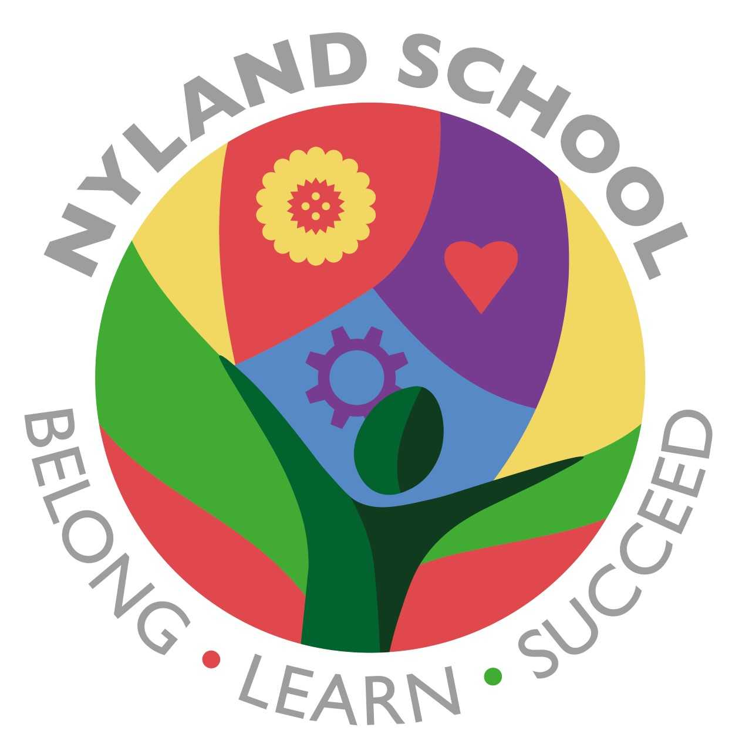

Maths
The children will be learning about:

- Addition and subtraction

They will practise recall of number bonds as well as recall of multiplication times tables depending on their ability

Computing
The children will be learning about:

- Sharing data and information
PSHE/British Values
The children will be learning about:

- Our school values or RRS –
- Be respectful
- Be responsible
- Be safe
- Zones of Regulation
- We will have a focus on kind hands, feet and words
Emotional Quotient
The children will be learning about
all aspects of EQ through activities and discussions:
- Learning to Play
- Understanding my Feelings
- Understanding other People’s Feelings
- Building trusting Relationships
- Building my Self-Esteem
- Building my Part in the Community
- Learning to Learn

