Self-regulation, Being me in the world, Zones, PASS, Individual liberty
Geography

The children will be learning about:
Extreme Weather
- Investigating the world’s climate
- Identifying where extreme weathers can be found and explain why
- Investigate and study an Earthquake
- Investigate and study a volcanoe
- Investigate and study a tsunami

Science
The children will be learning about: Living things in their habitats
- Identifying and classifying animals according to different characteristics
- Know what vertebrae and invertebrate are
- Create a classification system
- Observe habitats and how they suit the animals that live there
- Describe a simple food chain
Emotional Quotient
The children will be learning about:
Understanding my feelings

PSHE
The children will be learning about:
Health and wellbeing:
- Physical health and mental well-being
- Growing and changing
- Keeping safe

English
The children will be reading ‘Lights on Cotton Rock’ by David Litchfield and ‘BFG’ by Roald Dahl
- Skills: Commas in a list, inverted commas, expanded noun phases and adverbs to describe time
- Writing outcomes: character description, dialogue, recount and instruction writing
- Read Write Inc, Fresh start and RWI spelling

Computing
The children will be learning about:

- Creating & Editing videos
- Self-image & identity
- Privacy & security
Art
The children will be learning about:
- 3D sculpture
- Mask Making
PE
The children will be learning about:
- Kwik Cricket : Fielding & Striking
- Sports Day
DT
The children will be learning about:
- Birdhouses/ woodwork
RE
The children will be learning about:
- Islam: What do Muslims celebrate?

Avebury Class
Term 5 2026
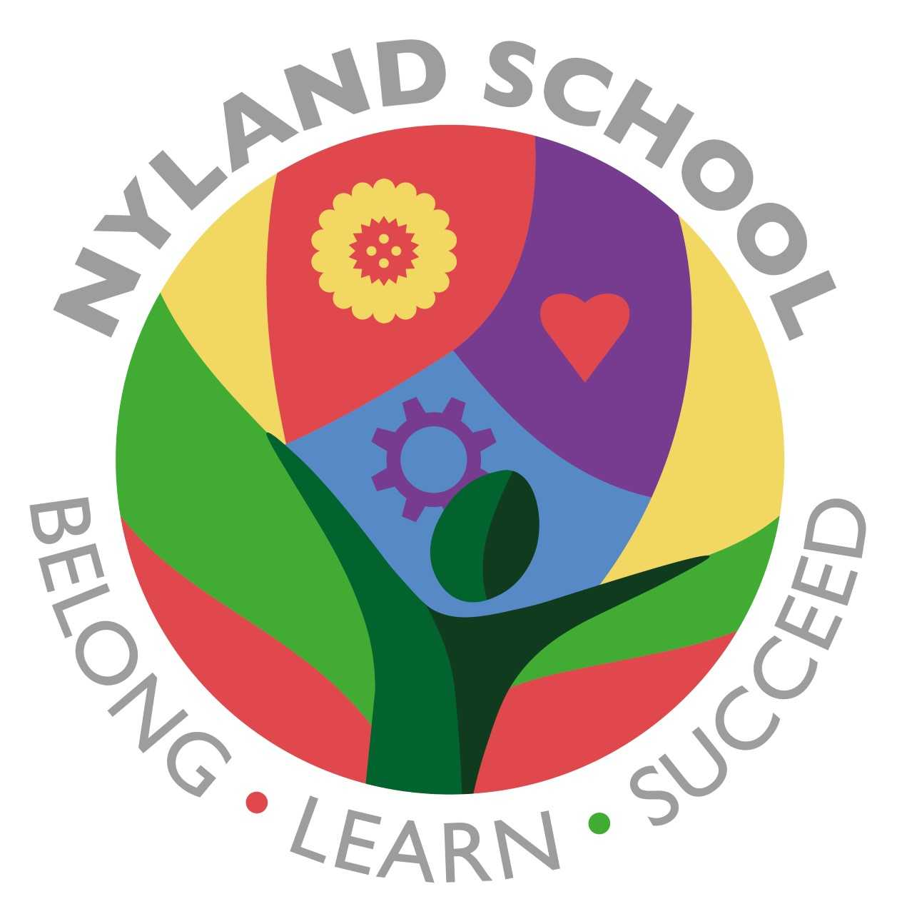

Maths
The children will be learning about:
Addition & Subtraction (2 weeks)
Fractions (2 weeks)
Geometry (2 weeks)

