English
The children will be learning about:

- Skills: Phonics, spelling and grammar, using the Read Write Inc programme
- Sentence-writing and comprehension activities
- Handwriting and letter formations
- Individual reading
- Class story time each day
- Class text – The Café at the Edge of the Woods

Rainbow Class
Term 5 2025-26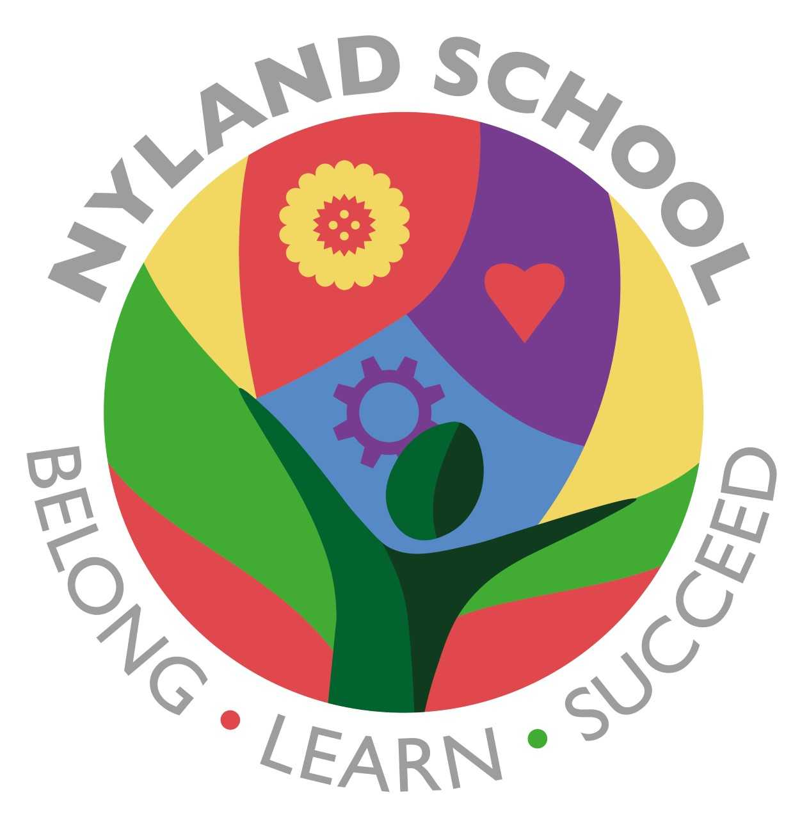

Maths
The children will be learning about:

- Number and place value
- Addition and subtraction

They will practise counting, recall of number bonds, as well as recall of multiplication times tables depending on their ability

Outdoors
- We aim to complete some learning and play activities outside when the weather permits

Computing
The children will be learning about:

- Protecting our identity and keeping personal information safe
- Not sharing logins or passwords with others
PSHE/British Values
The children will be learning about:

- Our school values or RRS –
- Be respectful
- Be responsible
- Be safe
- Zones of Regulation
- We will have a focus on Road Safety

Emotional Quotient
The children will be learning about
all aspects of EQ through activities and discussions:

- Learning to Play
- Understanding my Feelings
- Understanding other People’s Feelings
- Building trusting Relationships
- Building my Self-Esteem
- Building my Part in the Community.
- Learning to Learn

