Self-regulation, Being me in the world, Zones, PASS, Individual liberty

Science

The children will be learning about: Science Skills & performing different experiments :

What material make the best paper helicopter?

How does water and temperature affect glaciers?

What should we flush down the toilet?

How does a polar bear keep warm?

Why are worms good for the garden?

What is the best natural liquid to clean pennies?

Emotional Quotient

The children will be learning about:

Building trusting relationships

PSHE

The children will be learning about: Physical health and mental well-being

Growing and changing

Keeping safe

History

The children will be learning about:

Ancient Egypt

Understand chronology on a time line

Know some Gods

Explain mumification

Research the pyramids & the valley of kings

Learn about Egyptian beliefs about life after death

Examine Egyptian artefacts

Literacy

The children will be reading :

The Egyptian Cinderella

* Skills: using paragraphs, punctuating speech, extending sentences
* Writing outcomes: writing a letter, descriptive writing, rewriting an ending
* Read Write Inc, spelling and grammar

Computing

The children will be learning about:

Data collection

Creating a spreadsheet

Adding formula to a cells

Plan an event

Art

The children will be learning about:

Sketching

Designing

Mask making

PE

The children will be learning about:

Athletics :

Field events

Track events

DT

The children will be learning about:

Homes of the future

RE

The children will be learning about:

Sikh beliefs

The origins of Sikhism

Sikh traditions

**Avebury Class**

**Term 6 2025**

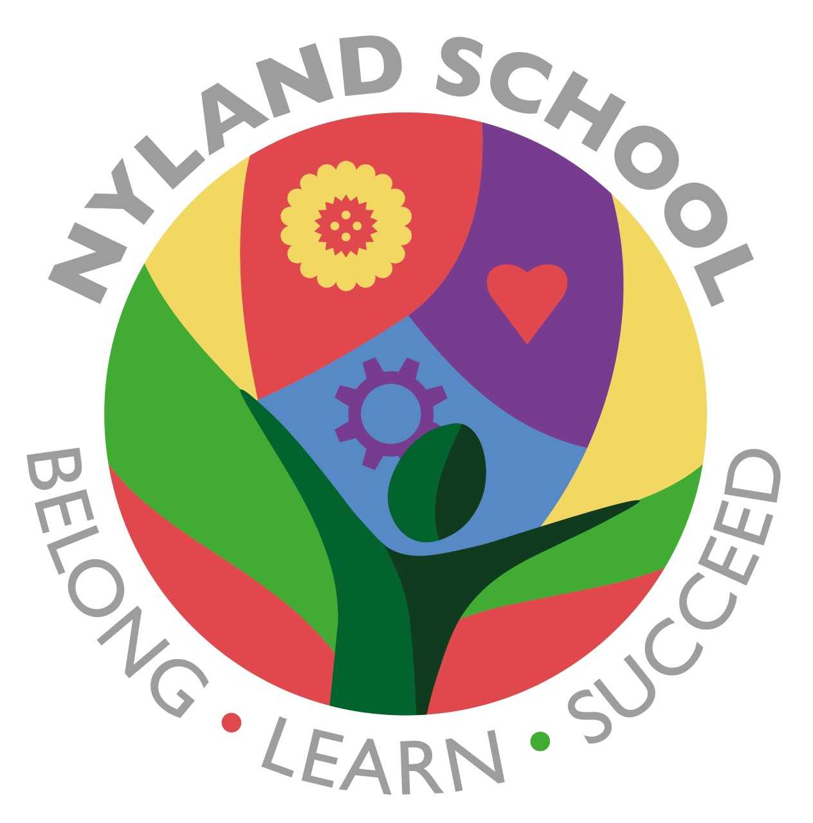

Maths

The children will be learning about:

Money

Time

Length

Weight

Statistics and data collection

Times table practice