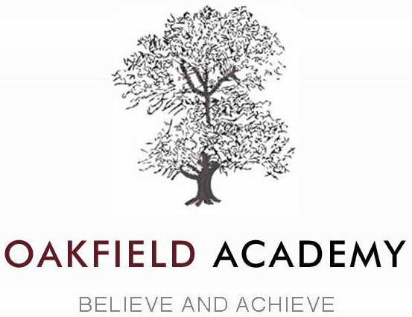
Breakfast Club – Autumn Term 2026

Dear Parents/Carers,
Oakfield Academy is pleased to offer a Breakfast Club for our pupils, running each school day from 8:00am to 8:25am.
Pupils should enter through the main Reception entrance (not the red gates) and will then be directed to the Breakfast Club room. A light breakfast will be provided, which may include toast, cereal, pastries, and squash. At 8:25am, pupils will make their way to their tutor bases.
We offer flexible attendance options, allowing pupils to attend on specific days, weekly, or for a full term. The costs are as follows:
- £2.60 per day
- £11.50 per week (£2.30 per day for 5 days)
- £69.30 for Term 1 £2.10 per day (7th September to 21st October)
- £71.40 for Term 2 £2.10 per day (2nd November to 18th December)
Please note that spaces are limited and must be booked and paid for in advance. To secure a place,
please contact the academy office by phone or email, providing your child’s name and the days or period you require. The appropriate charge will be confirmed and added to your child’s Arbor account for payment prior to attendance.
We also ask that you inform us of any medical conditions or allergies your child may have.
For safeguarding purposes, a register will be kept of all pupils attending Breakfast Club. If your child is unable to attend a booked session, please notify the academy office by phone or email.
All bookings must be made at least two school days in advance to allow registers to be updated and payment to be received. A member of staff will confirm your booking and your child’s start date via email.

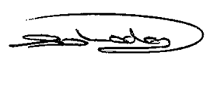
Mrs Sara Lodge
Finance Officer

