Monday 1st June  In 1998 the European Central Bank was founded in Brussels to define and execute the European Union's monetary policy. Devise a different way for a country to ‘pay’ for things. Explain what the ‘value’ of key items would be in your monetary system. | 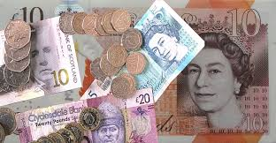
Tuesday 2nd June  In 455 King Gaiseric and the Vandals sacked Rome – Rome was looted for 14 days. Write a first person account from a Roman resident’s perspective watching your city being looted. | 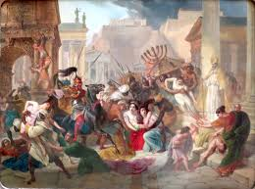
Wednesday 3rd June  In 1943 A mob of 60 from the Los Angeles Naval Reserve Armory beat up everyone perceived to be Hispanic, starting the week-long Zoot Suit Riots. Write a letter to the Los Angeles Navy explaining why violence and racism is unacceptable. | 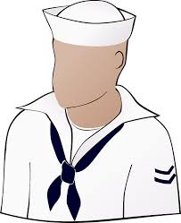
Thursday 4th June  In 1940 British complete the "Miracle of Dunkirk" by evacuating 338,226 allied troops from France via a flotilla of over 800 vessels including Royal Navy destroyers, merchant marine boats, fishing boats, pleasure craft and even lifeboats. Research and write a newspaper article on this ‘miraculous’ evacuation. | 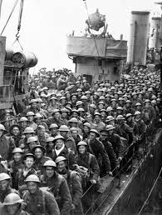
Friday 5th June  In 1257 Krakow, Poland, received city rights. Create a fact file on Krakow. What do you think has been the most significant event in Krakow’s history? | 