Behaviour and Relationships Policy
This is a STATUTORY policy
Recommended for review by the Deputy Head Teacher, HoY and Academy Council every year

Written/
Reviewed by: SLT

Approved by: Head Teacher

Ratified in: September 2023

Next review due: September 2024

Purpose
Oakfield Academy aims to maintain a positive atmosphere in which all staff and pupils can work to the best of their ability providing a safe, caring, inclusive and happy learning environment. The academy seeks to provide opportunities and challenges for its pupils and always aims to support pupils and staff in embracing the academy values to ensure success. This policy supports all stakeholders to allow everyone to work together in an effective and positive manner; the purpose of this policy is to:
- Promote positive relationships based on mutual respect
- Treat all pupils fairly and consistently
- Promote desired behaviour and discipline
- Ensure all pupils know, understand and follow the academy rules and code of conduct
- Encourage a shared approach with parents and the community in the development of our pupils
- To instil in pupils high standards of behaviour and develop self-discipline.

General Expectations
Good behaviour needs to be taught, modelled and rewarded. Poor or unacceptable behaviour needs to be addressed and where appropriate, sanctioned (see appendix C). We aim to achieve this by having high expectations of learning and behaviour in all areas of the academy; this includes the classroom, academy site, but also when our pupils are representing the academy in the wider community. In order to achieve this our pupils will:
- Behave appropriately in lessons
- Behave in a sensible manner between lessons, at break and at lunchtimes
- Behave appropriately when travelling to and from the academy
- Behave appropriately on academy trips and visits
- Treat staff, fellow pupils and members of the academy community with respect
- Aim for 100% attendance and punctuality in lessons
- Take pride in the academy and take care of academy equipment and buildings.

Behavioural Expectations
Our expectation is that all lessons are attended and pupils arrive on time and ready to learn without disruption. We ask that pupils work to the best of their ability and manage their own behaviour and to not disrupt their learning and that of their peers. A consistent approach by all members of staff is essential to keeping and maintaining acceptable levels of behaviour in the academy (see appendix A). Teachers, Heads of Department, Heads of Year, SLT and the wider academy community, all have a part to play in ensuring pupils understand what acceptable and appropriate behaviour is. This allows teachers to focus on delivering lessons which allow the pupils to make exceptional progress and create an environment in which pupils can achieve their personal best.
Staff will:
- Model exemplary behaviour
- Treat all pupils and adults with respect
- Speak politely to each other
- Build pupil confidence and self-esteem through positive reinforcement
- Meet and greet pupils before lessons
- Recognise pupils effort and achievements on a regular basis and celebrate success
- Keep parents informed about successes, efforts and achievements
- Challenge unacceptable behaviour
- Work in partnership with parents through regular contact to help improve behaviour.
Pupils will:
- Be prepared to learn
- Follow teacher instructions as required
- Not be rude or use inappropriate language
- Not disrupt the learning of others
- Wear appropriate uniform and follow academy policy on hairstyle, hair colour and jewellery
- Not smoke or vape on site or have/use any smoking or vaping paraphernalia
- Not use acts of aggression or any kind of physical violence
- Not bully or intimidate other pupils or staff
- Not use racist, sexist, homophobic or discriminatory comments of any form
- Not vandalise or disrespect academy property.

Rewarding Positive Behaviours
As an academy, we recognise that intrinsic motivation is most effective when pupils are encouraged by rewards rather than sanctions. Our aim is to create a rewards – based culture which encourages pupils to strive to be the best, not just in an academic sense, but in all areas of academy life and beyond (see appendix B).
We believe:
- That all pupils, irrespective of ability, should have access to an inclusive reward system
- That this reward system should be seen to be fair and consistent across subjects, houses and between staff
- That different pupils are motivated by different rewards. We aim to recognise this by providing a wide range of rewards, distributed in a number of ways.
Purpose:
- To motivate and encourage our pupils
- To recognise a pupil’s effort and achievement
- To celebrate pupil participation and contribution in all areas of academy life
- To teach and reinforce the concepts underpinning the academy infinity curriculum – Ambition, Etiquette, Honesty, Respect, Kindness, and Pride
- To reinforce the academy values of Believe and Achieve

Language of Choice
It is important that the language we use when addressing each other in our academy is consistent across all pupils and all staff. It is important that staff use consistent language when giving rewards and warning pupils about behaviour. This consistency from all staff will help pupils know when they have done well and when they have to make a choice about their behaviour. The language we all use around the academy should be polite and respectful. The use of courteous salutations to each other, as well as general good manners are important to us as an academy and should be encouraged at all times. Pupils and staff should expect this from each other. We will pick up on any member of the academy lowering their standards in terms of their language and will challenge it. Swearing, cursing, blaspheming and other types of poor language will be challenged and consequences applied.

Searching, screening and confiscation
The academy has a statutory obligation to manage the health and safety of staff, pupils and visitors and ensure that academy discipline is maintained. Under this authority we reserve the right to search and screen pupils without prior consent for “prohibited items”, these include:
- Knives and weapons
- Alcohol
- Illegal drugs
- Stolen items
- Tobacco, cigarette papers, vapes and lighters
- Fireworks
- Pornographic images
- Any article that has been or is likely to be used to commit an offence, cause personal injury or damage to property; and
- Any item banned by the academy rules which has been identified in the rules as an item which may be searched for or identified as a concern by the Head Teacher.
Mobile / Electronic Devices
The term ‘phone’ in this policy denotes mobiles phones, iPods, iPads, MP3, MP4 players, Smart watches and any similar portable electronic device. Mobile devices are not to be used in the academy by pupils during the academy day. Pupils who choose to use mobile devices will have their device confiscated for a set duration and their parent will be requested to collect it from Reception. If the problem is persistent we may ask the pupil to not bring a mobile device to the academy or to hand over the device to a member of staff from 8:25am until the end of the academy day.
- Responsibility for personally-owned mobile devices rests with the pupil and Oakfield Academy accepts no financial responsibility for damage, loss or theft.
- Oakfield Academy expects that mobile devices will be silenced at all times; KS2 pupils are asked to hand in their devices at the beginning of the academy day. KS3 pupils will also be expected to keep their phones in their bag and no mobile device should be visible during lessons.
- The use of mobile devices to intentionally record (photograph, video, audio) any member of Oakfield (staff or pupil) is prohibited. Individuals using mobile devices to record any member of Oakfield Academy without express permission will be sanctioned using Oakfield Academy’s disciplinary process.
- The use of a mobile device to bully or harass another pupil (cyber-bullying) is a major offence, and will be treated accordingly. Oakfield Academy acknowledges the fact many children have unlimited and unrestricted access to the internet via mobile phone networks, the academy will follow its policy on the use of mobile and smart technology to safeguard children and will follow peer on peer abuse procedures when mobile phones are used by a child within the academy to sexually harass their peers via their mobile and smart technology; share indecent images (consensually or non-consensually) and view and share pornography and other harmful content. Smart technology includes the use of filming through a smart watch with camera recording facilities; this is unacceptable and if it occurs safeguarding processes will be followed.
Use of Reasonable Force
Members of staff have the power to use reasonable force to prevent pupils committing an offence, injuring themselves or others, or damaging property, and to maintain good order and discipline in the classroom. Staff may also use such force as is reasonable given the circumstances when conducting a search without consent for knives or weapons, alcohol, illegal drugs, stolen items, tobacco and cigarette papers, fireworks, pornographic images, or articles that have been or could be used to commit an offence or cause harm.

Monitoring and Reporting
For the purposes of monitoring and reporting on rewards and behaviour we use the Edu Link One App platform. Since September 2020, teachers have been using the platform as a tracking and monitoring tool. Parents are able to log in and track: attendance, rewards, behaviour, and other academic data.

Suspensions
Ethos
At Oakfield Academy we believe that learning is the most important reason for being at the academy. In order to support this ethos, it may be necessary to consider suspension as a consequence for behaviour which threatens it. However, we view suspension as a last resort when all other possible methods of managing pupil behaviour have been exhausted. The decision to suspend is never taken lightly and careful consideration is taken of the facts and the surrounding circumstances before reaching a decision to suspend. We will also take a child’s special needs into consideration and decide whether a reasonable adjustment needs to be made; in line with DFE guidelines.
External Suspension
A pupil will usually have an External Suspension if they:
- Swear directly at a member of staff.
- Physically attack another pupil or member of staff

Other behaviours which may result in a suspension include (but are not limited to):
- The bullying or victimisation of another pupil
- Repeated disruption of the learning of others
- Damage to academy property
- Exhibiting indecent behaviours

Permanent Exclusion
Oakfield Academy aim to avoid permanent exclusion in all cases. However, there may be occasion when a pupil’s behaviour (either as a significant ongoing issue, or through a single extremely serious event) causes that pupil’s place in the academy to become untenable. In this case, Oakfield Academy will explore a range of options to then best meet the needs of the child, which may include (but is not limited to) directed education delivered through offsite Alternative Provision centres.
The Equality Act
We take account of the Equality Act and of our duty not to discriminate against pupils for any reason. We also take account of our statutory duties in relation to SEND needs.
The decision to suspend or exclude
The decision is made by the Head teacher or, in their absence, a senior leader. In such circumstances, the Head teacher will be consulted before a decision is made wherever possible. The decision to suspend or exclude a pupil is not taken lightly and the Head teacher will:
- Ensure that a thorough investigation has been carried out
- Consider all the evidence available to support the allegations
- Allow and encourage the pupil to give their version of events
- Keep a written record of the actions taken including the signed statements of witnesses
- Be confident that the procedures detailed later in this policy have been carried out
- Ensure SEND advice has been taken into account where appropriate.

Parents will be informed about the decision to suspend or exclude, and consulted where appropriate. The standard of proof applied when deciding to suspend or exclude is ‘balance of probabilities’, i.e. ‘in all probability did this happen’, not requiring evidence as in a Court of Law ‘beyond reasonable doubt’. Once the decision has been made to suspend or exclude, a pupil will only be sent home once contact has been made with parents (or named emergency contact) and where it is clear that the pupil will be returning to a place of safety. Work will be provided and either sent with the pupil or arrangements made for collection.
Periods of Suspension
The Head teacher may suspend a pupil for one or more fixed periods which do not exceed a total of 45 academy days in a single academy year. During a suspension of 5 or fewer days, work will be set by the academy for the pupil to complete at home. This work should be returned completed at the end of the suspension for marking. For a suspension of longer than 5 days, the academy will arrange educational provision from the sixth day of suspension. Before or at the end of any suspension, parents will be invited to attend a reintegration meeting at the academy with their child. This will usually take place with a member of the senior leadership team but may involve other staff as deemed appropriate by the academy. The purpose of the meeting is to ensure that the pupil understands the reason for the suspension and is committed to preventing the behaviour that led to it from being repeated. The academy will consider all further support needed to help the pupil, including referral to external agencies if appropriate. During the first five days of any suspension, the parents must ensure that their child is not present in a public place during normal academy hours without reasonable justification, whether with or without a parent. Failure to comply with this is an offence for which a fixed penalty notice can be issued.
Trustees’ Disciplinary Committee
The academy has a Trustees’ Disciplinary Committee which has responsibility for reviewing decisions in relation to suspension. The Disciplinary Committee consists of 3 members of the Board of Trustees who will be involved in reviewing suspension lasting 3 days or more. Parents have the right to appeal to the Trustees’ Disciplinary Committee regarding a decision to suspend their child. Full details of how this process and these meetings operate can be found within the Department for Education guidance (2022): https://consult.education.gov.uk/school-absence-and-exclusions-team/revised-school-behaviour-and-exclusion-guidance/supporting_documents/Suspension%20and%20permanent%20exclusion%20guidance.pdf
Summary
Oakfield Academy’s Behaviour and Relationships Policy is centred around the child to ensure that their safety is paramount. We aim to create an environment where all pupils are fully engaged and feel valued. The behaviour policy and procedures that teaching staff follow are designed to achieve these goals and allow each pupil to thrive in a supportive environment. Our Behaviour and Relationships Policy is in line with the following National guidelines:
- Academy Standards and Framework Act 1998
- DfE Behaviour and Discipline in Schools advice for Head teachers and academy staff, January2016
- Use of reasonable force Advice for Head teachers, Staff and Governing Bodies July 2013
- DfE SEND Code of Practice, September 2014
- Equality Act 2010
- DfE Mental Health and Behaviour in Schools departmental advice for academy staff, November2018
- https://www.gov.uk/government/publications/school-exclusion

Appendices

Appendix A
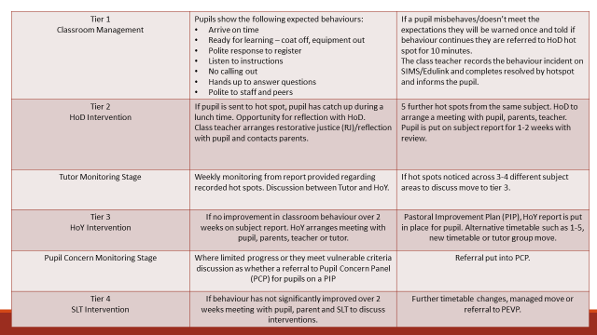

Appendix B
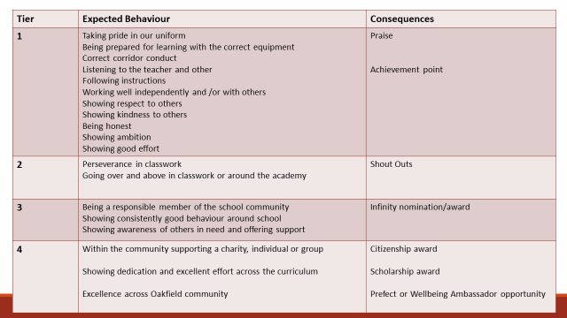

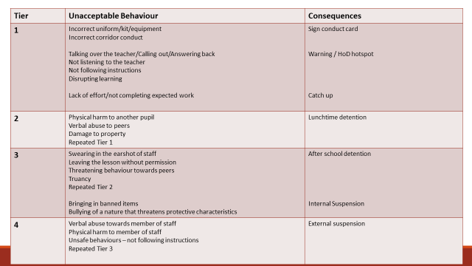
Appendix C

