C.A.R.D Home Workout

Either shuffle a deck of cards or find a random card generator (https://www.random.org/playing-cards/) making sure you leave the jokers in the deck. Pick 20 cards and place them on a table faced down in rows of 5. Each row is one round, at the end of each round, have 1-2 minutes rest before starting the next round.

On each card, the number on the card is the number of times you need to do the exercise; this is also known as repetitions or reps. If you find this number too easy, add 10 repetitions to the number.
Compete for this number of repetitions with as few stops as possible.
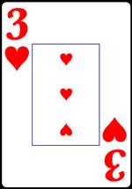

The suit is the exercise that you have complete. Hearts are cardio, an exercise that gets your heart pumping. Spades are push exercise, clubs are pull exercises and diamonds are leg exercises. See the table on the next page.

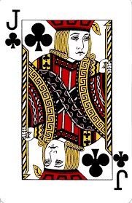
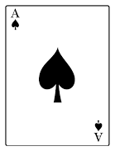
Picture cards like jacks, queens and clubs are all worth 10 repetitions. These cards will have a picture on them and a J, Q or K in the top corner.
Aces are worth 2 minutes rest. If you have this card set a timer or take note of a clock and rest for 2 minutes.
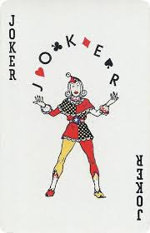
A joker is 50 repetitions, careful not to draw this one!!

Hearts | An exercise that trains your heart and lungs | - Mountain climbers
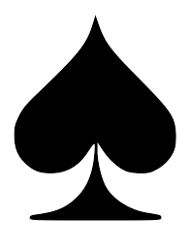  Spades | An exercise where you push weight or the ground away | - Push-ups
Clubs | An exercise where you pull an object towards you | - Table rows
Diamonds | An exercise that uses your leg muscles | - Walking lunges

See the C.A.R.D workout video on the Oakfield Academy’s youtube channel for explanations of how to complete these exercises.
So let look at one round.
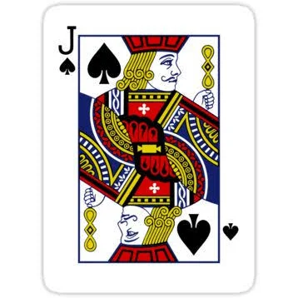
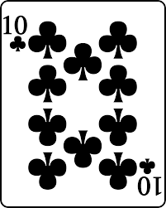
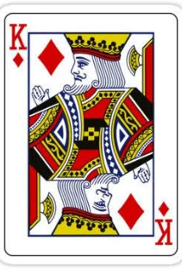
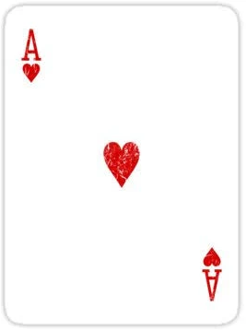

Now that I have drawn these five cards in one row I would need to do the following:
- Jack of spades- Picture card is 10 repetitions and the suit is spades, so I would need to complete 10 push-ups
- Ace of hearts- If this was a number or a picture card I would need to do some mountain climbers, however, because is an ace I will rest for 2 minutes instead
- King of diamonds- This is another picture card so it is worth 10 repetitions, this time the suit is diamonds so the exercise is walking lunges. I will need to do 10 walking lunges before moving on to the next card
- 10 of clubs- The number on the card is 10 and the suit is clubs, therefore I will need to complete 10 repetitions of table rows
- Joker of hearts- This is a joker card and the suit is hearts, this means I need to complete 50 mountain climbers
- This is the end of the round, I will now turn over the next row of cards and rest for 1-2 minutes
Work hard, and have fun! The harder you work the more you will get out of the workout.

