CRICKET ACTIVITIES
In the Summer term at Oakfield we would be teaching Striking and Fielding, including Cricket & Rounders. Here are some skills you can practise while you’re away from school. It will keep you active and enjoying fresh air, now that you are allowed to go out to exercise more.
If you don’t have the equipment, you can use any small ball including a tennis ball or a rolled up pair of socks. See what alternatives you can find for a bat but please check with a parent first. Be inventive!

intro/refresher to CRICKET SKILLS AND EXERCISES
When you play a sport it always helps you enjoy it more if you have a basic level of skill and understanding of the game. It will mean you can participate more, have more confidence and this helps you to stay motivated to keep playing and being active.

To be a good cricket player requires:

- Good hand eye co-ordination
- The ability to throw and catch a ball
- Good batting and bowling technique

The challenge is to practice exercises that develop these skills. Good concentration is a skill that can be developed over time.

EXERCISE 1 FIELDING: HAND-EYE COORDINATION, THROWING & CATCHING
“Catches win matches” as the old saying goes so improving hand eye coordination for catching is very important.
- Place two balls on the ground 3 metres in front of a wall.
- Pick up the first ball throw it underarm at the wall, clap your hands and the catch the ball with two hands as it rebounds off the wall.
- Then place the ball back on the ground, run to a marker behind you 10 metres away from the wall and run back to the second ball.
- Pick up the second ball throw it at the wall, clap your hands and catch the ball with one hand.
- Place the ball on the ground, run back to the 10-metre marker and return to the first ball, and repeat.
- Aim to increase speed and go as many times as you can without dropping the ball.
- You can also practice catching with your non-dominant hand at the second ball station.
Underarm Throwing Hands cupped together to catch

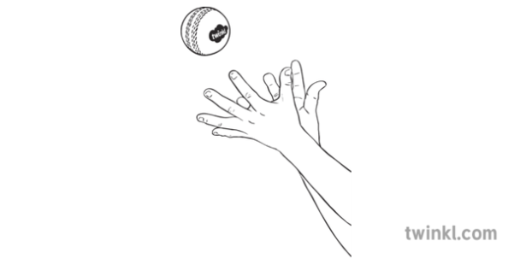
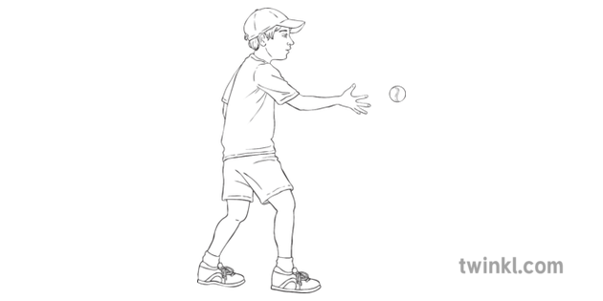

EXERCISE 2 BATTING; HAND EYE COORDINATION & BATTING TECHNIQUE
If you want to create a wicket/stumps for batting, you can use chalk to draw on a wall, or use a bin.
- A past but great Australian Cricket, Don Bradman used to do this exercise everyday as a kid (and it definitely worked for him).
- Stand about 4 metres back from a concrete wall and hit a tennis ball into the wall. When the ball rebounds hit it again.
- When hitting, face side on to the wall, feet shoulder width apart, bat lifted ready to hit the ball. As you hit the ball keep your front elbow up and hit straight through the ball so it bounces once before hitting the wall.
- Try to hit the ball as many times as possible before you lose control and you can even compete against your friends to see who can get the highest number of hits.
- As you improve try using a golf ball to increase the difficulty.

Watching the ball & in ready position Swinging the bat

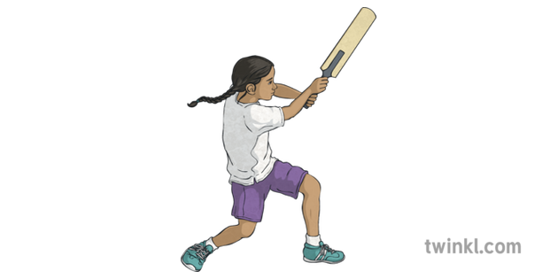
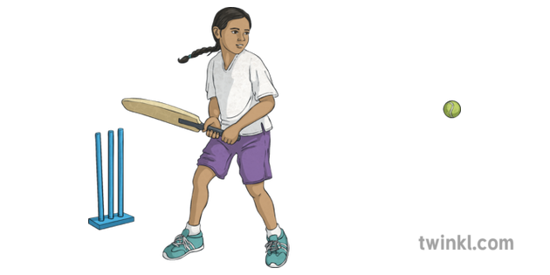

EXERCISE 3 BOWLING TECHNIQUE
A past but great Australian Cricketer, Don Bradman used to do this exercise everyday as a kid (and it definitely worked for him).
- Stand about 4 metres back from a concrete wall and hit a tennis ball into the wall. When the ball rebounds hit it again.
- When hitting, face side on to the wall, feet shoulder width apart, bat lifted ready to hit the ball. As you hit the ball keep your front elbow up and hit straight through the ball so it bounces once before hitting the wall.
- Try to hit the ball as many times as possible before you lose control and you can even compete against your friends to see who can get the highest number of hits.
- As you improve try using a golf ball to increase the difficulty.
Learning a proper cricket bowling technique can be difficult for beginners so it’s important to start slowly, get the technique right and then worry about the accuracy of the bowl later. The “Rock & Bowl” is a great leaners’ drill.
- Stand side on to the batsmen/wickets with your dominant hand at the back.
- Hold the ball with both hands under your chin and turn your head sideways to face the batsmen/target.
- Rock back and forth transferring weight from the front foot to the back foot in a smooth consistent motion.
- Now as you rock back extend your back arm and when you rock forward let your front arm extend and pull down and your back arm comes over your head and releases the ball in the direction of the batsmen.
This will take patience and practice to feel comfortable. You could watch some professional bowlers to see their techniques for some extra tips.

Practicing these 3 exercises regularly will give you the basic skills you need to join in with cricket matches and have fun.
If you would like to send us a photo or video of your skills, please send it to PE@oakfieldaceademy.org.
Good luck
The Oakfield PE Department

